# Andpad

UNG CECILE – GUIDON VINCENT – SELARIES JULIEN

Introduction of the features

* Image saved
* Data saved in files.
* Optimized & personnalized ListView
* Image Background
* Sharing notes
* Splash Screen for the Logo
* Optimized design
* Color Picker

1°) Image Saved

Images are saved in the directory of the application.

2°) Data saved

The Notepad is saved in a File, a JSon feature. We didn’t want to use a database manager because it would have been more heavy and less optimized for the few variables we want to save.

3°) Sharing notes

It’s possible to share notes and use it from external application, or the wordpress.

4°) Splash screen

Just like a firm, we are using a splash screen in order to display our beautiful logo.

5°) Optimized Design

The global design of the application has been created so it’s easy to understand, just like most of application nowadays.

6°) Optimized & Personalized ListView

A classic ListView create always the item and destroy it when a new item wants to be displayed. The problem with this is with a significant number of item, while scrolling will slow the display, and make it loses significant Frames.

This is how we are recycling the view and reusing it just by editing the text:

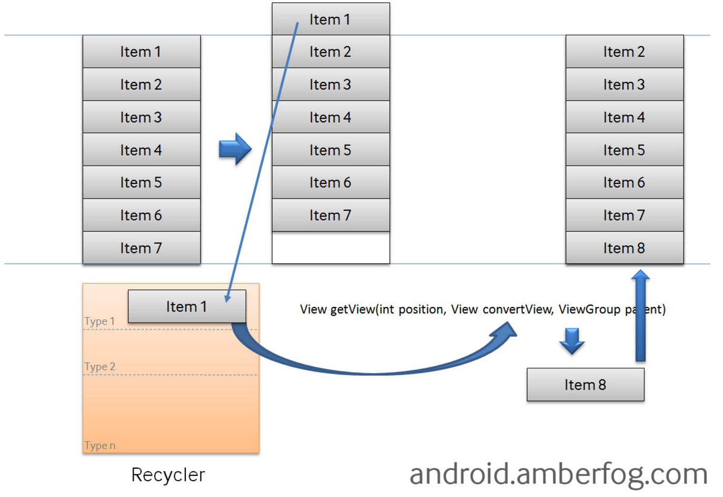

7°) Color picker

Since you can add a background image and the image is saved, we have added the option of changing the text color, so you can always able to see your text! ☺