A question we found interesting to look at in the given data set, was if females and males are feeling any differently regarding the safety in big cities. One could assume that women feel not as save as men, because women might be physically weaker. Thus, we chose to look at two different cities to see if we were right with this assumption. Looking at the average age of the participants in the study, we can assume that most of them drive through the city at night. Thus, a good infrastructure is important to them to get through the city safely and therefore it might be a good indicator to compare if results differ when looking at cities with very different infrastructures. Since Berlin has in comparison to Rome a really good infrastructure, looking at those two cities should give us a good picture if the gender influences the safety feeling of people. The results are shown in the following visualization.

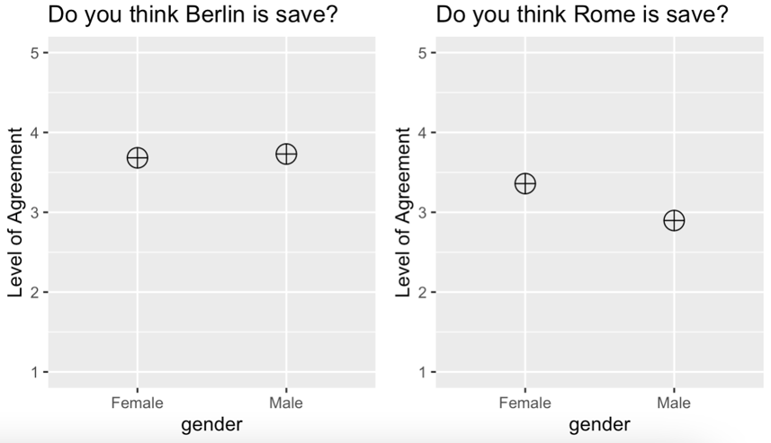

The results we got from the data were not as intuitive as we thought. In Berlin, the women in the given data set feel nearly as save as men, with both genders rather agree with the statement “Berlin is safe.”. But as already mentioned, that could be explained by the good infrastructure the city has. However, the results we got for Rome were really surprising to us. The women in the given data set actually feel safer in Rome than men do. A possible explanation for that might be the small statistical population in the data set. We also do not know where the people live in Rome. It might be that the women live in safer areas than men anyway.

Another thing we asked ourselves, was if locals think their city is too touristic compared to tourists. The hypothesis we had, was that locals perceive their city as too touristic whereas tourists will not have such an impression. However, the data did not confirm our hypothesis. In Berlin as well as in Paris and Stockholm, the tourists agreed more with the statement “The city is too touristic.” than the locals did. To get more information about that we looked at the average level of agreement from locals and tourists over all cities. To avoid biased results, we only included cities where we had locals in the data set. However, the result still was not confirming our assumption, but we got closer to it. There was barely any difference in the data set about how people felt about the city being too touristic. The mean for locals was 3.41 and the one for tourists was 3.49, so both rather agreed with the statement. A possible explanation for the data in Berlin, Paris and Stockholm might be that the tourists are doing sightseeing in the cities they visit and thus, are spending more time at touristic places. The locals in our data set might avoid such places and therefore get a whole different feeling for their city as tourist do. But they also do know whether their city is popular among tourists or not. One could assume that they can assess the amount of tourists pretty well, what would explain why they are so close to the mean of the tourists in the aggregated analysis.