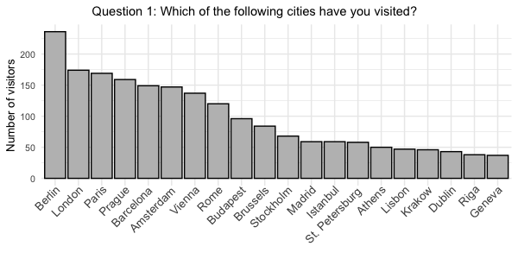

**Results of Part 1**

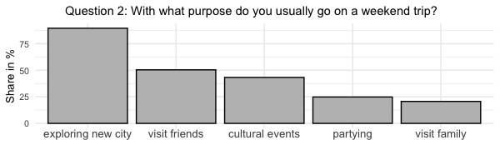

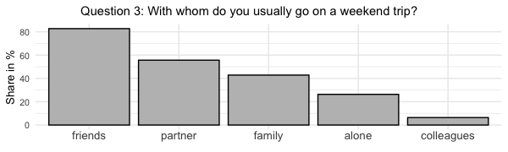

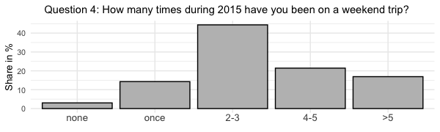

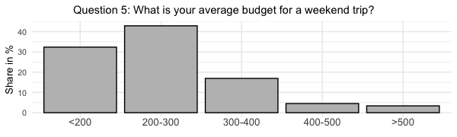

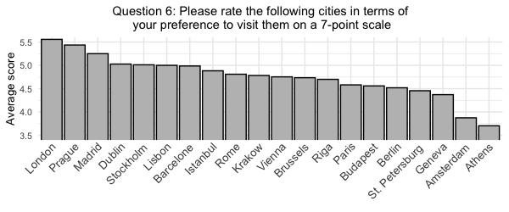

**Personal Data of the Participants**

* 113 out of 226 participants were male
* 153 out of 226 participant were female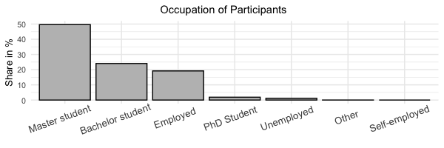
* the mean age was 25.5

