TP 3 : Lab Report

Emma DUCOS & Vincent HENRIC
NPM3D -January 30th, 2020

A. CloudCompare normals
Question 1 (2 points) : If you use a too small / too big radius, what is the effect on the normal estimation? Prove your point with screenshots of the dip scalar field.
The normal estimation is approximating the surface with a neighborhood chosen inside a sphere of a certain radius. If the radius is too small, only noise will appear ; but if the radius is too big, the approximation is too big and we loose information on the surface of the objects.
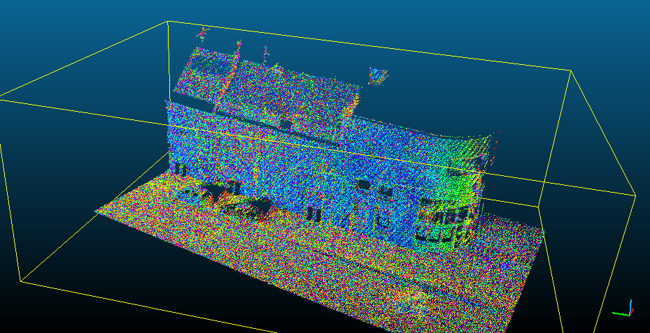Illustration 1: Dip scalar field with a radius of 2 cm
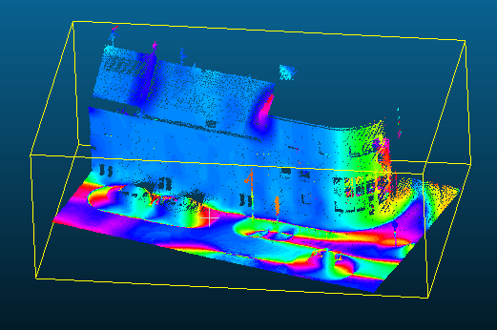Illustration 2: Dip scalar field with a radius of 2 m

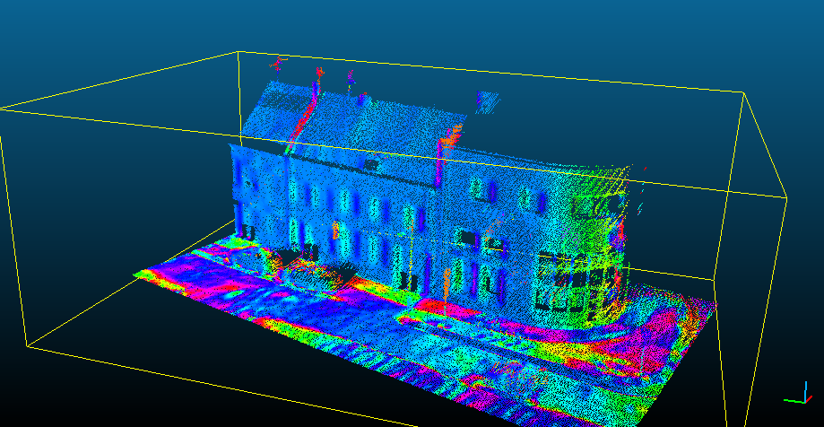Illustration 3: Dip scalar field with a radius of 50cm
A scalar field of 50cm looks like a better compromise. We can see the objects on the roof, the windows, have better visibility on the car, which is not as obvious with a radius of 2m. Contrary to a radius of 2cm, it is not too noisy : we have clear patterns representing the objects of the scene.

Question 2 (1 point) : How would you choose the neighborhood scale for a good normal estimation?
To choose the neighborhood scale for a good normal estimation we should decide what is the order of magnitude of the smallest object we want to approximate the surface in the scene. 50cm is a reasonable order of magnitude to be able to see the windows, the cars, details on the roof.

B. Local PCA
Question 3 (2 point) : Show a screenshot of your normals converted as “Dip” scalar field in CloudCompare.
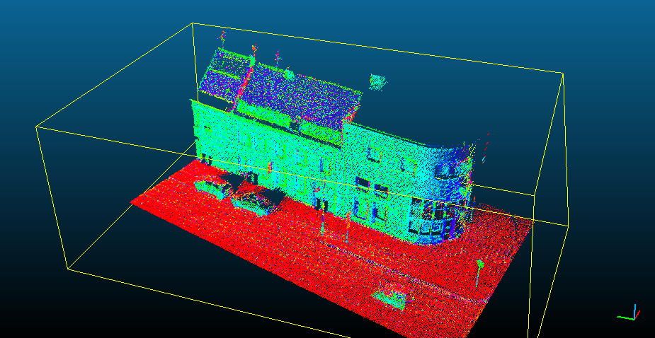Illustration 4: dip scalar field of the normals computed with our local PCA algorithm
Question 4 (1 point) : How could you measure the quality of your normal estimation with the eigenvalues?
The normals is given by the eigenvector of the smallest eigenvalue. We could compare the values of the smallest eigenvalues over the neighborhoods. We could measure the quality of the normal estimation by estimating how much the eigenvectors of the two smallest eigenvalues of the covariance matrix are colinears. If the ratio of the two eigenvectors is close to one (ie, the eigenvalues are almost equal), then the normal is not well defined. From a mathematical perspective, it is almost like the two smallest eigenvalues are equal, and the vectorial space induced by this eigenvalue is of dimension 2. So it is not clear what the direction of the normal vector should be. This could happen for very specific objects (objects that look like a long, thin line, for example), but the proportion of such cases should be small for the dataset we have.

Question 5 (4 points) : Show screenshots of the 4 features as scalar fields of the cloud. Can you explain briefly the names of the 3 last features considering their definition with eigenvalues?
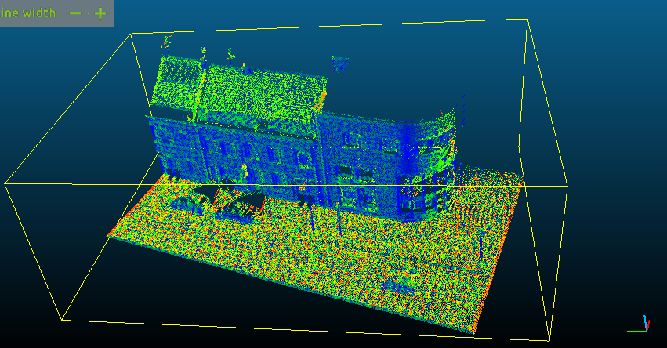Illustration 5: Verticality scalar field
Linearity is a scalar that takes values between 0 and 1. When linearity goes to zero, we can verify that the two biggest eigenvalues are of the same order of magnitude, so the points are equally distributed in the two directions. When the linearity is close to 1, lambda2 is small compared to lambda1. So the point clouds has more variability along one direction, which is typical of a line, like the streetlamps’ rods.
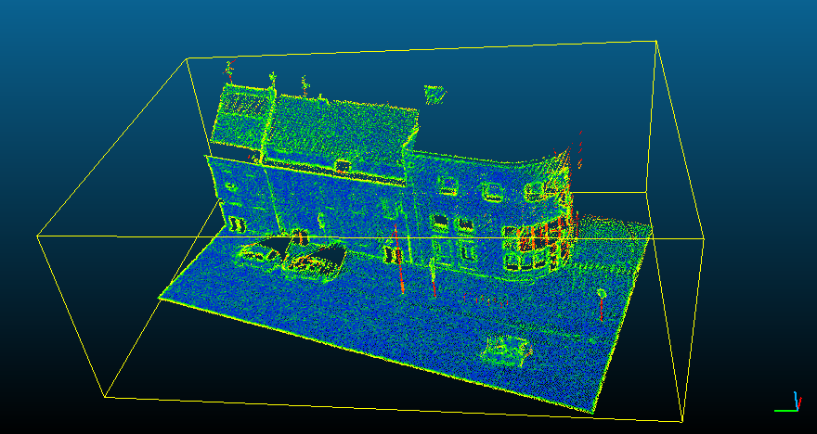Illustration 6: Linearity scalar field
Planarity is a scalar between 0 and 1. It is close to 0 when lambda2 is close to lambda3. In this case, the local variability of the point cloud is mainly along one direction (like for a thin line or a stick). It is close to 1 if lambda2 is close to lambda1, and lambda3 is small compared to them. In this case, the point cloud are distributed uniformly along the two main directions, given a planar shape. We can see with the streetlamps’ rods that the planarity is close to 0 for example, whereas it is close to 1 on the walls on the on ground (planar shape).
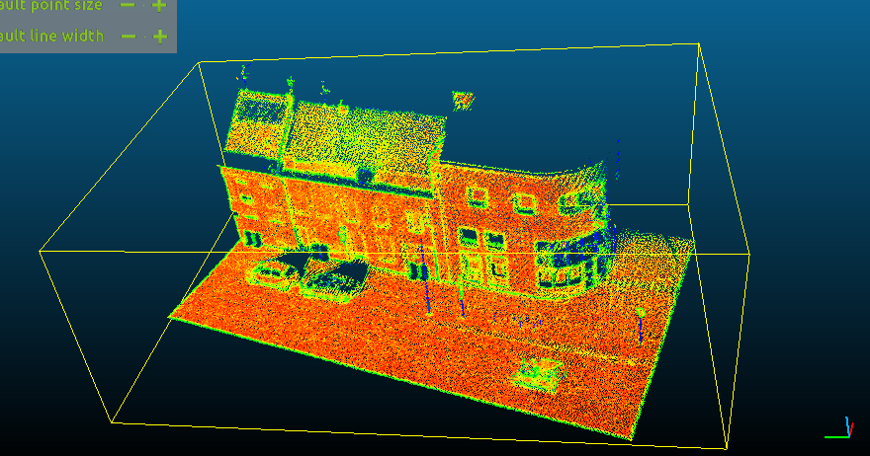Illustration 7: Planarity scalar field
The spericity is a scalar between 0 and 1. When it is close to 0, the normal direction’s eigenvalue is small compared to the biggest eigenvalue, which corresponds more to a planar shape. When it is close to 1, all the eigenvalues will have around the same value (lambda2 is between lambda3 and lambda1). So we have points clouds distributed in the same way in all directions, which correspond to the shape of a sphere or a ball. We can see that on the wheels of the cars for instance, slightly on the gutters or on the top of the roof.
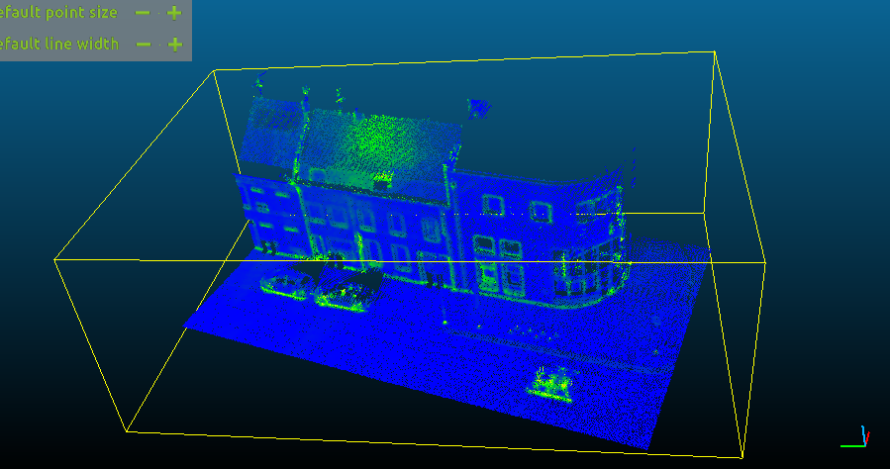Illustration 8: sphericity scalar field

C. Mini-Challenge : point classification
The last part of this practical session is a little machine learning challenge. Now that you know how to compute 3D descriptors, you can use them to classify a point cloud.

Mini-Challenge Rewards
In the report of this practical session, or in a separate report, explain your classification method briefly. If you tried several methods, you can show your cross validation results to support your choices. Bonus points will be awarded to the best scores but also for original ideas.
Point cloud classification can be a subject for the final project, if you are willing to go further, and implement more complex algorithm, you can ask more information by email.
The best/most original methods will be highlighted during the seminar on February 28, 2019.

Instructions
The mini-challenge will be hosted on the npm3d website as a temporary benchmark. First create an account with “MVA” as affiliation. All necessary instructions are available on the “Benchmark MVA” page.
To be able to submit results, you have to login and create a new method in your dashboard. Do not forget to put your name in your method name or description.
There is a 3 hours limit between each submission, and you are not allowed to create multiple methods to overcome this limitation. Cheaters will be harshly penalized.

Data
The data is a subpart of the bigger Paris-Lille-3D benchmark, coarsely subsampled with a 5cm grid. This drastically reduces the number of points, allowing you to still code your algorithm in python.
The training data consists of three clouds : MiniLille1.ply, MiniLille2.ply and MiniParis1.ply. Compared to the original Paris-Lille-3D dataset, the annotation comprises only 7 classes:
- Unclassified  - Ground  - Building  - Poles | - Pedestrians  - Cars  - Vegetation
You should not use the first class (Unclassified) during training. It will be ignored in the test. You can use a cross validation strategy on those three clouds to find the best parameters, features, or training/test strategy.
The goal is to classify every point of the cloud MiniDijon9.ply. The predicted labels should be stored as a text file named MiniDijon9.txt. You can use the function np.savetxt to write this file.
If you managed to implement an efficient algorithm (in C++ for example), you are allowed to use the bigger Paris-Lille-3D training set, but you will have to manage the different classes, and point densities. If you use this bigger dataset or any other training data than the one given for the challenge, you have to mention it by checking “Additional training data” in your method.

Tips
In classification.py, a basic strategy is already implemented. As a training set, we chose to use the same number of point per class. It should be better than taking random points because the classes are heavily unbalanced. Then, in each of the three training clouds, we chose 500 points per class if possible. For every training point, we compute the four basic features seen in part B, with a fixed radius of 50cm. Eventually we train a random forest classifier on those features.
There are several ways to obtain better results. Here are some leads :
- The features used here are very basic. You can find more of them by looking at the literature on point cloud classification. This article should be a good start.
- The scale parameter was not optimized. You can also imagine using multiple scales instead of one, however, you can be limited by the computation time. Unless you find a way to reduce it… If you want to go that way, this article should help you.
- Although you will have trouble finding a better classifier than random forests, the training strategy could be better than a random sampling. Try to search “active learning”, it can be used to find the best training points, instead of picking them randomly.
- If you are willing to use Deep Learning, it is possible to use volumetric convolutional neural networks, or more specific architectures to classify 3D points.

