TP 2 : Lab Report

Emma DUCOS & Vincent HENRIC
NPM3D - January 23th, 2020

A. CloudCompare ICP
Question 1 (1 points) : How well does ICP perform on those examples? What is the difference between the aligned cloud and the reference cloud? In the last example (Notre Dame), which cloud should be reference and why?
ICP perform perfectly when the two clouds are loosely alligned, but not when the clouds are far from being aligned. When the two point clouds are from slightly different point of view and time, like with the Notre Dame des Champs, some artefacts and slight misalignment can be seen. In this example, the biggest cloud point should be the reference, as its lignes and planes can be used as external added reference for checking validity of ICP. What’s more, we cannot appariate every point of Notre_Dame_Des_Champs_1 to Notre_Dame_Des_Champs_2 because Notre_Dame_Des_Champs_1 represent some zones that are not present in Notre_Dame_Des_Champs_2, causing the RMS to increase a lot if we take Notre_Dame_Des_Champs_2 as the reference.

Compared files (ref / other file) | RMS for ICP
Bunny_original / bunnry_perturbed | 7,3e-8
bunny_original / bunny_returned | 0,0133466
Notre_Dame_Des_Champs_1 / Notre_Dame_Des_Champs_2 | 1,32715
Notre_Dame_Des_Champs_2 / Notre_Dame_Des_Champs_1 | 12,5855

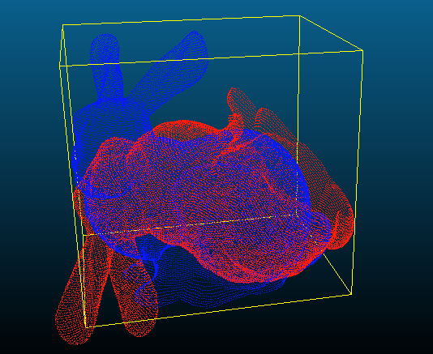Illustration 1: ICP between Bunny original and Bunny returned (original in blue, returned in red)

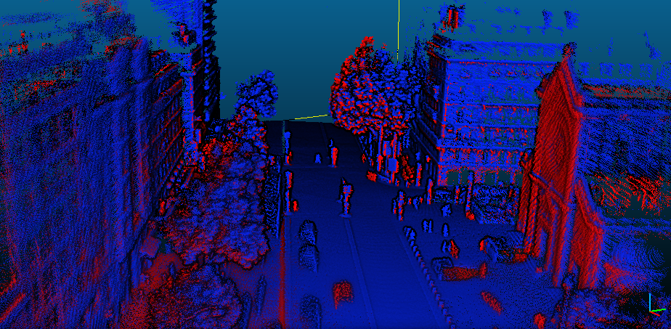Illustration 2: ICP for Notre Dame des Champs 1 and 2 (1 in blue, 2 in red)

B. Rigid transformation between matched set of points
Question 2 (2 points) : Report the RMS errors obtained. Why did the alignment worked while CloudCompare ICP could not align those two clouds? Would this function align the real 3D scans of “Notre Dame des Champs”? Why?
We obtained a RMS error of 0.0129 %.
Here, it worked since we computed an analytical solution, where we ensured that R was a rotation, while the CloudCompare ICP, without an initial alignement, cannot work properly.
However, it cannot directly work with the « Notre Dame des Champs » point clouds as the two cloud points do not have the same number of points (dimension error). We also would need to make sure that points with the same index in both datasets are the ones that should correspond to each other ; in other word, we first need to associate points.

C. Point to point ICP
Question 3 (2 points) : On two different graphs, plot the RMS during ICP convergence for those two examples (2D and bunny).
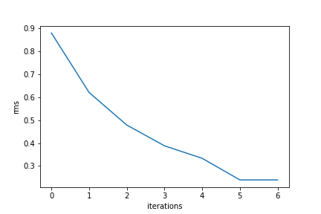Illustration 3: Graph of the RMS value duritng ICP iteration for the data2D image
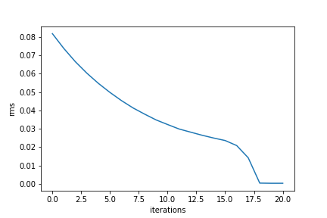Illustration 4: Graph of the RMS values during ICP iterations for the bunny volume

Question 4 (3 points) : On the same graph, plot the RMS during ICP convergence for the “Notre Dame Des Champs” clouds with 1000, 10000 and 50000 points used at each iteration. What do you think of those three curves?
We can see that it does not really converge, with a RMS largely over zero.
With more points, the variance (noise due to the choice of the points) is reduced and the curve becomes smoother.

D. Going further
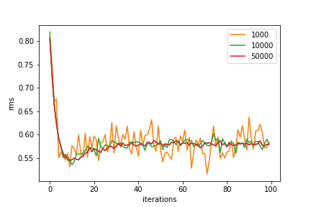Illustration 5: Graph of the RMS values during ICP iterations.
Question 5 (2 points) : Do the farthest points (in red color) have a corresponding point in the reference cloud? What effect do they have on ICP convergence? Do you think that computing RMS on the whole data cloud is a relevant measure of the convergence in that case? Why?
The farthest points do not have a corresponding point in the reference cloud. See the red building on the left in the illustration 6 below.
These points make ICP oscillate around the optimal registration, which can cause convergence issues. These points create noise in the RMS estimator and make it irrelevant. We should leave them out while computing the ICP and the RMS.

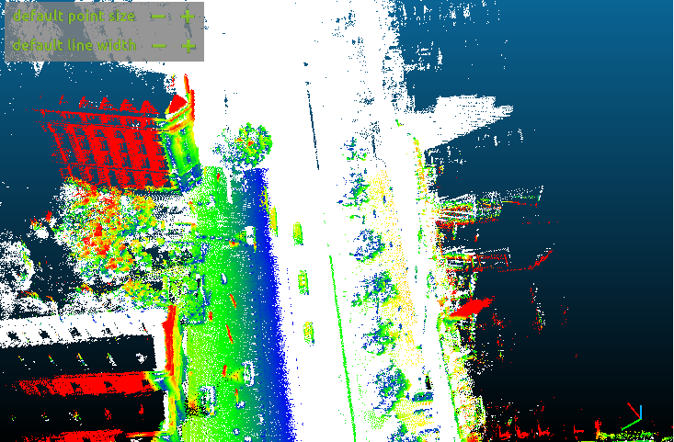Illustration 6: Distance between Notre_Dame_Des_Champs_1 and Notre_Dame_Des_Champs_2

Question Bonus 1 : With the method of you choice, compare the results of you ICP with the results of CloudCompare ICP (with and without changing final overlap parameter).
For Cloudcompare ICP, working with 100 % of the data d not give the best results, because of the noise of the unregistered points. 90 % of the cloud makes the best ICP registration, but any percentage lower does not give better results. Cf plot
Regarding our ICP algorithm, we found that a final overlap of 50 % gave the best RMS results.
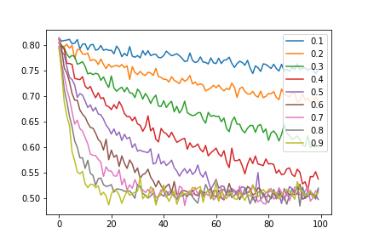Illustration 7: Graph of the RMS estimates during ICP iterations, for different amount of final overlap.
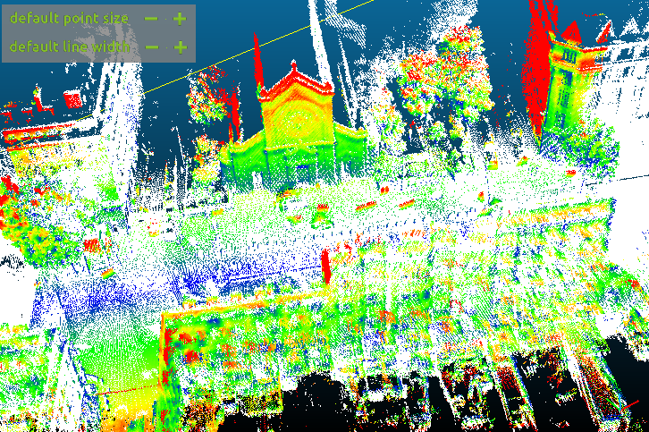Illustration 8: Cloudcompare ICP with 50 % final overlap

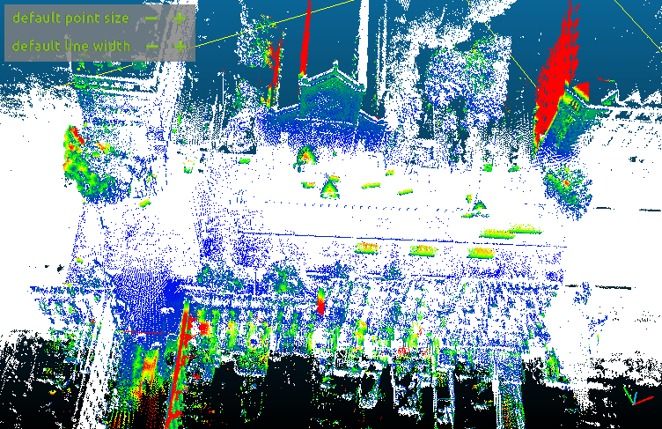Illustration 9: Cloudcompare ICP with 90 % final overlap
Question Bonus 2 : Compare your best ICP result with the best results obtained by CloudCompare. Could you beat CloudCompare ICP?
We had visualy very similar results, but it was difficult to determine if our algorithm or cloudcompare’s was the best.
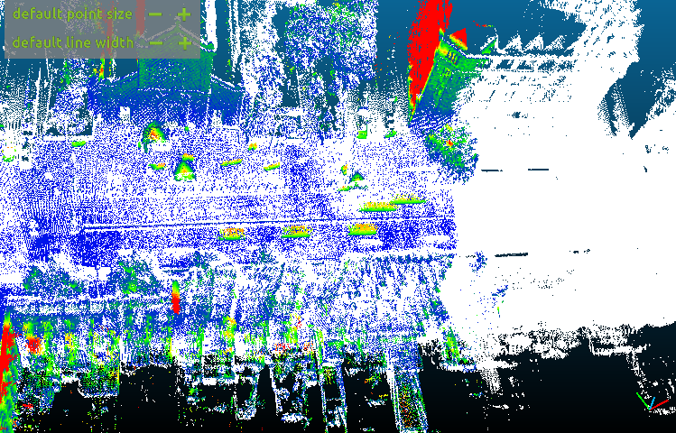Illustration 10: best ICP registration on cloudcompare
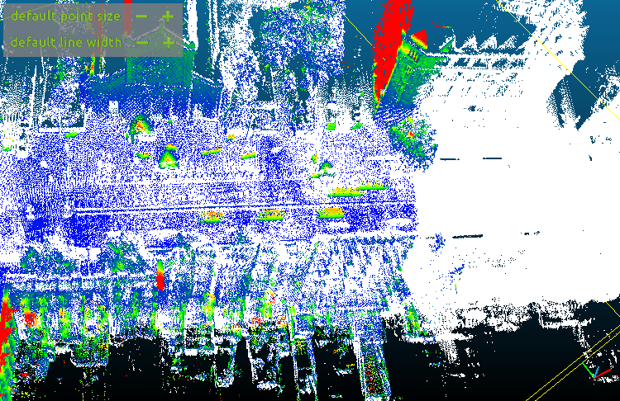Illustration 11: Our best ICP registration with 50% final overlap

