TP 2 : Lab Report

Emma DUCOS & Vincent HENRIC
NPM3D - January 23th, 2020

A. CloudCompare ICP
Question 1 (1 points) : How well does ICP perform on those examples? What is the difference between the aligned cloud and the reference cloud? In the last example (Notre Dame), which cloud should be reference and why?
ICP perform perfectly when the two clouds are loosely alligned, but not when the clouds are far from being aligned. When the two point clouds are from slightly different point of view and time, like with the Notre Dame des Champs, some artefacts and slight misalignment can be seen. In this example, the biggest cloud point should be the reference, as its lignes and planes can be used as external added reference for checking validity of ICP.

B. Rigid transformation between matched set of points
Question 2 (2 points) : Report the RMS errors obtained. Why did the alignment worked while CloudCompare ICP could not align those two clouds? Would this function align the real 3D scans of “Notre Dame des Champs”? Why?
We obtained a RMS error of 0.0129 %.
Here, it worked since we computed an analytical solution, where we ensured that R was a rotation, while the CloudCompare ICP, without an initial alignement, cannot work properly.
However, it cannot work with the « Notre Dame des Champs » point clouds as the two cloud points does not have the same number of points and are not, as such, in the same order.

C. Point to point ICP
Question 3 (2 points) : On two different graphs, plot the RMS during ICP convergence for those two examples (2D and bunny).
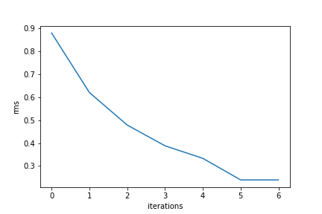Illustration 1: Graph of the RMS value duritng ICP iteration for the data2D image
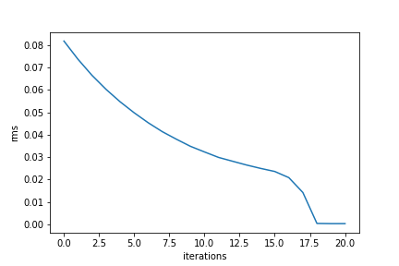Illustration 2: Graph of the RMS values during ICP iterations for the bunny volume

Question 4 (3 points) : On the same graph, plot the RMS during ICP convergence for the “Notre Dame Des Champs” clouds with 1000, 10000 and 50000 points used at each iteration. What do you think of those three curves?
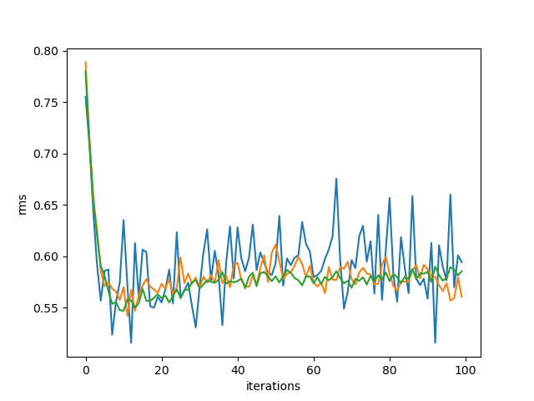Illustration 3: Graph of the RMS values during ICP iterations. The sampling limit value is 1000 for the blue curve, 10000 for the orange curve, and 50000 for the green curve.
We can see that it does not really converge, with a RMS largely over zero.
With more points, the variance is reduced and the curve becomes smoother.

D. Going further
In the last part of this practical session, you are going to learn tricks to optimize your ICP results and maybe even do better than CloudCompare.

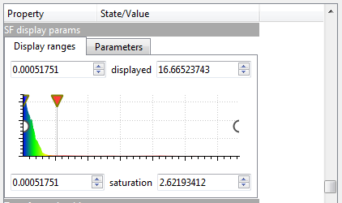
- Load Notre_Dame_Des_Champs_1.ply and Notre_Dame_Des_Champs_2.ply in CloudCompare. For each point of Notre_Dame_Des_Champs_2 you can compute the distance to Notre_Dame_Des_Champs_1 with the cloud to cloud distance tool (Tools > Distances > Cloud/Cloud Dist.). This tool will save the distances as a scalar field.
Tip (for a better visualization) : When this is done, select the cloud and find the scalar field display options in the “Properties” panel. Here you can adjust the saturation of the scalar field (slide the red triangle or directly enter a specific value in the saturation box)

Question 5 (2 points) : Do the farthest points (in red color) have a corresponding point in the reference cloud? What effect do they have on ICP convergence? Do you think that computing RMS on the whole data cloud is a relevant measure of the convergence in that case? Why?

(BONUS)

- Now try ICP on those two clouds, but this time, play with the “Final overlap” parameter. Here is what CloudCompare documentation says about it :

Final overlap: this is a new parameter for the version 2.6.1. It lets the user specify the actual portion of the data/registered cloud that would actually overlap the model/reference cloud if both clouds were registered. This let the user register entities with only a partial overlap (down to 10% or even less).

- When using this parameter, CloudCompare RMS becomes irrelevant as a measure of the alignment quality. To be able to compare the results, you have two choices :
  - Look at the clouds yourself with CloudCompare and check visually if some object are well aligned (you can look at lamp post, or road signs for example). Using the cloud to cloud distance tool can help the visualization.
  - Save the aligned clouds as .ply files (choose binary when asked) and create your own python function to compute a relevant RMS measure between two clouds. Following your answer at question 5, instead of computing RMS on all points, you can compute RMS on the 50%, 70% or 90% closest points, or even all 3 to have more relevant measures.

Question Bonus 1 : With the method of you choice, compare the results of you ICP with the results of CloudCompare ICP (with and without changing final overlap parameter).

- In your icp_point_to_point_stochastic implementation, add a final_overlap parameter and modify the function following this idea : at each iteration, after choosing a random number of point to compute one step, remove the farthest points depending on the final overlap parameter.

- In the data folder, you can find Notre_Dame_Des_Champs_2_CCbest.ply, this is the best alignment that can be obtained with CloudCompare.

Question Bonus 2 : Compare your best ICP result with the best results obtained by CloudCompare. Could you beat CloudCompare ICP?

