Comp 2322 Computer Networking
Project: Multi-thread Web Server

Name : Ho Kwun Chung
Student ID : 22074679d
Github link : github.com/VincentHo1689/COMP2322_Project.git

Project summary
Project objective
This objective if this project us to design a functional multi-threaded Web server in Python that can process HTTP requests sent from browsers or some other client programs, and to achieve this, this project should be focus on the application layer and the transport layer.
To clerify the objective, I further group the whole project into 5 parts:

1. Connection management
This part contains the multi-threaded server and the persistent connection management.
Firstly, multi-threaded server is for turning a single-process server into a multi-threading server, that the server can process different incoming connection at the same time, by creating a new thread for every connection.
Secondly, the persistent connection management allows user to have better management in the connection, that it allows both persistent HTTP connection (keep-alive) and non-persistent HTTP connection (closed), where persistent HTTP connection could reduce the overhead for the TCP handshake every time, reducing the total response time.

2. Request and response management
The server must act as a parser for the HTTP request; the server should support 2 types of command. GET command is for full retrieval of objects (header + body), while HEAD command is for efficient metadata retrieval (header only), used to check file status without consuming bandwidth for the body.
After the process finished, it should contain one of the status codes, it should be returning appropriate 3-digit status codes, including 200 OK, 400 Bad Request, 403 Forbidden, 404 Not Found, and 304 Not Modified based on the process status.

3. Content management
The server manages the delivery of different physical media types, including text files (HTML/TXT) and image files (JPG/PNG), ensuring the Content-Type header is accurately set for correct browser rendering.
There should be adding the logic to manage the fobidden content access, which is relate to the status code 403 Forbidden.

4. Caching handling
Lastly, it should be handling the Last-Modified and If-Modified-Since header by comparing these 2 timestamps, the server compares the file's state against the client's cache. If the file is unchanged, a 304 Not Modified response is sent, effectively bypassing the transmission of the Entity Body and saving Bandwidth.

5. Log file generation
After each request, it should have a log recorded to records the historical information about the client requests and server responses. There should include the data including the client hostname / IP address, access time, requested file name and response type, and the status code of that request

Library used for the server
In this project 5 library is used, including the socket, threading, os, datetime, and re library.
1. The socket library is for creating TCP socket to listen to any request and made response.
2. The threading library is for creating multi threaded server.
3. The os library is for checking the file and get its modified time for the Last-Modified header, it is also for the file access control to produce the 403 forbidden status code.
4. The datetime library is for creating the timestamp and reading the timestamp for the Last-Modified and If-Modified-Since header, it is also for comparing the time.
5. The re library is for parsing the HTTP request, recognizing strings after the header.

Development process & testing
The server was built in six steps, each one adding some new function on top of the current server to ensure the implemention can be handled. Each stage added a specific set of functions, and tested on its own, and then was put together with the work. This method made it possible to find and fix problems step by step.
1. Basic socket communication
The first step is to use the socket library to make a simple TCP server. The server use the IP address of 127.0.0.1 and assigned with a port number. It is using the listen() function to listen for the client. A simple handler function got the client socket, read the data that came in, and sent back a fixed 200 OK response with a HTML page. At this point, there was no real request parsing going on, all header is not read.
For testing, we used a browser and the curl command to go to http://127.0.0.1:[port]/. Both should showed the hardcoded page, which showed that the socket communication was working.
2. HTTP request parsing and basic status codes
The second stage used the re library to split the request into its method, URL, HTTP version, and header fields. The URL was used to get the file path. We used the os library to see if the file was there and if we could read it. The server made a response with the right status line based on the result. For example, if the file was present and readable, it return 200 OK with the file content. If the file was missing, it return 404 Not Found. If the permissions were not enough (cannot read), it return 403 Forbidden. If the request line could not be parsed into correct format, it return 400 Bad Request. The status code 304 would not be handled in this part, since it requires handling the Last-Modified and If-Modified-Since header. At this stage, a log file was also added. Each request wrote one line with the time, client IP, requested path, and response status code.
For testing, the server was going to get a existing text file, a non-exist text file, a file that unable read (chmod 000), and a request with wrong format. In every case, the expected status code was returned and a log file was made.

3. Image files and the HEAD method
The third step is to let server be able to handle binary image files and the HEAD method. We opened image files like .jpg and .png in binary mode using the rb tags. A small lookup table gave the correct Content-Type header based on the file's extension. The same file checks were made for a HEAD request as for a GET request, but only the status line and headers were sent back. The body was keep empty in the HEAD request.
For testing, first a browser was used to open image files, and the curl -I command was used to send HEAD requests. The images looked right in the browser, and the HEAD responses had the right headers but no body.

4. Caching with Last-Modified and If-Modified-Since
The fourth stage added features for caching. The server now dealing with a Last-Modified header to every 200 OK response for a file. I did this by using os.path.getmtime() and the datetime library. The server checked the time in the If-Modified-Since header comparing with the file's Last-Modified time when a request was sent. If the file didn't change, a 304 Not Modified response was sent, and the body was empty. If the file changed, return 200 OK with the new content.
For testing, a file was requested to get its Last-Modified value. Then, another request was sent with that value in the If-Modified-Since header. The server replied with 304 Not Modified. Next, send a request and try to get a 200 OK response if the file was changed.

5. Multi-threading
In the fifth stage, the server was changed from a single‑thread web server to a multi‑threaded web server. The threading library was used in this part. After the main thread accepted a new connection, start a new thread to handle that client, and then immediately went back to accept the next connection. Since multiple threads could write to the log file at the same time, a concurrent control on the log file is needed.
For testing, several browser tabs were opened at the same time, and a script should be running multiple curl commands at the same time. All requests should finished correctly, and the log file recorded every request without corrupted lines.

6. Persistent and non persistent connections
The final stage is the persistant connection management. The server first check the Connection header in each request. If the request was HTTP/1.0 or Connection header is close, the connect is non-persistant and the server should closed the socket after sending. For HTTP/1.1 (where keep‑alive is the default) or Connection header is keep‑alive, the persistant connect is made, and a socket was set with countdown timer, and the handling thread stayed in a loop to read and process multiple requests on the same connection. The loop exited when the client disconnected or the connection timeout.
For testing, curl was used with several URLs on one command line, which reuses a single connection in HTTP/1.1. it is used to check if multiple requests could be handled without setting up a new connection.

Full server structure design
To ensure the code is organized and easy to debug, the server is divided into six Python files. This structure separates the networking logic from the file management and HTTP processing.
server_main.py: This file is the entry point of the program. It sets up the main TCP socket, binds it to the IP address and port, and listens for incoming connections. When a client connects, it passes the connection to the threading module.
thread_create.py: This file manages the multi-threading logic. It starts a new thread for every client and handles the connection loop. It is responsible for checking if a connection should stay open for persistent HTTP or be closed after one request.
request_parser.py: This file is for processing the raw data sent by the client. It uses the re library to split the request into the method, URL, and header fields. It also identifies specific headers like Connection and If-Modified-Since.
file_manage.py: This file handles all interactions with the local file system. It checks if the requested file exists, verifies if the server has permission to read it, and retrieves the file's last modified timestamp for caching purposes.
response_gen.py: This file constructs the final HTTP response message. it combines the status line (such as 200 OK or 404 Not Found), the necessary header lines, and the file body into a byte format that can be sent over the network.
logger.py: This file is for generating the server log. It records the client’s IP address, the access time, the requested file, and the response status code. It uses a thread lock to ensure that multiple threads can write to the log file without causing errors.
Code execution
1. Simple multi-thread web server and GET/HEAD requests
Start server by running the command below:
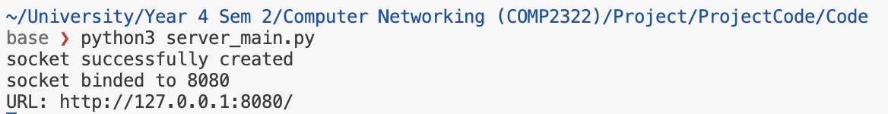

Simple HTML server by entering http://127.0.0.1:8080/ into browser:
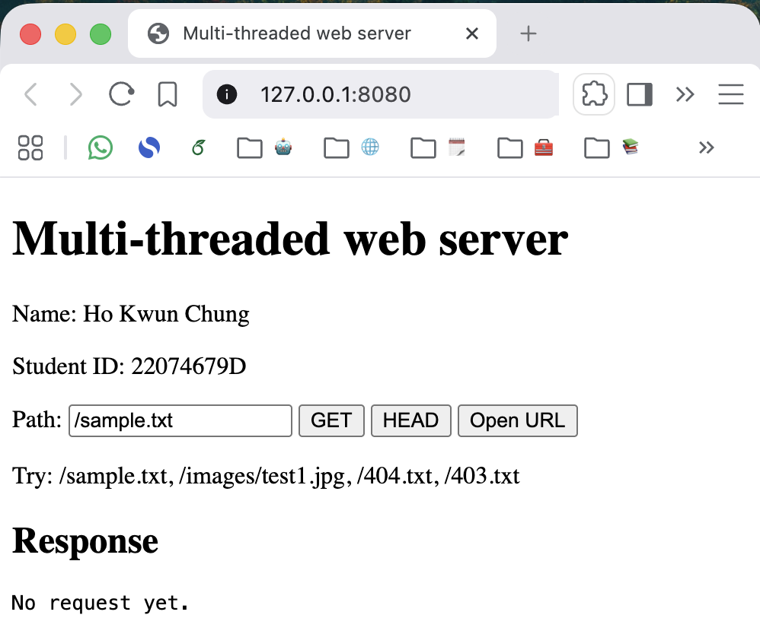

Testing GET and HEAD request on the browser, below also shows the request and response message exchanges:
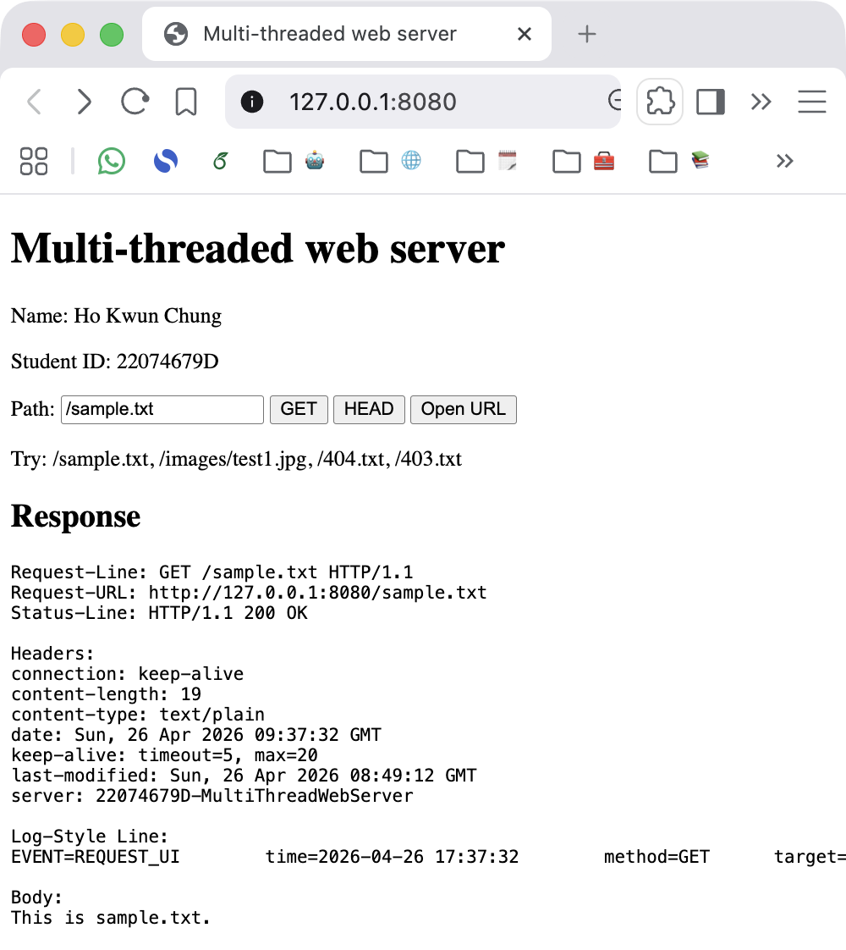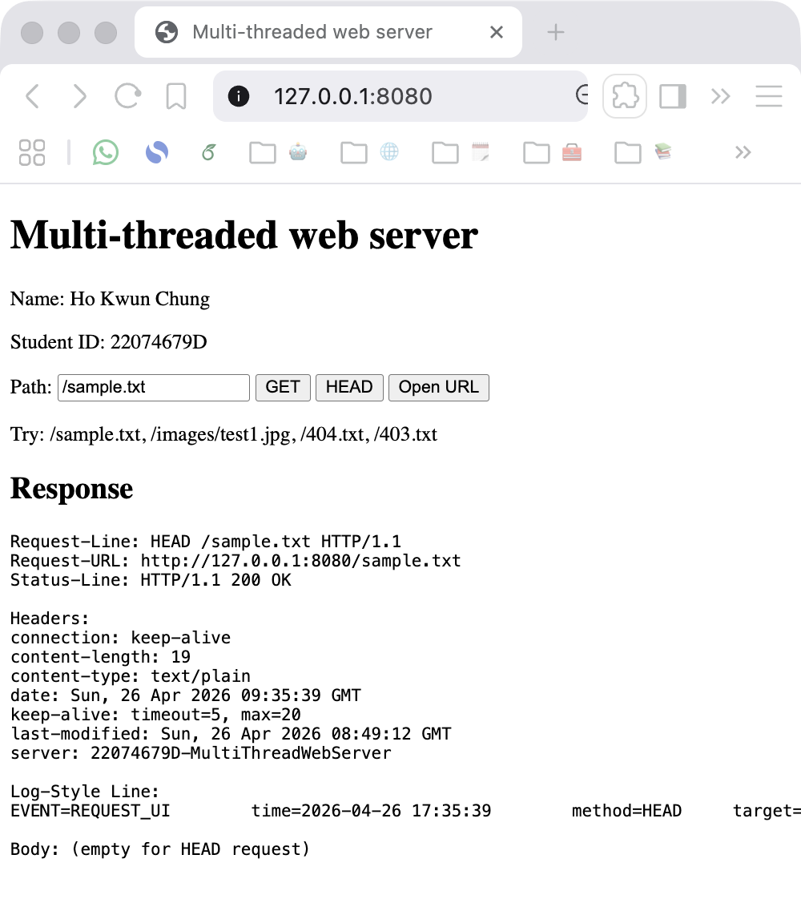
GET request HEAD request
2. Handling different file format

File can be accessed by adding the /[file_name] in path:
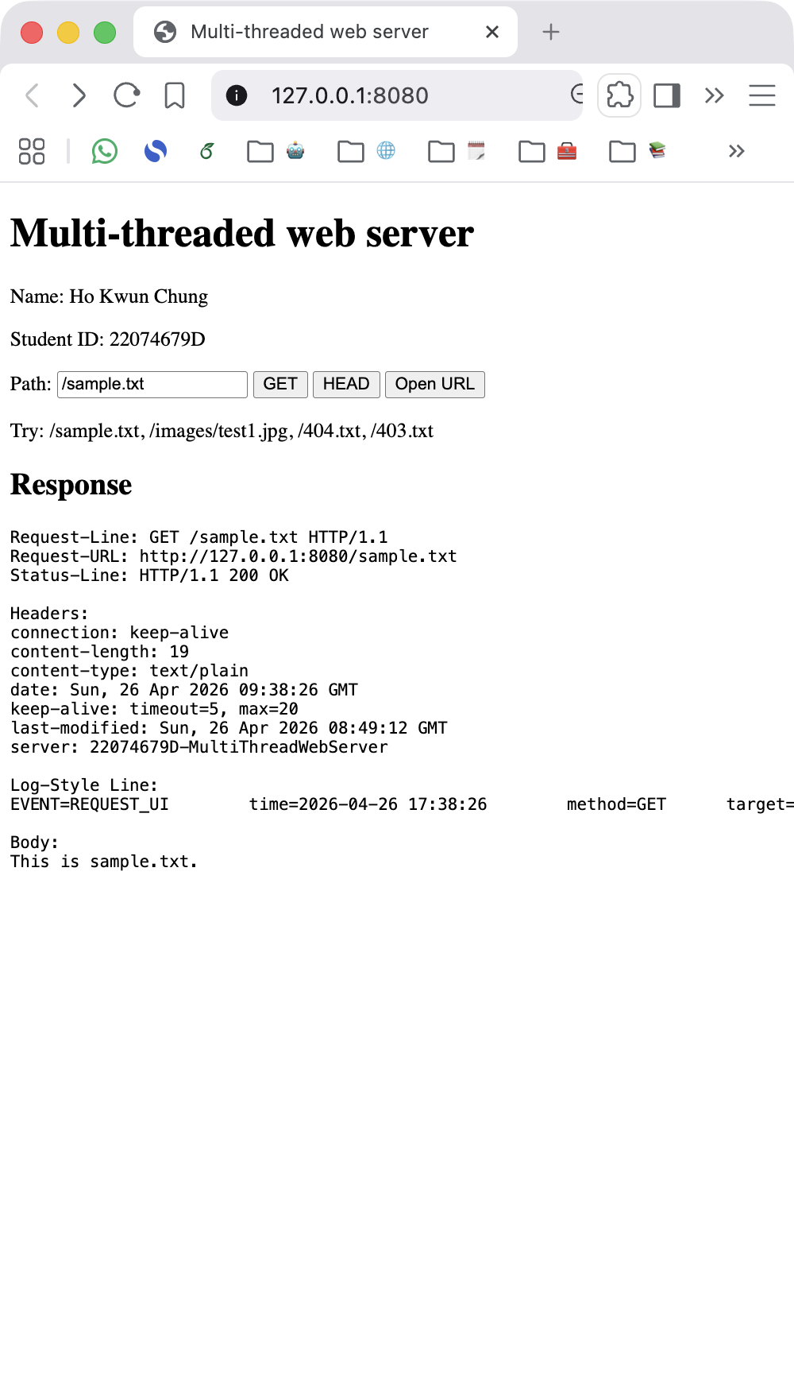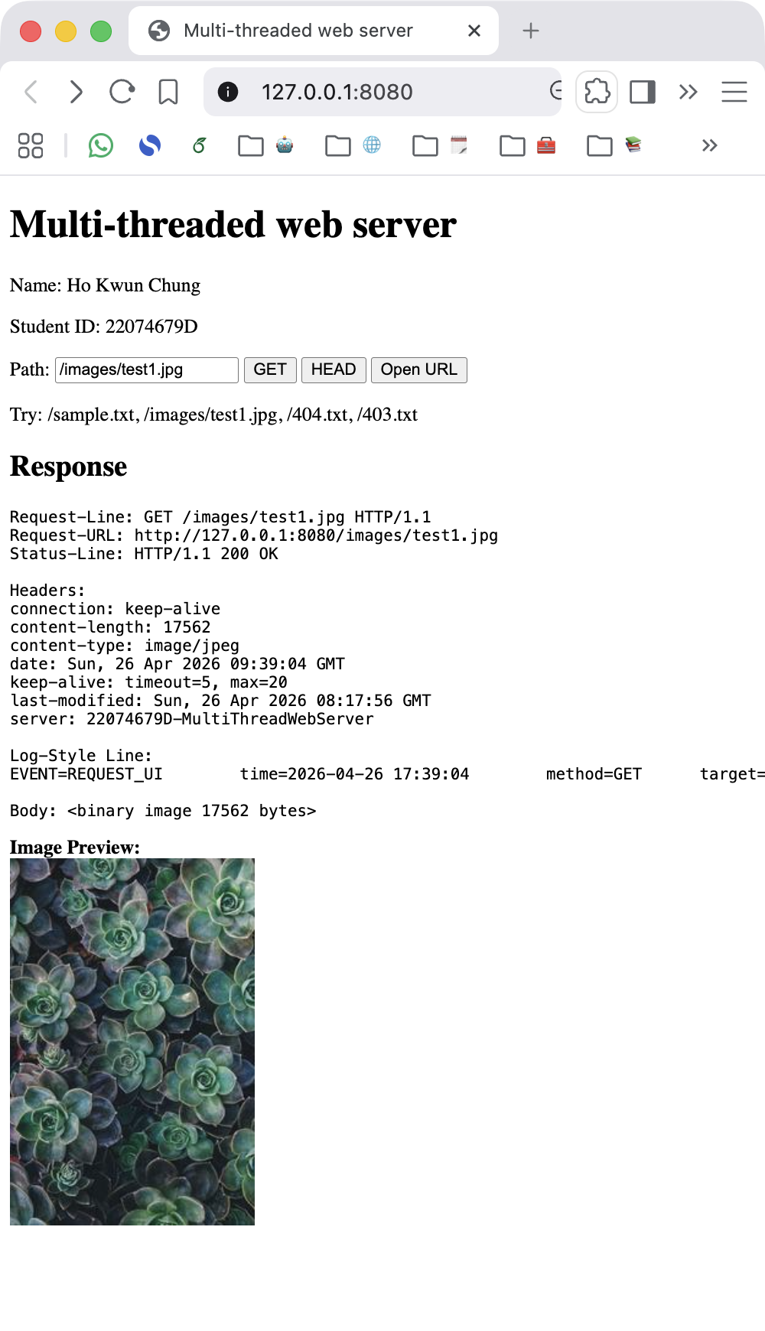
Text (with content-type: text/plain) Image (with content-type: image/jpeg)

The server can also directly open the file in adding /[file_name]
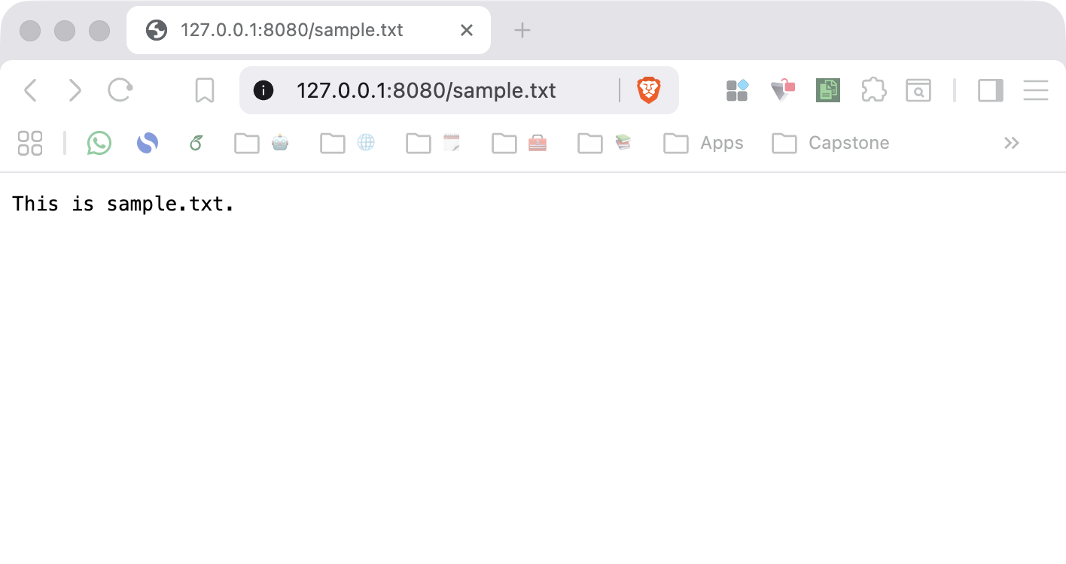
But in this case, the response cannot be seen, response could be checked from the logs.txt
3. Handling the status code
In this part, I would use the curl command to get the requests as the header like if-modified-since cannot be added in the browser, the curl -i command is used for showing the request header, the curl is sending the request to the server through terminal, which for status code 200 OK, 403 Forbidden and 404 File Not Found, it could still be opened from the server, while the 400 Wrong Method and 304 Not Modified it is going to modify the header and request method, which cannot simply handled in the browser:
For status code 200 OK, simply open the a file that is accessable:
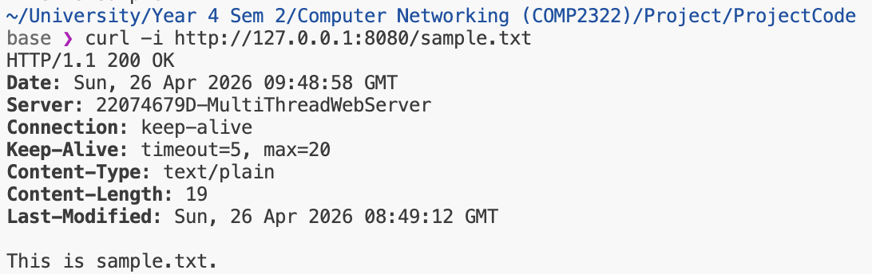
For status code 400 Bad Request, use curl with wrong method, since the server only allow GET and HEAD, if using other method such as POST, return status code 400 Bad Request:
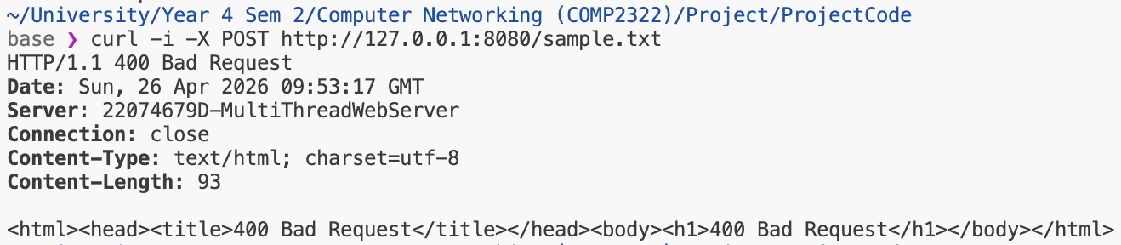
For status code 403 Forbidden, we could request server for a file that it don’t have access:
First create the text (403.txt) and set the access to 000, which cannot server don’t have read access, the cat function ensures it cannot be read.
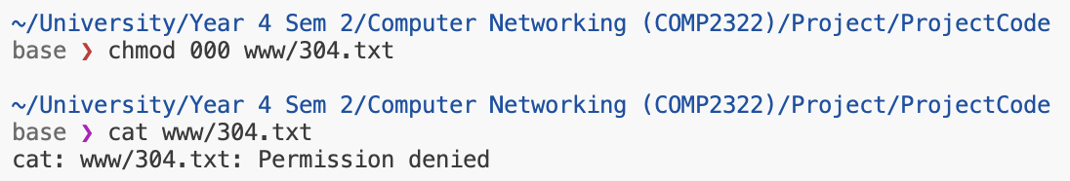
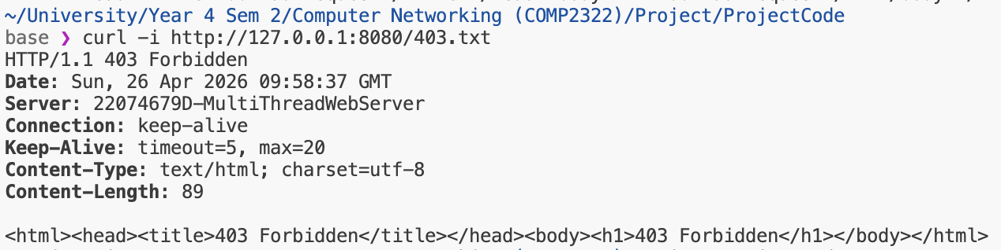
For status code 404 File Not Found, simple curl a file that does not exist:
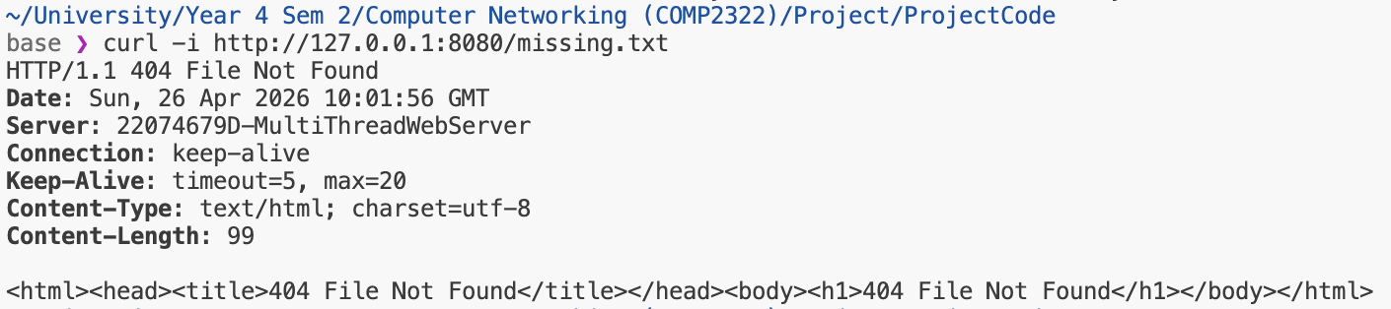
For status code 304 Not Modified, it has to change the Last-Modified and If-Modified-Since header, and in the request, we could acknowledge the server that we already seen it, by adding the header of the If-Modified-Since later than the time of the Last-Modified time stamp.
First, find the Last-Modified header by sending a request to server:
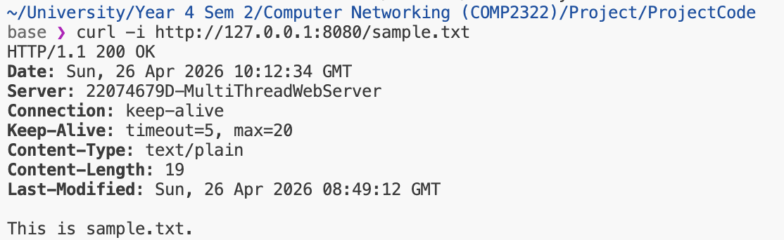
From the first request, we get the header of the Last-Modified, and we should set the If-Modified-Since header with the time later than the Last-Modified header, if so server will know the request already get the file and don’t have new changes, thus return code 304 Not modified, in this case since the sample.txt is modified at 8:49 GMT, so the If-Modified-Since header should be later than the 8:49 GMT, in this example, I used 9:00 GMT.
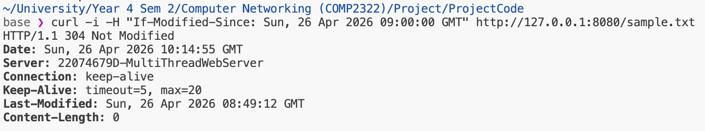
4. Multi-threading
This web server can handle multi-threading, i.e. it could allow multiple connection at the same time, and below it is handling 5 different connection accessing the index.html, we do this by using the for loop in terminal:
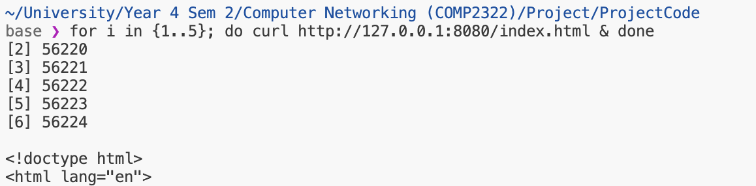
From the terminal output, 5 TCP socket is created, since the first thread is the server socket, so the thread starting from 2 to 6. Below is the logs, it shows that active thread of 6 before the connection closed, hor each thread when connection start it is assigned with a new connection thread ID.
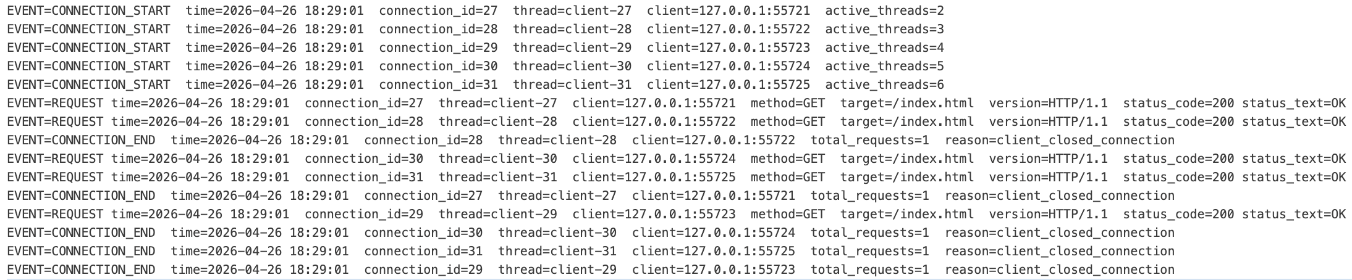

5. Persistant and non-persistant connection
For persistant connection, from the browser when calling even 10 continuous request every status code is in 200 OK, this is because the header don’t contain the Last-Modified and If-Modified-Since header, so every request is a GET method, but the persistent contains remained, with 5 second timeout if there is no new requests, connection would timeout, but if there is new request before timeout the request is send without needed to start connection again, any request is my default with Connection header keep-alive :

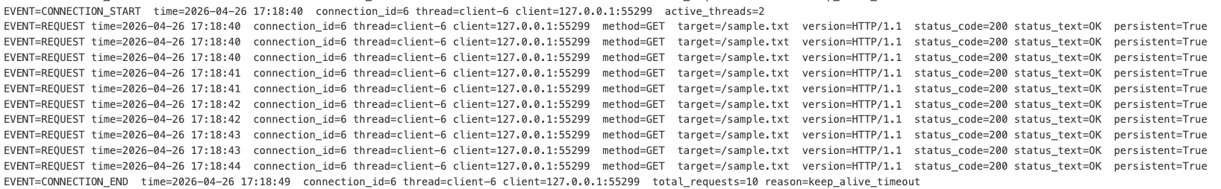
For non-persistant connection, simply set the header of the Connection to close, and from the logs.txt it could be seen that the connextion end immediately, while for the connection that keep-alive it last for 5 second.
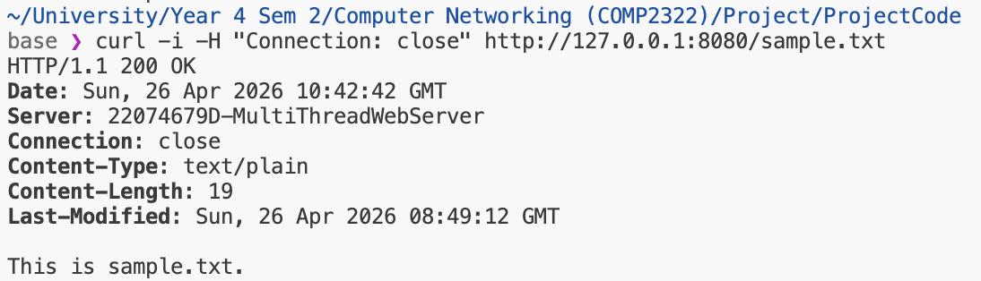

Log files and explanation
The logs.txt is to provide a clear and organized record of every connection. To ensure the data is easy to analyze, the logs are divided into common fields that track the specific connection and event-specific fields that record the details of a the event.

Common fields
Every log entry begins with a set of consistent identifiers that allow for easy tracking across a multi-threaded environment. These include the Event Type (connection start, request, or connection end), a precise time, and a unique connection_ID. Along with thread and the client’s IP and port in every line, the server ensures that even when multiple users are connected simultaneously, each client’s actions can be isolated and reconstructed during a review.

CONNECTION_START fields
When a new connection is first established, the log captures the initial state of the server. The primary field here is active threads, which records the total number of threads running at that exact moment. This is a efficient way to verify if the server is successfully spawning a new worker thread for every incoming user, proving that the multi-threading logic is functioning.

REQUEST fields
The request entries focus on the actual communication between the browser and the server. These fields document the HTTP method (such as GET or HEAD), the target file, and the HTTP protocol version. Additionally, the server logs the status code and status text to show how it handled the request, along with a persistence that indicates whether the connection remained keep-alive or close.

CONNECTION_END fields
Finally, when a connection is closed, the log provides a summary of the session’s efficiency. The total requests field shows how many files were transferred over that single connection, which is a used to test the keep-alive in the connection header. The reason field is also recorded to formally explain why the session ended.

Below is 3 lines of the example for a connection with 200 OK copied directly from the logs.txt, the tab and hightlight is used for increasing the readibility, common field is highlighted in yellow, and other field is event specific, the full log is in the logs.txt:
EVENT=CONNECTION_START time=2026-04-26 17:28:56 connection_id=8 thread=client-8 client=127.0.0.1:55367 active_threads=2
EVENT=REQUEST time=2026-04-26 17:28:56 connection_id=8 thread=client-8 client=127.0.0.1:55367 method=GET target=/sample.txt version=HTTP/1.1 status_code=200 status_text=OK persistent=True
EVENT=CONNECTION_END time=2026-04-26 17:29:01 connection_id=8 thread=client-8 client=127.0.0.1:55367 total_requests=1 reason=keep_alive_timeout

