**Git Cheat Sheet**

### I want to create a git repository for my new project

* Initialize your project folder as a git repository
  + git init
* add your project files to the git staging area
  + git add .
* commit your changes to the git repository
  + git commit -m “some commit message”

### I want to put my project on GitHub

* create a repository though the website (this will function as your remote server  
  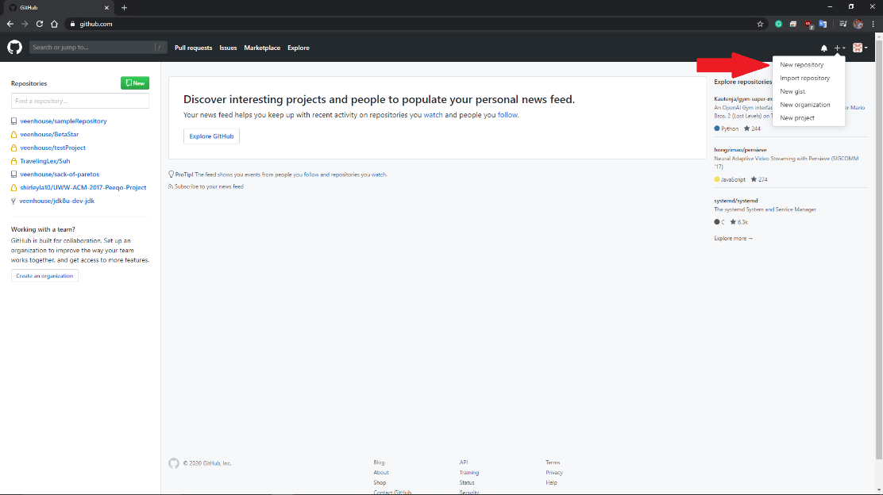
* Create a name for your project. You can also add a description and decide if the project will be publicly visible or not  
  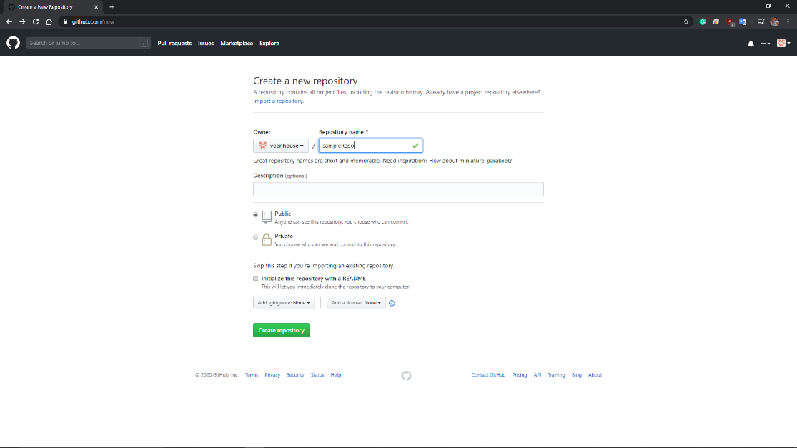
* Copy the address of your newly created repository
  + 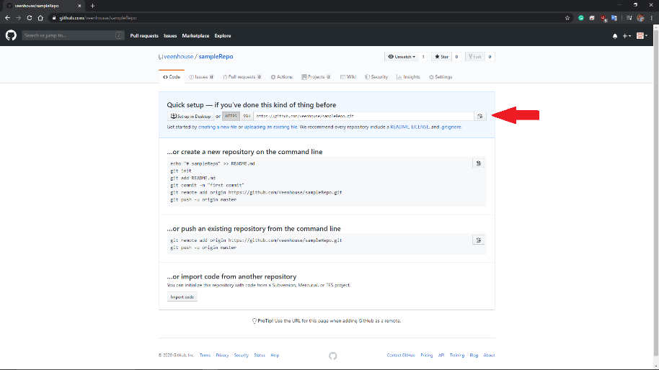
* On your local machine’s repository, you will need to establish a link to the remote repository  
  In your project’s directory:
  + Git remote add origin “projectUrl.git”
* Finally, push your local repository to the remote repository
  + Git push -u origin master

### I’ve made updates to my project and wish to put those changes on GitHub

* Add changes to the staging area
  + Git add .
* Commit your changes to the local repository
  + Git commit -m “some commit message”
* Push your changes to the remote repository
  + Git push origin <name of branch to push>

### I want to create a new branch

* On your local repository
  + Git checkout -b newBranch
  + Git add .
  + Git commit -m “new branch created”
* You may want to push this new branch to the remote repository
  + Git push -u origin master

### I want to pull updates from the remote repository to the my local repository

* On your local repository
  + Git pull

### I want to merge branches

* On your local repository
  + Switch to the branch you want to merge the changes into
    - Git checkout <branchToUpdate>
  + Merge branches
    - Git merge <branchWithUpdates>