Type 2 Diabetes– Chart Review Codebook

Updated: 7/12/2010

Study Staff assigned to this project:

Name Interviewer/Abstractor Number

Purpose of this study: The purpose of this chart review is to locate and document information in the medical record that indicates if an individual does or does not have diabetes and for those with diabetes if they also have diabetic retinopathy and/or macular edema. The primary goal of this chart review is not to collect a large amount of data, but to confirm if the individual should be considered a case, control, or if a determination cannot be made.

Timeline/Deadline for Completion:

Quality Assurance: Using the QA program one QA will be done for every 10 abstractions completed per abstractor. The program “QA chart” will be utilized in determining which charts are selected for quality assurance. This study will use the small study section of that program. Chart QA selection occurs with two Research Coordinators present during selection to prevent bias. Documentation of those selected will be marked by circling SID# with a blue pencil on the “working” list.

Number of Charts to be completed: 100

Symbols that may be utilized:
.U (should only be used if a complete date is not found, i.e. 12-.u-1991)

**NOTE: The use of the problem list as well as Diagnosis has been very helpful to use for ‘reference’ dates.

Diabetes & Diabetic Retinopathy – Chart Review Codebook

VERSION – 07/12/2010

The purpose of this chart review is to locate and document information in the medical record that indicates if an individual does or does not have diabetes. The primary goal of this chart review is not to collect a large amount of data, but to confirm if the individual should be considered a case, control, or if a determination cannot be made.

1. Patient is confirmed as having diabetes
Identify the earliest indication of diabetes that appears in the medical record. Locate a confirmed mention of any of the following diagnoses by a doctor in a clinical note. The coded diagnoses in the Problem list have known issues with reliability, so they should not be relied on as the sole source of the diagnosis.
*We are only interested in the codes listed below, so other items such as diabetes inspidus that are not explicitly mentioned here can be ignored altogether.

Type I / Juvenile
Diagnosis | ICD9 Code
Diabetes W/O Ment Compl, Ty I, Not Stat As Uncon | 250.01
Diabetes W/O Ment Compl, Type I, Uncontrolled 1093 | 250.03
Diabetes mellitus, insulin dependent (IDDM)
Diabetes mellitus, type 1
Diabetes, type 1
Diabetes, on insulin therapy

Type II / Adult
Diagnosis | ICD9 Code
Diabetes with other coma | 250.30  250.32
Diabetes with hyperosmolarity | 250.20  250.22
Diabetes with unspecified complication | 250.90  250.92
Diabetes with other unspecified manifestation | 250.80  250.82
Diabetes with peripheral circulatory disorder | 250.70  250.72
Diabetes with neurological manifestations | 250.60  250.62
Diabetes with opthalmic manifestations | 250.50  250.52
Diabetes with renal manifestations | 250.40  250.42
Diabetes mellitus without mention of complication  Diabetes W/O Ment Compl, Ii/Unspec Not Spec Uncon  Diabetes W/O Compl, Type Ii/Unspec, Uncontrol 1093 | 250.00  250.02
Diabetes mellitus, antepartum
Diabetes mellitus, type 2
Diabetes secondary to pancreatectomy
Diabetes secondary to pancreatic insufficiency
Diabetes, type 2

Other Diabetes/Related Conditions
Please specify the description of the condition that you find in the medical note.

Description | ICD9 Code
Impaired fasting glucose | 790.21
Impaired oral glucose tolerance test | 790.22
Abnormal glucose not otherwise specified | 790.2  790.29
Abnormal glucose during pregnancy | 648.8x
Gestational diabetes | 648.0x
Glycosuria | 791.5
Dysmetabolic syndrome X | 277.7
Screening for diabetes mellitus | V77.1
Polycystic ovary syndrome | 256.4

Undetermined Diabetes
**NOTE: Listing the diabetes type as “Undetermined” should be used sparingly – in most cases the type will be available in the medical record. This list is provided to give a comprehensive listing of terms related to diabetes that might be encountered.
Description | ICD9 Code
Diabetes | 1960-1968: 260.0  1969-06/1974: 250.0  07/1974-1978: 250.0  1979-present: 250.00-250.03
Diabetic Neuropathy | 1960-1968: 260.2  1969-06/1974: 250.3  07/1974-1978: (not specified)  1979-present: 250.60-250.63,  357.2
Diabetic Retinopathy | 1960-1968: 260.1  1969-06/1974: 250.3  07/1974-1978: (not specified)  1979-present: 250.50-250.53,  362.01-362.02
Diabetic Nephropathy | 1960-1968: 260.9  1969-06/1974: 250.3  07/1974-1978: 250.6  1979-present: 250.40-250.43,  583.81
Diabetes mellitus
Diabetes mellitus, delivered (current hospitalization)
Diabetes mellitus, uncertain type
Diabetes mellitus, uncontrolled
Diabetes mellitus, new onset
Diabetes self-management counseling

The field “Date of the first known diagnosis” should be the earliest date you found a mention of the diabetes diagnosis.

Continue looking forward in the medical record, after the earliest date where a diagnosis of diabetes was found, and determine if another confirmed diagnosis of diabetes appears in the clinical note. It is possible that the type could be different, which is why we are asking you to list the second type that you find. While you may find additional diagnoses later in the chart, we are only recording at most the first two. Continue to question 2.

If the subject has no diagnosis of diabetes, and no other indication of diabetes is found in the clinical notes, specify “No” to the question and skip to Question 2.

2. Family history of diabetes mellitus:
Go to the Summary Sheet and find the date when the patient was diagnosed with diabetes (if available). If the date is not available review the chart for past family history of diabetes.
- Check the MD notes of that visit for any documentation on family history. If you cannot find anything on family history in that note, then check if they have ever had a family member with diabetes. Check “yes” if family history of diabetes exists.
- If no diagnosis exists, scan the notes to see if there is a family history of diabetes, check “yes” if there is.
- If you are unable to find any information about family history, check "unknown".

Family member is defined as Indicate if any of the following relatives have Diabetes mellitus: Mother, Father, Brother, Sister, Son, Daughter, Uncle, Aunt, Grandmother, Grandfather, or Cousin.

3. Patient has been on any medication for diabetes
To find out if the patient was ever treated with any other medication for diabetes you should start at the visit in which they were first diagnosed with diabetes. Continue looking from that visit until you see when they were started on medication for diabetes. The medications we are looking for are listed as Type 1 or Type 2 diabetes medications. They are found in this codebook. If they have ever been treated with one of these medications, check “Yes” and indicate the type. If they were not treated with any of the medications listed in the box, check “No” and continue.

4. Additional comments/notes
Please use this area for any additional notes that you might want to make for yourself, or questions that need to be raised for a re-review.

5. Review Completed
This is an optional field that you may use to mark this chart review as completed. This does not need to be filled in if you choose to use some other mechanism (i.e. special folder for completed review forms) to manage the review.

Type 1 Diabetic Medications

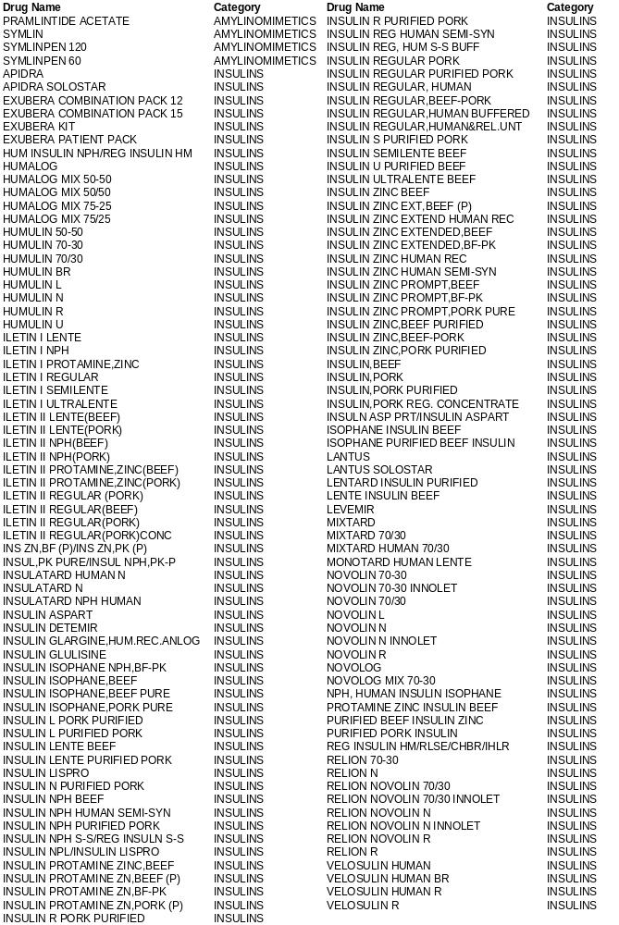
Type 2 Diabetic Medications
