Vincent La

Georgia Tech ID (vla6)

Manual Strategy Report

# Part 1: Technical Indicators

In this section, we present three different technical indicators:

1. Bollinger Bands
2. SMA (Simple Moving Average)
3. Rate of Change (ROC)

In each section below, we will present a description of how we developed each technical indicator, along with a graph that demonstrates the technical indicator using JPM over January 1, 2008 to December 31 2009.

## Bollinger Bands

Bollinger bands were originally created by John Bollinger and they are developed by:

1. Compute the rolling mean.
2. Compute the rolling two standard deviations above and below
3. Plot the rolling mean along with the two lines corresponding to two standard deviations above and below.

The Bollinger bands are useful because they demonstrate that in times of high volatility, the bands will spread out whereas in low volatility, the bands will contract. Below is a plot of the Bollinger bands using JPM. For example, one could use the Bollinger bands to indicate buy or sell. For example, if we see the price touching the lower band and starts to go back up, that could be a signal to buy. Furthermore, if we see the price touching the upper band and starts to go back down, we’d want to sell.

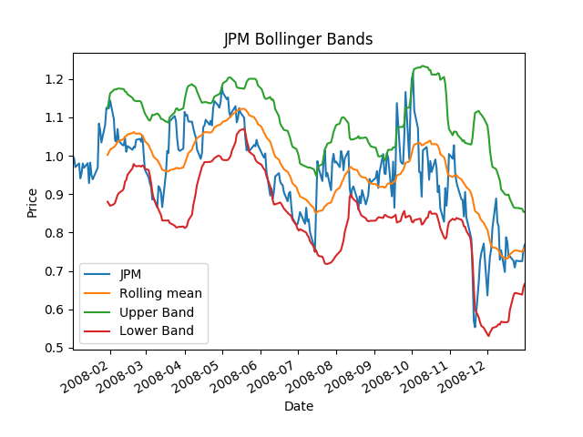

## SMA (Simple moving Average)

The simple moving average is a rolling mean over a given time period (we’ll use 20 day rolling mean). Thus, over the 20 day time period, we average all the values and we get one mean. We then move the window forward and take another mean. We repeat this every day.

To develop this indicator we will plot three things:

1. Price
2. SMA (Simple Moving Average)
3. Price/SMA

A plot of the SMA is shown below:

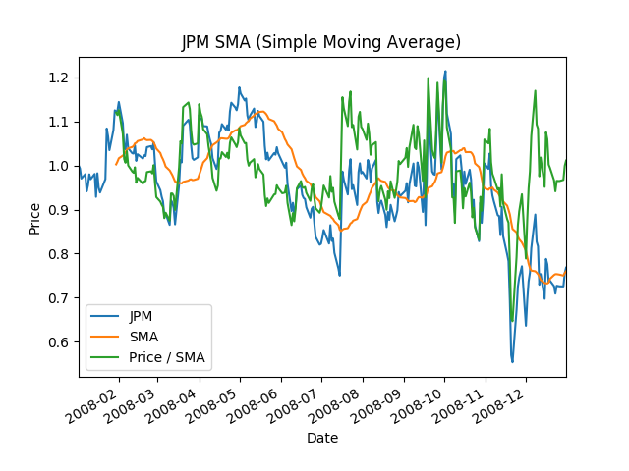

## Rate of Change (ROC)

The Rate of Change measures the percentage change between the most recent price and the price some time period ago (we’ll use 20 days in this case). If ROC is going up, that means bullish, if the ROC is going down, that means bearish.

To develop this indicator we plot two things:

1. Price
2. ROC using 20 day period

We can view the ROC curve for JPM below. Furthermore, as noted before, as ROC is going up we note that it’s bullish, when it’s going down we know it’s bearish. In particular when it’s above 0 we know we’re generally trending upwards, when it’s below, we know we’re generally downwards.

