Vincent La

Georgia Tech ID (vla6)

Strategy Learner Report

# Introduction

*Describe the steps you took to frame the trading problem as a learning problem for your learner. What are your indicators? Did you adjust the data in any way (discretization, standardization)? Why or why not?*

To frame the trading problem as a learning problem, I first took the data frame of prices for the stock. The overarching idea is that we are given a data frame of prices and we need to return a prediction for whether we need to BUY, SELL, or STAY (where stay is keep the same position as the previous day. To do this we need to do two steps:

1. Feature Engineering: How can we convert the prices data to features with values for each day to make the prediction?
2. Transforming the Data to create a Y value: What is the value we actually want to predict? How do we create that?

**Feature Engineering**

For feature engineering we created technical indicators as we did in the ManualStrategy assignment. The indicators that we use are:

1. Bollinger Bands
2. SMA (Simple Moving Average)
3. Rate of Change (ROC) aka Momentum
4. EWMA (Exponential Weighted Moving Average)

**Creating Y Value**

To create Y value we calculate the return in the training set after 20 days. We use 20 days as there are approximately 20 trading days in a month. This seems to be the standard in the industry.

Once we calculated the return in 20 trading days for each date, we then compared the return to constants, call them YBUY and YSELL. The definitions for these are as follows. YBUY represents a constant upon which if the N day return exceeds YBUY then you would want to take a LONG position. On the other hand YSELL represents a constant upon which if the N day return is below YSELL then you would want to take a SHORT position. In any other cases, we keep the same position as the previous day.

**Learner**

For the actual learner we used the RTLearner that we implemented in a previous assignment. We used a leaf size of 5. Furthermore we set YBUY and YSELL to 0.04 and -0.04, respectively. How we came to those values is that there’s a tradeoff in YBUY and YSELL in setting too low or too high. For example, if you set YBUY too low (eg. 0.00001) what’s happening here is that in some sense you are “overfitting” because in your training data you’re telling the algorithm that you want to take a long position even if the return in next 20 days is just barely positive. Thus, you’re adding noise to the dataset because in our construction the algorithm cannot necessarily tell difference between when return is very highly positive or just barely positive. Similarly, you can say the same thing about setting YSELL. However, you also don’t want to set YBUY too high or else you would never change your position and you have too low variance.

Finally, to summarize and synthesize, we use an RTLearner to predict whether or not we should take a long or short position using the technical indicators described earlier as features and setting the y variable mapping 20 day returns to long or short decisions based on comparisons to YBUY and YSELL.

# Experiment 1

*Using exactly the same indicators that you used in manual_strategy, compare your manual strategy with your learning strategy* ***in sample****. Plot the performance of both strategies* ***in sample*** *along with the benchmark. Trade only the symbol JPM for this evaluation.*

**Description of Experiment (Assumptions/Parameter Values)**

In this experiment, we test three portfolio values:

1. Benchmark (Buy and Hold JPM starting 2008-01-01)
2. Manual Strategy (This is the same as the manual strategy we used in the previous assignment. We will describe more below, but the manual strategy essentially uses Bollinger bands to inform buy/sell decisions)
3. Strategy Learner (This uses RT Learner as described in Section 1 of this report).

For our manual strategy we will use the Bollinger Bands technical indicator to guide our Sell or

Buy decisions. In particular:

1. Start by buying 1000 shares of JPM on the first day.
2. When the price hits the lower band, we buy.
3. When the price hits the higher band, we sell.

In terms of Assumptions and Parameter Values:

1. In Sample Start Date: 2008-01-01
2. In Sample End Date: 2009-12-31
3. Commission = 0
4. Impact = 0
5. Symbol traded = ‘JPM’

Next, we describe the outcome of the experiment in the plot below:

**Figure 1: In Sample Portfolio Value Comparison**

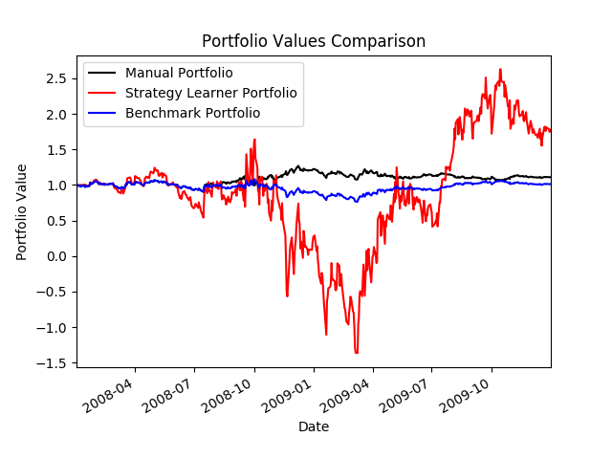

# Next, we also show the results in Chart/Table Form Below:

**Table 1: Portfolio Statistics Comparing Manual, Benchmark, and Strategy Learner**

|  |  |  |  |
| --- | --- | --- | --- |
| Metric | Manual Portfolio | Benchmark Portfolio | Strategy Learner Portfolio |
| Cumulative Returns | 11.01% | 1.23% | 66.3% |
| Standard Deviation of Daily Returns | 0.0148 | 0.017 | 2.28 |
| Mean of Daily Returns | 0.00032 | 0.00017 | -0.0189 |

# Note that we see a few interesting things.

1. Compared to the Manual and Benchmark Portfolio, the Strategy Learner Portfolio is much higher variance. This makes sense as the Manual Strategy that we are deploying is just based on Bollinger bands and trades only happen if the price hits the upper or lower limit of the Bollinger bands, so compared to the Strategy Learner Portfolio less trades will happen which reduces variance.
2. However, overall the Strategy Learner Portfolio performs best in the in-sample period. This makes sense because the Strategy Learner Portfolio is also trained in the same in-sample period. Furthermore, the Strategy Learner Portfolio trades more actively and can capture more variance. Thus, it makes sense that the Strategy Learner Portfolio will perform better in the end state than the Manual and Benchmark Portfolio.
3. Other reasons why Strategy Learner Portfolio has high variance may be because we choose a leaf size of 5 which is relatively small. Or our values for YBUY and YSELL are still relatively low. If we set them higher we should expect lower variance. Furthermore, because impact equals 0 in this scenario and commission equals 0 there is no penalty to making trades. If impact and commission were higher, we would expect lower variance.

We should expect this result every time with the in-sample data. Clearly the benchmark portfolio performance would remain the same because it is simply just buy and hold JPM and prices are deterministic. Similarly, the Manual Strategy that we use is also deterministic because we are using the Bollinger bands which is just a transformation of prices. With our strategy learner, because we are using RT Learner, there is some variation. However, overall this variation will be very small and since we are training and testing over the same time period, we would expect the relative result to be the same every time with the in-sample data.

# Experiment 2

*Provide an hypothesis regarding how changing the value of impact should affect in sample trading behavior and results (provide at least two metrics). Conduct an experiment with JPM on the in-sample period to test that hypothesis*

By changing impact, we are essentially putting a higher “penalty” on making trades. By this I mean that in Experiment 1 with 0 commission and 0 impact we essentially assumed that making trades is costless. In the real world, making trades is not costless. Thus, by imposing some non-zero impact we are saying that the cost of making a trade is non 0 so our algorithm needs to predict a “higher” return by making the trade in order to make the trade than it would otherwise need to when impact is 0.

Specifically, we hypothesize the following effect:

1. **As Impact Decreases**: This means that the cost of trading is lower and thus our strategies would use more trades. The benchmark portfolio is clearly unaffected since this is just buy and hold JPM from the beginning so having an impact or not would not effect this. In theory, our Manual Strategy is also affected; however, since in this case, I am just using Bollinger bands then the amount of trades being executed is relatively low and it would only be triggered if the price deviates significantly from the rolling mean. Thus, the biggest effect would be on our Strategy Learner. As impact decreases, our strategy learner would be willing to make more trades. At the extreme if impact is 0, our Strategy Learner will be trained to make the trade as long as the return is greater or less than YBUY or YSELL, respectively.
2. **As Impact Increases**: Alternatively, if impact is higher the effect would be the opposite. This means that there is higher cost associated with trading so now our Strategy Learner will only be trained to make a trade as long as the return is greater or less than YBUY + impact or YSELL - impact, respectively. In summary, the measured return would have to be greater or less because of the non-zero impact in order for us to decide to take a long or short position.

To summarize, I believe what would happen in this case in the in-sample period is that as impact increases, we would see:

1. **Cumulative Return will likely be lower**
2. **Variation (for example, as measured by daily standard deviation) will also be lower**

As impact decreases, we would see the opposite of the above. To summarize I believe (1) is true since if impact increases, then we will make less trades since it is more costly to make a trade and so on the in-sample period we are likely to see lower returns. However, variation also decreases. (At the extreme, imagine if impact was set to a constant that was substantially high. In this case, it would never be worth it to make a trade because the impact is so high so then the Strategy our algorithm learns would essentially be the benchmark).

We demonstrate this below with a few graphs in Figure 2 below.

1. Impact = 0.01
2. Impact = 0.03
3. Impact = 0.05
4. Impact = 0.1

Note we bolded Standard Deviation of Daily Returns in Table 2 below to highlight the decreasing relationship of Impact and Standard deviation.

**Table 2: Portfolio Statistics of Strategy Learner Varying Impact**

|  |  |  |  |  |  |
| --- | --- | --- | --- | --- | --- |
| Metric | Strategy Learner (Impact = 0) | Strategy Learner (Impact = 0.01) | Strategy learner (Impact = 0.03) | Strategy Learner (Impact = 0.05) | Strategy Learner (Impact = 0.1) |
| Cumulative Returns | 66.3% | 78.4% | 49.1% | 22.5% | 32% |
| Standard Deviation of Daily Returns | **2.28** | **0.5763** | **0.095** | **0.045** | **0.0372** |
| Mean of Daily Returns | -0.0189 | -0.005 | 0.0047 | 0.00142 | 0.00124 |

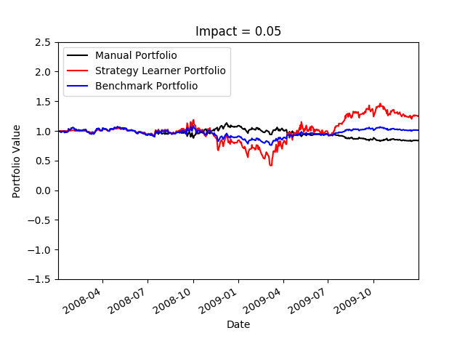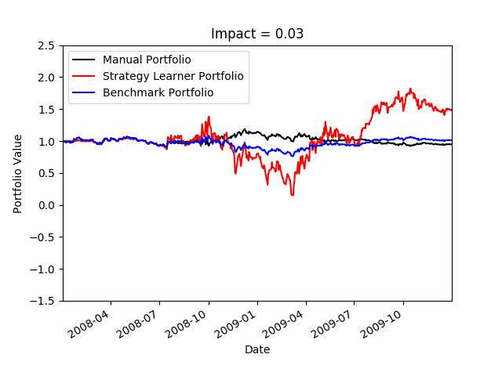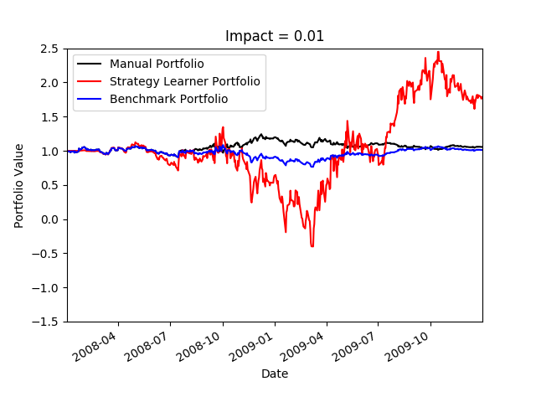**Figure 2: Portfolio Value Comparison (Varying Impact)**

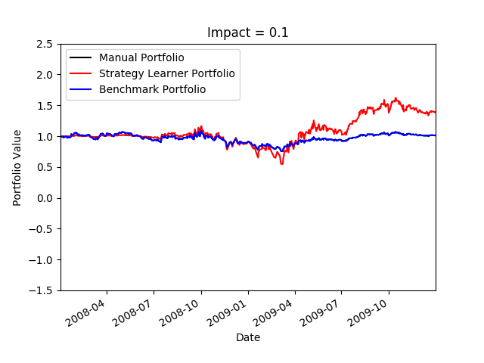

As you can see above, when varying impact, we generally see the trends we hypothesize. As we increase Impact the variance of the Strategy Learner Portfolio gets smaller and smaller while the cumulative return also generally gets smaller and smaller. We even note the same for Manual Portfolio as well. Notice that when impact = 0.1, the Manual Portfolio actually is the same as the benchmark portfolio. This is because the impact is so high that the price never deviates enough from the Bollinger bands to make a trade worthwhile. However, for Strategy Learner Portfolio, the cumulative return is lower and variance is lower.