Vincent La

903178639-vla6-hw5

# 1.2 Multi Layer Perceptron

## 1.2.b

*Calculate the number of "trainable" parameters in the model with providing the calculation details. How many floating-point computation will occur when a new single data point comes in to the model?*

*Note that on Calculating the Number of “trainable parameters”, the following Piazza Posts were consulted:*

1. [*https://piazza.com/class/jjjilbkqk8m1r4?cid=928*](https://piazza.com/class/jjjilbkqk8m1r4?cid=928)
2. [*https://piazza.com/class/jjjilbkqk8m1r4?cid=928*](https://piazza.com/class/jjjilbkqk8m1r4?cid=928)

Note that the number of “trainable parameters” come from Weights, biases, etc. which are being trained/learned in the model.

We can calculate this using code (note that formatting taken from this SO [post](https://stackoverflow.com/questions/53035690/how-to-test-python-code-responding-to-another-post)):

|  |
| --- |
| print(sum(p.numel() for p in best_model.parameters() if p.requires_grad)) |

**This returns 2,965 trainable parameters.**

For the number of floating point operations, note that a sigmoid function is 4 operations. Furthermore, a dot product between two vectors of size n returns 2n -1 operations, since we have n multiplications and n-1 summations.

Thus, if there are 2,965 trainable parameters, we have close to ~20,000 floating point operations.

## 1.2.c

Learning Curves for MLP:

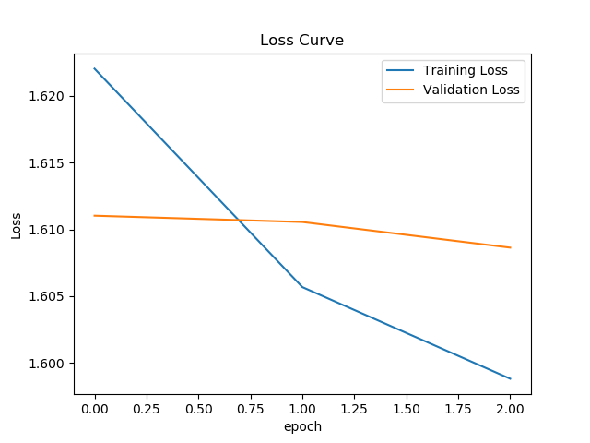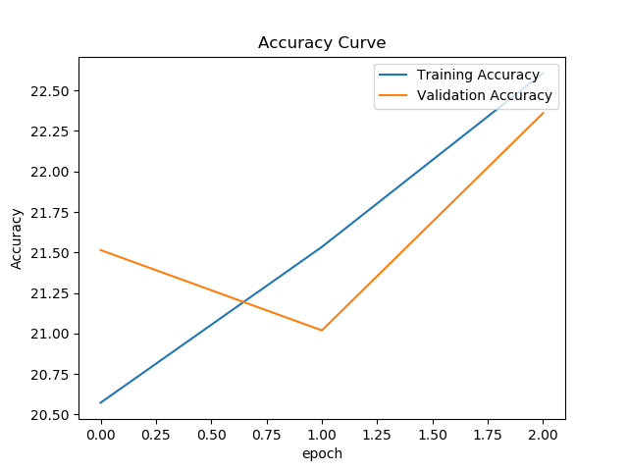

## 1.2.d

Confusion Matrix for MLP

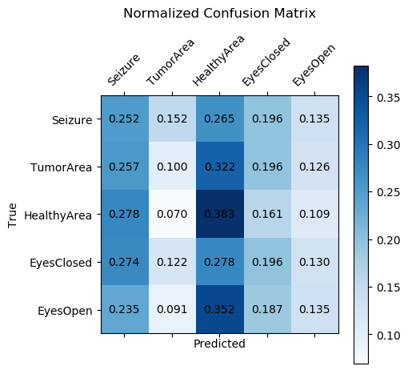

## 1.2.e

*Modify your model class MyMLP in mymodels.py to improve the performance. It still must be a MLP type of architecture. Explain your architecture and techniques used. Briefly discuss about the result with plots.*

The first thing I tried was increasing the **number of epochs to 5** without changing anything else. Below are the graphs that resulted:

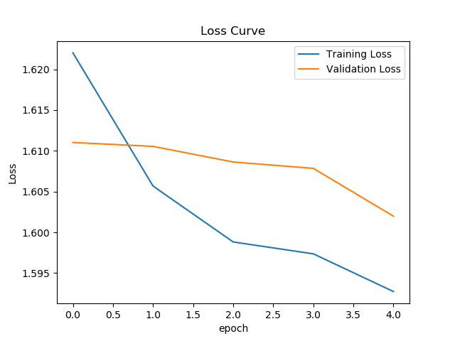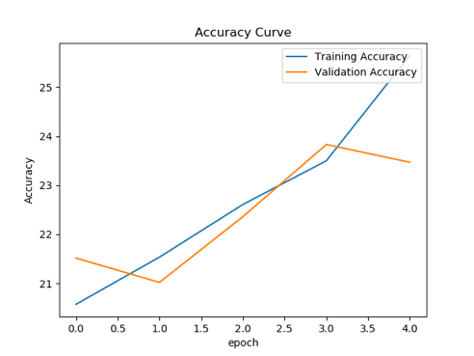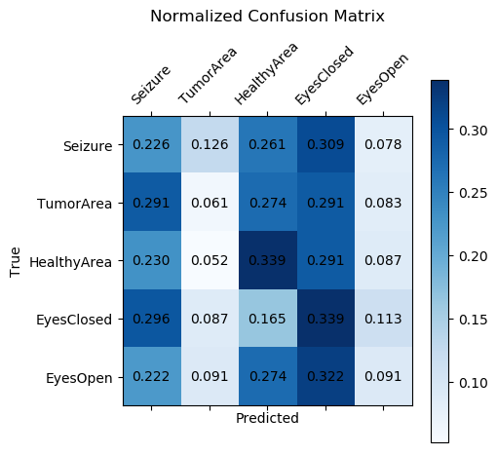

As you can see, even with changing epochs to 5 there is some improvements, Loss goes down closer to 1.6, and validation accurate moves up to around 23.5%.

Now, I try increasing the **number of epochs to 10** without changing anything else. Below are the graphs that results:

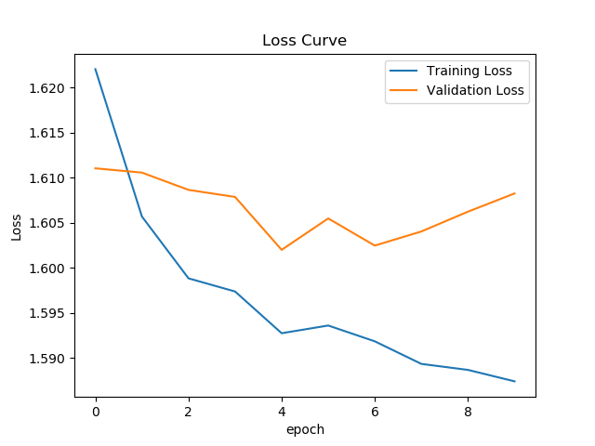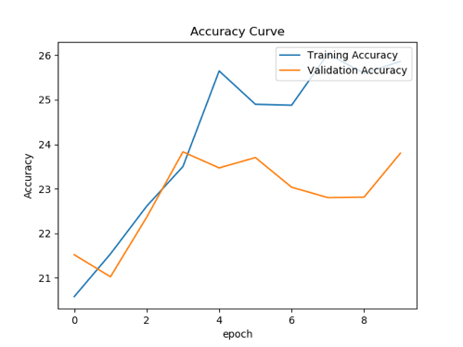

As you can see, not much difference just changing number of epochs to 10. In fact, we see Training performance improve but not Accuracy, which makes sense as we are now more likely to overfit the data. So next, we will change the epochs back to 5 and add more layers.

**Epochs to 20 and Adding 1 More Hidden Layers (2 Total):**

Next, we set Epochs to 20 and add 1 more Hidden Layers (2 Total)

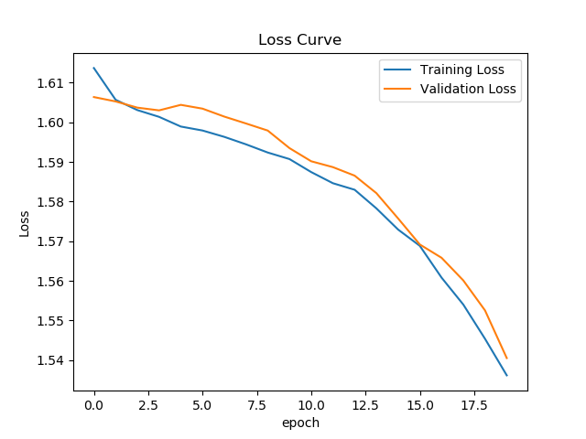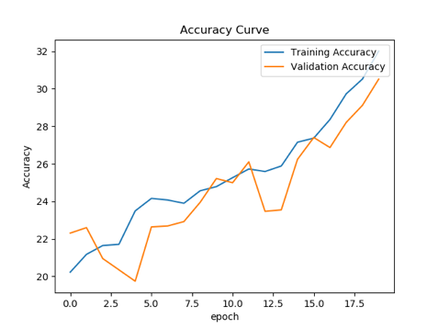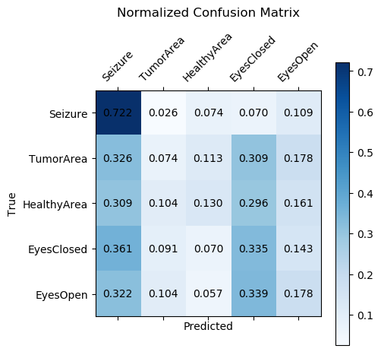

Now we set Epochs to 20, but add one more hidden layer. Notice that now Validation Accuracy tracks with Training Accuracy and is up to 32, with Loss down to 1.54.