Vincent La

903178639-vla6-hw2

# Logistic Regression Proofs

## 1.1.a Batch Gradient Descent

*Derive the gradient of the negative log-likelihood in terms of* ***w*** *for this setting.*

We know that:

$$NLL\left(D, w\right)= -\sum_{\left\{i=1\right\}}^{N}{[\left(1-y_{i}\right)\log\left(1-σ\left(w^{T}x_{i}\right)\right)+y_{i}\log{σ(w^{T}x_{i})]}}$$

First, we prove that

$$\frac{∂}{∂z}\left(σ\left(z\right)\right)=σ(z)(1-σ\left(z\right))$$

Note that

$$\frac{∂}{∂z}\left(σ\left(z\right)\right)= -{\left(1+e^{-z}\right)}^{-2}(-e^{-z})$$

$$=\frac{e^{-z}}{{\left(1+e^{-z}\right)}^{2}}$$

$$=\frac{1}{1+e^{-z}}*\frac{e^{-z}}{1+e^{-z}}$$

$$=σ\left(z\right)*(1-σ\left(z\right))$$

So now that we know this identity we can proceed.

To derive the gradient of the negative log-likelihood we have:

$$\frac{∂}{∂w_{j}}NLL\left(D, w\right)= -\sum_{\left\{i=1\right\}}^{N}{\frac{∂}{∂w_{j}}[\left(1-y_{i}\right)\log\left(1-σ\left(w^{T}x_{i}\right)\right)+\frac{∂}{∂w_{j}}y_{i}\log{σ(w^{T}x_{i})]}}$$

$$-\sum_{\left\{i=1\right\}}^{N}{\left[\frac{1-y_{i}}{1-σ\left(w^{T}x_{i}\right)}+\frac{y_{i}}{σ\left(w^{T}x_{i}\right)}\right]*\frac{∂}{∂w_{j}}σ(w^{T}x_{i})}$$

$$-\sum_{\left\{i=1\right\}}^{N}{\left[\frac{y-σ(w^{T}x_{i})}{σ(w^{T}x_{i})(1-σ\left(w^{T}x_{i}\right))}\right]*(σ(w^{T}x_{i})(1-σ\left(w^{T}x_{i}\right)x^{j})}$$

$$= -\sum_{\left\{i=1\right\}}^{N}{x^{j}(y_{i}-σ\left(w^{T}x_{i}\right))}$$

## 1.2 Stochastic Gradient Descent

### 1.2.a

*Show the log likelihood, l, of a single (x_t, y_t) pair*

For a single (x_t, y_t) pair, recall that y_t can only take on values 1 or 0 (since we’re assuming binary classifier.

Thus, log likelihood, l, of a single pair is

$$\left\{\begin{aligned}\log{σ\left(w^{T}x_{i}\right) if y=1} \\ \log\left(1-σ\left(w^{T}x_{i}\right)\right) if y=0 \end{aligned}\right.$$

### 1.2.b

*Show how to update the coefficient vector*

For a single training point, recall that

$$\frac{∂}{∂w}l\left(w | y, x\right)=\left(y-σ\left(w^{T}x_{i}\right)\right)x^{j}$$

This is taken from question 1.1 of this HW assignment.

Thus, the update rule is

$$w^{t+1}=w^{t}+η\left(y-σ\left(w^{t}x_{i}\right)\right)x^{j}$$

Where the learning rate is represented by $η$*.*

### 1.2.c

*What is the time complexity of the update rule from* ***b if x_t is very sparse?***

Notice that if x_t is very sparse, then in the update rule, notice that if $x^{j}=0$; then $w^{t+1}=w^{t}$. Thus in the case where it is very sparse then in the case where the feature is 0, then you don’t actually need to update.

Let $D_{non-zero}$ represent the non-zero features. Then, the time complexity is

$$O\left(D_{non-zero}\right)$$

Or I suppose that if x_t is actually very very sparse, then the time complexity might be argued as $O\left(1\right)$ or constant.

### 1.2.d

Briefly explain the consequence of using a very large learning rate and very small learning rate.

If learning rate is too small, it will take longer to converge; if the learning rate is too large, may fail to converge.

### 1.2.e

Under the penalty of L2 norm regularization, notice that

$$\frac{∂}{∂w_{j}}[l-μ\sum_{j=1}^{d}{{\left(w_{j}\right)}^{2}]=}$$

$$\left(y-σ\left(w^{T}x_{i}\right)\right)x^{j}-2μw^{j}$$

Thus the update rule becomes

$$w^{t+1}=w^{t}+η\left[\left(y-σ\left(w^{T}x_{i}\right)\right)x^{j}-2μw^{j}\right]$$

Notice that now when x^j is zero, or when there is a sparse matrix, there is still an update that happens. Thus the time complexity is

$$O(D)$$

Where D is the number of features.

## 2.1 Descriptive Statistics

|  |  |  |
| --- | --- | --- |
| Metric | Deceased Patients | Alive Patients |
| Event Count |  |  |
| 1. Average Event Count | 1027.74 | 683.16 |
| 1. Max Event Count | 16829 | 12627 |
| 1. Min Event Count | 2 | 1 |
| Encounter Count |  |  |
| 1. Average Encounter Count | 24.84 | 18.695 |
| 1. Max Encounter Count | 375 | 391 |
| 1. Min Encounter Count | 1 | 1 |
| Record Length |  |  |
| 1. Average Record Length | 157.042 | 194.702 |
| 1. Median Record Length | 25.0 | 16 |
| 1. Max Record Length | 5364 | 3103 |
| 1. Min Record Length | 0 | 0 |
| Common Diagnosis | DIAG320128  DIAG319835  DIAG313217  DIAG197320  DIAG132797 | DIAG320128  DIAG319835  DIAG317576  DIAG42872402  DIAG313217 |
| Common Laboratory Test | LAB3009542  LAB3023103  LAB3000963  LAB3018572  LAB3016723 | LAB3009542  LAB3000963  LAB3023103  LAB3018572  LAB3007461 |
| Common Medication | DRUG19095164  DRUG43012825  DRUG19049105  DRUG956874  DRUG19122121 | DRUG19095164  DRUG43012825  DRUG19049105  DRUG19122121  DRUG956874 |

## 2.3. SGD Logistic Regression

Let C = Regularization Constant

e = Learning Rate

With C = 0 and e = 0.01 (top left): **ROC: 0.62**

With C = 0 and e = 0.3 (top right): **ROC: 0.65**

With C = 0 and e = 0.5 (bottom left): **ROC: 0.61**

With C = 0 and e = 1 (bottom right): **ROC: 0.58**

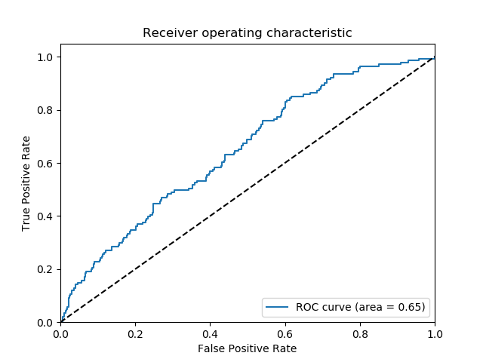

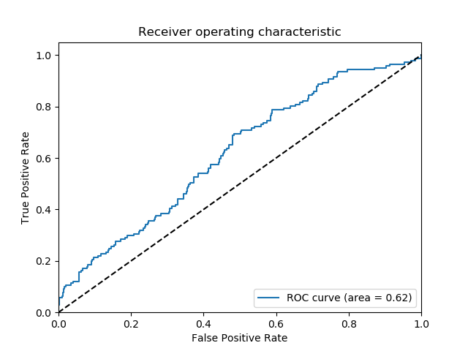

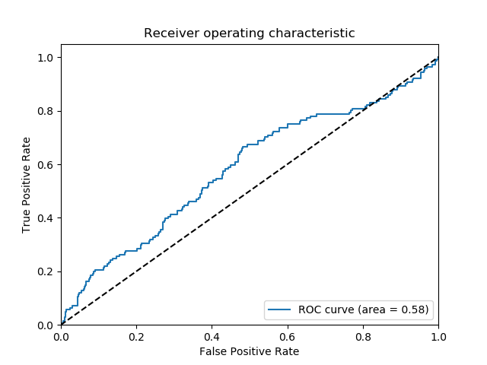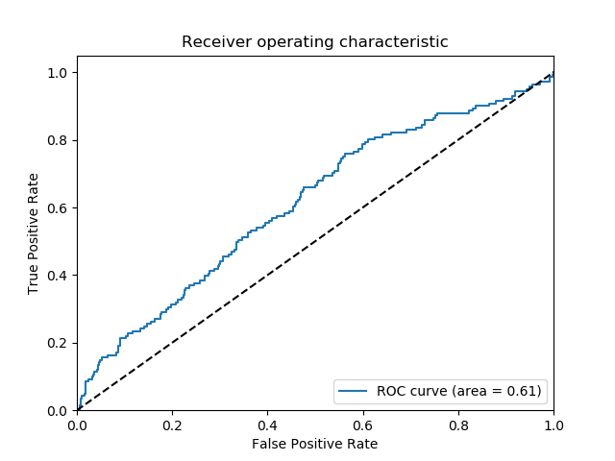

Notice that when we increasing learning rate parameter we generally got better ROC which means that perhaps with very low learning rate, we are overfitting. However, notice that when learning rate is too large performance, ROC goes down again. Note if too large, the implementation may actually fail to converge.

In the previous example, learning rate of e = 0.3 seemed to have yielded the best ROC. Thus let’s take that and now start varying the regularization parameter, C

With C = 0.1 and e = 0.3 (top left): **ROC: 0.63 (ROC Flipped)**

With C = 0.3 and e = 0.3 (top right): **ROC: 0.63 (ROC Flipped)**

With C = 0.5 and e = 0.3 (bottom left): **ROC: 0.62 (ROC Flipped)**

With C = 0.7 and e = 0.3 (bottom right): **ROC: 0.62 (ROC Flipped)**

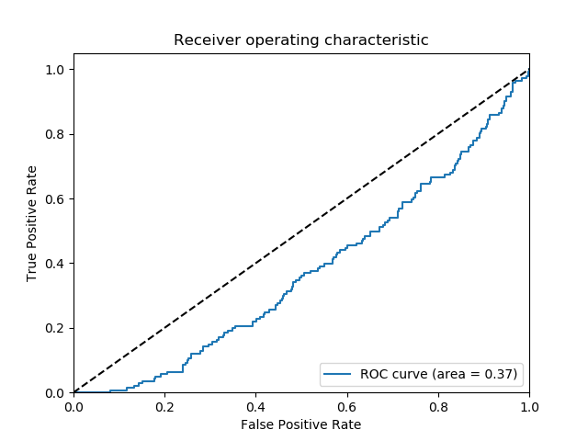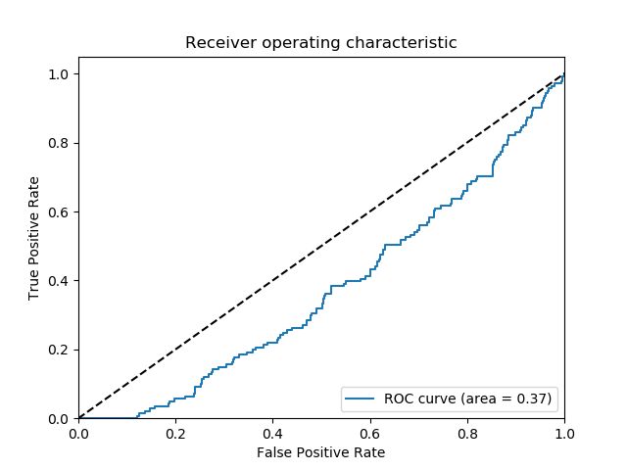

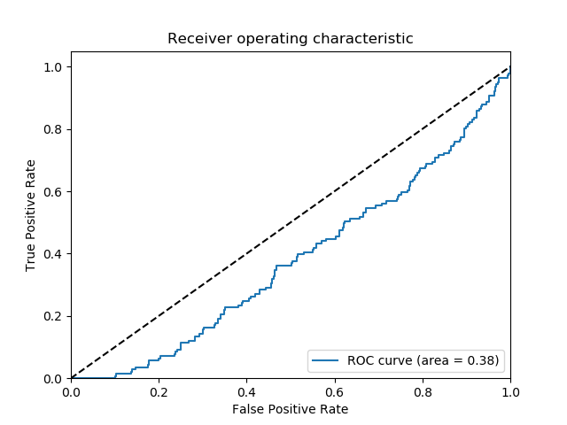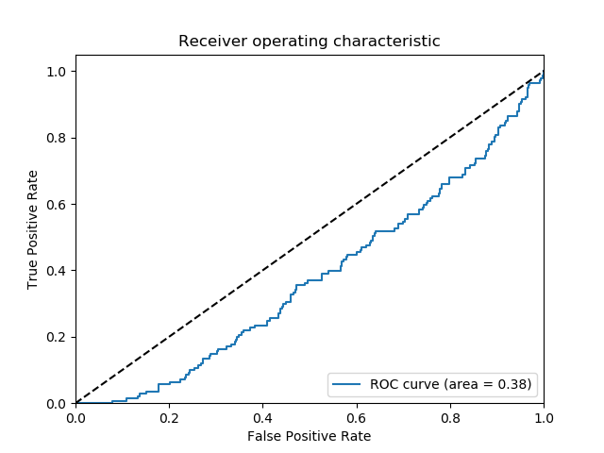

Interestingly enough notice that varying the regularization term doesn’t change performance too much.