## Test plan for M4

Expected Gameplay:

* The game begins at the start screen. Press the "Start" button or the spacebar to begin.
* A clock is displayed in the top-left corner of the screen, indicating the current time. The screen's brightness dynamically changes to reflect the time of day, transitioning between lighter and darker. Shadows will also shift in direction and intensity as time changes.
* There is a clock on the left corner of the screen. The screen will get lighter and darker based on what time of the day it is.
* You start in the kennel room, confined in a cage with an exit tunnel. Next to you is an older cat. Follow the on-screen prompt above the character to press "E" and initiate dialogue.
* Go through the tunnel to pick up the flashlight by pressing "E". You can also eat fish using "E". After interacting with items, a text box will appear to update your stats. Food will disappear with colored particles based on its stat.
* Engage in dialogue with the raccoon to learn how to handle encounters:
  + Each action has its own distinct sound effect.
  + For attacks, there are three patterns that the player must draw correctly for a successful attack. These patterns are randomly assigned.
  + NPCs have three possible attack types. Avoid colliding with anything inside the designated box.
* Once you defeat the raccoon, you can exit the tunnel and enter the city. Note that you cannot return to the tunnel after leaving.
* In the city, rooms you can interact with will have their lights on and will be excluded from shadows. Enter these rooms, pick up items you want and defeat the NPCs inside.
* The city also has various items including a ma
* Avoid patrols in the city; colliding with them will cost you a life. When you lose a life due to a patrol, a tombstone will appear at the collision site, and your dropped items will be visible. Your stats will update to reflect the loss of items.
* Each NPC you defeat on the map will drop a key. Collect these keys to unlock the "boss room," which is located beyond the lobby.

Creative Components:

* **Particle System – 20%**
  + Defeated NPCs will vanish in a burst of white particles.
  + Eating food triggers particles: green for beneficial food and orange for harmful food.
* **Save and Load – 10%**
  + You can move around, lose a life, or pick up items during gameplay. If you attempt to quit the game, a save screen will appear.
  + Choosing to save allows the game to automatically load from your last position upon restarting, with inventory, lives, and stats preserved.
* **Basic Physics – 10%**
  + Friction has been applied to certain surfaces:
    - Grass in the city has higher friction compared to the road.
    - The lake in the center of the grass also has greater friction than the surrounding grass.

## Test plan for M3

Expected Gameplay:

* The game starts on the start screen. Press the start button or press space to start the game.
* You start the game in the kennel room, confined in a cage with an exit tunnel. Next to you, there is an older cat. Approach the cat to receive instructions.
* Go into the tunnel. You will see a shrimp, when you are in the pick-up radius of the items, you will see instructions above them. Press E to eat the shrimp.
* You just got poisoned (a bit)! You will see a green text that warns you that not all food is safe.
* When you are closer to the backpack, see the instructions to collide with the backpack to collect it.
* There's a racoon protecting the exit. You will have to defeat the racoon in order to unblock the exit. To start an encounter you can collide it.
  + Encounters are described later on in the test plan.
* Once you leave the tunnel you enter the city map.
* As you move around the city, the camera* follows the player.
  + When not at the boundaries of the map the screen is centered around the player
  + The background will shift as the player remains still relative to the screen
  + If at a boundary then the player can move around freely without the camera being affected.
* Around the city are various rooms you can enter, along with patrols that are roaming the streets in search of you.
  + Patrol interactions should work the same as in previous milestones.
* The rooms that can be entered within the city are the following:   
  1) Right after entering the city. Building on the corner.   
  2) At first crossroads when moving up. Building on the NW corner.   
  3) Building on the NE corner near the top of the map.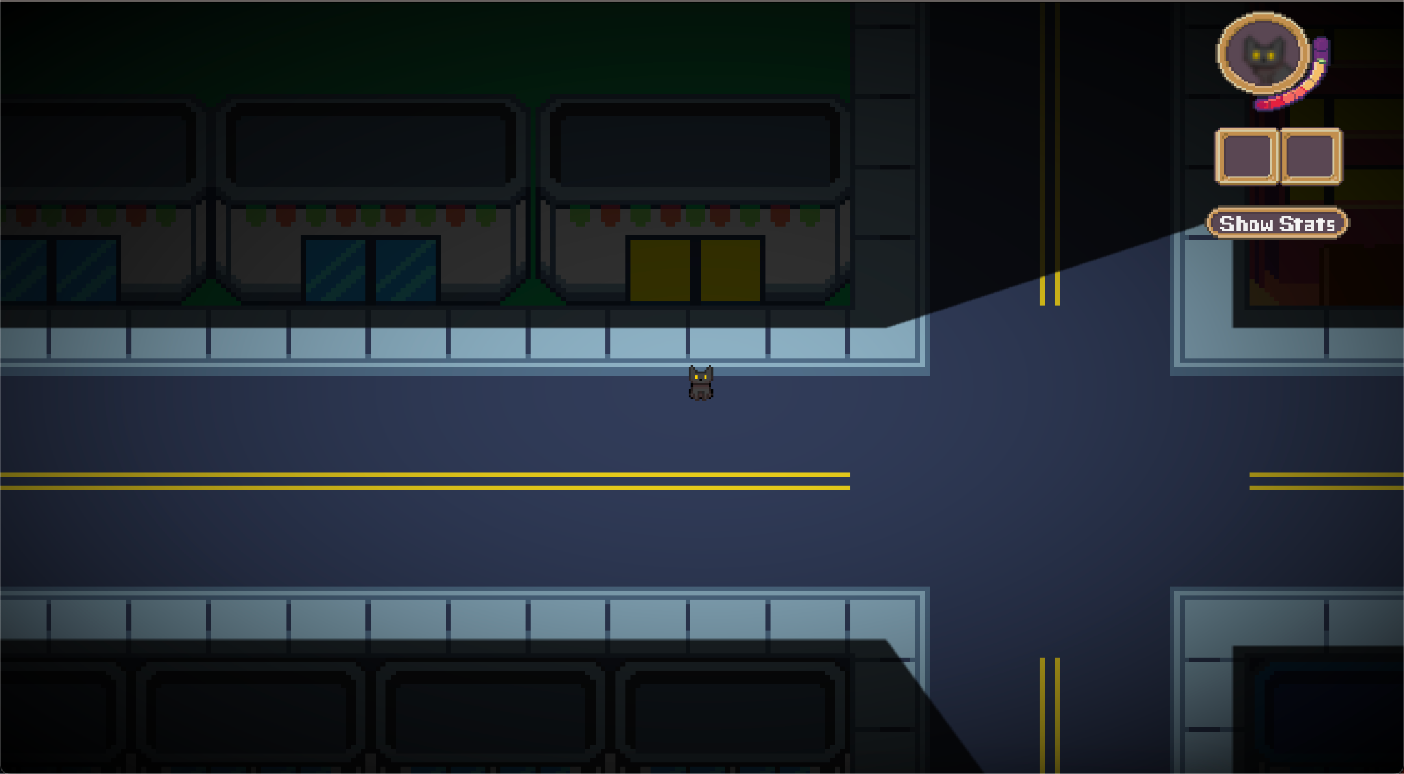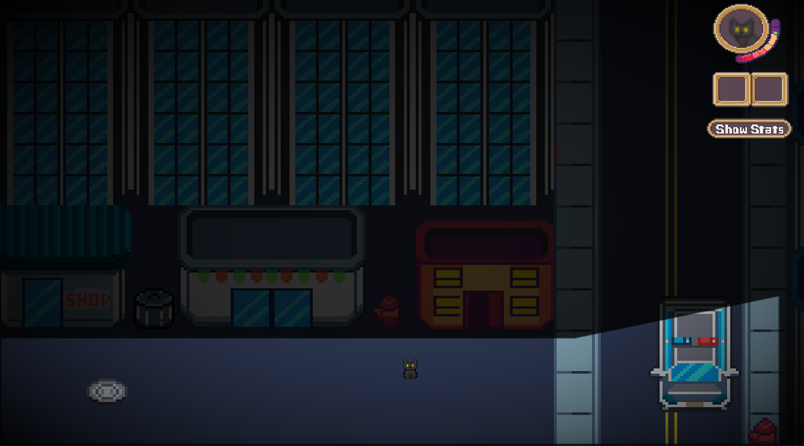

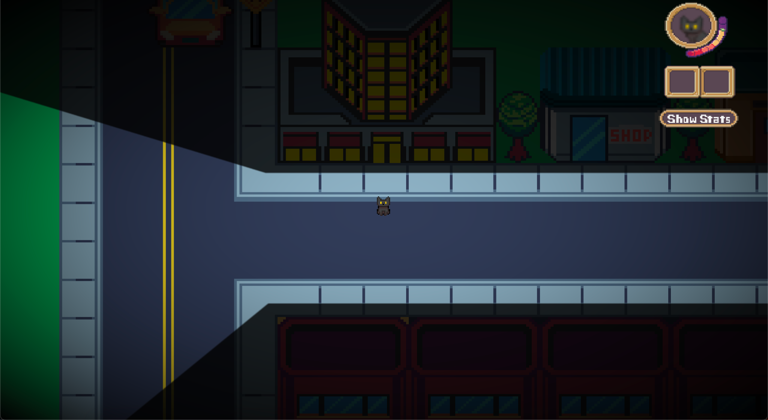

\**Camera System (Creative Component)*

**Rooms in City:**

* The lobby (3)
  + There are 2 patrols roaming with flashlights, 3 collectible objects and a food item.
  + There is an NPC in the room that begins an encounter when you collide with the NPC.
* Two office rooms (1) and (2)
  + Has money to increase reputation or necklace that increases cuteness.
  + Depending on screen size this room also has a camera system.

Key Input Tests:

* **Space Key**
  + Saves the entire play state (except for dynamically created items like buttons.)
  + If you press space again in the start state, it loads the game from the previous version. To test this you can move the player a bit, and you will see it in the place you left it.
* **Key “F”**
  + Activates/deactivates the FPS counter on the screen. The counter will appear on the bottom left of the screen.
* **Key “E”**
  + Picks up items, including equippable and consumable items.
    - If it is a consumable item, it will increase or decrease your hp based on its item stat.
    - If it is an equippable item, it will appear on your inventory in the top right corner.
* **Key “P”**
  + Pauses the game only while in PlayState and opens up a test menu. The ‘game screen’ should be darkened and nothing is updated. From here, you can press additional keys:
    - **Key “Y”**
      * Saves file. Next time you start the game, you will start from where you were.
    - **Key “N”**
      * Deletes saved file. Next time you start the game, you will start from scratch.
    - **Key “C”**
      * Un-pause game. You can now continue playing as usual.

Show Stats Button:

* When the player clicks ‘Show Stats’ their stats are displayed.
  + These are up to date and can be tested by picking up items that affect player stats.
* When the player clicks ‘Hide Stats’ their stats are hidden.

Creative Components:

* **Audio Feedback – 10%**
  + Described in *Encounter Test.*
* **Dynamic Shadows – 20%**
  + There is a light source coming from the cat which clashes with bounding boxes to create shadows across the map. This can be fully appreciated when walking around the city.
* **Mouse Gestures – 10%**
  + Described in *Encounter Test.*
* **Complex Prescribed Motion – 10%**
  + Described in *Encounter Test.*
* **Camera Control – 10%**
  + Described in *Expected Gameplay.*

Encounter Test:

* Player Actions:
  + *Audio Feedback (Creative Component)*
    - Every Action (Attack, Charm, Intimidate) has an associated audio element.
      * Attack – a slash sound.
      * Charm – a cat meowing sound.
      * Intimidate – a cat hissing sound.
    - There is also Encounter Music when the encounter begins.
  + Attack:
    - If the player presses attack, they are transported to an attack screen where they have to imitate one of three random attack motions.
    - These motions are demonstrated to the player via *Complex Prescribed Motion (Creative Component)*.
    - The player must click and trace the motion, matching the same number of dots as are shown on the ‘attack screen’. This is *Mouse Gestures (Creative Component)*
      * If they trace the motion correctly, the player’s attack hits. Otherwise it misses. A message is displayed to the player, letting them know the outcome of their attack.
  + Charm:
    - If the player presses charm, a message appears informing the player what the result was. The NPC’s mood bar is updated accordingly.
  + Intimidate
    - If the player presses intimidate, a message appears informing the player what the result was. Then the NPC’s mood bar is updated accordingly.
* NPC Actions:
  + After the player does their action, then the NPC tries to attack the player.
  + An attack window pops up where the player must beat a bullet hell mini game. Every time they are hit by a ‘bullet’ they lose 1 HP.
    - The duration of the attack varies per NPC.
    - The rate at which ‘bullets’ are spawned is dependent on an NPC’s ferocity.
  + At the end of the duration, the player is free to take a player action once again.
* Encounter Resolutions:
  + Player Wins (by either knockout, intimidate or charm):
    - A message appears letting the player know they won the encounter.
    - The player’s stats are updated and the update is shown to the player.
    - When the player presses space, the encounter screen is exited and the game returns to the previous state of PlayState.
    - The NPC is no longer in the game after they are defeated.
  + NPC Wins (by knockout)
    - A message saying game over is displayed and the game over screen is displayed. The player then restarts the game by pressing space.

## Test plan for M2

Expected Gameplay:

* The game starts on the start screen. Press the start button or press space to start the game.
* You start the game in the kennel room, confined in a cage with an exit tunnel. Next to you, there is an older cat. Approach the cat to receive instructions.
* Go into the tunnel. You will see a shrimp, when you are in the pick-up radius of the items, you will see instructions above them. Press E to eat the shrimp.
* You just got poisoned (a bit)! You will see a green text that warns you that not all food is safe.
* When you are closer to the backpack, see the instructions to collide* with the backpack to collect it.
* Once you leave the tunnel you enter the lobby with a darkened screen. There are 2 patrols roaming with flashlights, 3 collectible objects and a food item.
* You can pick up a maximum of 2 items at the same time. If you pick up an item when your inventory is full, you drop the item that has been there the longest (FIFO). You will see a red text that warns you about the inventory capacity.
* To enter the encounter screen press 0.

*The backpack is a mesh, and the collision is an oriented bounding box and mesh collision calculated using Separating Axis Theorem.

Key Input Tests:

* **Key “0”**
  + Starts the encounter screen
* **Space Key**
  + Saves the entire play state (except for dynamically created items like buttons.)
  + If you press space again in the start state, it loads the game from the previous version. To test this you can move the player a bit, and you will see it in the place you left it.
* **Key “F”**
  + Activates/deactivates the FPS counter on the screen. The counter will appear on the bottom left of the screen.
* **Key “E”**
  + Picks up items, including equippable and consumable items.
* If it is a consumable item, it will increase or decrease your hp based on its item stat.
* If it is an equippable item, it will appear on your inventory in the top right corner.

A* Pathfinding Testing:

* If the player is detected (i.e. went inside the light cone), the two patrols start chasing the player. A red blinking visual effect is displayed when the player is being chased.

Encounter State Test:

* Player Actions:
  + Attack:
    - If the player presses attack, a message describing a hit or a miss is displayed. If a hit, the amount of damage done to NPC is shown as well as them being intimidated. Then their HP bar and mood bar update accordingly.
  + Charm:
    - If the player presses charm, a message appears informing the player what the result was. The NPC’s mood bar is updated accordingly.
  + Intimidate
    - If the player presses intimidate, a message appears informing the player what the result was. Then the NPC’s mood bar is updated accordingly.
* NPC Actions:
  + After the player does their action, then the NPC tries to attack the player.
  + If it’s a hit, a message is displayed with the damage done. Another message appears showing the player’s remaining HP.
  + If it’s a miss, a message is displayed but no update to the player’s HP.
* Encounter Resolutions:
  + Player Wins (by either knockout, intimidate or charm):
    - A message appears letting the player know they won the encounter.
    - The encounter screen is exited and the game returns to the previous state of PlayState.
  + NPC Wins (by knockout)
    - The game returns to the start screen with a game over message.

## Test Plan for M1

Loading the Game:

* After the game is launched, the start screen should be the only visible window.
* Press on the Start button or press Space. This will lead to the state changing to play state and the game window should be visible.

Input Tests:

* Directional Movement Keys:
  + Pressing WASD should move the player cat:
    - W -> Up
    - A -> Left
    - S -> Down
    - D -> Right
  + Pressing opposing keys should not cause any movement.
  + Pressing opposing keys and then letting go of one should let the player move in the direction of the held down key.
  + Pressing two keys that are not opposing should cause a diagonal movement. The diagonal movement speed should not be faster than cardinal direction movement speed.
* Escape Key:
  + Pressing the Esc key should close the game window.

Collision Tests:

* Perpendicular Collision with Wall:
  + Hitting a wall while moving perpendicularly to it should cause the player or patrol to stop. Holding down the movement key, or spam pressing it should not create any visual effects.
* Diagonal Collision with Wall:
  + Hitting a wall at an angle that is not 90 degrees should:
    - Prevent the player or patrol from going through the wall. The velocity component that is perpendicular to the wall should be set to 0.
    - Let the player or patrol “slide” on the wall. The movement that is not perpendicular to the wall should persist.
* Player collision with Patrol:
  + The game should close.
* Player collision with cone:
  + Once the player enters the yellow cone in front of the patrol, the screen should start flashing red. This should be turned off once the player leaves the cone.