

DMIS - An Integrated Busines DMIS - An Integrated Business Management Information System for Drabbit Marketing s Management Information System for Drabbit Marketing

A System Proposal Presented to the Faculty of the
College of Computer and Information Science
Mapua Malayan Colleges Mindanao
Gen. Douglas Mac Arthur Highway
Talomo, Davao City

_____________________

In Partial Fulfilment of the
Academic Requirements for the Subject
SYSTEMS ANALYSIS AND DESIGN

Zian Wayne G. Matunding
Vincent Jon V. Libranza

TABLE OF CONTENTS
Section | Page
Part I. Systems Analysis Report | 3
Introduction | 3
The Organization | 6
Vision | 7
Mission | 7
Business Environment | 7
Critical Success Factors | 9
The Current System | 9
Description of Operations | 10
Problem/Opportunity Definition | 17
Functional Requirements | 20
Use Cases | 22
Use Case Glossary | 23
Feasible Alternatives | 25
Alternative 1: Spreadsheet-Based System | 25
Alternative 2: Off-the-Shelf Accounting Software | 26
Alternative 3: Custom Web-Based Information System | 27
Feasibility Analysis | 28
Operational Feasibility | 28
Technical Feasibility | 29
Economic Feasibility | 29
Schedule Feasibility | 30
Scope and Limitations | 31
Scope of the Study | 31
Limitations of the Study | 32
The Proposed System | 33
General Objective | 33
Specific Objectives | 34
Scope of Automation | 35
Data Dictionary | 39
Data Dictionary for Data Flow Diagram | 39
Data Dictionary for Entity Relationship Diagram | 40
References | 43

Part I
SYSTEMS ANALYSIS REPORT
Introduction

Drabbit Marketing is a sole proprietorship operating at Plainview Village KM.10 Sasa, Davao City, engaged in the distribution and supply of plastic bags, trash bags, plastic containers, cling wrap, aluminum foil, and related packaging products. The business serves retail and commercial customers throughout the Davao region, coordinating daily operations through manual processes that include order intake, procurement, delivery scheduling, inventory monitoring, invoicing, and customer communications.

The global shift toward digital business operations has accelerated significantly in recent years. According to the International Finance Corporation (IFC), over 90 percent of enterprises in developing economies are classified as small and medium enterprises (SMEs), yet fewer than 30 percent have adopted any form of digital management system. In the Philippines, the Department of Trade and Industry (DTI) reported in its 2023 MSME Development Plan that digitalization remains a critical gap among micro and small enterprises, particularly in the Visayas and Mindanao regions. The Philippine Statistics Authority (PSA) likewise documented that manual record-keeping continues to be the dominant practice among sole proprietorships in Davao City, contributing to operational inefficiencies, data loss, and reduced competitiveness.

Related studies affirm the need for information systems in small businesses. Laudon and Laudon (2020) established that transaction processing systems provide the operational backbone of small enterprises by automating routine data capture and reducing error rates. Turban et al. (2018) further noted that real-time inventory monitoring and automated invoicing are among the highest-impact features for SME digitalization, directly addressing cash flow irregularities and fulfillment delays. Locally, a 2022 study published in the Mindanao Journal of Science and Technology found that SMEs in Davao City that adopted web-based order and inventory management systems reported an average 40 percent reduction in order processing errors and a 35 percent improvement in invoice turnaround time within six months of deployment.

Market trends further support the urgency of digitalization for packaging distribution businesses. The packaging supply industry in the Philippines is experiencing year-on-year demand growth, driven by e-commerce expansion and increased household consumption. The Philippine E-Commerce Roadmap 2022-2028 highlights the need for supply chain digitalization among distributors to remain competitive. Without an integrated information system, businesses like Drabbit Marketing risk losing customers to more digitally capable competitors.

This Systems Analysis Report documents the organizational context, current system operations, problem and opportunity definitions, functional requirements, use case descriptions, feasibility analysis, scope and limitations, and the proposed system overview for the Drabbit Marketing Information System project. The report serves as the analytical foundation for the design and development of a proposed business management system intended to digitize and automate the core operational workflows of Drabbit Marketing.

The analysis presented in this report is based on direct interviews with the business proprietor, Rufino N. Libranza Jr., observation of current day-to-day business activities, and review of existing manual records and operational pain points. The findings confirm that current operations are highly dependent on pen-and-paper recording and informal coordination, which introduces significant risk of error, financial loss, and customer dissatisfaction. There is a clear and demonstrated need for an integrated digital system to address these operational deficiencies.

The Organization

Drabbit Marketing is a sole proprietorship founded and owned by Rufino N. Libranza Jr., located at Plainview Village KM.10 Sasa, Davao City. The business operates within the packaging and household supply distribution sector, catering to retail and commercial customers throughout the Davao region. The proprietor manages all core business functions including procurement, order management, delivery coordination, and customer relations.

Figure 1.1
Organizational Structure
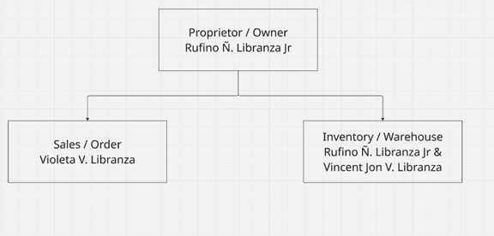

Vision
To become a leading packaging supply business in Davao City by leveraging technology-driven operations that ensure accurate, efficient, and transparent service delivery to every customer and partner.

Mission

To provide quality packaging products to businesses and households while continuously improving operational efficiency through the adoption of digital tools that automate order management, inventory tracking, invoicing, and customer service processes.

Business Environment

Drabbit Marketing operates in the local packaging and household supply distribution sector in Davao City. The business occupies a ground-floor commercial space at Plainview Village KM.10 Sasa, Davao City, which serves both as a storage facility and walk-in transaction area. The business does not have branches and operates exclusively within the Davao region. It is a single-location sole proprietorship with the proprietor functioning as the primary decision-maker for all operational activities.

Orders are received via phone calls or in-person visits, with no digital ordering channel currently in place. Inventory levels are tracked manually through physical stock counts, creating risk of undetected shortages or overstock situations. Invoices and receipts are prepared by hand, resulting in delays in billing and payment collection. Customer records are stored in physical files with no digital backup, exposing the business to data loss. There is no formal system for handling complaints or product returns, with all issues resolved informally.

With respect to ICT infrastructure, Drabbit Marketing currently employs minimal digital tools. The business has one desktop computer and one mobile phone used by the proprietor for communication purposes only. The desktop computer runs Microsoft Windows and is used primarily for basic document preparation in Microsoft Word and for accessing Facebook Messenger for informal supplier coordination. There is an active broadband internet connection provided by a local ISP, with stable connectivity sufficient for web-based application use. No enterprise software, accounting system, inventory management tool, or point-of-sale system is currently installed. There is no local area network, server infrastructure, or MIS department. All business data is maintained exclusively in physical logbooks and handwritten receipts.

Critical Success Factors

The following critical success factors were identified through stakeholder interviews and direct observation of business operations:

Critical Factor | Description
Accurate Order Management | Elimination of manual order errors through a digital order entry and tracking module.
Real-Time Inventory Visibility | A live inventory dashboard ensuring stock levels are always current and visible to the proprietor.
Automated Invoicing and Billing | System-generated invoices that reduce delays in revenue collection and improve cash flow.
Customer Data Integrity | A centralized digital customer database protecting contact details and transaction history from loss.
Audit Trail and Control | Complete transaction logging enabling the proprietor to detect discrepancies and resolve disputes.
Service Quality and Responsiveness | Order status notifications and a complaints management module to improve customer satisfaction.

The Current System

Drabbit Marketing does not currently employ any information system. There are no enterprise software applications, accounting platforms, or inventory management tools in use. All operational activities are conducted manually through pen-and-paper record-keeping, verbal communication, and informal messaging via mobile phone. The sole desktop computer on the premises is used only for basic word processing and is not integrated into any business process workflow.

Description of Operations

The current system of Drabbit Marketing operates entirely through manual and informal processes. The following describes how core business activities are currently conducted.

Order Receiving

Customer orders are received through direct phone calls or walk-in visits to the business. The proprietor or staff manually records each order on paper, noting the product type, quantity, and customer details. There is no order management software or digital form in use, making the process prone to transcription errors and missed entries.

Inventory Monitoring

Inventory levels are tracked by conducting physical counts of available stock. There is no real-time inventory system, meaning the proprietor must manually inspect storage to determine availability before committing to an order. This creates delays in order confirmation and risk of promising products that are already out of stock.

Procurement and Restocking

Procurement decisions are made based on the proprietor's manual assessment of inventory levels. Purchase orders to suppliers are placed verbally or through informal messaging. There is no automated alert or threshold-based system to trigger restocking, resulting in reactive rather than proactive procurement.

Invoicing and Payment

Invoices and receipts are prepared manually and delivered to customers either in person or via messenger. Payment collection is done in cash or through informal bank transfers with no automated confirmation. Delayed invoice preparation leads to slow payment turnaround and cash flow irregularities.

Delivery Scheduling

Delivery schedules are coordinated manually by the proprietor. There is no system to match confirmed orders against delivery records or to notify customers of delivery status. Disputes regarding deliveries must be resolved through personal communication with no formal audit trail.

Customer Records and Complaints

Customer information is stored in physical files or informally remembered by the proprietor. There is no digital customer profile or transaction history database. Customer complaints and product returns are handled informally with no documentation or follow-up mechanism in place.
Figure 1.2
Activity Diagram of the Current System
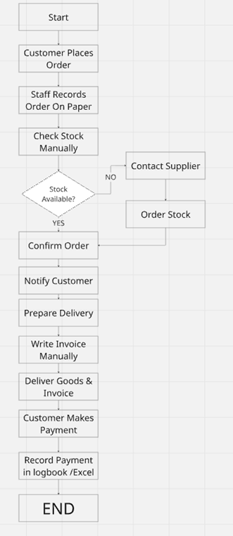

Figure 1.3
Context Level Data Flow Diagram of the Current System

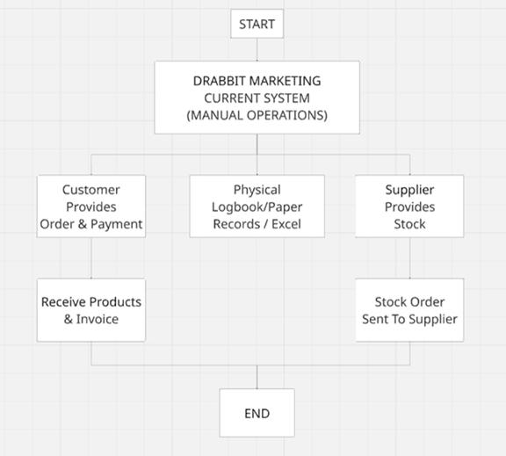

Figure 1.4
Level 0 Data Flow Diagram of the Current System
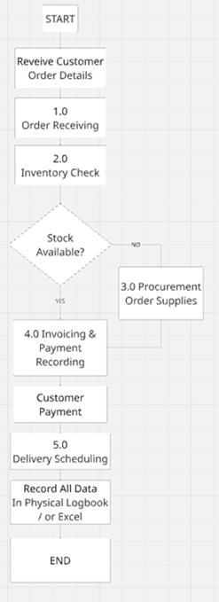

Figure 1.5
DFD Explosion - Process 1.0: Order Receiving (Current System)
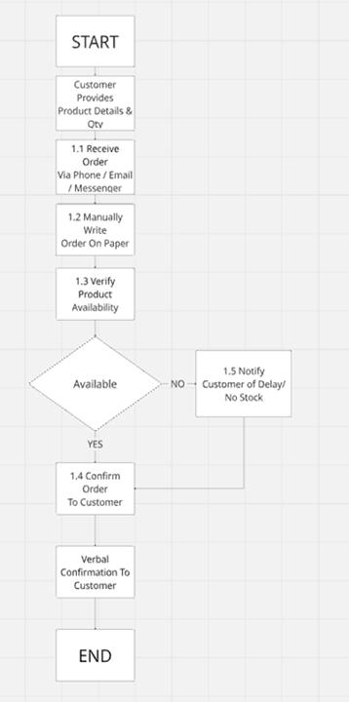

Problem/Opportunity Definition

The following problems were identified through stakeholder interviews with the proprietor, Rufino N. Libranza Jr., and direct observation of current business operations. Issues are categorized using the formal PIECES Framework (Performance, Information, Economics, Control, Efficiency, Service) as required in Systems Analysis and Design.

Table 1.1
Problem-Opportunity Definition Matrix (PIECES Framework)
Key Area |  | Member 1 - Zian Wayne G. Matunding | Member 2 - Vincent Jon V. Libranza | Opportunity
Performance | Problem | Manual recording of orders leads to frequent errors and missed deliveries. | No centralized system to track inventory levels in real time. | Implement an order management module and real-time inventory dashboard.
 | Cause | Reliance on pen-and-paper recording for all business transactions. | No inventory management software has been adopted by the business.
 | Effect | Increased risk of order fulfillment errors affecting customer satisfaction. | Stock shortages or overstock situations affecting business cash flow.
Information | Problem | No centralized database for customer information and order history. | Lack of reports on sales trends and top-performing products. | Create a customer database and build a sales reporting dashboard.
 | Cause | All customer records are stored in physical files with no digital backup. | Owner lacks access to a reporting or analytics tool for decision-making.
 | Effect | Risk of losing critical customer data due to damage or misplacement. | Poor business decisions made due to lack of accurate sales insights.
Economics | Problem | High operational costs due to labor-intensive manual processes. | Delayed invoicing slows down revenue collection and cash flow. | Automate routine tasks and invoice generation to reduce costs.
 | Cause | Manual processes require significant time and human resource investment. | Invoices are manually prepared and sent with considerable delays.
 | Effect | Reduced profit margins due to high operational overhead and inefficiency. | Cash flow problems and financial instability from slow invoice turnaround.
Control | Problem | No formal audit trail exists for transactions and inventory changes. | Difficulty detecting discrepancies between orders and actual deliveries. | Implement transaction logging and automated order-delivery matching.
 | Cause | Manual records do not support any audit trail or version history. | No system is in place to cross-reference orders against deliveries.
 | Effect | Undetected financial and inventory losses go unaddressed for long periods. | Delivery disputes with customers or suppliers are difficult to resolve.
Efficiency | Problem | Repetitive manual tasks consume the majority of daily working hours. | No automated alerts for critical stock level thresholds. | Automate repetitive tasks and set up automated stock level alerts.
 | Cause | No digital tools are available to automate routine business processes. | No monitoring or alert system of any kind is currently in place.
 | Effect | Staff time wasted on low-value tasks reduces overall business productivity. | Stockouts that could have been prevented occur due to lack of alerts.
Service | Problem | Customers cannot check order status without directly calling the owner. | No formal system for handling customer complaints or product returns. | Provide order status notifications and a complaints management module.
 | Cause | No customer-facing portal or notification system currently exists. | Complaints are handled informally with no documentation or follow-up.
 | Effect | Customer dissatisfaction grows due to lack of order status transparency. | Unresolved complaints lead to customer churn and loss of business.

Functional Requirements

The following functional requirements define the operational behaviors and capabilities of the proposed Drabbit Marketing Information System. These requirements were derived from the PIECES problem-opportunity analysis, observed operational needs, and stakeholder interviews.

Table 1.2
Functional Requirements
ID | Category | Description
FR-01 | User Authentication | The system shall provide a secure login mechanism requiring a valid username and password. Access shall be denied to unauthorized users, and sessions shall expire after a defined period of inactivity.
FR-02 | User Management | The system shall allow the administrator to create, update, deactivate, and assign roles to system user accounts including Proprietor and Staff roles with corresponding access privileges.
FR-03 | Order Management | The system shall allow the proprietor and staff to create, update, and track customer orders with automatic order number generation, status updates (Pending, Confirmed, Dispatched, Delivered), and order history logging.
FR-04 | Inventory Monitoring | The system shall display real-time inventory levels for all products and automatically update stock quantities upon order fulfillment or stock receipt from suppliers.
FR-05 | Low Stock Alerts | The system shall generate automated alerts when product inventory falls below a defined minimum threshold, prompting restock action from the proprietor.
FR-06 | Customer Database | The system shall maintain a digital database of customer profiles including contact details, delivery address, order history, and transaction records.
FR-07 | Invoice Generation | The system shall automatically generate formatted invoices upon order confirmation, recording payment status, due dates, and amount details.
FR-08 | Sales Dashboard | The system shall provide a reporting dashboard displaying sales trends, top-performing products, and revenue summaries over user-defined time periods.
FR-09 | Report Exporting | The system shall allow the proprietor to export sales reports, inventory reports, and audit logs in PDF or spreadsheet format for offline review and record-keeping.
FR-10 | Audit Trail | The system shall log all transactions, inventory changes, and user actions with timestamps and user identifiers to provide a complete and verifiable audit trail.
FR-11 | Delivery Tracking | The system shall enable recording and monitoring of delivery schedules and cross-reference confirmed orders with delivery records to detect fulfillment gaps.
FR-12 | Complaints Management | The system shall allow logging and tracking of customer complaints and product returns, with case IDs, status updates (Open, In Progress, Resolved), and resolution notes.
FR-13 | Order Status Notifications | The system shall provide automated status notifications to customers at key milestones such as order confirmation, dispatch, and delivery completion.
FR-14 | Backup and Recovery | The system shall perform automated daily backups of all data to a designated cloud or local storage location, with a recovery mechanism to restore the system to a previous state in the event of data loss or system failure.

Use Cases

The use cases below describe the primary interactions between system actors and the proposed Drabbit Marketing Information System. The main actors are the Proprietor/Administrator (primary) and the Staff (secondary). The use case diagram is presented followed by the use case glossary.
Figure 1.6
Use Case Diagram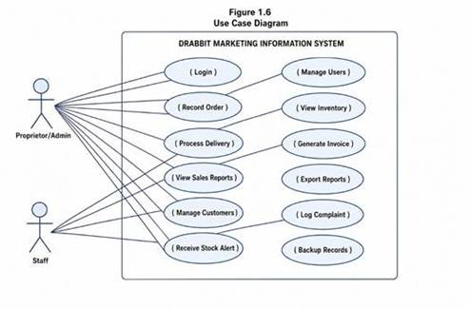
Table 1.3
Use Case Glossary
UC | Name | Actor(s) | Description | Expected Output
UC-01 | Login | Proprietor / Staff | User enters credentials to access the system; invalid credentials are rejected. | Session opened; user directed to dashboard.
UC-02 | Manage Users | Proprietor | Proprietor creates, edits, or deactivates user accounts and assigns roles. | User record saved with assigned role and access rights.
UC-03 | Record Customer Order | Proprietor / Staff | User enters a new customer order specifying products, quantities, and delivery details. | Order saved with auto-generated reference number; status set to Pending.
UC-04 | Check Inventory Levels | Proprietor / Staff | User views the inventory dashboard to check current stock quantities for all products. | Live inventory levels displayed with low-stock indicators highlighted.
UC-05 | Process Delivery | Proprietor / Staff | User marks an order as dispatched and records delivery details in the system. | Order status updated to Delivered; inventory decremented automatically.
UC-06 | Generate Invoice | Proprietor | System generates an invoice for a confirmed order which the proprietor reviews and sends to the customer. | Formatted invoice produced with order details, amounts, and payment due date.
UC-07 | View Sales Reports | Proprietor | Proprietor accesses the sales dashboard to review revenue trends and top products over a selected period. | Sales summary report displayed with filterable data.
UC-08 | Export Reports | Proprietor | Proprietor exports selected reports in PDF or spreadsheet format. | Report file downloaded to local device.
UC-09 | Manage Customer Profile | Proprietor / Staff | User adds or updates customer contact details, address, and notes in the database. | Customer record saved and accessible from the order entry form.
UC-10 | Log Customer Complaint | Proprietor / Staff | A complaint or return request is recorded with product details and resolution status. | Complaint logged with unique case ID; status set to Open.
UC-11 | Receive Stock Alert | Proprietor | System triggers an automated notification when product stock falls below the minimum level. | Alert displayed on dashboard prompting the proprietor to reorder.
UC-12 | Backup Records | Proprietor | Proprietor initiates a manual backup or reviews automated backup status. | Data backed up; confirmation message displayed with timestamp.

Feasible Alternatives

Prior to selecting the proposed technology approach, three feasible alternative approaches were evaluated for developing the Drabbit Marketing Information System. Each alternative was assessed on the basis of development cost, operational suitability, scalability, and alignment with the business's resources and environment.

Alternative 1: Spreadsheet-Based System (Microsoft Excel / Google Sheets)

This approach involves building a structured spreadsheet system using Excel or Google Sheets to manage orders, inventory, and invoices through formulas and manually maintained tables. While spreadsheets are widely accessible and require no programming, they do not support real-time alerts, automated workflows, or multi-user access control. As the business grows, spreadsheet maintenance becomes increasingly error-prone and unscalable.

Table 1.4
Estimated Budget - Alternative 1: Spreadsheet-Based System
Item | Estimated Cost | Notes
Hardware (Existing PC + Internet) | Php 0.00 | Already available
Microsoft 365 Subscription (annual) | Php 3,299.00 | Personal plan
Template Design / Setup Labor | Php 5,000.00 | One-time
Staff Training | Php 2,000.00 | One-time
Annual Maintenance (manual updates) | Php 3,000.00 | Recurring
TOTAL (Year 1) | Php 13,299.00

Alternative 2: Off-the-Shelf Accounting Software (e.g., QuickBooks, Wave)

Commercial accounting platforms offer ready-made modules for invoicing, basic inventory, and customer records. However, these platforms are typically designed for larger businesses and include many features irrelevant to a small sole proprietorship. Subscription costs can be prohibitive, localization for Philippine VAT and BIR requirements adds complexity, and customization to match Drabbit Marketing's specific workflow is limited without developer assistance.

Table 1.5
Estimated Budget - Alternative 2: Off-the-Shelf Software
Item | Estimated Cost | Notes
QuickBooks Online Subscription (annual) | Php 14,400.00 | Simple Start plan
Hardware (Existing PC) | Php 0.00 | Already available
Internet Connection (annual) | Php 9,600.00 | Existing broadband
Setup and Configuration Fee | Php 8,000.00 | One-time
Staff Training | Php 5,000.00 | One-time
Annual Technical Support | Php 6,000.00 | Recurring
TOTAL (Year 1) | Php 43,000.00

Alternative 3: Custom Web-Based Information System (Proposed)

A custom-built web application developed specifically for Drabbit Marketing's workflows provides the most direct and scalable solution. It allows the system to be tailored precisely to the business's order management, inventory, invoicing, reporting, and complaint handling needs without unnecessary features or subscription fees. A web-based deployment ensures accessibility from any device with a browser, including the proprietor's mobile phone, without requiring installation.

Table 1.6
Estimated Budget - Alternative 3: Custom Web-Based System
Item | Estimated Cost | Notes
Hardware Cost (Desktop PC - existing) | Php 0.00 | Already available
Internet Connection (annual) | Php 9,600.00 | Existing broadband
Web Hosting (annual, shared) | Php 3,500.00 | Cloud-based hosting
Domain Name Registration (annual) | Php 800.00 | One-time/annual
System Development Cost | Php 45,000.00 | One-time custom dev
Testing and Quality Assurance | Php 5,000.00 | One-time
User Training | Php 3,000.00 | One-time
Annual Maintenance and Support | Php 8,000.00 | Recurring
TOTAL (Year 1) | Php 74,900.00
TOTAL (Year 2 onwards) | Php 21,900.00 | Recurring only

Feasibility Analysis

Operational Feasibility

Alternative 1 (Spreadsheet) is operationally accessible since the proprietor already has Microsoft Office experience. However, as order volumes grow, manual spreadsheet maintenance becomes burdensome and error-prone. Alternative 2 (Off-the-Shelf Software) provides operational tools but requires the proprietor to adapt to a generic interface not designed for packaging distribution, potentially reducing adoption. Alternative 3 (Custom Web System) is designed specifically around the proprietor's daily workflow, minimizing the learning curve and maximizing operational fit. The proprietor confirmed willingness to use a web-based system accessible from the existing desktop and mobile phone.

Technical Feasibility

The existing ICT infrastructure of Drabbit Marketing includes one desktop computer running Windows, one mobile phone, and an active broadband internet connection. This is sufficient to support a web-based application without any additional hardware investment. Alternative 1 requires no special technology. Alternative 2 requires software installation and configuration. Alternative 3 requires only a browser and internet connection for access, which the business already possesses. Development will use React and TypeScript for the frontend, Node.js with Express for the backend, Turso as an edge-compatible SQL database, all of which are mature and widely supported technologies deployable on Vercel.

Economic Feasibility

Alternative 1 has the lowest Year 1 cost at Php 13,299 but provides minimal automation value and requires continuous manual effort, resulting in high hidden labor costs. Alternative 2 costs Php 43,000 in Year 1 with recurring annual subscriptions and limited customization. Alternative 3 has a higher initial Year 1 investment of Php 74,900 but recurring annual costs of only Php 21,900 from Year 2 onwards. Given the reduction in labor hours, elimination of billing delays, and prevention of stockout losses, the custom web system is expected to recover its initial investment within 18 to 24 months of deployment.

Schedule Feasibility

Alternative 1 can be implemented within two weeks. Alternative 2 can be configured and deployed within one month. Alternative 3, as a custom-built solution, is estimated to require four to six months for full development, testing, training, and deployment within the academic term. This timeline is feasible given the project schedule outlined in Part II.

Table 1.7
Weighted Scoring Model for the Different Candidates
Feasibility Criteria | Wt. | Alt 1: Spreadsheet | Alt 2: Off-the-Shelf | Alt 3: Custom Web (Proposed)
Operational Feasibility | 30% | 55 (16.5) | 70 (21.0) | 95 (28.5)
Technical Feasibility | 30% | 70 (21.0) | 65 (19.5) | 90 (27.0)
Economic Feasibility | 30% | 80 (24.0) | 65 (19.5) | 75 (22.5)
Schedule Feasibility | 10% | 95 (9.5) | 85 (8.5) | 75 (7.5)
TOTAL WEIGHTED SCORE | 100% | 71.0 | 68.5 | 85.5

Based on the weighted scoring model, Alternative 3 (Custom Web-Based Information System) received the highest total score of 85.5 out of 100. This alternative is selected as the proposed solution for the Drabbit Marketing Information System.

Scope and Limitations

Scope of the Study

The proposed Drabbit Marketing Information System covers the following modules and functionalities:

User Authentication and User Management module for secure system access and role-based user account administration. Order management module for creating, tracking, and updating customer orders with auto-generated reference numbers and status history. Real-time inventory monitoring dashboard displaying current stock levels with automated low-stock alerts for threshold-based restocking triggers. Automated invoice generation module producing formatted billing documents upon order confirmation with payment status tracking. Customer database storing contact details, addresses, order histories, and transaction records in a secure and searchable digital format. Sales and performance reporting dashboard with export functionality for PDF and spreadsheet formats. Delivery scheduling and tracking module with order-to-delivery cross-referencing for accurate fulfillment management. Full transaction audit trail logging all system activities with timestamps for financial and inventory accountability. Complaints and returns management module for documenting, tracking, and resolving customer service issues. Automated daily backup and manual backup capability with data recovery mechanism.

Limitations of the Study

The system requires active internet connectivity for access. Offline mode and local caching are not supported in the initial release. Automated online payment gateway integration (e.g., GCash, PayMongo) is outside the scope of this study; payment tracking is limited to manual status updates recorded in the system. The system is designed exclusively for single-business use by Drabbit Marketing and does not support multi-branch or multi-tenant operations. A public-facing customer ordering portal is not included in this study and may be considered for future development. Advanced accounting features such as BIR tax computation, payroll management, and financial statement generation are outside the scope of this study.

The Proposed System

Based on the results of the feasibility analysis, Alternative 3 — a custom web-based information system — is selected as the proposed solution. This alternative received the highest weighted score of 85.5, reflecting its superior operational fit, technical accessibility, and long-term economic value for Drabbit Marketing.

General Objective

The general objective of the Drabbit Marketing Information System is to develop a web-based business management application that automates the core operational workflows of Drabbit Marketing, including order management, inventory monitoring, invoice generation, customer records management, sales reporting, delivery tracking, and complaints handling, thereby addressing the operational inefficiencies currently caused by manual, paper-based processes.

Specific Objectives

1. Develop a web-based order management module that allows the proprietor and staff to create, track, and update customer orders with auto-generated reference numbers, eliminating manual pen-and-paper recording.

2. Implement a real-time inventory dashboard with automated low-stock threshold alerts to prevent stockout situations and enable proactive procurement decisions.

3. Automate invoice generation upon order confirmation to reduce billing delays, accelerate payment collection, and stabilize business cash flow.

4. Build a centralized customer database that securely stores contact details, order history, and transaction records to prevent data loss from physical file misplacement.

5. Provide a sales and performance reporting dashboard with export functionality to equip the proprietor with accurate, real-time business insights for informed decision-making.

6. Implement a user authentication and role-based access control system to ensure data security and restrict system access to authorized personnel only.

7. Establish an automated backup and data recovery mechanism to protect all business data against loss or system failure.

Scope of Automation

The following processes are targeted for automation in the proposed system:

Process | Current (Manual) | Proposed (Automated)
Login / Access Control | No system login; anyone can access records. | Secure login with username/password; role-based access control.
Order Recording | Customer orders recorded by hand on paper. | Digital order entry form with auto-generated reference numbers and status tracking.
Inventory Tracking | Physical stock counts conducted manually. | Real-time inventory dashboard with automated low-stock notifications.
Invoice Preparation | Invoices written manually with considerable delays. | System-generated invoices produced automatically upon order confirmation.
Customer Records | Customer information stored in physical files. | Centralized digital customer database with full transaction history.
Sales Reporting | No reports; proprietor relies on memory. | Automated sales dashboard with exportable reports.
Delivery Tracking | No cross-referencing of orders and deliveries. | Delivery records linked to orders; status tracked with timestamps.
Complaints Handling | Complaints addressed verbally with no documentation. | Complaints module with case IDs, status tracking, and resolution notes.
Audit and Control | No audit trail; discrepancies may go undetected. | Full transaction log with timestamps for complete operational accountability.
Data Backup | No backup; all data in physical logbooks. | Automated daily cloud backup with manual backup option and recovery capability.

Figure 1.7
Activity Diagram of the Proposed System
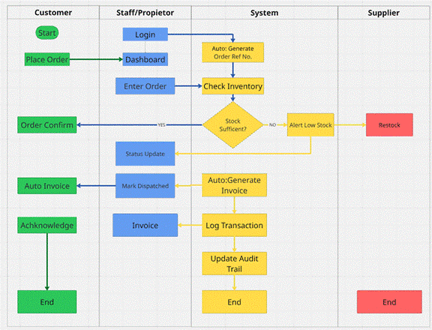

Figure 1.8
Context Level Data Flow Diagram of the Proposed System
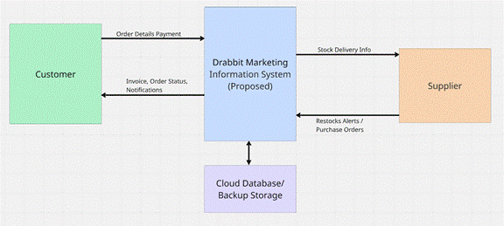
Figure 1.9
Level 0 Data Flow Diagram of the Proposed System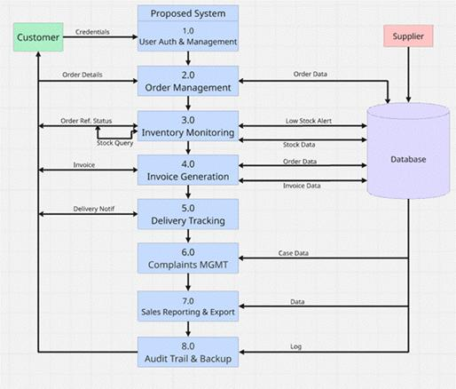
Figure 1.10
Entity Relationship Diagram of the Proposed System
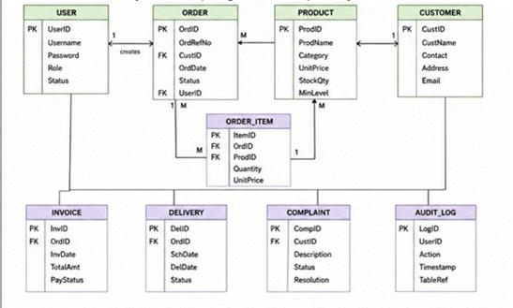

Data Dictionary

The following data dictionary defines the key data stores and entities used in the proposed Drabbit Marketing Information System.

Data Dictionary for Data Flow Diagram

Table 1.8
Data Dictionary - DFD Processes
Process Name | Proc # | Input Flows | Output Flows
User Auth & Management | 1.0 | User credentials, User-Profile-Data | Authenticated-Session, User-Record
Order Management | 2.0 | Order-Details, Customer-ID, Product-ID | Order-Record, Order-Ref-Number, Stock-Query
Inventory Monitoring | 3.0 | Stock-Query, Supplier-Stock-Data | Stock-Levels, Low-Stock-Alert
Invoice Generation | 4.0 | Order-Record, Payment-Info | Invoice-Document, Invoice-Record
Delivery Tracking | 5.0 | Order-Record, Delivery-Details | Delivery-Record, Delivery-Notification
Complaints Management | 6.0 | Complaint-Details, Customer-ID | Complaint-Record, Case-ID, Status-Update
Sales Reporting & Export | 7.0 | Order-Records, Invoice-Records | Sales-Report, Export-File
Audit Trail & Backup | 8.0 | All-Transaction-Data | Audit-Log-Entry, Backup-Confirmation

Data Dictionary for Entity Relationship Diagram

Table 1.9
Data Dictionary - Entities and Attributes
Entity | Attribute | Data Type | Business Definition
USER | UserID | INT (PK) | Unique identifier for each system user.
USER | Username | VARCHAR(50) | Login name of the system user.
USER | Password | VARCHAR(255) | Encrypted password for authentication.
USER | Role | ENUM | Defines access level: Proprietor or Staff.
USER | Status | ENUM | Active or Inactive account status.
CUSTOMER | CustomerID | INT (PK) | Unique identifier for each customer.
CUSTOMER | CustomerName | VARCHAR(100) | Full name of the customer or business.
CUSTOMER | Contact | VARCHAR(20) | Phone number of the customer.
CUSTOMER | Address | TEXT | Delivery address of the customer.
PRODUCT | ProductID | INT (PK) | Unique identifier for each product.
PRODUCT | ProductName | VARCHAR(100) | Name of the packaging product.
PRODUCT | Category | VARCHAR(50) | Product category (e.g., plastic bags).
PRODUCT | UnitPrice | DECIMAL(10,2) | Selling price per unit of the product.
PRODUCT | StockQty | INT | Current quantity on hand in inventory.
PRODUCT | MinLevel | INT | Minimum stock threshold for alert trigger.
ORDER | OrderID | INT (PK) | Unique identifier for each customer order.
ORDER | OrderRefNo | VARCHAR(20) | Auto-generated reference number for the order.
ORDER | OrderDate | DATE | Date the order was created in the system.
ORDER | Status | ENUM | Current status: Pending, Confirmed, Dispatched, Delivered.
ORDER_ITEM | ItemID | INT (PK) | Unique identifier for each line item in an order.
ORDER_ITEM | Quantity | INT | Quantity of a product in the order line.
ORDER_ITEM | UnitPrice | DECIMAL(10,2) | Price per unit at the time of order.
INVOICE | InvoiceID | INT (PK) | Unique identifier for each invoice.
INVOICE | InvoiceDate | DATE | Date the invoice was generated.
INVOICE | TotalAmount | DECIMAL(10,2) | Total amount due on the invoice.
INVOICE | PaymentStatus | ENUM | Unpaid, Partial, or Paid.
DELIVERY | DeliveryID | INT (PK) | Unique identifier for each delivery record.
DELIVERY | ScheduledDate | DATE | Date delivery is scheduled to occur.
DELIVERY | DeliveryDate | DATE | Actual date of delivery completion.
DELIVERY | Status | ENUM | Pending, In Transit, or Delivered.
COMPLAINT | ComplaintID | INT (PK) | Unique identifier for each complaint case.
COMPLAINT | Description | TEXT | Details of the customer complaint or return request.
COMPLAINT | Status | ENUM | Open, In Progress, or Resolved.
COMPLAINT | Resolution | TEXT | Notes on how the complaint was resolved.
AUDIT_LOG | LogID | INT (PK) | Unique identifier for each audit log entry.
AUDIT_LOG | Action | VARCHAR(100) | Description of the action performed.
AUDIT_LOG | Timestamp | DATETIME | Date and time the action was recorded.
AUDIT_LOG | TableRef | VARCHAR(50) | Name of the database table affected.

Part II
PROJECT DESCRIPTION

Project Title

"An Integrated Business Management Information System for Drabbit Marketing"

The proponents chose this title because it precisely describes both the scope and the purpose of the proposed solution. The term Integrated reflects the system's design as a unified platform that combines order management, inventory monitoring, invoice generation, customer records, sales reporting, delivery tracking, complaints handling, and audit trail functions under a single web-based application, eliminating the fragmented and disconnected manual processes currently in use. Business Management Information System accurately classifies the type of information system being developed, as it supports the transaction processing and management reporting needs of the organization. The inclusion of Drabbit Marketing in the title anchors the system to its specific client, reinforcing that the solution is purpose-built for the business’ operational context rather than a generic off-the-shelf product.
Project Logo
Figure 2.0
Project Logo


Project Organization

The project team is composed of two members organized under clearly defined roles to ensure efficient coordination and delivery. The Project Manager oversees the overall project plan, sprint execution, task allocation, timeline compliance, and communication with the client. The Lead Developer is responsible for the system architecture, backend logic, database design, and integration of core functionalities including authentication, order management, inventory monitoring, invoice generation, and reporting. Both members collaborate on systems analysis documentation, testing, quality assurance, and training activities.

Table 1.10
Project Team Organization

Member | Role | Responsibilities
Zian Wayne G. Matunding | Project Manager / Analyst | Project planning, client interviews, systems analysis documentation, sprint coordination, and quality assurance.
Vincent Jon V. Libranza | Lead Developer / Designer | System architecture, database design, frontend and backend development, integration, and deployment.
Authentication Service | Turso Authentication | Provides secure user login and session management using anonymous sign-in and configurable identity providers for the proprietor and staff.
Data Visualization | Recharts | React-based charting library used to render sales trend charts and inventory reports on the sales dashboard.
Internet Connectivity | Broadband Internet Connection | Enables cloud hosting access, Turso.  Turso synchronization, and system use from the proprietor's desktop or mobile device.
Device | Desktop Computer / Mobile (Windows) | Primary devices used by the proprietor and staff to access and operate the system through any modern web browser.

Project Methodology

The development of the Drabbit Marketing Information System follows the Agile Scrum Methodology, which emphasizes iterative development, continuous stakeholder feedback, and incremental delivery of working system features. The project is organized into four phases executed across multiple sprints, allowing the team to develop, test, and refine system modules progressively based on validated requirements and proprietor feedback.

Phase 1 - Requirements Gathering and Planning

The team conducts stakeholder interviews with the proprietor, Rufino N. Libranza Jr., observes current business operations, and documents the existing manual processes. This phase produces the systems analysis report, the PIECES matrix, the problem-opportunity definition, functional requirements, and the feasibility analysis. Project objectives, scope, and system architecture are finalized at the end of this phase.

Phase 2 - System Design and Development

The team designs and develops the core modules of the Drabbit Marketing Information System in incremental sprints. Modules are developed in the following sequence: user authentication and access control, order management, inventory monitoring and alerts, invoice generation, customer database, sales dashboard and reporting, delivery tracking, complaints management, and audit trail. Each module is unit-tested before integration.

Phase 3 - Testing and Enhancement

The integrated system undergoes functional testing, integration testing, and user acceptance testing with the proprietor. Defects identified during testing are resolved and the system is refined based on user feedback before proceeding to deployment.

Phase 4 - Deployment and Implementation

The completed system is deployed to a cloud hosting environment and made accessible to the proprietor and authorized staff. User training is conducted, final documentation is completed, and the system is handed over to the client.

Project Schedule
Table 2.0
Activity / Task | Timeline | Person Assigned | Expected Deliverable
Phase 1 - Requirements Gathering and Planning
Data Gathering and Stakeholder Interviews | Week 1-2 | All Members | Interview notes, observed workflow documentation, client requirements
Systems Analysis and Documentation | Week 2-4 | All Members | PIECES Matrix, POM, Functional Requirements, Use Cases, Feasibility Analysis
Client Meeting and Approval | Week 4 | All Members | Approved project scope, validated requirements, meeting minutes
Phase 2 - System Design and Development
Database Design and ERD | Week 4-5 | V.J. Libranza | Entity Relationship Diagram, Data Dictionary, database schema
User Authentication and Access Control | Week 5 | V.J. Libranza | Secure login module with role-based access control
Order Management Module | Week 5-6 | V.J. Libranza | Functional order entry, tracking, and status update module
Inventory Monitoring and Alerts | Week 6 | V.J. Libranza | Real-time inventory dashboard with low-stock alert notifications
Invoice Generation Module | Week 6-7 | V.J. Libranza | Automated invoice generation upon order confirmation
Customer Database Module | Week 7 | V.J. Libranza | Customer profile management with order history and search
Sales Dashboard and Reporting | Week 7-8 | V.J. Libranza | Sales reports on export functionality in PDF and spreadsheet formats
Delivery Tracking and Complaints Modules | Week 8 | V.J. Libranza | Delivery records module and complaints management module
Audit Trail and Backup Module | Week 8-9 | V.J. Libranza | Transaction log with timestamps and automated backup system
Phase 3 - Testing and Enhancement
Functional and Integration Testing | Week 9-10 | All Members | Test cases, bug reports, and testing documentation
User Acceptance Testing | Week 10-11 | All Members | UAT results, proprietor sign-off, issue resolution log
Phase 4 - Deployment and Implementation
System Deployment | Week 11 | V.J. Libranza | Deployed system on cloud hosting, accessible to client
User Training | Week 11-12 | All Members | Training completion, user manual, minutes of training
Final Documentation and Handover | Week 12 | All Members | Final project documentation, signed acceptance letter

Figure 2.2
Gantt Chart
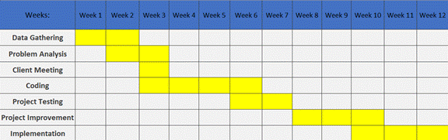

Technology

The Drabbit Marketing Information System is developed using a web-based technology stack that supports order management, inventory tracking, automated invoicing, customer records, sales reporting, and audit trail functionalities. The selected technologies are appropriate for the business's existing ICT infrastructure, which consists of a desktop computer running Windows and an active broadband internet connection. The tables below describe the technologies to be used.

Table 2.1
Technology Category | Technology Used | Purpose
Programming Language | TypeScript 5.x | Primary programming language used across both the frontend (React components) and backend (Node.js server), providing static typing and improved code reliability.
Frontend Library | React 19 | Component-based UI library for building the web application interface, managing application state, and rendering all system screens in the browser.
CSS Framework | Tailwind CSS 4.x | Utility-first CSS framework for designing a responsive and accessible user interface that works on both desktop and mobile browsers.
Edge SQL Database | Turso (LibSQL) | Edge-compatible SQL database for structured relational data queries handled by the backend server layer.
Backend Runtime | Node.js + Express | Server-side runtime and web framework that handles API routes, business logic, database connections, and HTTP request processing.
Version Control System | Git | Tracks and manages source code changes throughout development.
Repository Hosting Platform | GitHub | Supports source code storage, collaboration, and version management.
IDE / Code Editor | Cursor / Visual Studio Code | Used for code development, debugging, AI-assisted code completion, and project file management throughout the development process.
PDF Generation | jsPDF | Client-side JavaScript library for generating formatted invoice and report PDF files directly in the browser for download and printing.
Build Tool | Vite 6.x | Fast frontend build tool and development server for bundling the React application during development and production builds.
Deployment Platform | Vercel | Cloud deployment platform for hosting the web application online, making it accessible from any browser without local installation.

Part III
USER ACCEPTANCE AND TRAINING
User Acceptance Training

Preliminary Testing Results

Functional Requirement
Table 2.3
1. User Authentication and User Management | a. Login using valid credentials  b. Logout user  c. Maintain user session  d. Restrict unauthorized access  e. Create, update, and deactivate user accounts
2. Order Management | a. Create customer order  b. Generate order reference number  c. Update order status (Pending, Confirmed, Dispatched, Delivered)  d. View order history
3. Inventory Monitoring | a. View current inventory levels  b. Automatically update stock quantities after order fulfillment  c. Display inventory dashboard
4. Low Stock Alerts | a. Detect products below minimum stock threshold  b. Generate low-stock notification  c. Display alert on dashboard
5. Customer Database Management | a. Add customer profile  b. Update customer information  c. View customer transaction history
6. Invoice Generation | a. Generate invoice from confirmed order  b. Calculate invoice total amount  c. Record payment status  d. Print or export invoice
7. Sales Dashboard and Reporting | a. View sales summary  b. View top-performing products  c. Filter reports by date range  d. Display revenue trends
8. Report Exporting | a. Export sales report to PDF  b. Export inventory report to spreadsheet  c. Export audit logs
9. Delivery Tracking | a. Log customer complaint  b. Update complaint status  c. Record resolution notes  d. View complaint history
11. Audit Trail | a. Record user activities  b. Record inventory changes  c. Record order transactions  d. View audit logs
12. Backup and Recovery | a. Perform manual backup  b. Perform automated backup  c. Restore backed-up data  d. Verify backup integrity
13. Product Management | a. Add new produc  b. Update product details  c. Deactivate product  d. Update product pricing and stock thresholds
14. Supplier Management | a. Add supplier record  b. Update supplier information  c. View supplier details  d. Maintain procurement history

Each of the test cases was examined, and the results were recorded. The tests were conducted to verify that the Drabbit Marketing Information System performed according to the specified functional requirements. All modules were evaluated for accuracy, reliability, usability, and data integrity. The results of the User Acceptance Testing (UAT) are presented in Table 2.3 Actual User Acceptance Testing Results, which summarizes the outcome of each test case, observed system behavior, and user feedback gathered during the evaluation process.

Table 2.4
User Acceptance Testing Results

Test Case # | Tested By | Tested Date | Expected Outcome | Actual Outcome | Remarks
1a | Violeta V.  Libranza | 6/16/2026 | Be able to log in using valid credentials. | User successfully authenticated and redirected to the dashboard. | PASSED
1b | Adrian John L. Vic | 6/13/2026 | Be able to log out of the system. | User successfully logged out and returned to the login page. | PASSED
1c | Rufino N. Libranza JR | 6/14/2026 | Maintain active user session. | User session remained active until logout. | PASSED
2a | Violeta V.  Libranza | 6/16/2026 | Create a customer order. | Customer order was successfully recorded in the system. | PASSED
2b | Adrian John L. Vic | 6/13/2026 | Generate order reference number. | System generated a unique order reference number successfully. | PASSED
2c | Rufino N. Libranza JR | 6/14/2026 | Update order status. | Order status was updated correctly. | PASSED
2d | Violeta V.  Libranza | 6/16/2026 | View order history. | Order history was displayed accurately. | PASSED
3a | Rufino N. Libranza JR | 6/14/2026 | View current inventory levels. | Inventory levels were displayed correctly. | PASSED
3b | Rufino N. Libranza JR | 6/14/2026 | Automatically update stock quantities. | Inventory quantities were updated after order processing. | PASSED
3c | Violeta V.  Libranza | 6/16/2026 | Display inventory dashboard. | Inventory dashboard loaded successfully. | PASSED
4a | Adrian John L. Vic | 6/13/2026 | Detect low-stock products. | System identified products below minimum stock levels. | PASSED
4b | Rufino N. Libranza JR | 6/14/2026 | Generate low-stock notification. | Low-stock notification was generated successfully. | PASSED
5a | Violeta V.  Libranza | 6/16/2026 | Add customer profile. | Customer profile was successfully saved. | PASSED
5b | Adrian John L. Vic | 6/13/2026 | Update customer information. | Customer information was updated successfully. | PASSED
5c | Rufino N. Libranza JR | 6/14/2026 | View customer transaction history. | Customer transaction history was displayed accurately. | PASSED
6a | Violeta V.  Libranza | 6/16/2026 | Generate invoice. | Invoice was generated successfully. | PASSED
6b | Rufino N. Libranza JR | 6/14/2026 | Calculate invoice total amount. | Invoice totals were calculated accurately. | PASSED
6c | Adrian John L. Vic | 6/13/2026 | Record payment status. | Payment status was updated correctly. | PASSED
6d | Violeta V.  Libranza | 6/16/2026 | Export or print invoice. | Invoice was exported successfully. | PASSED
7a | Adrian John L. Vic | 6/13/2026 | View sales summary. | Sales summary was displayed accurately. | PASSED
7b | Rufino N. Libranza JR | 6/14/2026 | View sales summary. | Product performance report was displayed successfully. | PASSED
7c | Violeta V.  Libranza | 6/16/2026 | Filter reports by date range. | Reports were filtered correctly. | PASSED
7d | Adrian John L. Vic | 6/13/2026 | Display revenue trends. | Revenue trend data was displayed accurately. | PASSED
8a | Rufino N. Libranza JR | 6/14/2026 | Export sales report to PDF. | Sales report was exported successfully. | PASSED
8b | Violeta V.  Libranza | 6/16/2026 | Export inventory report to spreadsheet. | Inventory report was exported successfully. | PASSED
8c | Adrian John L. Vic | 6/13/2026 | Export audit logs. | Audit logs were exported successfully. | PASSED
9a | Rufino N. Libranza JR | 6/14/2026 | Create delivery schedule. | Delivery schedule was recorded successfully. | PASSED
9b | Violeta V.  Libranza | 6/16/2026 | Update delivery status. | Delivery status was updated correctly. | PASSED
9c | Adrian John L. Vic | 6/13/2026 | Link delivery records to orders. | Delivery records were linked successfully. | PASSED
9d | Rufino N. Libranza JR | 6/14/2026 | View delivery history. | Delivery history was displayed accurately. | PASSED
10a | Violeta V.  Libranza | 6/16/2026 | Log customer complaint. | Complaint record was saved successfully. | PASSED
10b | Adrian John L. Vic | 6/13/2026 | Update complaint status. | Complaint status was updated successfully. | PASSED
10c | Rufino N. Libranza JR | 6/14/2026 | Record resolution notes. | Resolution notes were saved successfully. | PASSED
10d | Violeta V.  Libranza | 6/16/2026 | View complaint history. | Complaint history was displayed correctly. | PASSED
11a | Adrian John L. Vic | 6/13/2026 | Record user activities. | User actions were recorded in the audit log. | PASSED
11b | Rufino N. Libranza JR | 6/14/2026 | Record inventory changes. | Inventory changes were logged successfully. | PASSED
11c | Violeta V.  Libranza | 6/16/2026 | Record order transactions. | Order transactions were recorded in audit logs. | PASSED
11d | Adrian John L. Vic | 6/13/2026 | View audit logs. | Audit logs were displayed correctly. | PASSED
12a | Rufino N. Libranza JR | 6/14/2026 | Perform manual backup. | Manual backup completed successfully. | PASSED
12b | Violeta V.  Libranza | 6/16/2026 | Perform automated backup. | Automated backup executed successfully. | PASSED
12c | Adrian John L. Vic | 6/13/2026 | Restore backed-up data. | Data restoration completed successfully. | PASSED
12d | Rufino N. Libranza JR | 6/14/2026 | Verify backup integrity. | Backup files were verified successfully. | PASSED

Appendix ___ shows the actual document of the UAT with the users' signatures.

Training Results
The training was conducted for the users after the completion of User Acceptance Testing. The results are shown in Table 2.4
Table 2.5
Training Results
Date | Module | User | Results
6/14/2026 | User Authentication and User Management | Rufino N. Libranza JR | The training on login, logout, session management, and user account administration was administered successfully.
6/16/2026 | Order Management | Violeta V.  Libranza | The training on creating customer orders, updating order status, and managing order records was administered successfully.
6/14/2026 | Inventory Monitoring and Low Stock Alerts | Rufino N. Libranza JR | The training on inventory tracking and low-stock alert monitoring was administered successfully.
6/16/2026 | Customer Database Management | Violeta V.  Libranza | The training on customer profile creation, updates, and transaction history management was administered successfully.
6/16/2026 | Invoice Generation | Violeta V.  Libranza | The training on invoice creation, payment status tracking, and invoice exporting was administered successfully.
6/16/2026 | Sales Dashboard and Reporting | Violeta V.  Libranza | The training on viewing sales reports, revenue trends, and report exporting was administered successfully.
6/16/2026 | Delivery Tracking and Complaints Management | Violeta V.  Libranza | The training on delivery monitoring, complaint logging, and complaint resolution procedures was administered successfully.
6/14/2026 | Audit Trail and Backup Management | Rufino N. Libranza JR | The training on audit log monitoring, manual backup, automated backup, and recovery procedures was administered successfully.

Appendix ___ shows the minutes of this training.

Parallel Testing Results
Table 2.6
Parallel Testing Results
Test Case # | Tested By | Tested Date | Expected Outcome | Actual Outcome | Remarks
PT-1 | Rufino N. Libranza JR | 6/14/2026 | Customer orders should be recorded in both the manual process and the system. | Both methods recorded the order successfully. | PASSED
PT-2 | Rufino N. Libranza JR | 6/14/2026 | Inventory quantities should match between manual records and the system. | Inventory records were consistent. | PASSED
PT-3 | Violeta V.  Libranza | 6/16/2026 | Customer information should be identical in both processes. | Customer records matched successfully. | PASSED
PT-4 | Violeta V.  Libranza] | 6/16/2026 | Generated invoices should match manually prepared invoices. | Invoice records were accurate and consistent. | PASSED
PT-5 | Rufino N. Libranza JR | 6/14/2026 | Delivery records should be reflected correctly in both processes. | Delivery records matched expected results. | PASSED
PT-6 | Violeta V.  Libranza | 6/16/2026 | Sales reports should produce consistent results. | Sales report data were accurate and consistent. | PASSED
PT-7 | Violeta V.  Libranza | 6/16/2026 | Complaint records should be documented correctly. | Complaint records matched successfully. | PASSED
PT-8 | Violeta V.  Libranza | 6/16/2026 | Final business records should match between manual and automated processes. | Records were accurate and consistent. | PASSED
Appendix ___ shows the actual Parallel Testing documentation and evaluation forms.

PART IV
CONCLUSION AND RECOMMENDATIONS

Conclusion
The development of the Drabbit Marketing Information System successfully addressed the operational challenges associated with the business's manual and paper-based processes. Prior to the implementation of the system, order recording, inventory monitoring, invoicing, customer record management, delivery tracking, and complaints handling were performed manually, resulting in inefficiencies, delays, and increased risk of human error. The developed system provided a centralized web-based platform that automates and integrates these core business operations into a single information system.
The objectives of the project were achieved through the successful development and testing of the system's major functionalities, including user authentication, order management, inventory monitoring, low-stock alerts, customer database management, invoice generation, sales reporting, delivery tracking, complaints management, audit trail logging, and backup and recovery features. User Acceptance Testing results demonstrated that users were able to perform essential business transactions accurately and efficiently using the system. The successful completion of testing, training, and implementation activities indicates that the system is functional, reliable, and capable of supporting the day-to-day operations of Drabbit Marketing.
Therefore, the Drabbit Marketing Information System met its intended objectives by improving operational efficiency, enhancing data accuracy, strengthening inventory control, supporting informed decision-making through reporting features, and reducing the reliance on manual record-keeping processes. The system provides a practical and sustainable solution for the business's current operational needs while establishing a foundation for future digital transformation initiatives.
Recommendations
Although the Drabbit Marketing Information System successfully achieved its intended objectives, several enhancements may be considered for future versions to further improve system functionality and business value.
Future development may include the implementation of a supplier management and procurement module capable of generating purchase orders, tracking supplier transactions, and monitoring restocking activities. Integration of SMS and email notification services may also be considered to provide automated updates regarding order status, delivery schedules, and low-stock alerts.
Future versions of the system should also improve inventory cost management by ensuring that the purchase price of existing stock remains unchanged when new inventory is restocked at a different cost. Instead, the system should record each stock replenishment using its actual purchase price while preserving the original purchase cost of previously available inventory. This enhancement would provide more accurate inventory valuation, cost tracking, and profit computation, particularly when supplier prices fluctuate over time.
The complaints management module may also be enhanced by integrating it with the inventory and financial reporting components of the system. When products are replaced or exchanged due to verified customer complaints, the system should automatically deduct the replacement item from inventory using its corresponding purchase cost while reflecting the associated expense in the net income computation. This enhancement would ensure that inventory records remain accurate and that financial reports properly account for the costs incurred from product replacements, resulting in more reliable profit calculations and business performance reporting.
Additional analytical features such as advanced sales forecasting, demand prediction, and inventory trend analysis may be incorporated to support strategic business planning and inventory optimization. The inclusion of barcode or QR code scanning functionality may further improve inventory accuracy and speed up stock monitoring processes.
Future versions may also support multi-branch operations, allowing centralized management of inventory, orders, and reports across multiple business locations. Furthermore, integration with accounting systems, enhanced dashboard visualizations, and mobile application support may improve accessibility, reporting capabilities, and overall system scalability.
By implementing these enhancements, the Drabbit Marketing Information System can continue to evolve and provide greater operational efficiency, decision-making support, and long-term value to the organization.

References

Published Materials:

Department of Trade and Industry - Philippines. (2023). MSME Development Plan 2023-2028. Makati City: DTI Publishing Office.

International Finance Corporation. (2023). SME Finance Forum Report 2023. Washington, D.C.: IFC World Bank Group.

Laudon, K. C., & Laudon, J. P. (2020). Management Information Systems: Managing the Digital Firm (16th ed.). Hoboken, NJ: Pearson Education.

Philippine Statistics Authority. (2023). 2023 Annual Survey of Philippine Business and Industry: Wholesale and Retail Trade. Quezon City: PSA.

Turban, E., Volonino, L., & Wood, G. R. (2018). Information Technology for Management: Driving Digital Transformation to Increase Local and Global Performance, Growth, and Sustainability (11th ed.). Hoboken, NJ: John Wiley & Sons.

Published Online Materials:

Department of Trade and Industry - Philippines. (2022). Philippine E-Commerce Roadmap 2022-2028. Retrieved from https://www.dti.gov.ph/resources/e-commerce-roadmap/

Mindanao Journal of Science and Technology. (2022). Impact of Web-Based Systems on SME Operations in Davao City. Retrieved from https://www.mindanaojst.edu.ph/vol20/sme-davao

International Finance Corporation. (2023). Closing the SME Finance Gap. Retrieved from https://www.ifc.org/en/topic/financialinstitutions/sme-finance

APPENDICES
Appendix A
Letter in Conducting a Study
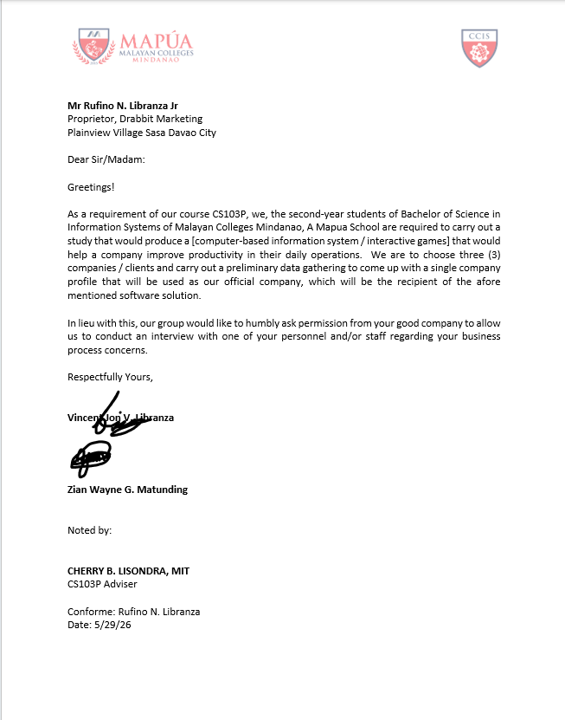
Appendix B
Letter in Conducting an Interview


Appendix C
Problem Statement and Factors

Statement of the Problem

General Problem
Business operations at Drabbit Marketing are commonly managed through fragmented and manual processes, resulting in inefficient order processing, inventory inaccuracies, and delayed customer service for both staff and management.

Factor 1: | Reliance on manual recording of orders, inventory, and customer transactions using paper-based methods.
Factor 2: | Absence of a centralized platform for managing sales, inventory, and customer records.
Factor 3: | Lack of real-time monitoring and reporting of business performance and inventory levels.
.
Specific Problem 1
Management and staff experience difficulty in tracking orders and maintaining accurate inventory records due to manual processes.

Factor 1: | Order information is recorded manually across separate logbooks and paper forms.
Factor 2: | Inventory levels are not updated in real time, leading to stock discrepancies.
Factor 3: | Staff must manually verify order and stock information by checking physical records.

Specific Problem 2
Inventory discrepancies and stock-out situations occur due to the lack of an integrated inventory management system.

Factor 1: | Inventory counts are manually maintained by staff without automated updates.
Factor 2: | Stock deductions after order fulfillment are not automatically recorded.
Factor 3: | Low-stock alerts are not generated, resulting in undetected shortages until a stockout occurs.
.
Specific Problem 3
Manual invoice generation and sales reporting delays the billing process and limits management’s ability to make data-driven decisions.

Factor 1: | Invoices are manually prepared by staff, increasing the risk of errors and delays.
Factor 2 | Sales data is not consolidated into readily available reports for management review.
Factor 3: | Business decisions depend on manually compiled summaries, resulting in delays and possible inaccuracies.

Appendix D
Problem Statement Approval

Date: 6/9/26

The Drabbit Marketing Information System is now undergoing its primary testing phase. As part of the process, the developers seek to validate whether the proposed system effectively addresses the identified problems in business operations and management at Drabbit Marketing. As our client, we would like to conduct this testing with you to verify if the system has achieved the desired solutions to these problems.

Below is the PSA matrix that will serve as evidence that the system has been evaluated and approved. We appreciate your cooperation.

Problem Statement Approval Matrix

Problem | Solution | Remarks | Status
Difficulty in tracking customer orders and maintaining accurate inventory records due to manual processes. | The Drabbit Marketing Information System provides a centralized platform where staff can record orders, monitor inventory levels, and manage customer records in real time. | Verified during user testing. | Approved
Inventory discrepancies and stock-out situations caused by the absence of automated inventory management. | The system automatically deducts stock quantities upon order fulfillment and generates low-stock alerts to prevent shortages. | Verified through inventory tests. | Approved
Delays in invoice generation and limited access to sales reports due to manual preparation processes. | The system automates invoice generation from confirmed orders and provides a sales dashboard with exportable reports for management review. | Verified through invoice and reporting tests. | Approved

Approved by:
Rufino N. Libranza JR
Owner, Drabbit Marketing

Date Approved: 6/13/26

Appendix E
Letter in Conducting System Testing
Appendix F
User Acceptance Testing Results
Appendix G
Minutes of the Trainings
Appendix H
Letter of Project Acceptance

Appendix I
Certificate

Appendix J
Photos
CURRICULUM VITAE
Name: Vincent Jon V. Libranza
Address: Plainview Village Sasa Davao City
Mobile: 09617617843
Email Address: vjLibranza@mcm.edu.ph

2024 - Present
Bachelor of Science in Information Systems
Mapúa Malayan College of Mindanao
McArthur Highway, Matina, Davao City
Eligibility & Certifications
2025 - NONE
2026 - AWS Cloud Training Badge Completionist

Name: Zian Wayne G. MATUNDING
Address: Deca Homes Cabantian, Davao City
Mobile: 09568407963
Email Address: zwMatunding@mcm.edu.ph

2024 - Present
Bachelor of Science in Information Systems
Mapúa Malayan College of Mindanao
McArthur Highway, Matina, Davao City
Eligibility & Certifications
2025 - IT - Specialist Java
2026 - AWS Cloud Training Badge Completionist

