1. 设置gcc

https://blog.csdn.net/davidhopper/article/details/79121346?utm_medium=distribute.pc_relevant.none-task-blog-BlogCommendFromMachineLearnPai2-2.channel_param&depth_1-utm_source=distribute.pc_relevant.none-task-blog-BlogCommendFromMachineLearnPai2-2.channel_param

(2)

‘cd /D d:\code\boost_1_66_0

bootstrap gcc

b2 -j8 --build-dir=.\tmp --build-type=complete threading=multi link=shared address-model=64 toolset=gcc stage （或者b2）

（3）

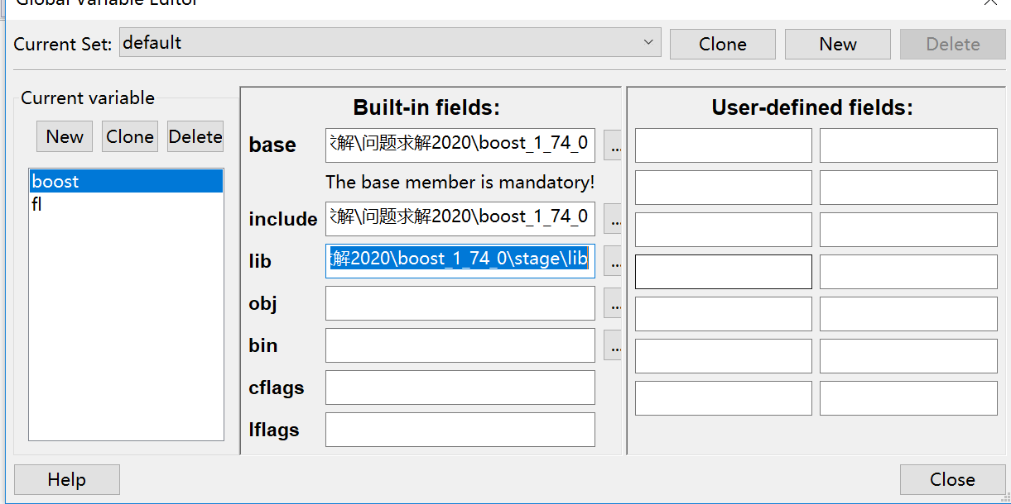

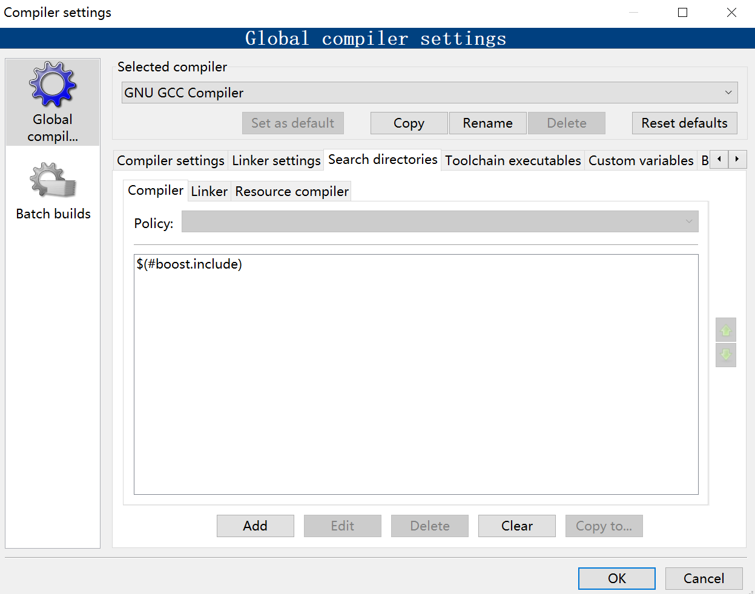

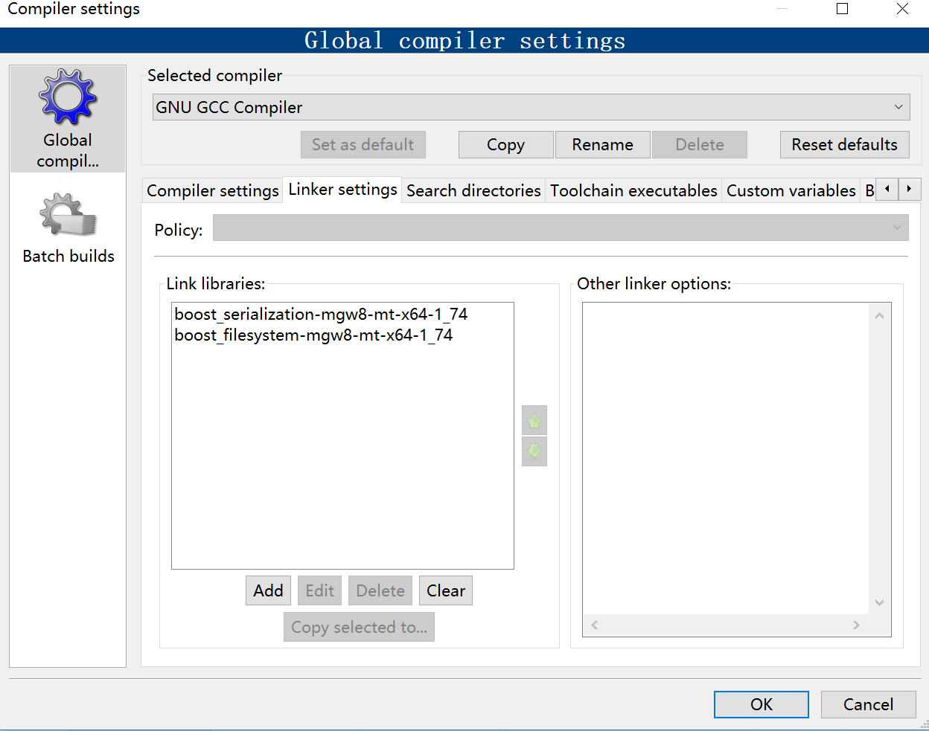

#include <boost/filesystem.hpp >

#include <iostream>

namespace fs= boost :: filesystem ;

int main (){

fs :: path myPath ("C:/ Boost / Serialization ");

bool pathExists =fs :: exists ( myPath );

std :: cout << pathExists << std :: endl ;

fs :: path newPath = myPath / " test . txt ";

pathExists =fs :: exists ( newPath );

std :: cout << pathExists << std :: endl ;

fs :: path myPathCreated = myPath /" TestFolder ";

fs :: create_directory ( myPathCreated );

pathExists =fs :: exists ( myPathCreated );

std :: cout << pathExists << std :: endl ;

}

https://www.jianshu.com/p/307c3561a6e4