**Access Control List (ACLs)**

Student’s Name

Professor Name

University Affiliation

Course Number

Date

**Access Control List (ACLs)**

**Introduction**

Access Control Lists (ACLs) are a fundamental component of network security that help regulate and manage network traffic by providing granular control over the flow of data. ACLs allow network administrators to define rules and policies that determine which packets are allowed or denied access to network resources based on specific criteria. This report aims to explore the concept of ACLs, including their different types, advantages, disadvantages, placement within the traffic flow, and the overall impact they have on controlling network traffic.

In today's digital landscape, where cybersecurity threats continue to evolve and pose significant risks to organizations, implementing effective access control mechanisms is crucial. ACLs play a vital role in protecting networks from unauthorized access, data breaches, and other malicious activities. By filtering and controlling traffic, ACLs enable organizations to enforce security policies, restrict access to sensitive resources, and prevent unauthorized communication between network segments.

This report will delve into the two main types of ACLs: standard and extended IP ACLs. It will discuss their respective purposes and explore the advantages and disadvantages of each type. Additionally, the report will examine where ACLs are typically placed within the traffic flow, considering the ingress, egress, and transit points. By understanding these aspects, network administrators can design and implement ACLs in a manner that aligns with their organization's security requirements.

Moreover, this report will provide insights into the overall effect of ACL control on network traffic. It will highlight the benefits of using ACLs to enhance network security and enforce access control policies. However, it is essential to recognize the potential challenges associated with ACL configuration, management, and potential unintended consequences.

By the end of this report, readers will have a comprehensive understanding of ACLs, enabling them to make informed decisions when it comes to implementing and managing access control mechanisms in their network infrastructure.

**Standard and Extended IP ACLs**

Standard and Extended IP Access Control Lists (ACLs) are two types of ACLs used to control and manage network traffic based on specific criteria. Each type has its own characteristics and is designed for different purposes as discussed below.

***2.1 Standard IP ACLs***

Standard IP ACLs are used to filter traffic based on source IP addresses. They allow or deny packets based on the source IP address alone as illustrated in figure 3. Standard ACLs are numbered from 1 to 99 and 1300 to 1999. They are commonly used for basic traffic filtering and access control at the network perimeter in addition.

* The Standard IP ACLs are the basic type of ACLs and operate at the network layer (Layer 3) of the OSI model as illustrated in figure 5.
* They are primarily used for filtering traffic based on source IP addresses.
* Standard IP ACLs are identified by numbers ranging from 1 to 99 and 1300 to 1999 (Liu et al, 2011).
* They can only evaluate the source IP address of packets.
* Standard IP ACLs have a simple syntax that consists of the ACL number and the permit or deny statement as illustrated in figure 4.

*Example:*

1. access-list 10 permit 192.168.1.0 0.0.0.255
2. access-list 20 deny any

***2.2 Extended IP ACLs***

Extended IP ACLs provide more granular control over network traffic by filtering packets based on multiple parameters, such as source and destination IP addresses, protocols, port numbers, and other packet attributes. Extended ACLs are numbered from 100 to 199 and 2000 to 2699. They offer more flexibility and are typically used for advanced traffic filtering within the network.

* The Extended IP ACLs provide more advanced and granular traffic filtering capabilities than standard ACLs.
* They operate at both the network layer (Layer 3) and transport layer (Layer 4) of the OSI model.
* Extended IP ACLs can filter traffic based on various criteria, including source and destination IP addresses, protocols, source and destination ports, and other TCP/IP header fields (Smetters & Good, 2009).
* They are identified by numbers ranging from 100 to 199 and 2000 to 2699.
* Extended IP ACLs offer greater flexibility in defining access control rules and allow for more fine-grained control over network traffic.

*Example:*

1. *access-list 101 permit tcp any host 192.168.1.10 eq 80*
2. *access-list 102 deny icmp any any*

**Advantages and Disadvantages of Each Type**

***3.1 Standard IP ACLs***

*Advantages:*

1. Simple to configure and implement
2. Low processing overhead on routers
3. Useful for basic traffic filtering

*Disadvantages:*

1. Lack of granularity in controlling traffic
2. Limited to filtering based on source IP addresses only
3. Difficult to manage in large and complex networks

***3.2 Extended IP ACLs***

*Advantages:*

1. Provides granular control over network traffic
2. Offers flexibility to filter traffic based on various parameters
3. Enables more complex traffic filtering and access control policies

*Disadvantages:*

1. Increased configuration complexity
2. Higher processing overhead on routers
3. Prone to misconfiguration, leading to unintended consequences

**Placement of ACLs in Traffic Flow**

ACLs can be placed at different points in the network traffic flow, depending on the specific security requirements and network architecture. Common placement options include:

1. *Ingress ACLs:* Applied on incoming traffic at the network edge or interface, before the traffic enters the network. This helps filter traffic at the point of entry, preventing unauthorized access.
2. *Egress ACLs:* Applied on outgoing traffic at the network edge or interface, before the traffic leaves the network. Egress ACLs help enforce security policies, restrict outbound traffic, and prevent data leakage.
3. *Transit ACLs:* Applied on traffic passing through intermediate network devices, such as routers or switches. Transit ACLs can be used to filter and control traffic between different network segments or enforce security policies within the network.

**Overall Effect of ACL Control on Traffic**

ACLs play a crucial role in enhancing network security and controlling traffic flow. By selectively allowing or denying access to network resources, ACLs help mitigate security risks, prevent unauthorized access, and enforce security policies. Effective ACL control ensures that only authorized traffic is permitted, reducing the potential for malicious activities, network congestion, and resource abuse. However, improper configuration or mismanagement of ACLs can lead to unintended consequences, such as blocking legitimate traffic or creating network bottlenecks.

In terms of placement within the traffic flow, both standard and extended IP ACLs can be applied at various points in a network, such as on routers or firewalls. The placement depends on the desired access control requirements and the network architecture (Stiegler,1979).

In sum, standard and extended IP ACLs are valuable tools for network administrators to enforce access control policies, filter traffic, and enhance network security. The selection of the appropriate ACL type depends on the specific filtering requirements and the level of control needed over the network traffic.

**Conclusion**

In conclusion, Access Control Lists (ACLs) are an integral part of network security. Standard and Extended IP ACLs provide different levels of granularity and control over network traffic. They can be strategically placed at various points in the network traffic flow to enforce security policies and regulate access to network resources. While ACLs offer significant benefits in terms of network security, their configuration and management require careful planning and consideration to ensure proper functionality and avoid unintended consequences.

**Appendix**

***Ilustrations***

1. *Figure 1 ACL*

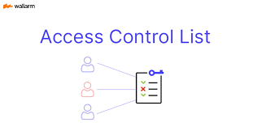

1. *Figure 2 ACL*

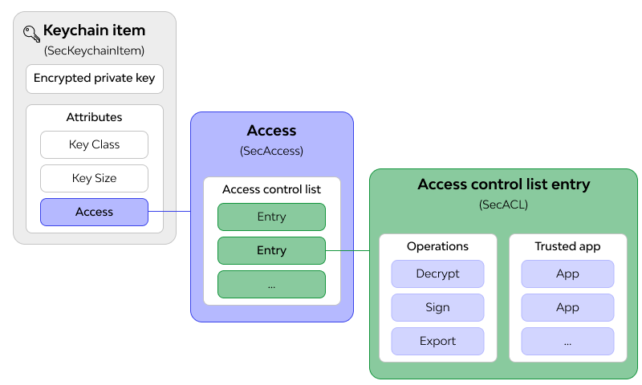

1. *Figure 3 ACL*

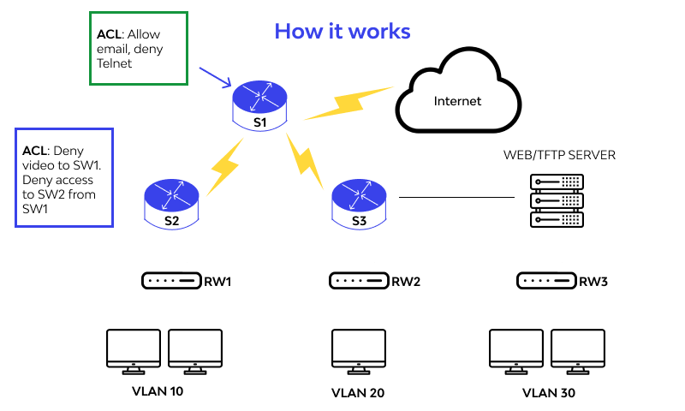

1. *Figure 4 ACL*

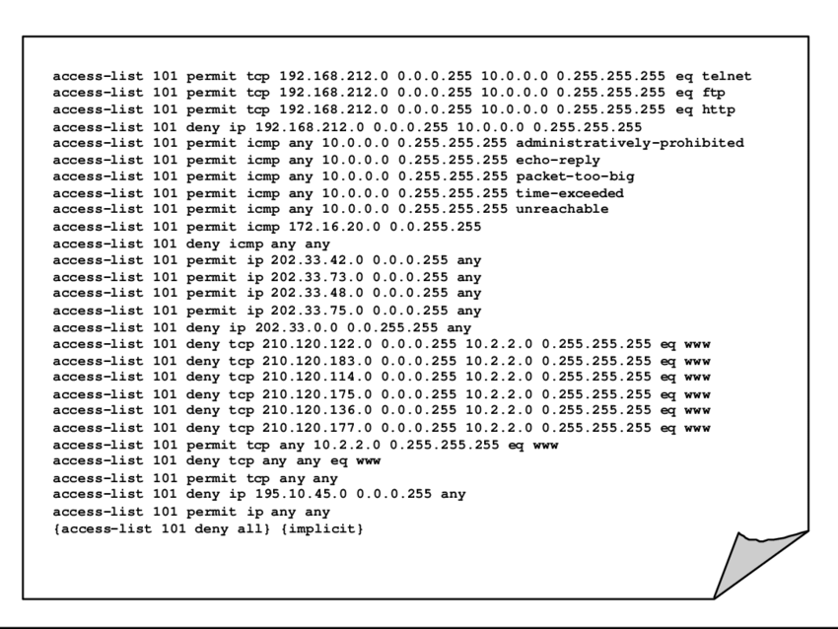

1. *Figure 5 ACL*

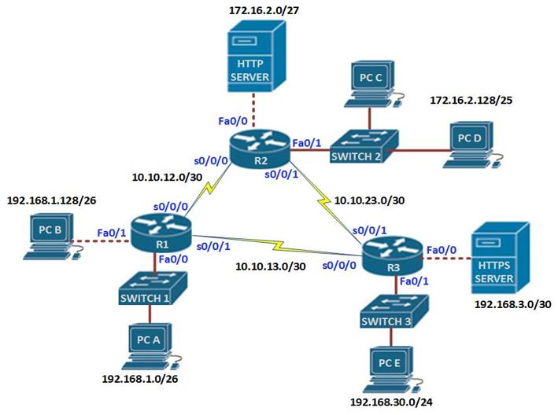

**References**

Liu, A. X., Torng, E., & Meiners, C. R. (2011). Compressing network access control lists. *IEEE Transactions on Parallel and Distributed Systems*, *22*(12), 1969-1977.

Stiegler, H. G. (1979). A structure for access control lists. *Software: Practice and Experience*, *9*(10), 813-819.

Qian, J., Hinrichs, S., & Nahrstedt, K. (2001). ACLA: A framework for access control list (ACL) analysis and optimization. In *Communications and Multimedia Security Issues of the New Century: IFIP TC6/TC11 Fifth Joint Working Conference on Communications and Multimedia Security (CMS’01) May 21–22, 2001, Darmstadt, Germany* (pp. 197-211). Springer US.

Hu, V. C., Ferraiolo, D., & Kuhn, D. R. (2006). *Assessment of access control systems*. Gaithersburg, MD, USA: US Department of Commerce, National Institute of Standards and Technology.

Sandhu, R. S., & Samarati, P. (1994). Access control: principle and practice. *IEEE communications magazine*, *32*(9), 40-48.

Smetters, D. K., & Good, N. (2009, July). How users use access control. In *Proceedings of the 5th Symposium on Usable Privacy and Security* (pp. 1-12).