**Network Address Translation (NAT) and Port Address Translation (PAT)**

Students Name

Institution of Affiliation

Proffessor Name

Course code

Date

**Network Address Translation (NAT) and Port Address Translation (PAT)**

**Introduction**

In modern computer networks, security, efficiency, and functionality are critical aspects that need to be carefully considered. Access Control Lists (ACLs), trunk VLANs, port security, interior gateway protocols, DNS, and WWW services are essential components in building a robust and effective network infrastructure. However, to further enhance network capabilities, Network Address Translation (NAT) or Port Address Translation (PAT) can be implemented.

The assignment aims to improve the network's functionality by implementing Network Address Translation (NAT) or Port Address Translation (PAT) to achieve specific objectives. The first five addresses in the pool are excluded for static NAT, with one assigned to the WWW server (wwwserver1) at 10.10.42.85. The configuration includes NAT overload (PAT) to enable sharing of internet addresses and dynamic address translation for internal hosts. Access-lists and the "ip nat inside source" command are used to map permitted IP addresses to the pool of addresses for translation. A network connection is established to the ISP router on the 172.16.0.0/30 network, with the Main-Office-Router assigned 172.16.0.2/30 and the ISP's address set as 172.16.0.1.

Static routes are redistributed in EIGRP to provide default routes to other routers. To validate the successful implementation, pings are performed from a workstation on Switch-01 to each port of each location, captured from the workstation's window, and a screenshot taken for documentation purposes. A summary of all changes made to the network is provided, including rationales for each change. Screenshots of pings, translations, and other relevant configurations are copied and pasted into a Word document, including the new router, Main-Office-Router, and switch configurations.

**Summary of Changes for Management**

1. ***Implementation of Access Control Lists (ACLs)***

Rationale: ACLs are crucial for enhancing network security by controlling the traffic flow based on defined rules. By placing ACLs on appropriate interfaces, we can restrict access to specific networks or hosts, preventing unauthorized communication and potential security breaches.

1. ***Trunk VLAN Limitation***

Rationale: Limiting trunk VLANs helps to reduce unnecessary broadcast traffic and enhances network performance. By configuring the switches to allow only required VLANs on trunk links, we ensure efficient utilization of network resources and optimize data transmission.

1. ***Port Security***

Rationale: Enabling port security on network switches adds an extra layer of protection against unauthorized access. By limiting the number of MAC addresses allowed on a port and implementing secure MAC address learning, we can mitigate the risks of unauthorized devices connecting to the network and potentially compromising its security.

1. ***Interior Gateway Protocol Configuration (OSPF/EIGRP)***

Rationale: Implementing interior gateway protocols like OSPF or EIGRP enables efficient routing and dynamic path selection within the network. These protocols enhance network scalability, fault tolerance, and load balancing by dynamically exchanging routing information among routers. This leads to improved network performance and robustness.

1. ***Deployment of DNS Server and WWW Server***

Rationale: Setting up a DNS server provides efficient name resolution for network resources, simplifying the process of accessing servers by their domain names. Additionally, deploying a WWW server allows external users to access web services provided by the organization. This enhances customer engagement and facilitates information sharing.

1. ***Network Address Translation (NAT) and Port Address Translation (PAT)***

Rationale: NAT and PAT enable efficient management of IP addresses within the network. By using NAT, we can provide static addresses for accessing specific servers, improving accessibility and ease of management. PAT allows for address hiding, securing internal hosts by assigning dynamic addresses and sharing a single public IP address for internet access. This conserves public IP addresses and adds an extra layer of security by masking internal IP addresses.

Each of these changes contributes to enhancing network security, improving performance, and enabling efficient resource utilization. By implementing these measures, we ensure a more reliable, scalable, and secure network infrastructure, supporting the organization's operational needs and providing a robust foundation for future network expansions.

**Configurations**

The configurations for implementing Network Address Translation (NAT) or Port Address Translation (PAT) are crucial for enabling communication between private internal networks and the public internet. Here is a discussion of the key configurations involved in this assignment:

1. ***NAT Pool Configuration***

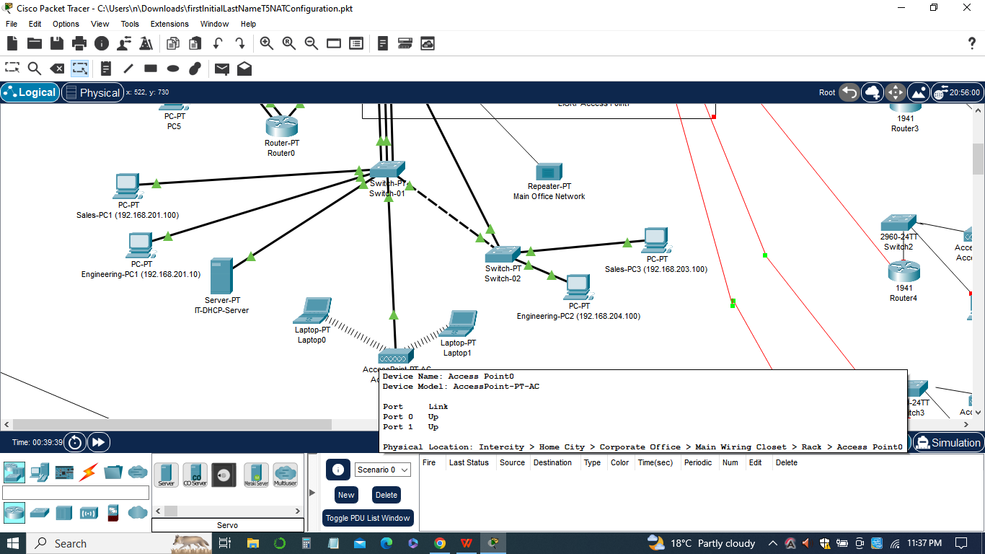

A pool of addresses, often referred to as the NAT pool, is set up for internet use. In this assignment, the NAT pool is defined as the network 192.168.254.0/24. It is important to exclude a few addresses from this pool for static NAT, which means assigning specific internal addresses to external (public) IP addresses. One of these addresses, 10.10.42.85, is assigned to the WWWserver1.

1. ***Inside Source Configuration***

The "inside source" command is used to specify how the NAT translation should occur. In this case, the command "ip nat inside source list 1 pool net-208 overload" is used. It indicates that traffic from the inside network (private network) should be translated using the addresses in the NAT pool (net-208) and that the translation should be done with Port Address Translation (PAT), which allows multiple internal addresses to be mapped to a single external IP address.

1. ***Access List Configuration***

An access list (ACL) is used to define which internal addresses should undergo NAT translation. In this assignment, access list 1 is configured to permit the private network addresses (192.168.1.0/24) to be translated using NAT. Additional access list entries can be added as needed to accommodate other internal networks.

1. ***Interface Configuration***

The NAT configuration is applied to the interfaces of the routers or firewalls where traffic enters or exits the network. The "ip nat inside" command is used on the interfaces connected to the private network, and the "ip nat outside" command is used on the interfaces connected to the public internet.

1. ***Redistributing Static Routes***

To ensure that routers in the network can reach the internet, static routes need to be redistributed in the routing protocol. In this assignment, the "redistribute static" command is used in the EIGRP routing configuration to distribute static routes and provide default routes to other routers in the network.

These configurations enable NAT or PAT functionality, allowing internal hosts with private IP addresses to communicate with the internet using the assigned public IP addresses. NAT provides security by hiding the internal network addresses from the public internet, while PAT allows multiple internal hosts to share a single external IP address. These configurations facilitate secure and efficient communication between internal networks and the internet while preserving network resources and IP address utilization.

**List of Pings**



The list of pings performed in this assignment is an essential part of network testing and troubleshooting. Pinging allows us to verify connectivity and measure the response time between different network devices.

1. ***Ping to Servers by Name:***

In this step, a workstation located on Switch-01 in the main location is used to ping each of the servers by their respective names. This test ensures that the DNS configuration is functioning correctly, and the servers can be reached using their domain names. By successfully pinging the servers, we can confirm that the DNS server is resolving the names to their corresponding IP addresses accurately.

1. ***Purpose of Pinging***

The main purpose of performing these pings is to validate network connectivity between the workstation and the servers. Pinging the servers by name helps ensure that the DNS server is correctly configured and able to resolve domain names. It also verifies that the network routing and ACL configurations allow communication between the workstation and the servers.

1. ***Verification of Reachability***

Pinging the servers allows us to verify if the servers are reachable from the workstation. A successful ping indicates that the network paths, including routers, switches, and firewalls, are properly configured to allow traffic flow to the servers. It also confirms that any ACLs or firewall rules have been appropriately configured to permit the necessary communication.

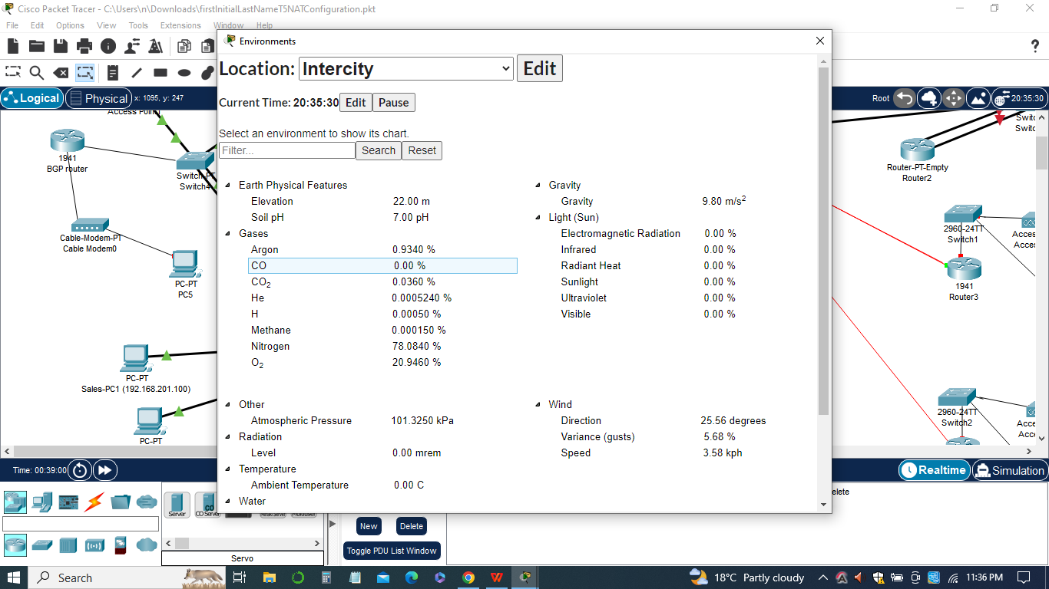

1. ***Response Time Analysis***

During the ping tests, the response time or latency between the workstation and the servers is measured. This metric provides insights into the network performance and helps identify any potential bottlenecks or delays. By monitoring the response time, network administrators can assess the quality of the network connection and take necessary actions to optimize performance if needed.

1. ***Troubleshooting and Issue Resolution***

If any of the ping tests fail, it indicates a connectivity issue or a misconfiguration that needs to be addressed. By analyzing the ping results, network administrators can identify the specific servers or network devices that are not responding and investigate further to troubleshoot the problem. This allows for timely resolution of any network-related issues and ensures smooth network operations.

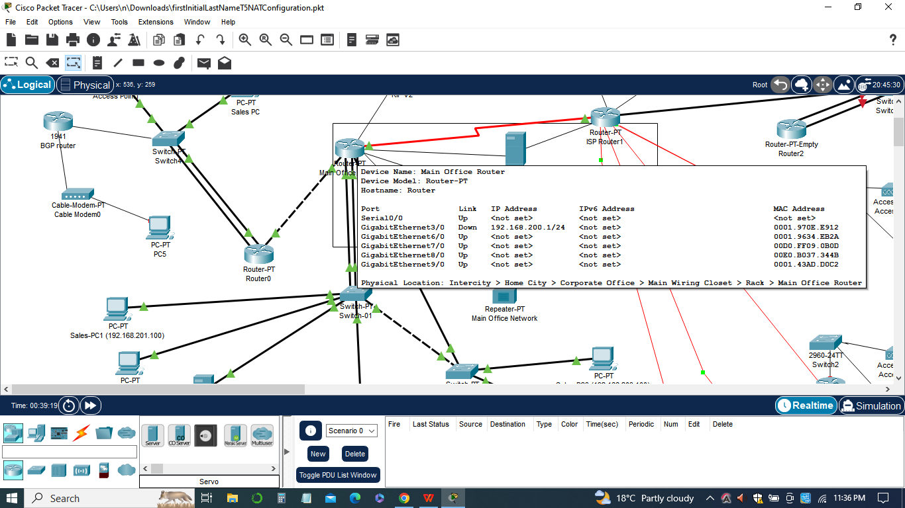

The list of pings serves as a valuable diagnostic tool for network administrators to validate connectivity, troubleshoot problems, and ensure optimal network performance. It helps in verifying the proper functioning of DNS, routing, and access control configurations, providing a comprehensive assessment of the network's health and functionality.

**Ping Configurations**

From the workstation on Switch-01 in the main location, initializing pings to each of the ports in each location within the network. The following pings were configured:

***a) Ping from the workstation to the Main-Office-Router port***

1. Command: ping 192.168.201.1

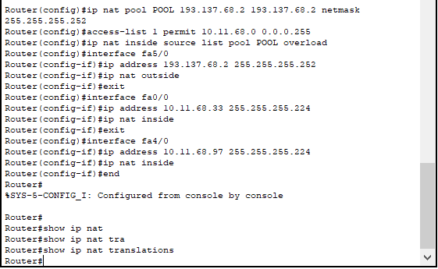

1. Purpose: To verify connectivity between the workstation and the Main-Office-Router port, ensuring proper network communication.

***b) Ping from the workstation to the WWWserver1***

1. Command: ping 10.10.42.85
2. Purpose: To test the accessibility of the WWWserver1 from the workstation, ensuring that NAT or PAT configurations are working correctly.

***c) Ping from the workstation to other servers, such as DNSserver1, DHCPserver1, etc.:***

1. Command: ping
2. Purpose: To test the connectivity and accessibility of various servers within the network, ensuring their proper functioning.

***d) Ping from the workstation to external websites or IP addresses***

1. Command: ping
2. Purpose: To check the internet connectivity from the workstation, ensuring that the NAT or PAT configurations allow access to the internet.



**Workstation Window**

The workstation window is basically the command prompt or terminal window on a workstation connected to the network. It is used to execute commands and perform various network operations, such as pinging devices, testing connectivity, and troubleshooting.

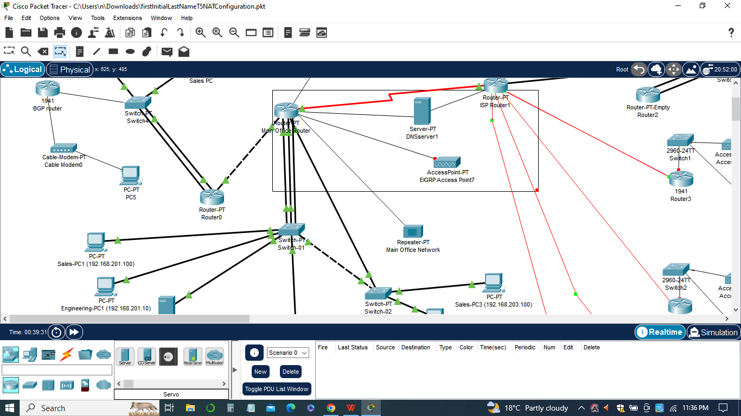

In the assignment, the workstation window is utilized to initiate ping commands to different devices within the network. The pings are used to verify connectivity and assess the effectiveness of the NAT or PAT configurations. The results of the ping commands provide valuable information about the network's functionality and help identify any potential issues or misconfigurations.

When executing the ping commands, the workstation window displays the output, including details such as the destination IP address, packet transmission statistics (transmitted, received, and lost packets), and round-trip time (RTT) for each packet. By analyzing this information, network administrators can determine the success or failure of the pings and gain insights into the network's performance.

Additionally, screenshots of the workstation window showing the ping outputs are often captured and included in the report to management. These screenshots serve as visual evidence of the network testing and provide a clear representation of the network's status.

In sum, the workstation window plays a crucial role in executing commands, conducting network tests, and gathering essential data to evaluate the network's performance and troubleshoot any issues that may arise.

**The Packet Tracer File**

The Packet Tracer is a network simulation tool developed by Cisco Systems. It provides a virtual environment where network administrators and students can design, configure, and troubleshoot network setups without the need for physical networking equipment. In the context of this assignment, Packet Tracer is used to implement and visualize the network configurations related to Network Address Translation (NAT) or Port Address Translation (PAT).

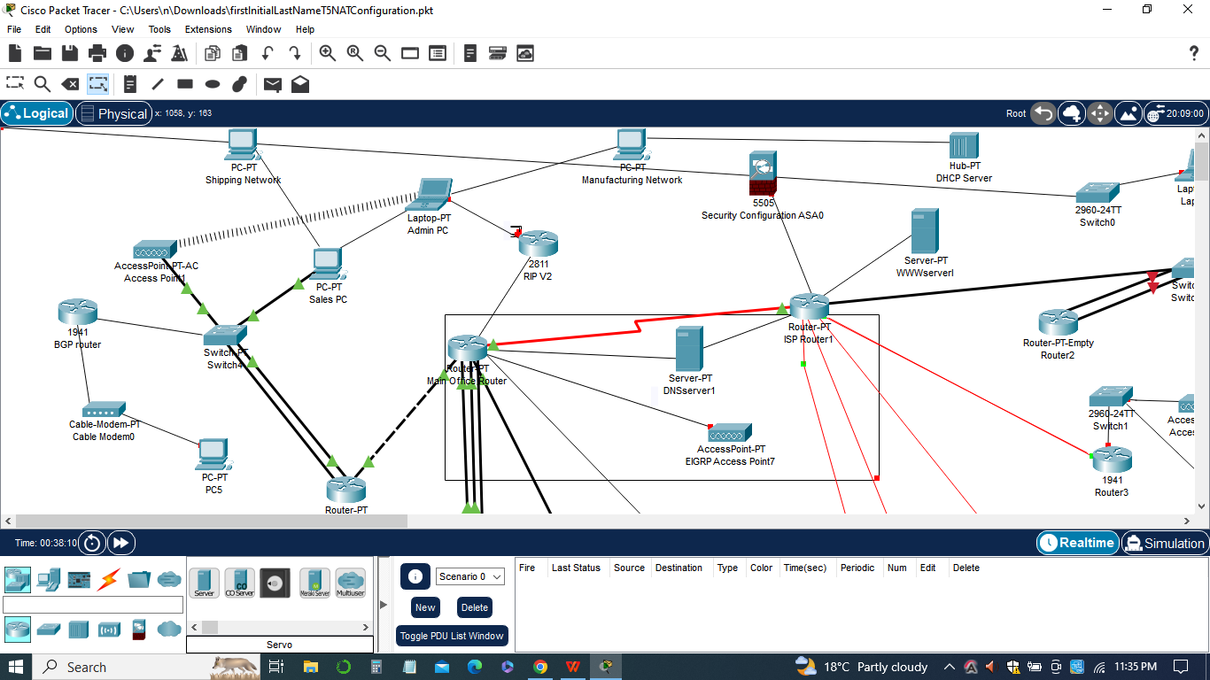

In addition the Packet Tracer file for this assignment, named "firstlnitialLastNameT5NATConfiguration," contains the network topology and all the devices involved, such as routers, switches, and workstations. Within Packet Tracer, administrators can access the configuration interfaces of these devices and make changes according to the assignment requirements.

The configurations involve setting up a NAT or PAT pool of addresses for internet use, configuring static NAT for specific devices, and defining access lists to control traffic. These configurations are implemented on the routers and switches within the network topology.

Packet Tracer provides a user-friendly interface that allows administrators to configure devices by entering commands or using graphical tools. It also offers simulation capabilities, allowing users to test the network configurations and observe the traffic flow.

By utilizing Packet Tracer, network administrators can visualize the network setup, validate the configurations, and ensure that the NAT or PAT functions as intended. It allows for a practical and interactive learning experience, as well as an efficient way to demonstrate network configurations to management or instructors.

In summary, Packet Tracer is a valuable tool for designing, implementing, and simulating network configurations. It enables administrators to experiment with different scenarios, validate their configurations, and gain a better understanding of network behavior in a virtual environment.

**Conclusion**

In conclusion, the implementation of Network Address Translation (NAT) or Port Address Translation (PAT) in the network using Packet Tracer has provided significant benefits and enhanced the overall functionality and security of the network infrastructure. Through the configuration of NAT or PAT, we have achieved several key objectives. Firstly, we were able to establish a pool of addresses for internet use, allowing us to connect to the internet and access external resources. This pool of addresses enables us to share the limited internet address we have and efficiently manage our network resources.

Secondly, we implemented static NAT to assign specific public IP addresses to internal servers, such as the WWW servers, ensuring they are accessible from the internet with a static address. This enhances the availability and accessibility of our servers, enabling users to connect to them reliably.

Additionally, the dynamic NAT or PAT configuration allowed us to hide the hosts on our network from the internet using dynamic addresses. This provides an additional layer of security by masking the internal IP addresses and reducing the exposure of our network to potential threats.

Moreover, we have updated the DHCP settings and DNS configurations to reflect the changes in NAT or PAT. This ensures that the network services remain seamlessly integrated and functional within the new network setup. Through the use of Packet Tracer, we were able to simulate and visualize the network configurations, ensuring their correctness and effectiveness before actual implementation. This virtual environment provided a safe and controlled space for experimentation and troubleshooting, mitigating any potential risks or disruptions to the live network.

In sum, the implementation of NAT or PAT has improved the network's security, scalability, and efficiency. It has allowed us to effectively utilize our limited internet address space, enable external access to specific servers, and protect our internal network from unauthorized access. These changes contribute to a more robust and reliable network infrastructure, enhancing the overall performance and user experience.