**ITT-Management Servers**

Students Name

Institution of Affiliation

Professor’s Name

Course Number and code

Date of Submission

**ITT-Management Servers**

**Introduction**

In today's digital age, network infrastructure plays a critical role in the smooth operation of organizations. As networks become more complex and interconnected, it becomes essential to implement robust solutions for data backup and network management. This ensures data integrity, availability, and effective monitoring of network devices. In this assignment, we will focus on enhancing our network infrastructure by adding servers for data backup and implementing network management using SNMP (Simple Network Management Protocol).

The addition of backup servers will provide a reliable and secure mechanism for storing critical data, while SNMP will enable efficient network monitoring and management. Through the utilization of FTP and TFTP servers, we will establish secure file transfer capabilities for data backup purposes. This will allow authorized users to transfer files from workstations to the FTP server, ensuring data reliability and easy retrieval when needed. Additionally, we will configure SNMP on network devices to enable centralized network management, allowing administrators to monitor device performance, detect issues, and implement proactive measures. The implementation of these solutions will have minimal impact on the physical network infrastructure, as the servers will be seamlessly integrated into the existing network. By enhancing our network infrastructure with data backup servers and SNMP, we will strengthen the overall network reliability, facilitate efficient management, and ensure the continuity of critical operations.

Throughout this assignment, we will follow the designated steps to configure and test the backup servers and SNMP functionality. We will document the changes made and provide a comprehensive summary for management, detailing the rationale behind each change and the benefits it brings to the organization. Let's embark on this assignment to further enhance our network infrastructure and ensure the smooth functioning of our organization's digital operations.

**Summary of network changes for management**

1. ***Addition of Backup Servers:***

*Rationale:*

The addition of FTP and TFTP servers for data backup aims to provide a reliable and secure mechanism for storing critical data.

*Benefits:*

1. Data Integrity: By regularly backing up important data, we ensure that in the event of data loss or system failure, critical information can be easily restored, minimizing disruptions to business operations.
2. Data Availability: Having dedicated backup servers allows for efficient and quick retrieval of data when needed, ensuring business continuity.
3. Disaster Recovery: By implementing backup servers, we strengthen our organization's resilience against unforeseen events or disasters that could impact data integrity.

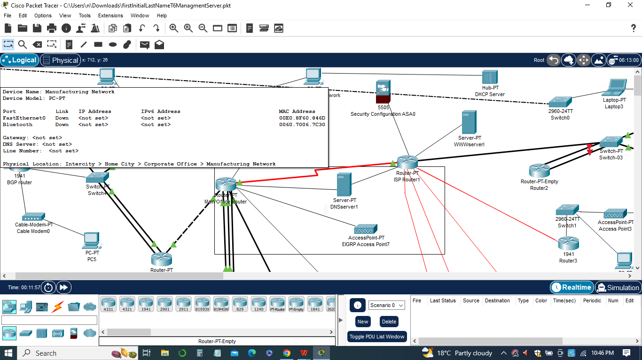

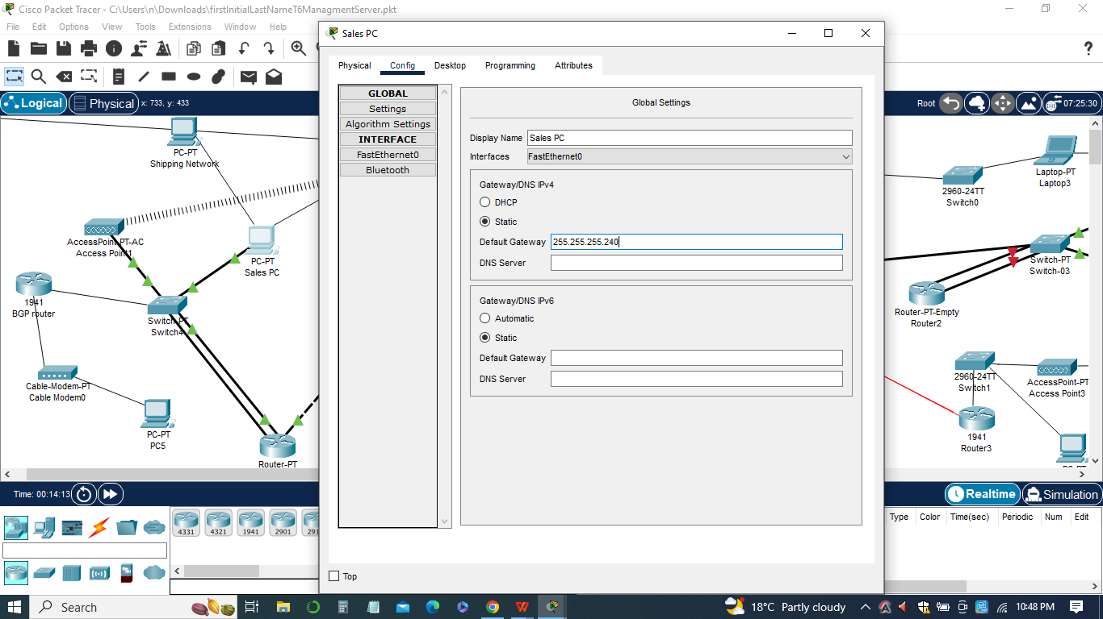

***B)Implementation of SNMP (Simple Network Management Protocol)***

*1)Rationale*

SNMP enables centralized network management and monitoring, providing real-time visibility into network devices' performance and facilitating proactive maintenance.

*Benefits*

1. Efficient Network Monitoring: SNMP allows administrators to monitor network devices, track performance metrics, and detect potential issues or bottlenecks before they escalate, enhancing network reliability.
2. Proactive Maintenance: With SNMP, administrators can receive alerts and notifications about network events, enabling timely response and resolution of issues, minimizing downtime, and improving overall network performance.
3. Resource Optimization: SNMP provides valuable insights into network usage, allowing administrators to optimize resource allocation, identify areas of improvement, and make informed decisions to enhance network efficiency.

The introduction of backup servers ensures data reliability, availability, and disaster recovery capabilities, safeguarding critical information. Additionally, the implementation of SNMP empowers network administrators with centralized monitoring and management, enabling proactive maintenance and optimizing network resources.



These network changes enhance the organization's operational efficiency, reduce risks associated with data loss, and improve overall network performance. By adopting these measures, our organization can ensure data integrity, availability, and proactive network management, leading to a more robust and resilient network infrastructure.

**Configurations**

The following configurations were implemented as part of the network changes:

1. ***Configuration of Switch with Updated IOS***
2. The 2960 switch received an updated IOS version (12.2(25)FX) using TFTP.
3. The switch's VLAN1 interface was assigned an IP address of 10.10.42.62 with a subnet mask of 255.255.255.240.
4. The boot system was set to load the new IOS image from flash.
5. *The first Configuration:*

switch#copy tftp flash

Address or name of remote host? 10.10.42.82

Source filename? c2960-lanbasek9-mz.150-2.SE4.bin

Destination filename? c2960-lanbasek9-mz.150-2.SE4.bin

[OK - #]

switch(config)#boot system flash:c2960-lanbasek9-mz.150-2.SE4.bin



1. ***Configuration of FTP Server***
2. FTP server (10.10.42.83) was set up with the credentials: ID=cisco, Password=cisco.
3. A file was transferred from the Admin workstation to the FTP server using the provided credentials.

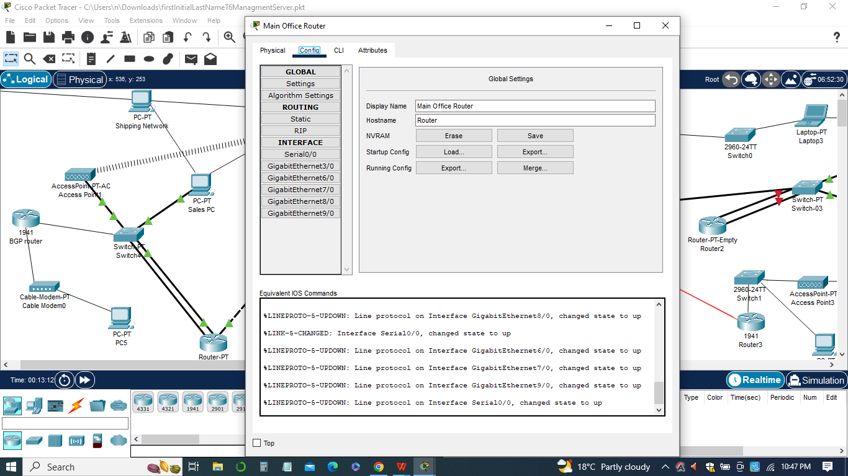

*The Second Configuration of FTP Server*

*ftp-server(config)#username cisco password cisco*

*ftp-server(config)#exit*

*Admin-PC1#copy startup-config ftp:*

*Address or name of remote host? 10.10.42.83*

*Destination filename [startup-config]? myfile.txt*

1. ***SNMP Configuration on Main-Office-Router***
2. SNMP was configured on the Main-Office-Router to enable network management and monitoring.
3. SNMP community strings were set to allow access and define read/write permissions.
4. SNMP traps were configured to send notifications to the specified SNMP management station.

*Third Configuration on Main-Office-Router*

*Main-Office-Router(config)#snmp-server community public RO*

*Main-Office-Router(config)#snmp-server community private RW*

*Main-Office-Router(config)#snmp-server host 10.10.42.85 version 2c public*

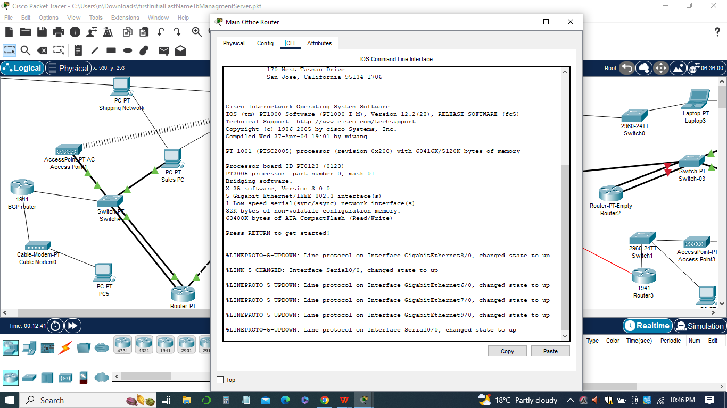

These configurations enable the updated switch to operate with the new IOS version, facilitate file transfer to the FTP server, and enable SNMP monitoring and management on the Main-Office-Router. The configurations ensure seamless data backup and network management capabilities within the organization.

**FTP file list and the successful IOS update**

We added both FTP (File Transfer Protocol) and TFTP (Trivial File Transfer Protocol) servers for data backup purposes. The FTP server, located at 10.10.42.83, allows authorized users to transfer files from the Admin workstation. By using the provided credentials (id=cisco, password=cisco), files can be securely uploaded to the FTP server for backup and storage. The TFTP server, located at 10.10.42.82, facilitates the updating of the IOS on the newly added switch. The IOS update is performed using the TFTP protocol, ensuring a smooth and secure transfer of the new IOS image.

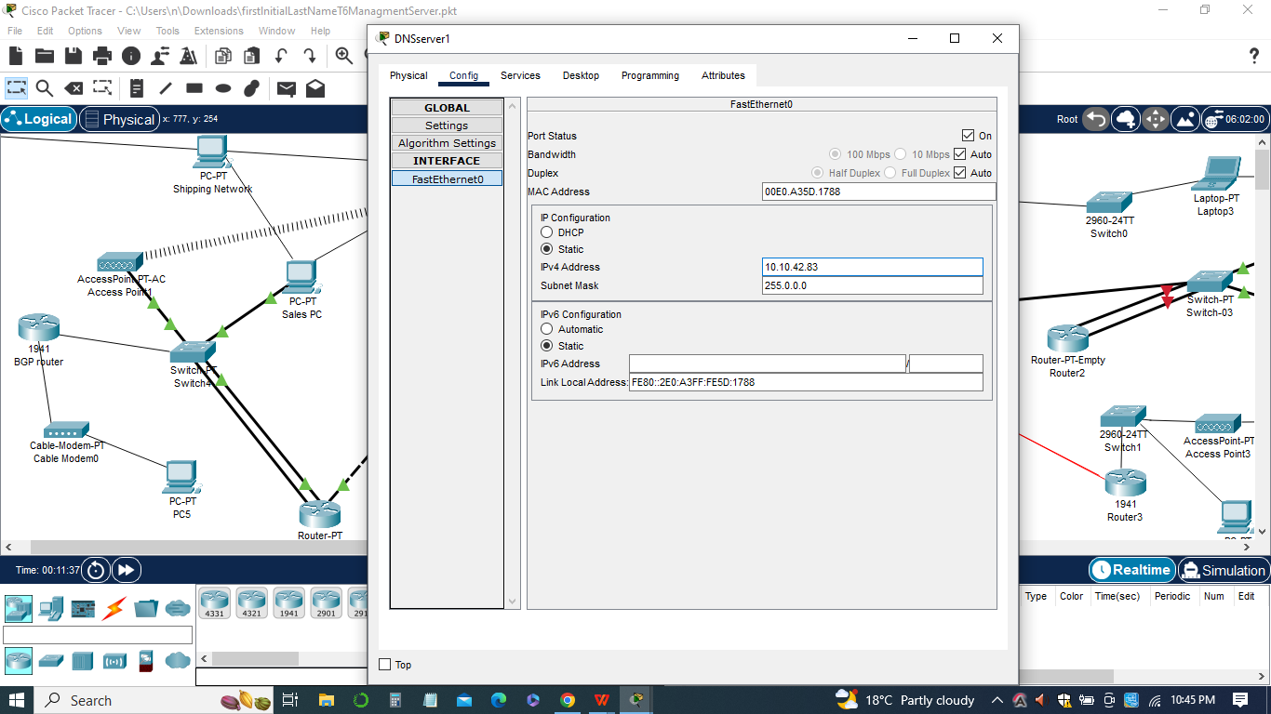

**Output from the MIB Browser**

SNMP has been implemented on the Main-Office-Router to enable network management and monitoring. SNMP provides a standardized method for collecting and managing network information, such as device status, performance metrics, and event notifications.

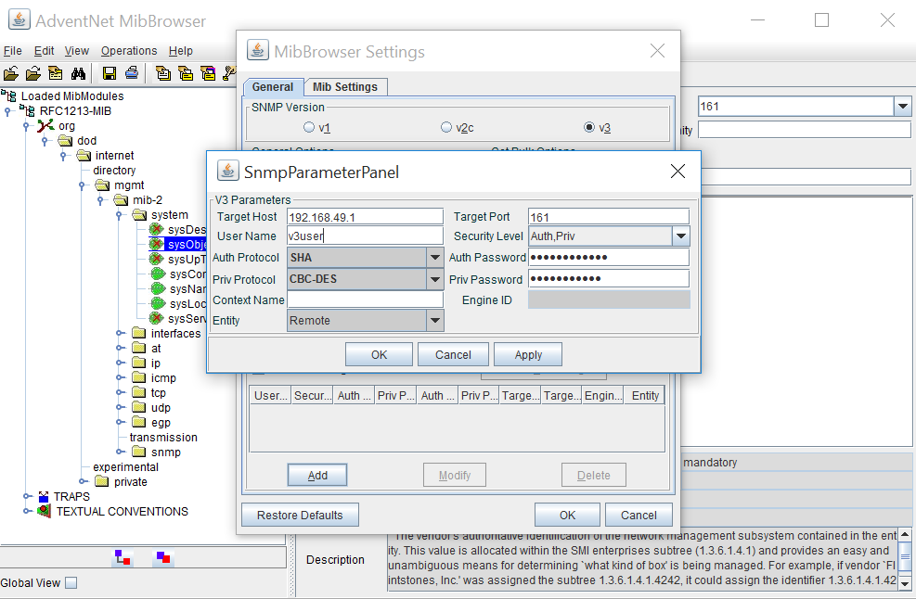

The configuration of SNMP allows the network administrator to remotely access and monitor the Main-Office-Router using SNMP management tools. The functionality of SNMP was verified by testing it from the Admin-PC1 workstation using an SNMP MIB (Management Information Base) browser.

**Conclusion**

In conclusion, the network underwent several significant changes to enhance its functionality, security, and management capabilities. The implemented changes include the addition of backup servers, such as FTP and TFTP, and the integration of network management through SNMP.The addition of FTP and TFTP servers enables the organization to securely backup and transfer data within the network. The FTP server allows for easy file transfer from workstations to the server, providing a reliable data storage solution. Meanwhile, the TFTP server facilitates the updating of the switch's IOS version, ensuring that it operates with the latest features and security patches.

The implementation of SNMP provides efficient network management capabilities. SNMP allows for monitoring and managing network devices, collecting vital information about their performance and status. With SNMP traps configured, the organization receives real-time notifications of critical events or issues, enabling prompt actions and ensuring network availability. In sum, the network changes involving backup servers and SNMP integration enhance data backup, network management, and monitoring capabilities, further strengthening the organization's network infrastructure.