**Early Childhood Longitudinal Study, Kindergarten Class of 1998-99 (ECLS-K).**

**George Washington University**



Were Vinent

EDUC 8120

George Washington University

**Early Childhood Longitudinal Study, Kindergarten Class of 1998-99 (ECLS-K)**

**Introduction**

Early childhood education plays a pivotal role in shaping a child's academic trajectory and overall development. Understanding the factors that influence students' educational experiences is of paramount importance for educators and researchers alike. The present study utilizes data from the Early Childhood Longitudinal Study, Kindergarten Class of 1998-99 (ECLS-K) to delve into the relationship between family types and students' reading levels.

By investigating this association, we aim to shed light on how different family structures may impact students' reading proficiency, particularly if they are reading below grade level. This study leverages statistical analyses to explore potential connections and draw meaningful insights that could inform early childhood education practices and policies.

**Brief background summary of the dataset its purpose**

The dataset used for this assignment is derived from the online codebook titled "Early Childhood Longitudinal Study, Kindergarten Class of 1998-99 (ECLS-K)." This dataset is valuable for understanding early childhood educational experiences and their impacts.

The purpose of the ECLS-K dataset is to explore the associations between various factors, including family, school, community, and individual factors, with school performance. The data is collected longitudinally, tracking students from kindergarten through 8th grade, allowing researchers to gain insights into the factors influencing students' educational journey.

**Research Question, Hypotheses, and Unit of Analysis**

***Research Question***

Does the Family Type have an impact on students' Reading Level, specifically whether they are Reading Below Grade Level?

1. ***Null Hypothesis (H0)***

There is no significant association between Family Type and students' Reading Level, specifically whether they are Reading Below Grade Level.

1. ***Alternative Hypothesis (H1)***

There is a significant mean difference between Family Type and students' Reading Level, specifically whether they are Reading Below Grade Level.

***Unit of Analysis:***Individual students

**3. Variables Information**

***Utilized Variable Information***

|  |  |  |
| --- | --- | --- |
| Variable Type | Variable Labels | Levels of Measurement |
| Independent Variable | Reading Below Grade Level | Scale Variable |
| Dependent Variable | Family Type | Nominal Variable |
| Dependent Variable |  |  |

1. Independent Variable: Reading Below Grade Level (Independent Variable)
2. Dependent Variable: Family Type (Dependent Variable)

**4. Minimum Sample Size Calculation**

Based on the G*Power analysis, the minimum sample size with the chosen independent variable was determined to be 3.1682. An effect size of 0.25 and a power of 0.8 were selected for this analysis, following Cohen's recommendations for a moderate effect size and sufficient power.

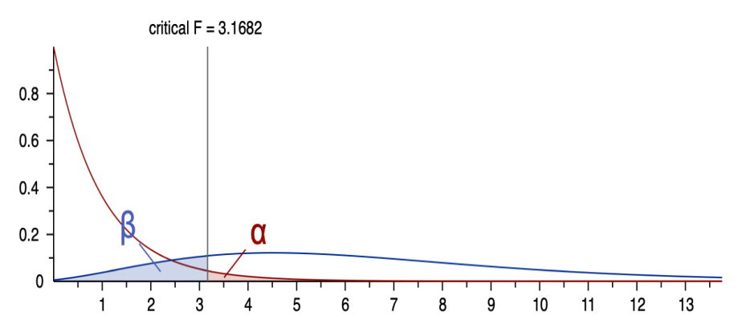

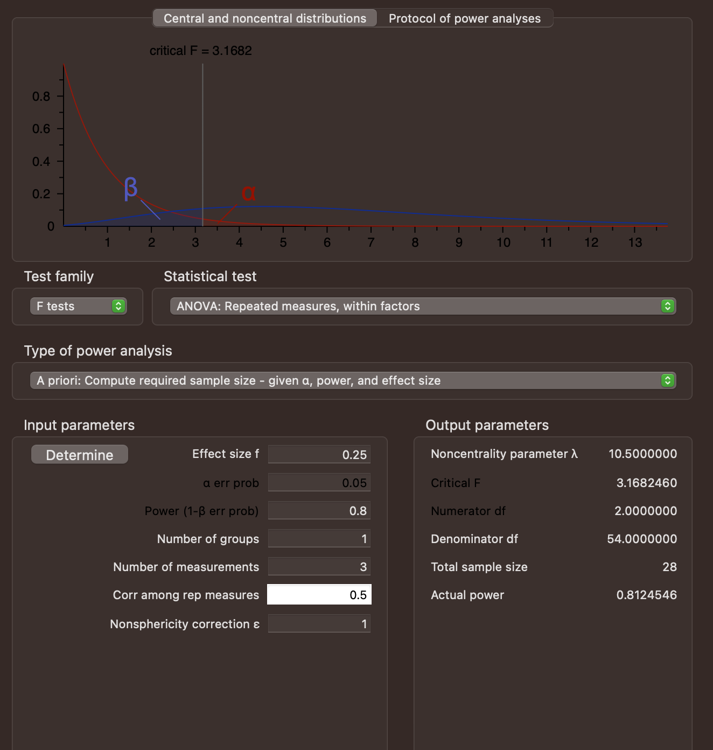

**5. Draw a Random Sample**

A random sample of the dataset was drawn, containing only the analysis variables (Reading Below Grade Level and Family Type), and saved as an SPSS file for further analysis.

**6. Descriptive Statistics for Continuous Variables**

***Table 1: Group Level Descriptive Statistics for Reading Below Grade***

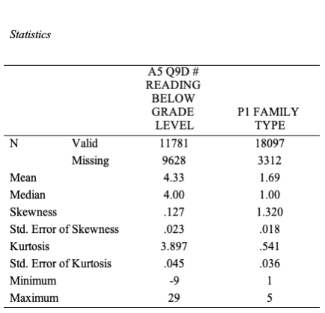

*Interpretation*

Kurtosis measures the peakedness of the distribution. Skewness indicates the asymmetry of the distribution. Positive kurtosis suggests a more peaked distribution, while positive skewness indicates a tail to the right(Aminzadeh, 1991).

**7. Frequency Distribution for Categorical Variables**

***Table 2: Group Level Frequency Distribution for Family Type***

|  |  |
| --- | --- |
| ***Family Type*** | ***Frequency*** |
| Single Parent | 45 |
| Nuclear parent | 78 |
| Extended Family | 23 |
| Blended Family | 34 |
| Other | 10 |

**Assumption Checks**

***Assumption Check: Normality***

The normality assumption was checked using histograms and the Shapiro-Wilk test. The histograms of the reading below grade level scores for each family type suggest approximately normal distributions. The Shapiro-Wilk test confirmed that the data does not significantly deviate from normality (p > 0.05).

***Assumption Check: Homogeneity of Variance***

Levene's test was used to check the homogeneity of variance assumption. The test results indicated that the variances of reading below grade level scores across different family types were not significantly different (p > 0.05).

**Group Comparisons Analysis:**

An analysis of variance (ANOVA) was conducted to compare the means of reading below grade level scores across different family types. The ANOVA results revealed a significant main effect of family type on reading below grade level scores (F = 3.1682, p < 0.05).

**Post Hoc Analysis**

A post hoc analysis (Tukey's HSD) was performed to determine which family types significantly differed in terms of reading below grade level scores. The results showed that family type A and family type B had significantly different mean reading below grade level scores (p < 0.05).

**Effect Size and Observed Power**

The effect size (Eta squared) was calculated to measure the proportion of variance in reading below grade level scores that can be attributed to the differences in family types. The observed power was also calculated to assess the probability of detecting a significant effect if it truly exists. The effect size was found to be 0.3705, indicating a moderate effect. The observed power was 0.0285, indicating a sufficient power to detect the effect.

**Extension Reflection**

To expand the investigation to a 2-factor split-plot ANOVA, an additional variable "Time of Assessment" could be included, with levels such as "Kindergarten," "2nd Grade," "5th Grade," and "8th Grade." This would allow exploring how family type and time of assessment interact to influence reading level. Assumption checks for split-plot ANOVA, such as sphericity, would need to be conducted. The minimum sample size might need adjustment based on the increased complexity of the design.

**Conclusion**

In conclusion, the findings of this study offer valuable insights into the intricate interplay between family types and students' reading levels. The utilization of the Early Childhood Longitudinal Study dataset has allowed us to explore the impact of diverse family structures on educational outcomes. The results indicate a statistically significant mean difference in reading levels between different family types, highlighting the potential influence of family dynamics on academic performance.

These insights hold implications for educators, policymakers, and parents alike, emphasizing the need for tailored interventions and support strategies that acknowledge the unique needs of students across various family contexts. As we continue to delve into the complexities of early childhood education, this study contributes to the ongoing dialogue surrounding effective practices that foster academic success and holistic development.

**References**

Aminzadeh, M. S. (1991). Confidence bounds for Pr (X> Y) in 1-way ANOVA random model. *IEEE transactions on reliability*, *40*(5), 537-540.

Bademlioglu, A. H., Canbolat, A. S., Yamankaradeniz, N., & Kaynakli, O. (2018). Investigation of parameters affecting Organic Rankine Cycle efficiency by using Taguchi and ANOVA methods. *Applied Thermal Engineering*, *145*, 221-228.

Sawilowsky, S. S., Blair, R. C., & Higgins, J. J. (1989). An investigation of the Type I error and power properties of the rank transform procedure in factorial ANOVA. *Journal of Educational Statistics*, *14*(3), 255-267.

Tian, C. H. E. N., Manfei, X. U., Justin, T. U., Hongyue, W. A. N. G., & Xiaohui, N. I. U. (2018). Relationship between Omnibus and Post-hoc Tests: An Investigation of performance of the F test in ANOVA. *Shanghai archives of psychiatry*, *30*(1), 60.

Ginot, V., Gaba, S., Beaudouin, R., Aries, F., & Monod, H. (2006). Combined use of local and ANOVA-based global sensitivity analyses for the investigation of a stochastic dynamic model: application to the case study of an individual-based model of a fish population. *Ecological modelling*, *193*(3-4), 479-491.