Stolen Vehicle Searching System
Design document.

Technologies used
- C++
- WebtoolKit
- Casablanca C++ REST SDK.
- MongoDB Cloud
As per as request of assignment. We need to build a high performance services. So, all components from front-end to backend is written in C++.
CPP REST and Webtoolkit is also a light web server and they works independency (self-host application).

Architecture
Webtoolkit
Cpp REST
MongoDB C++ driver
Web Application
Web Service
Vehicle Data Access
Vehicle Objects
Service Engine
Stolen Vehicle Searching System component

Diagram

    - Class Diagrams
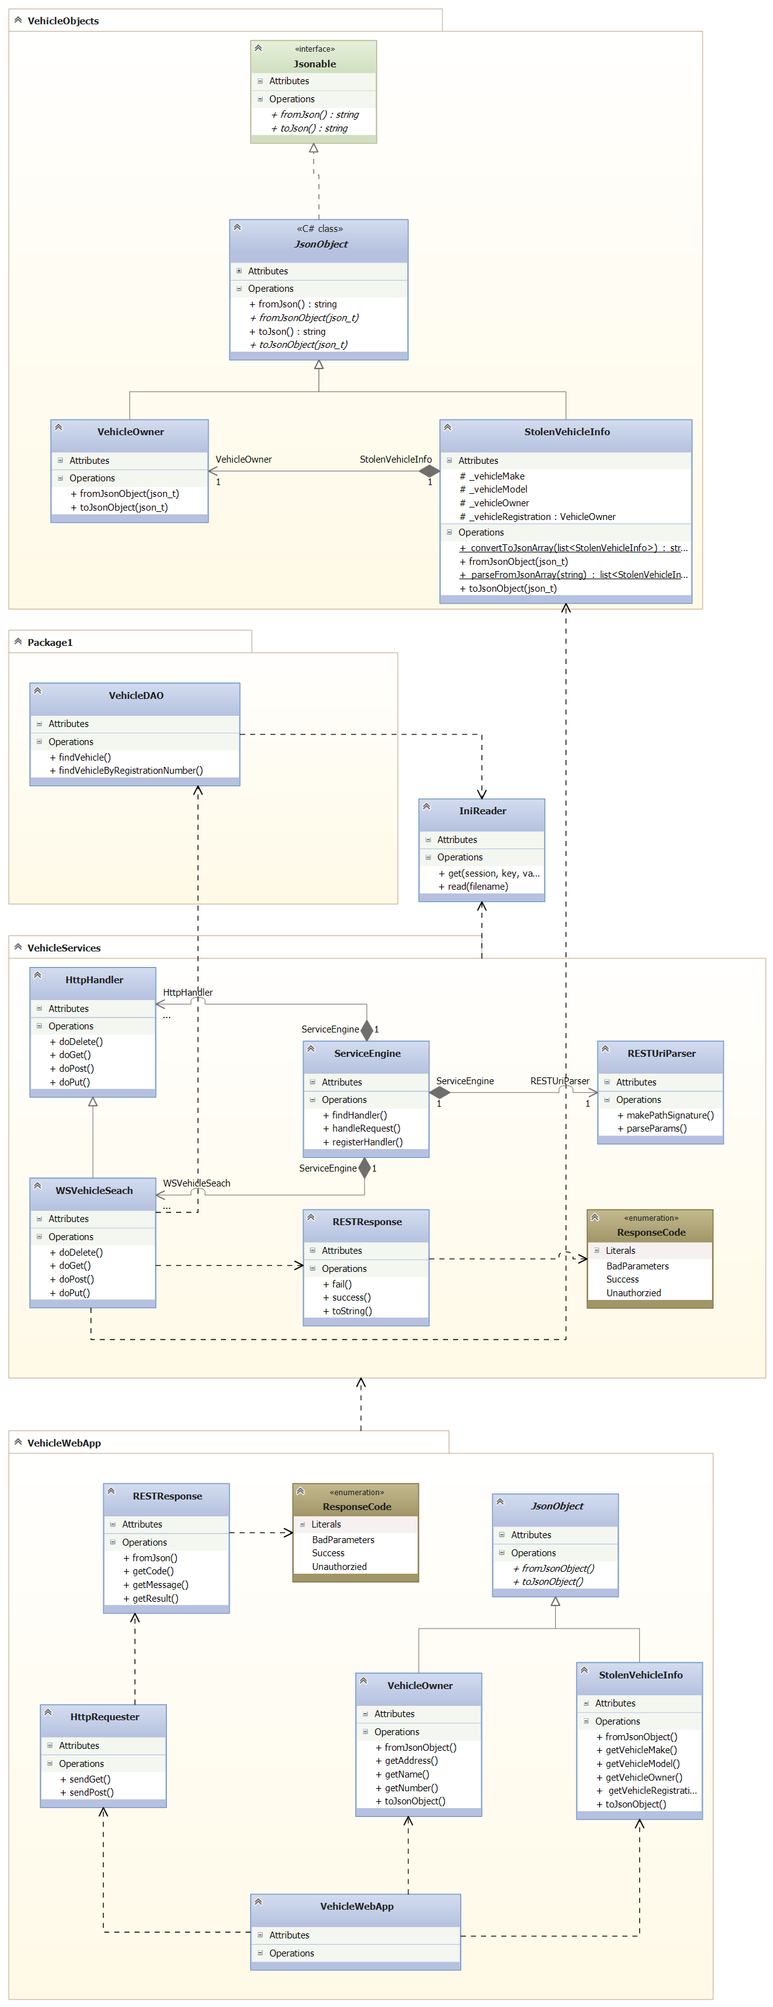

    - Sequence Diagram
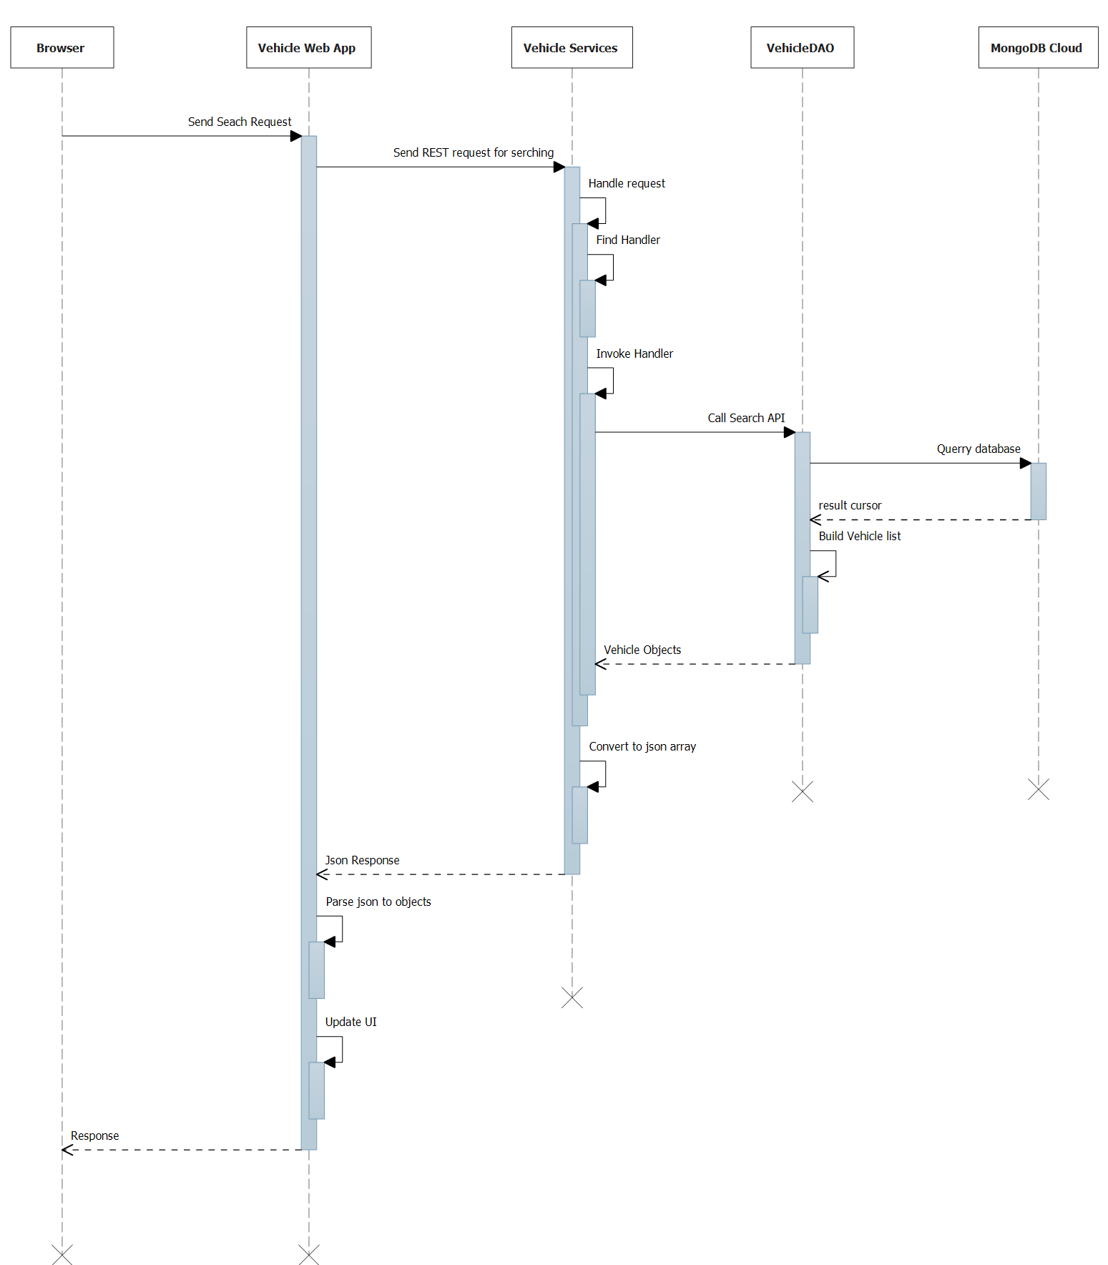

Handle request in Services Application becomes complicate because Cpp REST doesn’t support REST API mapping.

So, the system must handle request itself by register a key pair between Request Path and Handler.
Let’s see below handle request flow.

Finding handler method.
Register Path - Handler
Listen request
Find Handler
Invoke Handler
Response path not found
Handler not found
Return response
Request sent
Register pattern path 1 | <fix path X>\{param1}\ | Handler 1
Register pattern path 2 | <fix path X>\{param1}\{param2} | Handler 2
Register handle table

 | Request Path | Handler | Param1 | Param2 | ...
1 | <fix path X>\value\ | Handler 1 | value | N/A
2 | <fix path X>\value1\value2 | Handler 2 | value1 | value2
3 | <fix path x>\ | Not found | N/A | N/A
3 | <fix path Y>\value | Not found | N/A | N/A
Finding Handler and parse parameter follow REST style rule.

