Thanksgiving with the family is stressful enough without being late. This Thanksgiving week, we’ll get you where you need to go. **On time**.

Southwest Airlines operates more flights than any other domestic carrier (twice as many as the next guy).

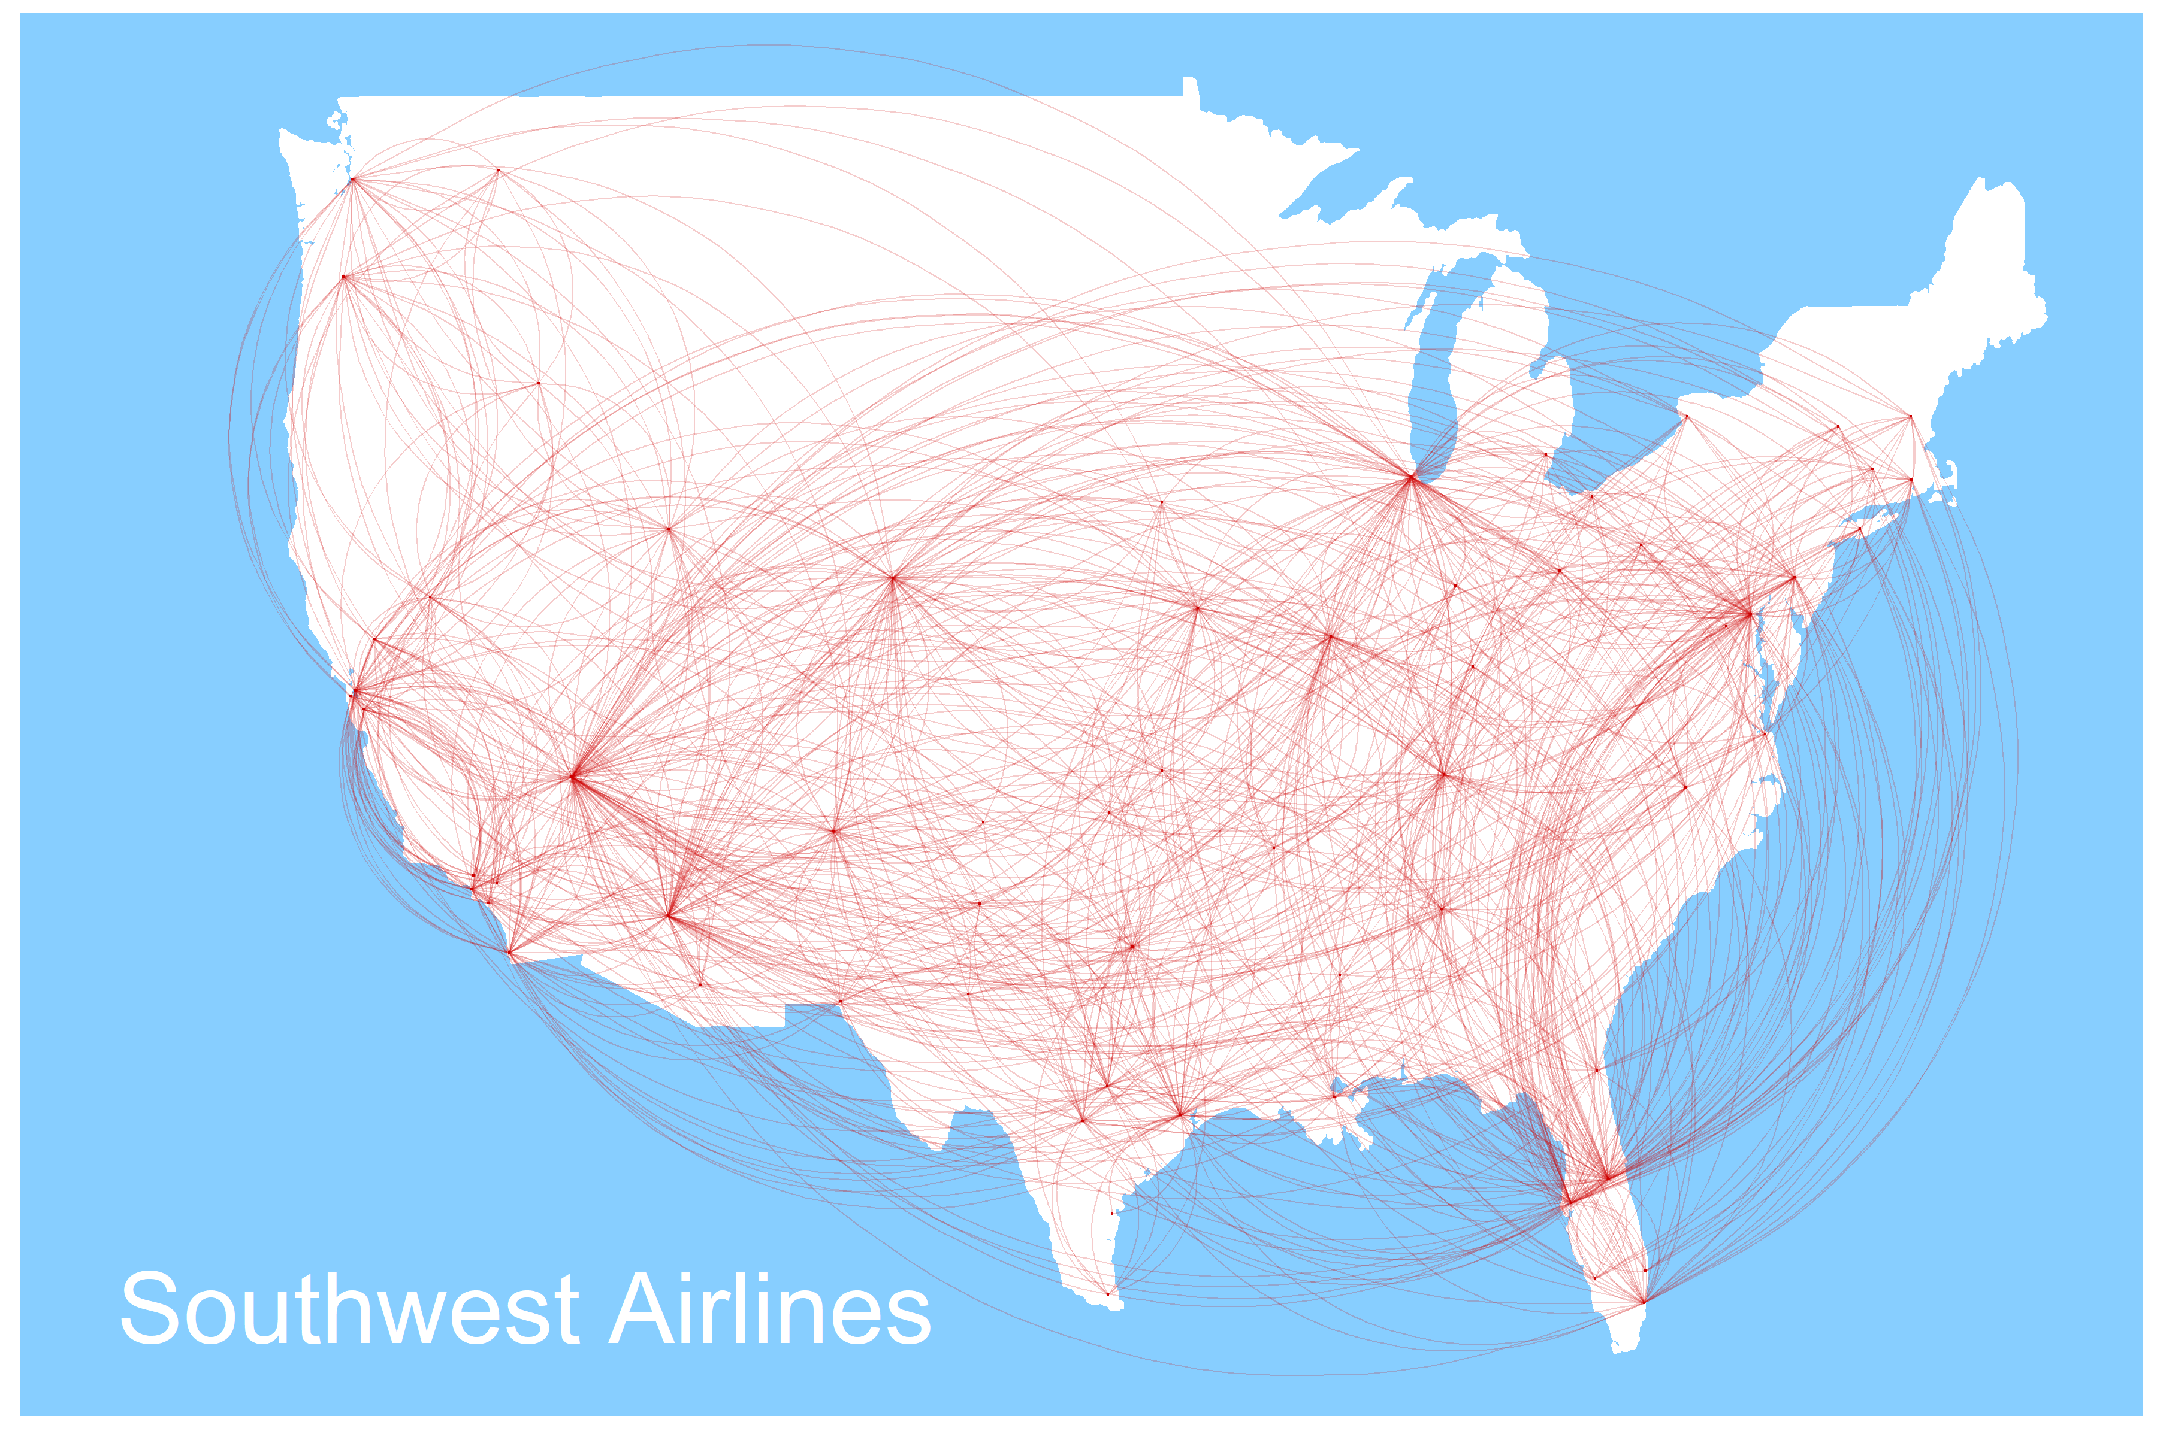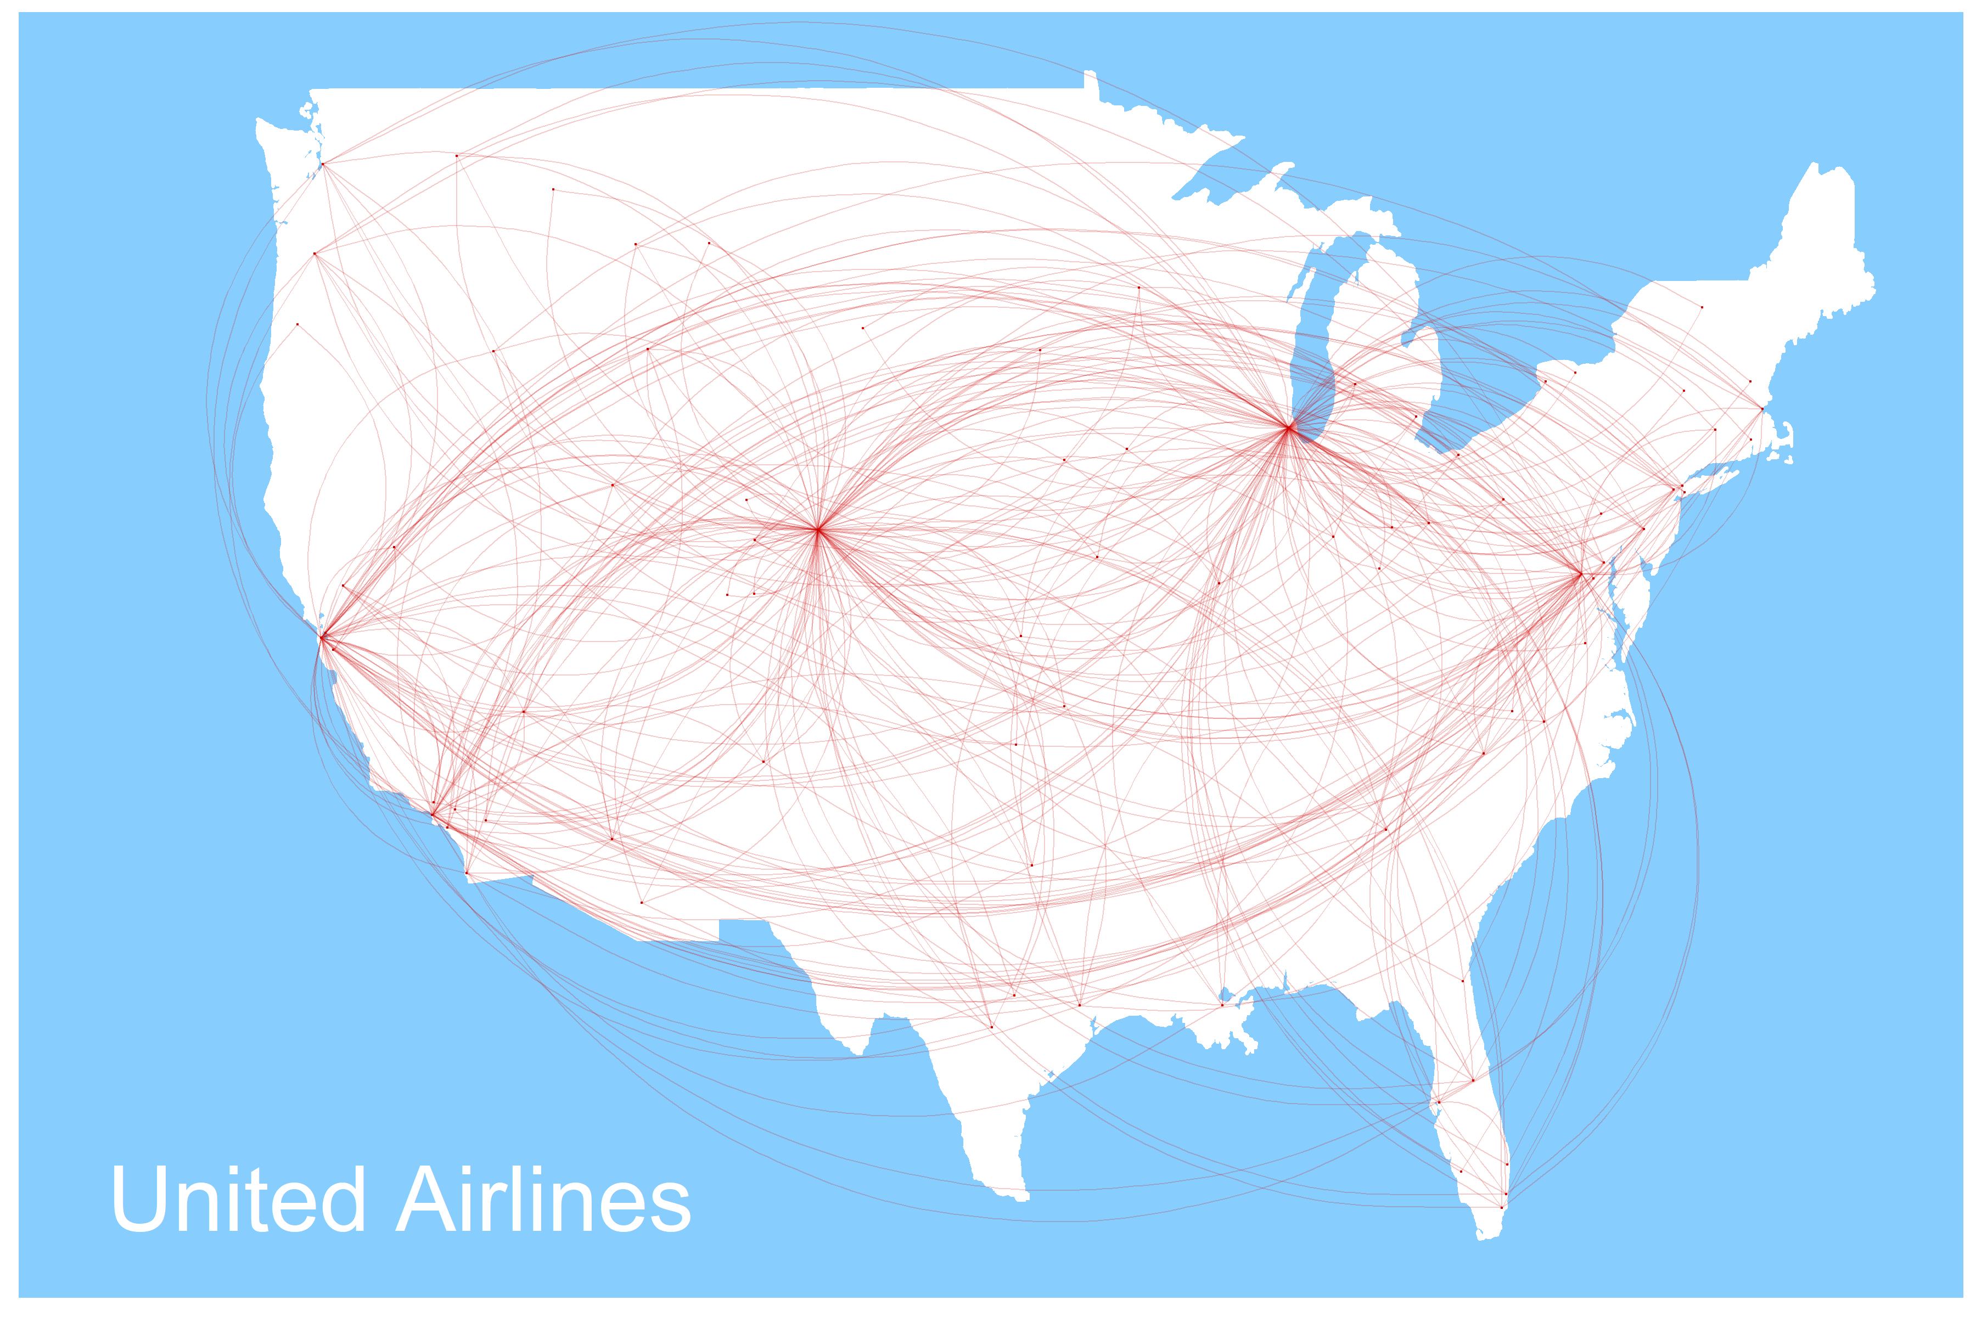

­­

Southwest Airlines was one of the leaders in on-time arrivals during the Thanksgiving week last year

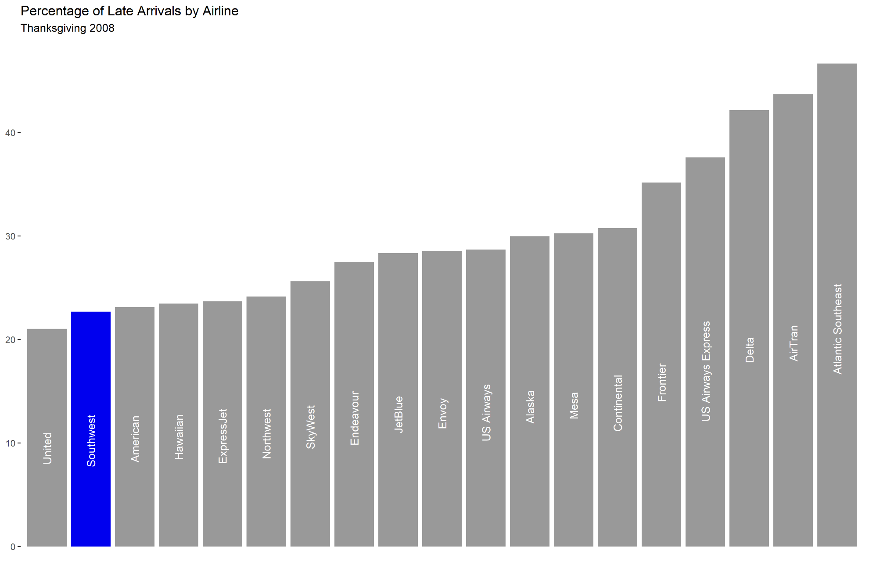

Southwest Airlines: more turkey, less waiting