Code Review Utility

This is a utility to simplify the process of reviewing code remotely through emails.

It has main functions:

1. Create a code review package and email it (with a standard template) to a reviewer(s)
2. Allow the reviewer to easily review the code (display before and after changes), provide comments and send them back to the coder
3. Allow the creator of the code review package to commit/check-in the package

Contents

Installation 2

Code Review Package UI for the Coder 2

Code Review Comment Package UI for the Reviewer(s) 5

Commit/Check-in Code Review Package UI 10

Settings for the Code Review Utility 13

Automatic Updates 14

# Installation

1. Download the utility from <ftp://129.221.31.86/ftp/Code%20Review%20Utility%20Installer/>
2. Double click on CodeReviewUtility.msi to start installation.
3. Follow the instructions
4. Launch the utility through the desktop shortcut

## Required Software

* SubVersion Client <http://www.sliksvn.com/en/download>
* Tortoise SVN <http://tortoisesvn.net/downloads.html>

**Note:**

* It may take up to a minute for the UI to display when the utility is started for the first time.
* Every time the utility is invoked, it will automatically check for any updates and provide a notification if an update is available.

# Code Review Package UI for the Coder

The Main window has two tabs

1. Review Details
2. Files

By Default a ‘Check List Window’ will popup listing the check list items for the Coder. This window can close and re-open with the ‘Checklist...” button.

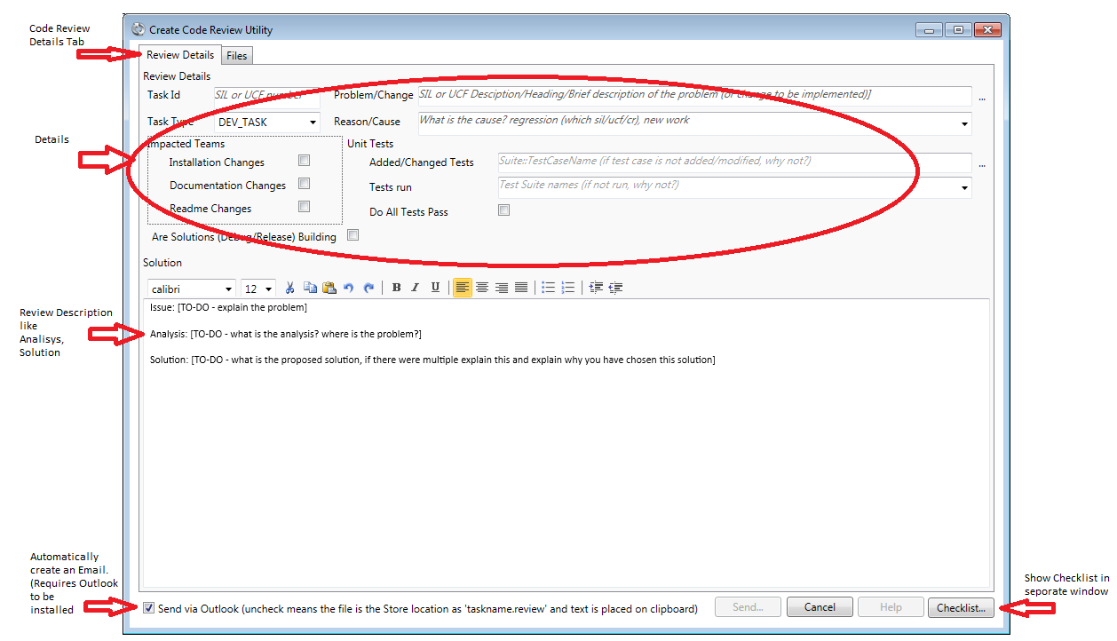

Figure 1. Create Code Review - Review Details Tab

**Step 1:**

Enter the required details for the code review, this include a Task Name, Short description of the problem, the Cause, Details of impacted teams and Unit Test information and a text editor to provide more detail information for a review, with the analysis and solution.

**Step 2:**

After entering the Review Details, select the Files Tab to select the folder that contains the modified/new/delete files.

Select the source code folder – this can be the root folder or a sub folder. The utility will scan the folder contents for any changes and then display them in the UI.

Select the files you want to include in the review package. You can also check for any ‘unversioned files’ Check/uncheck the file you want to include in the package. By default all files are selected.

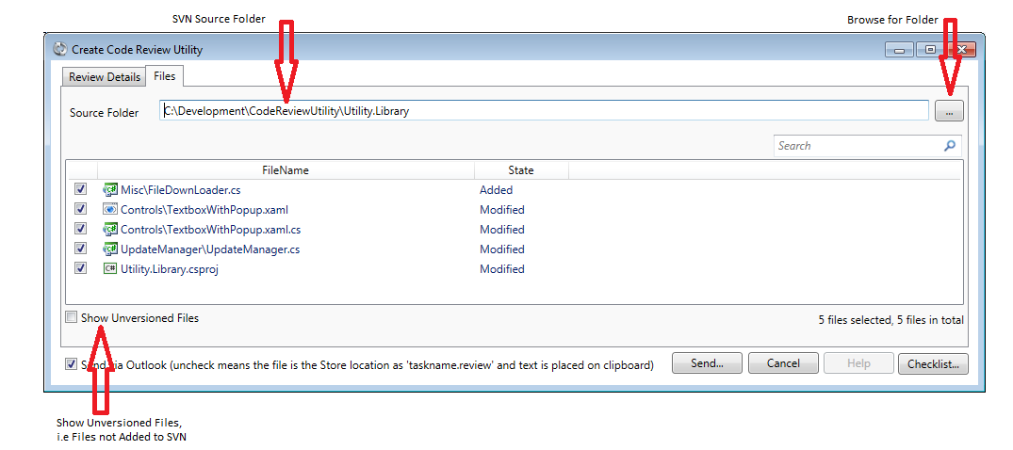

Figure Create Code Review – Files Tab

Through the context menu, some SVN operations can be performed, like Show Log, Add, and Revert. The menu will act on the current selected items.

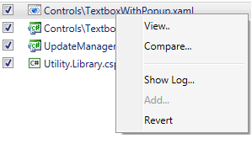

Figure 3 Context menu to perform SVN type operations

Note: When changes are made to any files under the Source folder, like status change, the View will automatically refresh.

**Step 4:**

Press the OK button – this will automatically generate an email.

* It will be prefilled with a template – you need to fill information like the Issue, Analysis and Solution which also can be done on the Review Details tab.
* It will contain the source changes as an attachment

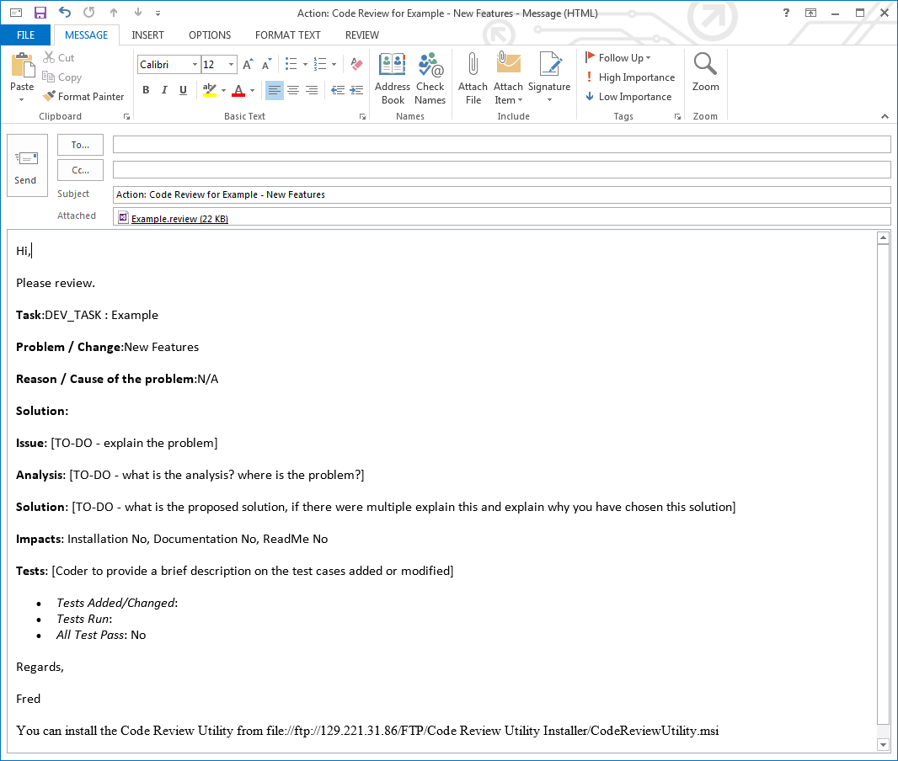

Figure 4 New code review email generated with source changes as attachment.

**Note:** the Code Review Utility UI will close down once OK button is clicked.

The Code review package will be saved in the Store. The location of the Store can be set in the Settings Dialog. See the section for the Settings dialog for more details.

The default location is **%ApplicationData%\Unisys\\CodeReviewUtility Store**

# Code Review Comment Package UI for the Reviewer(s)

**Step 1:**

The reviewer(s) will receive an email with the .review file attachment.

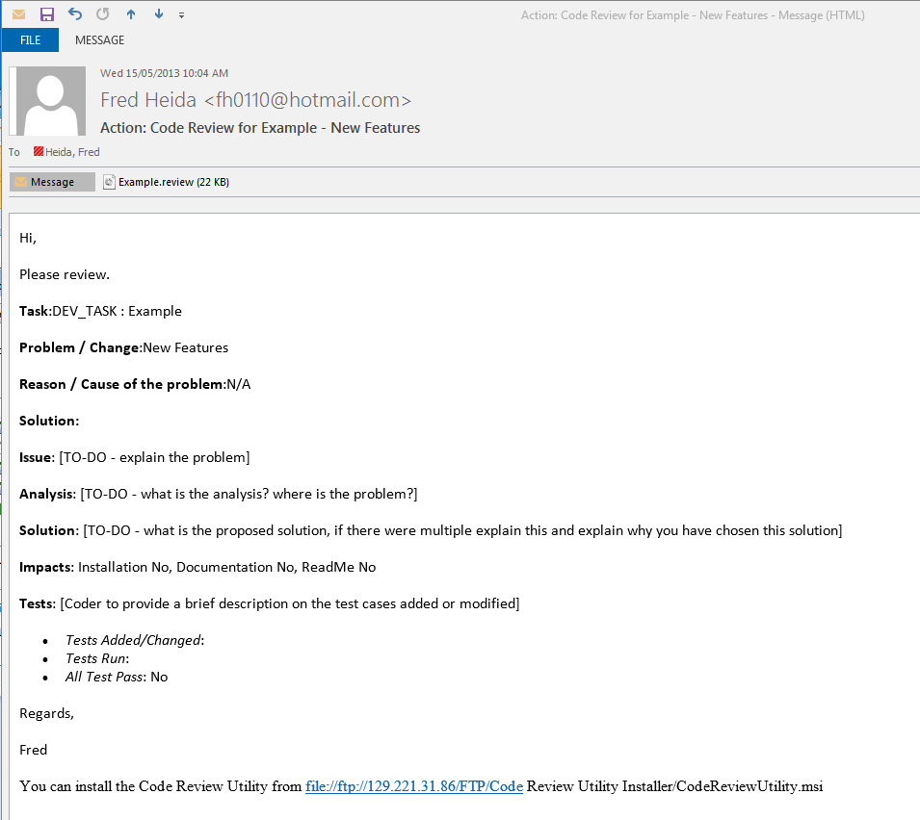

Figure 5 Code Review Email received by the Reviewer

**Step 2:**

Open the attachment by double clicking it. You might get the following dialog -this depends on the security settings on your machine. Click Open.

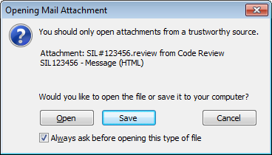

Figure 6 Security Warning

This will open the Code Review Comment Main window.

By Default a Check List Window’ will popup listing the check list item for a Reviewer. This window can close and re-open with the ‘Checklist...” button.

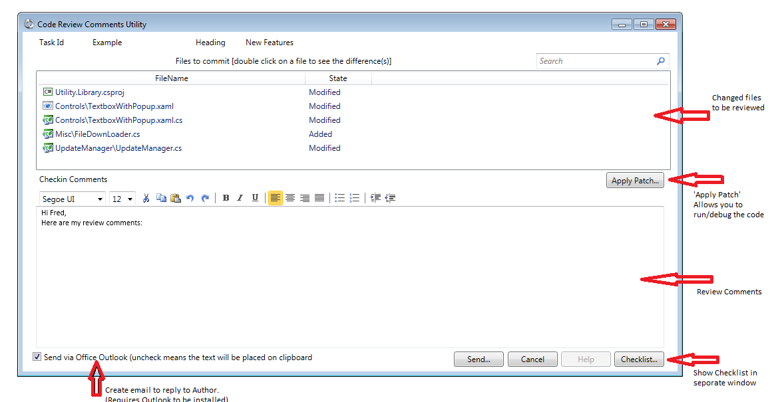

Figure 7 Code Review Comments Window

**Step 3:**

This dialog will allow you to view the difference between the ‘before’ and ‘after’ changes.

Double click on each file - it will open the default diff view tool (the one configured with SVN) displaying the code changes.

Review each change.

You can provide review comments, if any, in the **Review comments** section of the dialog.

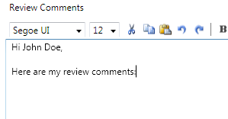

Figure 8 Enter Review Comments

Enter “No issues” if you have no review comments.

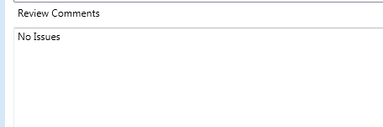

Figure 9 No Review Comments

**Step 4:**

Press the Ok button to auto-generate a comments email to be sent back to the coder.

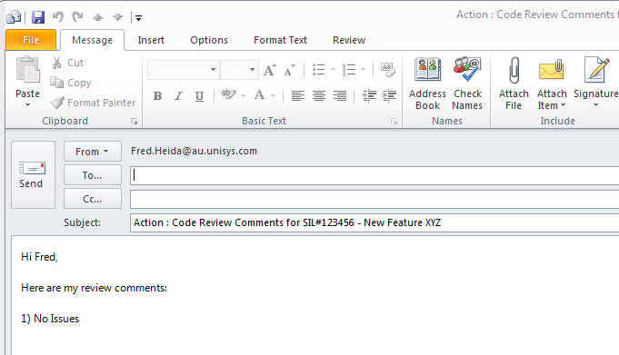

Figure 10 Generated Email with your Comments

# Commit/Check-in Code Review Package UI

When a code review package is created, it gets stored in the ‘Store’. This is a folder specified in the Settings Dialog.

When a package is opened from this location, the user will get prompted to either ‘Commit’ or ‘Review’ the package.

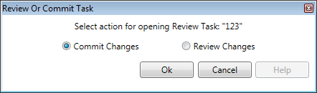

Figure 11. Commit/Review Prompt

The ‘Review Changes’ option will open the Code Review Comment Package.

The ‘Commit Changes’ will display the following:

The Files that make up the package, of the Review Details entered when the package was created.

In the text editor, you can copy/past any review comments you received from the reviewer. The’ Checkin Comments Preview’ window gives a preview of the text that will be used when the package gets commented to SVN.

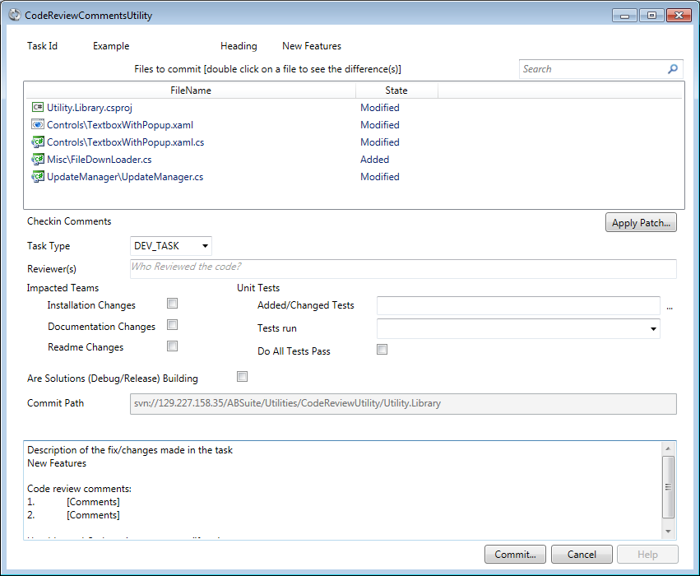

Figure 4. Code Review Commit

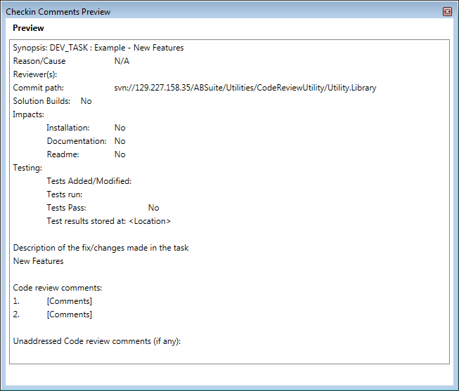

Figure 5. Checkin Comments Preview

After select the Commit button the SVN Commit window get displayed, to finally commit the changes in to SVN with the required description filled out.

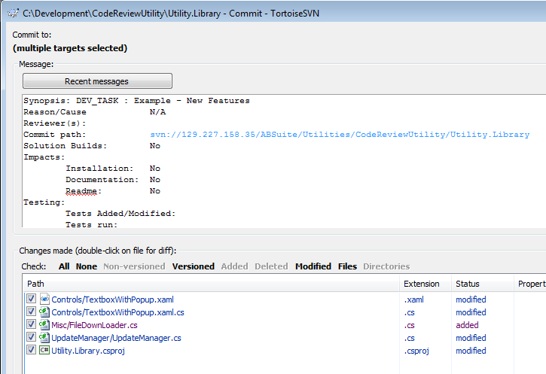

Figure 6. SVN Commit

# Settings for the Code Review Utility

Through the System Menu, Settings... See Figure 6, the settings can be changed/modified:

1. Specifying an Alternate Comparer. This is useful when doing reviews on a machine that does not have SVN installed
2. The Store location. A folder where all review package you create will be saved.
3. Modify the Show Check List at Start up. If this is check the Check List window will popup automatically when the utility start up.

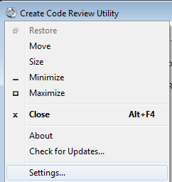

Figure 7. System Menu

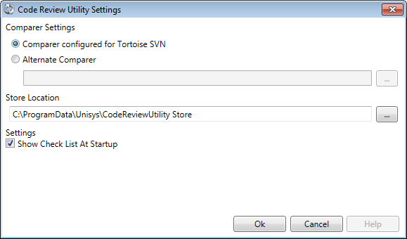

Figure 8. Settings Window

# Automatic Updates

When there is an updated version of the Utility, you will receive a notification of that whenever this utility is started.

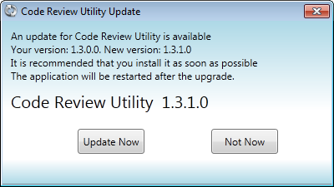

Figure 11 Update notification

The new version will be automatically downloaded and installed by clicking ‘Update Now’.