# Vibrant----------------------------

# Oak Creek

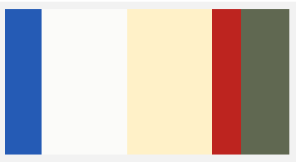 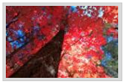

**255BB5 / FBFBF9 / FFF1C8 / BD241F / 606851**

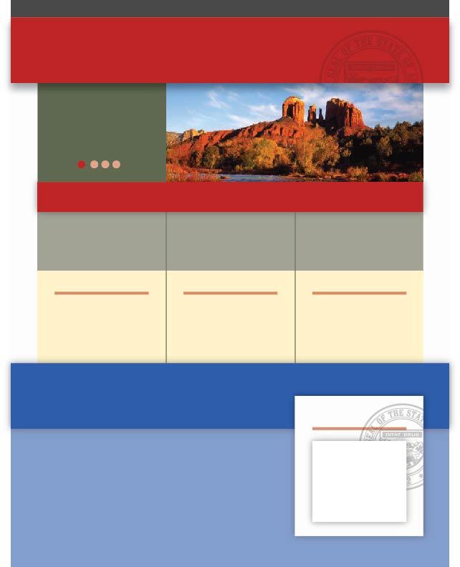

# Scottsdale

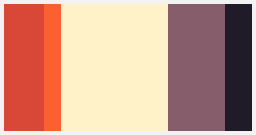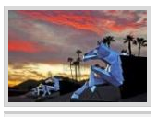

**D94837 / FC5F32 / FFF1C8 / 865D6B / 1F1B29**

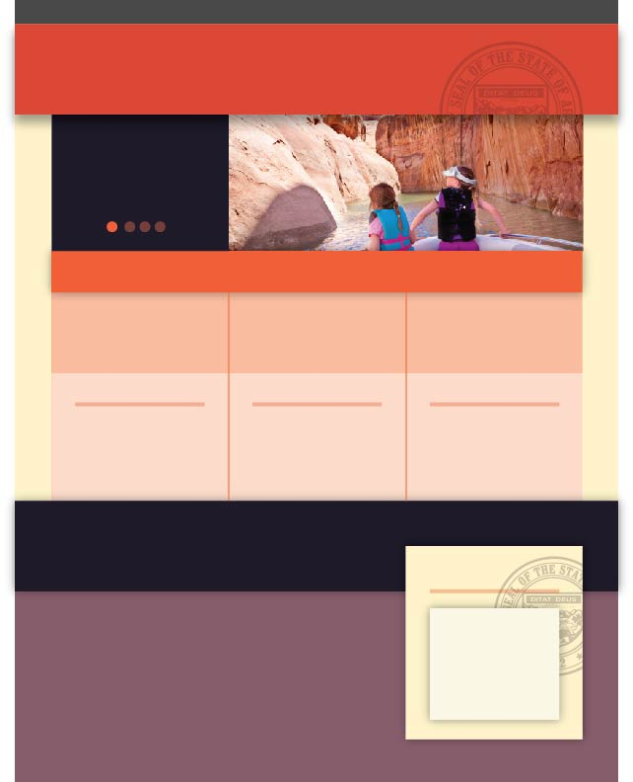

# Verde Valley

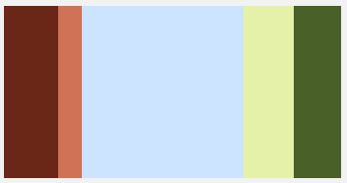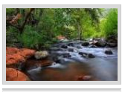

**6A2717 / D07256 / CCE4FF / E5F1A9 / 496028**

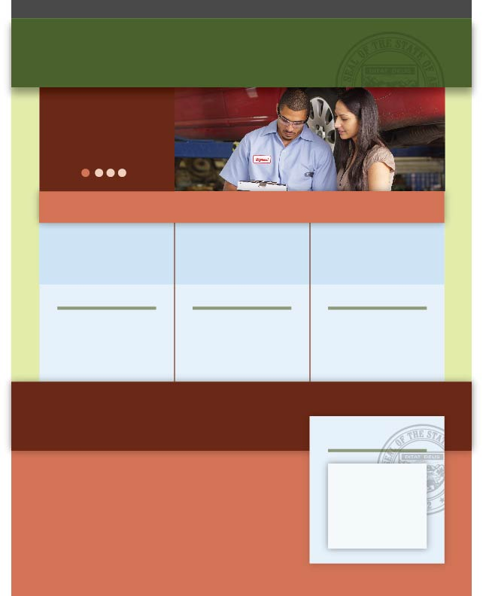

# Flagstaff winter (warm up)

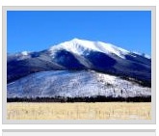

**0F0F0F / E1CAA1 / CCE4FF / 255BB5 / 13256D**

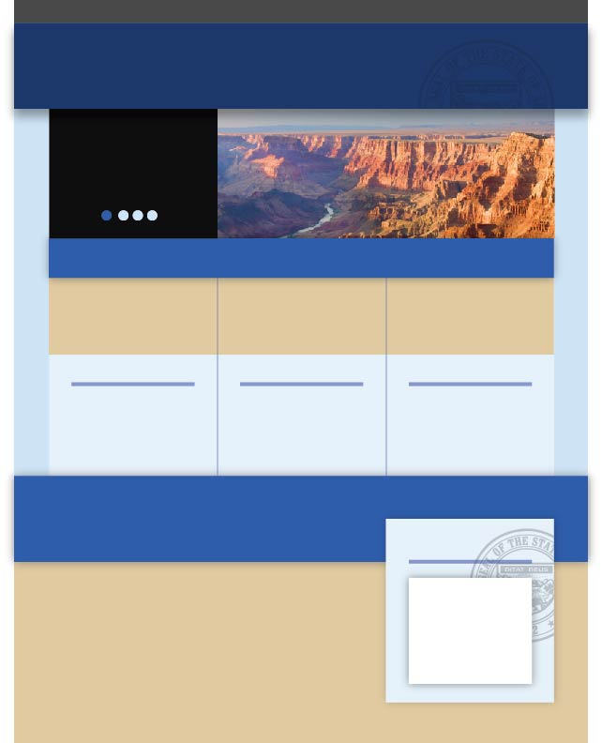

# Muted---------------------------

# Holbrook

 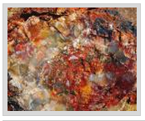

**0F0F0F / 73584D / F1CAA1 / B84117 / 600504**

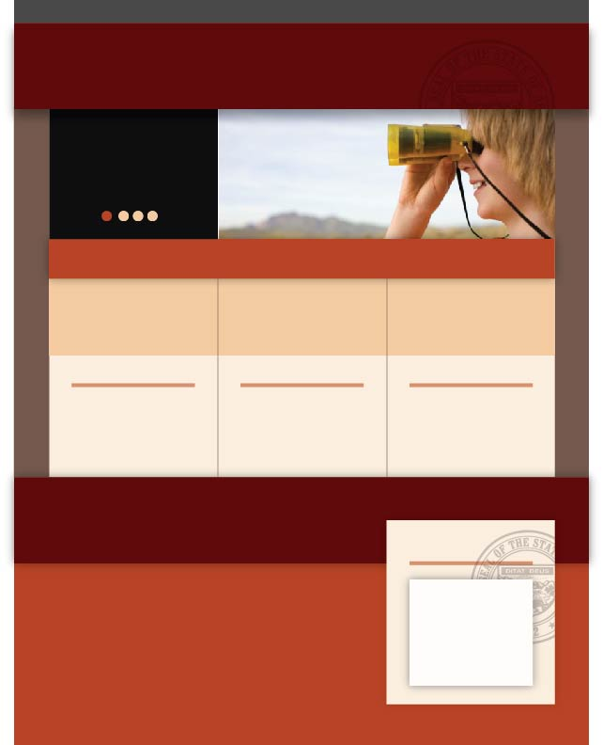

# Strawberry

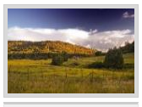

**3E3D28 / 66633A / D2C0AC / F9DD62 / 403F67**

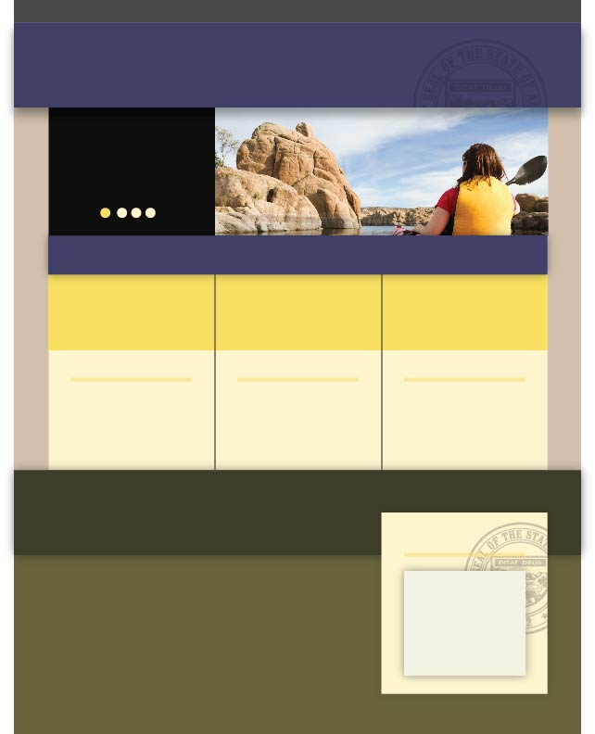

# Bisbee

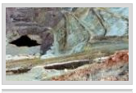

**5C8984 / C3DBE7 / D2C0AC / B5977D / 8B8175**

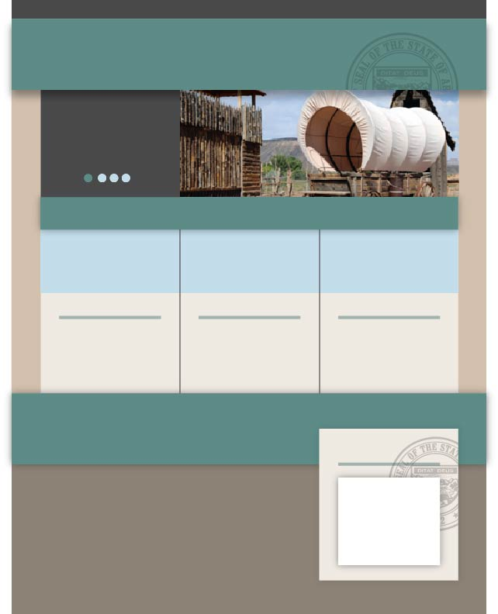

# Page

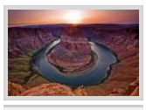

**381C33 / 3E3D28 / 4D5466/ F0963C / 6A2717**

# Blended-----------------------------------

# Winslow

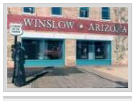

**A16678 / 44B2C1 / 04162A/ D2C0AC / 8B8175**



# Douglas

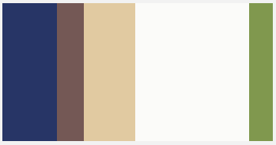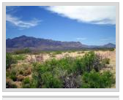

**273566 / 745855 / E1CAA1 / FBFBF9 / 80984E**

