**1. PyCharm Installation Guidelines**

1. Download PyCharm: Visit the JetBrains website (<https://www.jetbrains.com/pycharm/>) and download the appropriate version of PyCharm for your operating system (Windows, macOS, or Linux) and choose the Community Edition.

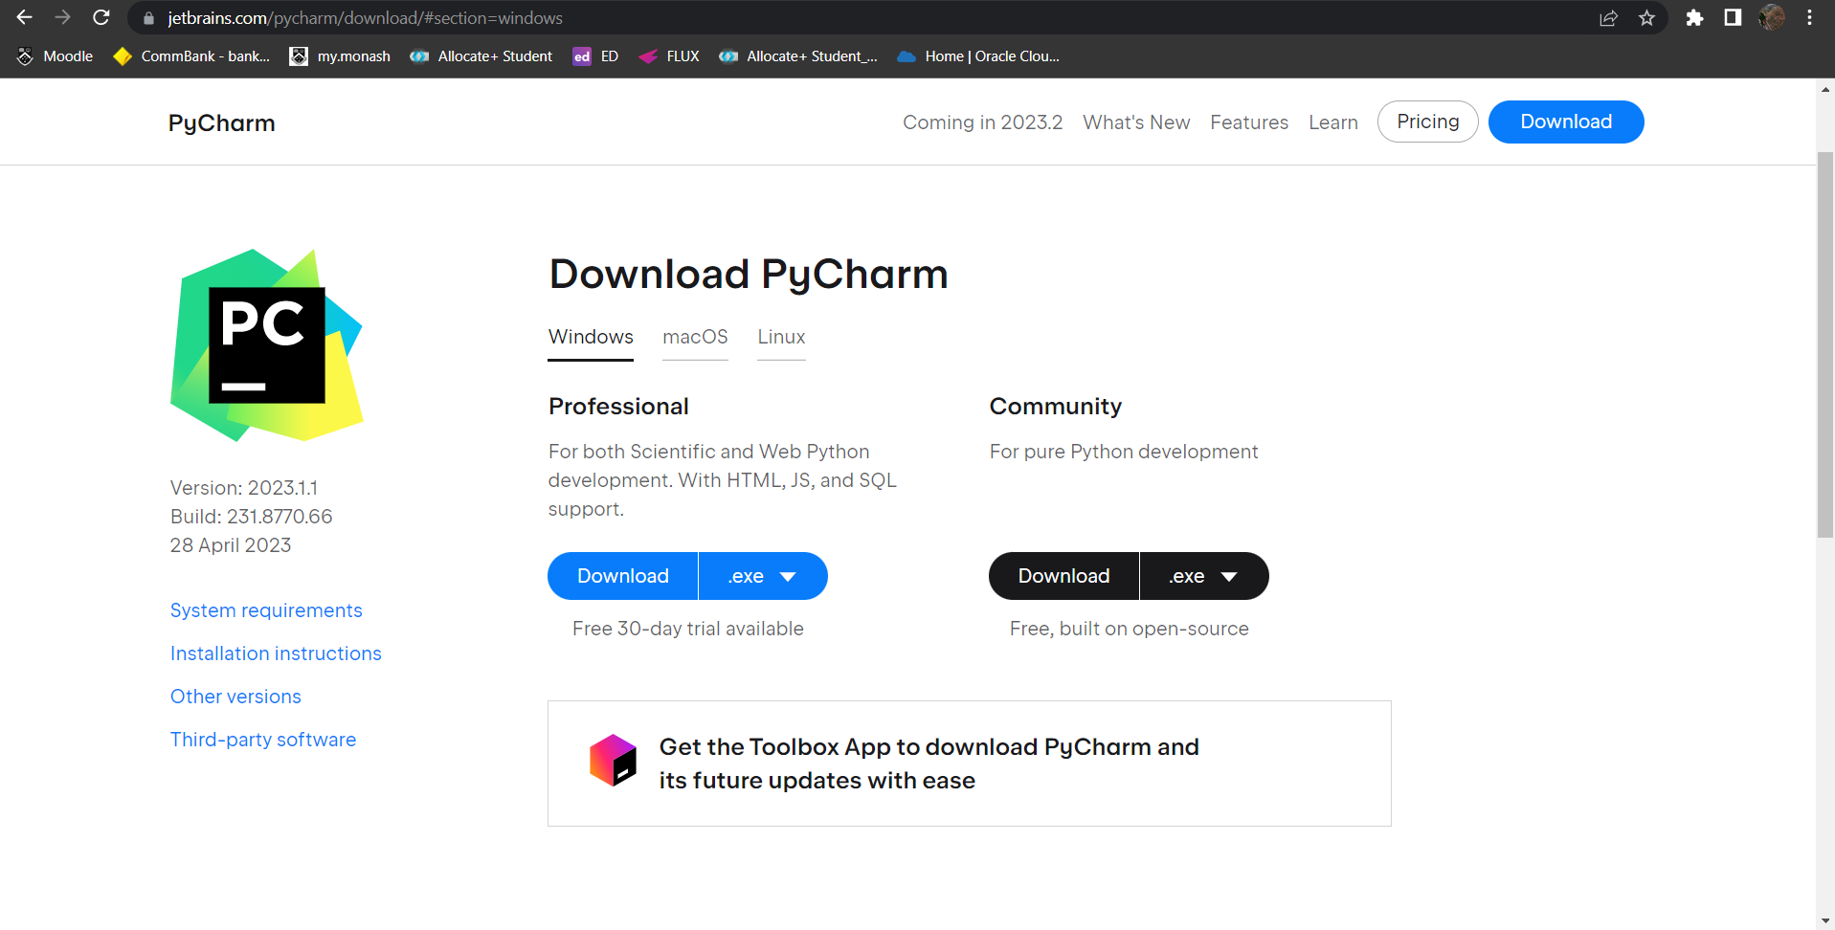

1. Install PyCharm: Run the downloaded installer and follow the on-screen instructions to complete the installation process. Make sure to select any desired preferences during the installation, such as the installation location and additional components.

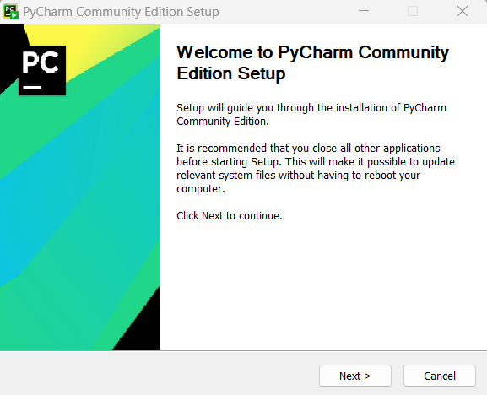

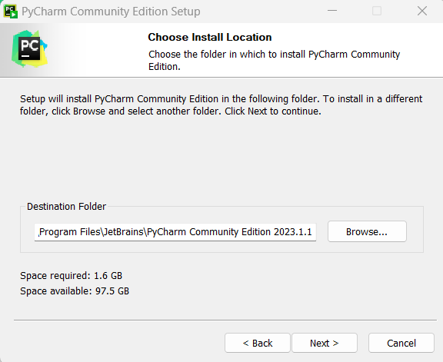

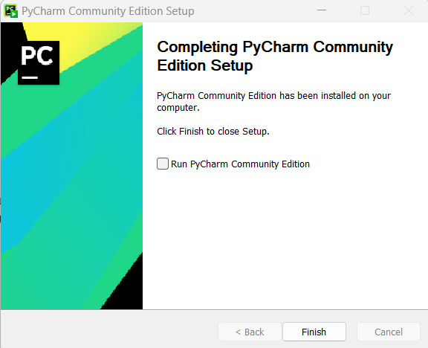

1. Open PyCharm: After installation, launch PyCharm from your applications or desktop shortcut. Upon opening, you'll be prompted to configure the IDE settings.
2. Open project: Click on "Open Project" or select "File" -> "Open" from the menu. Choose a location on your computer where you have saved the folder.
3. Select the interpreter: Click on File -> Settings -> <Project Name> -> Python Interpreter -> Add local interpreter -> Choose Python 3.9

Click on OK. Then open the python files you wish to look at.

**Project Structure and Running the Script**

1. To look at the data used as part of the Monash Rental System, navigate to the data folder, and locate the data files i.e., property.txt, application.txt, wishlist.txt, and application.txt.

**Note**: The data folder must be in the same directory hierarchy with all python classes scripts (i.e., class.py)

1. Open MonasRentalSpace.py (Controller class) then run the script.

**2. Troubleshooting**

1. **ModuleNotFoundError: No module named 'tabulate' in Python**
2. Navigate the unresolved reference ‘tabulate’. (Please refer to the red circle)

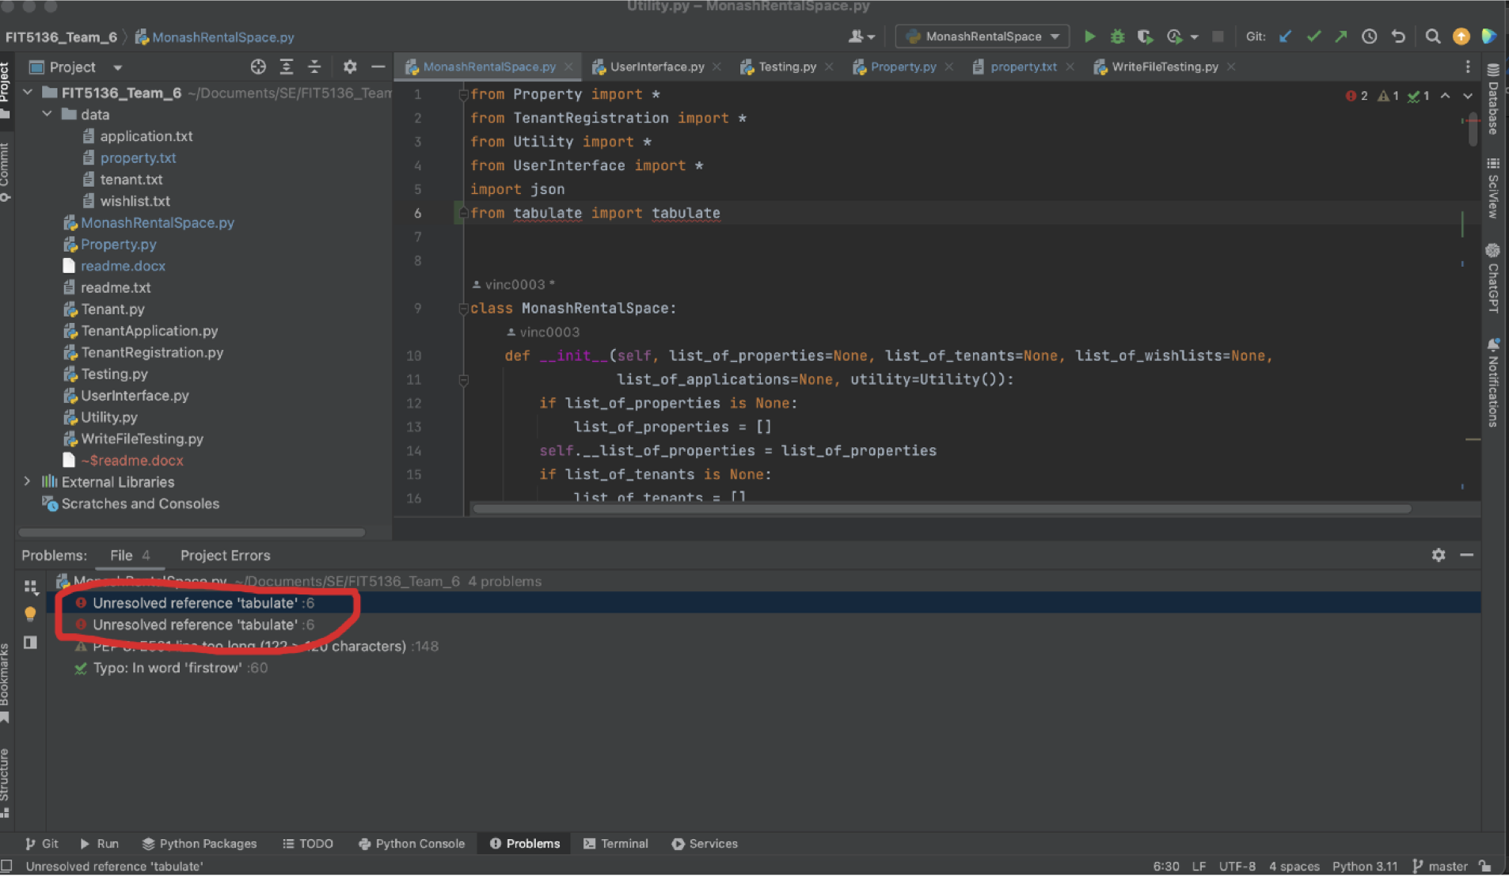

1. Click on red light bulb then **Install package tabulate**. (Please refer to the red circle)

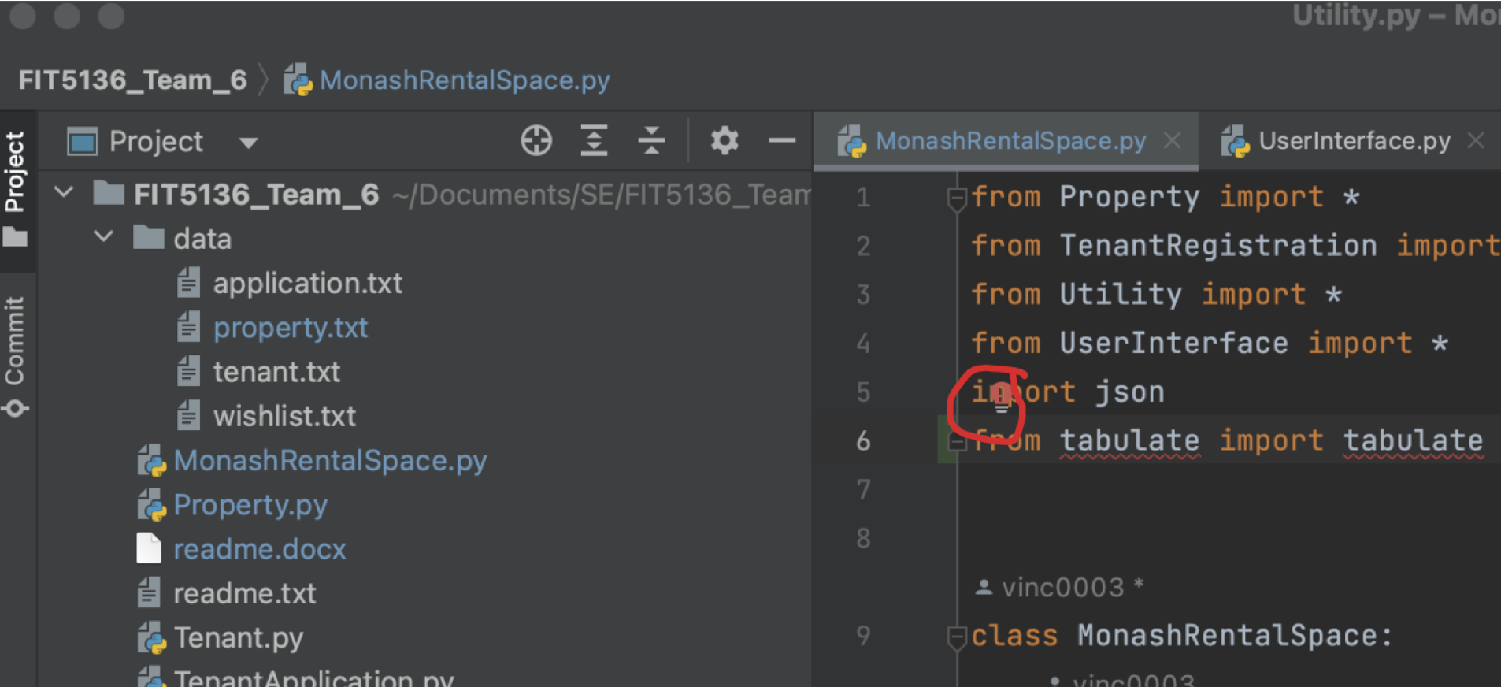

1. **Running the application:**
2. The application starts and opens up to the following options:  
   A picture containing text, screenshot, font, design

   Description automatically generated

1 – Login: allows the user to log into the MRS application

2 – Registration: allows the user to register as a tenant (Yet to be implemented)

3 – Exist MRS: allows the user to exit the MRS application

1. On choosing Login, the tenant is presented with the following options:  
   A screen shot of a computer

   Description automatically generated with medium confidence

1- Search Property: allows the tenant to view all the properties (search and filter yet to be implemented)

2- View Wishlist: allows the tenant to view his wishlist

3- Calculate Optimal Rental Price: (Yet to be implemented)

4- Logout: allows the tenant to log out of the application

5- Exit MRS: allows the tenant to exit the MRS application

1. On choosing the search property option, the tenant is presented with the following options:  
   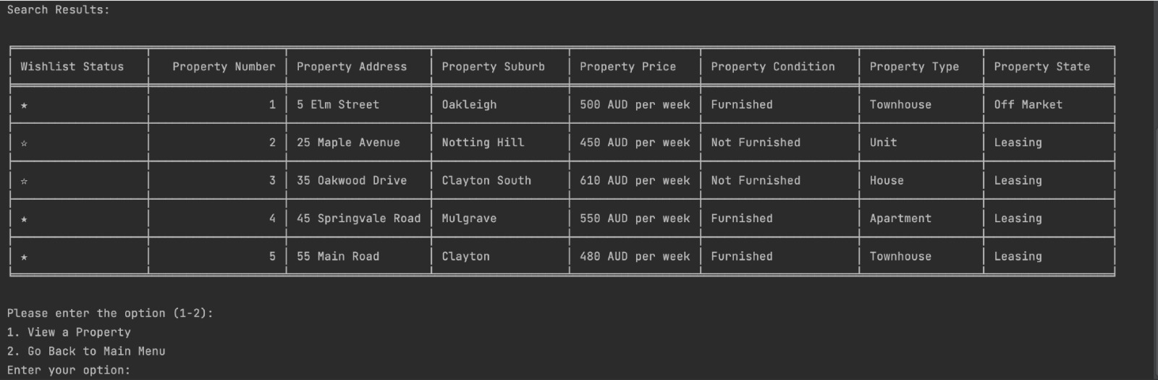
2. View Property: allows the tenant to view all the properties.
3. Go Back to Main Menu: takes the tenant back to main menu
4. On entering the view property option, tenant is asked to enter the property number, and then given the following options:

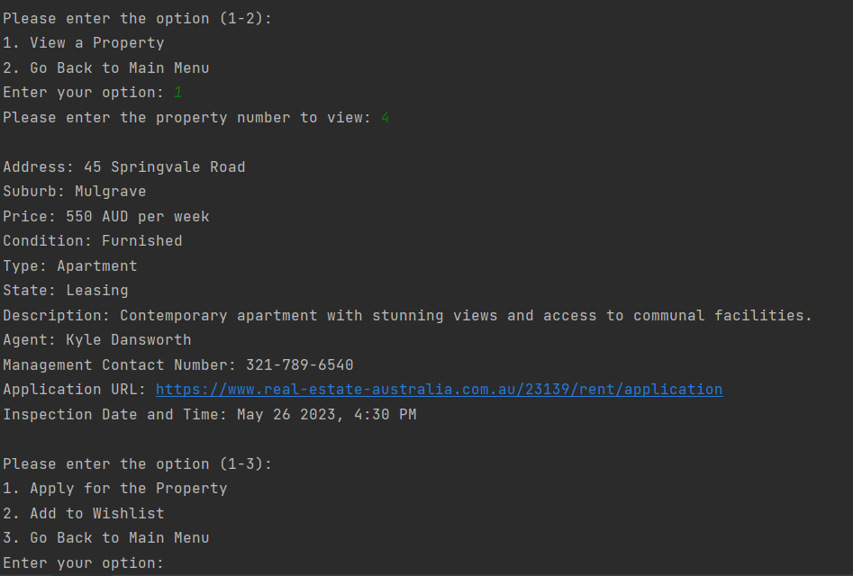

1. Apply for the Property: Tenant can apply for this property.
2. Add to wishlist: allows the tenant to add the property to wishlist
3. Go Back to Main Menu: Takes the tenant back to main menu
4. On applying for property (Option 1), the tenant is asked to confirm if he wishes to use existing details:

5.1. IF yes (Option 1), the tenants will need to enter their mobile phone and saving (option).

5.2. IF no (Option 2), the tenants will need to enter their first name, last name, email, mobile phone and saving.

1. On adding to wishlist (Option 2), the tenant is notified that the property has been added to wishlist.
2. From the main menu, the tenant can view his wishlist, and is presented with the following options:

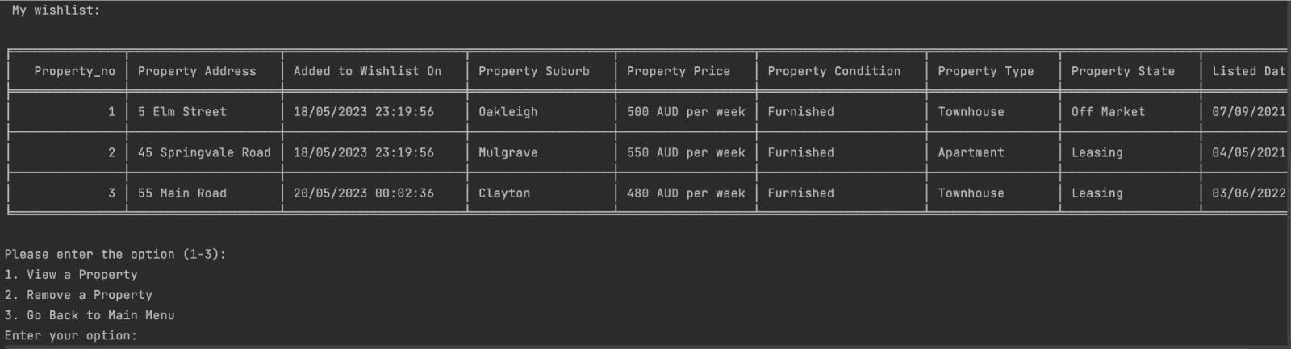

1. View a property: provides the tenant with a more detailed description of the property of his choice.
2. Remove a property: provides the tenant with an option to remove a property from his wishlist
3. Go back to main menu- takes the tenant back to the main menu.