**vincent-portfolio Documentation**

**Project Setup**

1. (Terminal) npx create-next-app@latest
   1. <https://nextjs.org/docs/getting-started/installation>

1. (Terminal) npm run dev -> to run

1. (To open the website in the VSCode) CRTL + Shift + P -> Simple browser: show -> <http://localhost:3000>

1. Remove the return content in the page.js

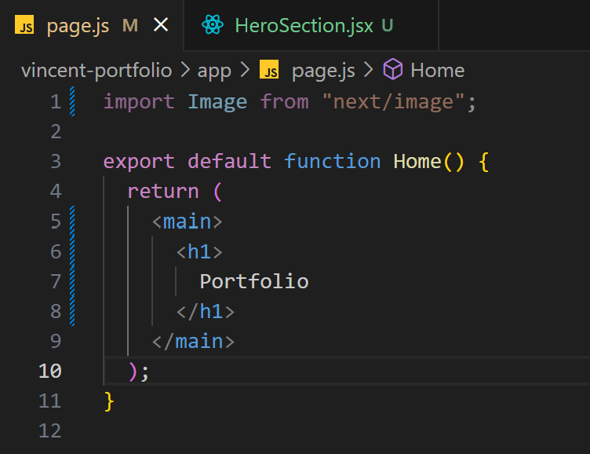

1. Inside app folder, create a components folder
2. Inside components folder, create a HeroSection.jsx file
3. Use **rafce** to create a template