**VINC-SCRIBE**

**Setup:**

* <https://tailwindcss.com/docs/guides/vite#react>
* (New Vite React project with Tailwind CSS)
* Follow the instructions in the link
* Remove App.css

**Font Setup:**

* <https://fonts.google.com/>

* Modify index.html (Paste the embedded to the index.html)

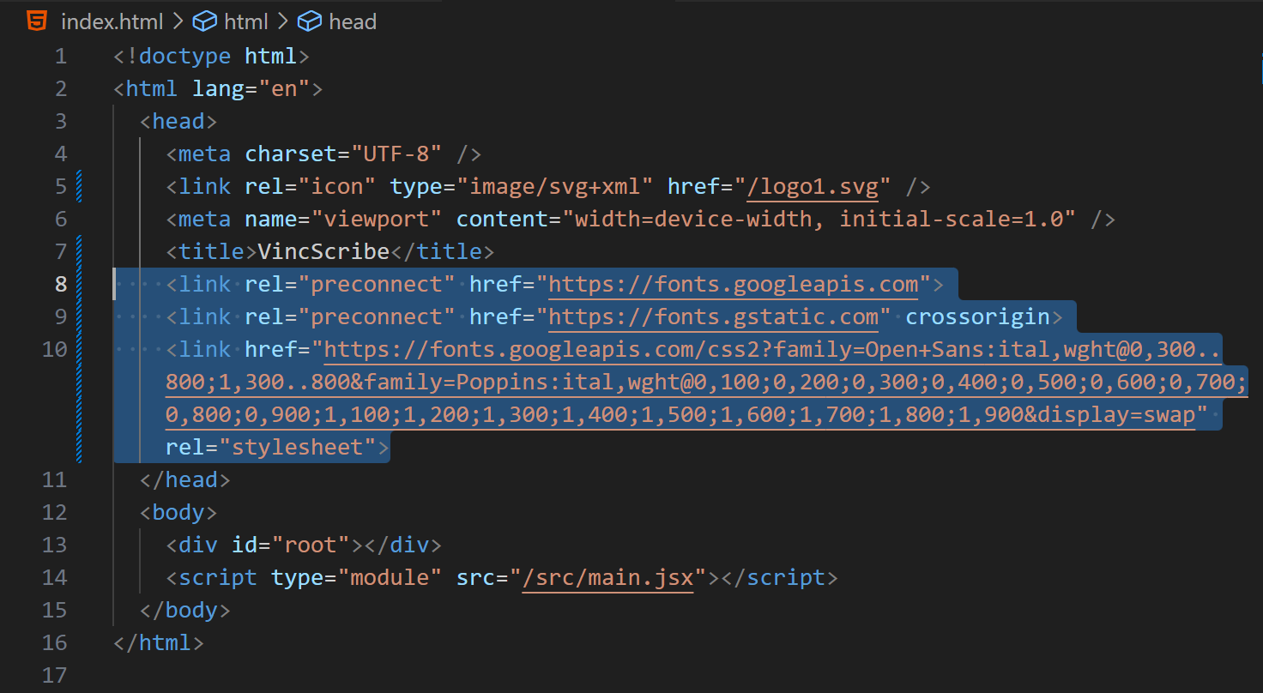

* Modify scr/index.css

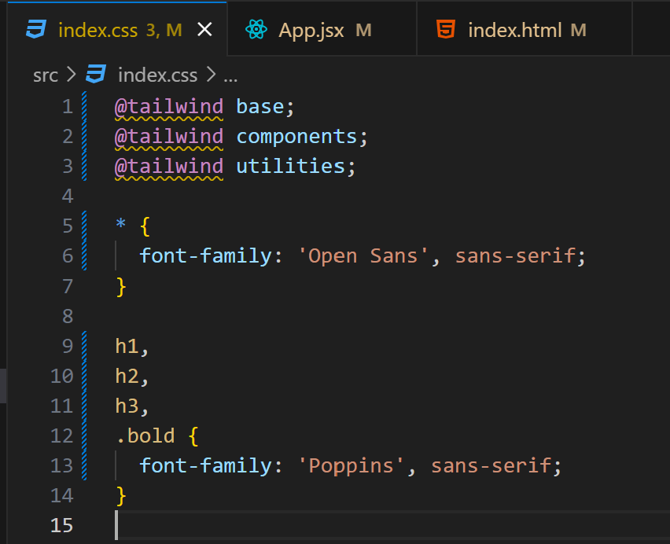

* Add font-awesome cdn in the index.html (below title tag)
* <https://cdnjs.com/libraries/font-awesome>

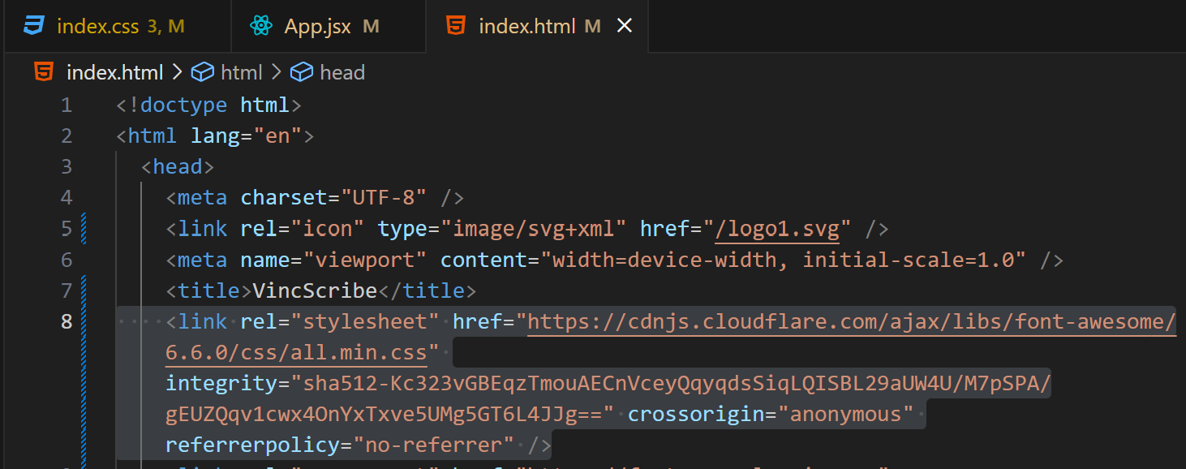

**Tab Logo Setup:**

* Add logo1.svg in the public folder
* Modify index.html

