Data Science and Deep Learning in Germany,
the UK, and Finland

Department of Computer Science and Information Engineering
Min-Sheng, Tsai
Table of Contents
Introduction 3
Content 4
Germany: Pioneering Industrial Applications 4
Technical University of Munich (TUM) 4
Technische Universität Berlin (TU Berlin) 4
RWTH Aachen University 4
Merantix 5
United Kingdom: A Hub for AI Innovation 5
University of Cambridge 5
University of Oxford 6
Imperial College London 6
University College London (UCL) 6
Meta AI (formerly Facebook AI Research) 6
Google AI (DeepMind) 6
OpenAI 7
Finland: A Leader in AI Education and Implementation 7
Aalto University 8
University of Helsinki 8
Tampere University 8
Nokia's AI Initiatives 8
Wolt, The food delivery industry 8
Graph_Survey_In2023 9
Conclusion 12
Reference 13

Introduction
The European Union (EU) is actively pursuing AI development and integration into various sectors, including the economy. However, there isn't a specific "AI generation" in the Euro currency system. The Euro is the official currency of 19 out of the 27 EU member states, and its value is influenced by various economic factors, including but not limited to AI.

That said, AI technologies are increasingly being utilized in finance and economics across the Eurozone. For example, AI algorithms are employed in financial trading, risk assessment, fraud detection, and customer service in banks and financial institutions operating within the Eurozone. Additionally, AI is being used to optimize supply chains, improve productivity, and enhance decision-making processes in industries across the EU, which indirectly impacts the Euro economy.

EU institutions also have initiatives to promote AI development. The European Commission has released strategies and investment plans to boost AI research, innovation, and deployment across member states. These efforts aim to ensure that Europe remains competitive in the global AI landscape and can leverage AI technologies to drive economic growth and societal progress.


Content
Data Science and Deep Learning are at the forefront of technological innovation, transforming industries and economies globally. Germany, the United Kingdom, and Finland stand out as pioneers in these fields, each with distinct approaches and significant contributions. This article explores the state of Data Science and Deep Learning in these three countries, highlighting key developments and their overall impact.

Germany: Pioneering Industrial Applications
Germany is renowned for its strong industrial base, where Data Science and Deep Learning are integral to driving innovation. The country is a leader in the Industry 4.0 revolution, leveraging these technologies to enhance manufacturing processes, predictive maintenance, and supply chain optimization. In the automotive sector, giants like Volkswagen, BMW, and Daimler are at the forefront, using AI for autonomous driving, vehicle diagnostics, and smart manufacturing.

Technical University of Munich (TUM)
TUM is renowned for its excellence in engineering and technology education. The university's Department of Informatics and affiliated institutes are leaders in AI research. TUM collaborates closely with industry partners and participates in national and international AI projects, focusing on robotics, machine learning, and autonomous systems.

Technical University of Berlin (TU Berlin)
TU Berlin is a prominent research university known for its contributions to AI and computer science. The university's Department of Electrical Engineering and Computer Science conducts cutting-edge research in AI, data analytics, and computational intelligence. TU Berlin's interdisciplinary approach fosters innovation and industry collaboration in AI-driven technologies.

RWTH Aachen University
RWTH Aachen University is a pioneer in engineering and technical education, offering comprehensive programs in computer science and AI. The university's Chair of Computer Science 5 (Information Systems) focuses on AI research areas such as machine learning and intelligent systems. RWTH Aachen's partnerships with industry and research institutes drive advancements in AI applications across various sectors.

Merantix
Merantix is a leading AI company based in Berlin, specializing in applied AI solutions for healthcare, autonomous systems, and industrial applications. The company collaborates with academic institutions and industry partners to develop AI-driven products that address complex challenges in sectors such as medical imaging, autonomous vehicles, and predictive maintenance.

Research institutions such as the Max Planck Institutes play a crucial role in advancing AI and Data Science. These prestigious institutions, alongside collaborations between universities and industries, drive applied research in these fields. The German government's AI strategy, which includes significant investments in AI research and development, aims to position Germany as a global leader in AI technologies.

Germany's AI Leadership
Germany's commitment to AI education and innovation, exemplified by institutions like TUM, TU Berlin, RWTH Aachen, and companies like Merantix, positions it as a global leader in AI technology. These entities drive advancements in AI research, industry adoption, and technological innovation, contributing to Germany's competitive edge in the global AI landscape.

United Kingdom: A Hub for AI Innovation
The United Kingdom is a global hub for AI and Data Science, driven by strong academic institutions, a vibrant startup ecosystem, and supportive government policies. Leading universities, including the University of Cambridge, University of Oxford, and Imperial College London, are renowned for their cutting-edge research in Data Science and Deep Learning. The Alan Turing Institute, the UK's national institute for data science and AI, plays a pivotal role in driving research and innovation across various sectors.

University of Cambridge
The University of Cambridge’s Department of Computer Science and Technology is a leader in AI research, offering a range of AI-related courses. The university hosts several research groups focused on machine learning, natural language processing, and computer vision. Additionally, the Leverhulme Centre for the Future of Intelligence (CFI) at Cambridge explores the implications of AI on society, aiming to ensure that AI development benefits humanity as a whole.

University of Oxford
Oxford University’s Department of Computer Science boasts a strong AI program, with courses in machine learning, robotics, and data science. The Oxford Internet Institute conducts extensive research on the social and ethical implications of AI and technology. Oxford is also home to the Future of Humanity Institute, which investigates global challenges, including those posed by AI advancements.

Imperial College London
Imperial College London's Department of Computing offers comprehensive AI courses and engages in groundbreaking research in machine learning, robotics, and bioinformatics. The college’s Data Science Institute serves as a hub for AI applications across various disciplines, fostering interdisciplinary research and collaboration. Imperial's commitment to AI research is reflected in its partnerships with industry leaders and its emphasis on real-world applications of AI technologies.

University College London (UCL)-Reference_link_has_teaching_course
UCL’s Department of Computer Science is a significant contributor to AI research, with strengths in machine learning, computational statistics, and AI ethics. The UCL Centre for Artificial Intelligence is a leading research center dedicated to advancing AI technologies and their applications. UCL’s AI research spans a wide range of fields, from healthcare to security, demonstrating its broad impact on society.

The UK is also home to several leading AI organizations that significantly contribute to the global AI landscape:

Meta AI (formerly Facebook AI Research)
Meta AI, previously known as Facebook AI Research (FAIR), has a strong presence in London. The London office focuses on advancing the state of the art in AI through open research and collaboration. Key areas of research include natural language processing, computer vision, and reinforcement learning. Meta AI aims to develop AI systems that can understand and interact with the world more naturally and effectively.

Google AI (DeepMind)
Google AI's London office is home to DeepMind, one of the world’s leading AI research labs. Acquired by Google in 2015, DeepMind is renowned for its breakthroughs in deep learning and reinforcement learning. Notable achievements include the development of AlphaGo, the first AI program to defeat a human professional Go player, and AlphaFold, which made significant advancements in protein folding predictions. DeepMind continues to work on a range of projects aimed at solving complex problems and improving AI's capabilities in various domains.

OpenAI
While OpenAI is primarily based in San Francisco, it has a growing presence in London. OpenAI focuses on ensuring that artificial general intelligence (AGI) benefits all of humanity. The London office supports research and development efforts in AI, contributing to OpenAI's mission to create safe and beneficial AI. OpenAI is known for developing advanced AI models, such as GPT-3, which powers this conversation.
London's status as a global AI hub is strengthened by leading AI organizations and a rich ecosystem of academic institutions, startups, and industry leaders. The UK's supportive regulatory environment and focus on ethical AI development make it an attractive destination for AI research. Notable startups like DeepMind thrive here, supported by a vibrant venture capital scene and government initiatives such as the AI Sector Deal, which underscore the UK's commitment to AI research, skills development, and ethical deployment.

Finland: A Leader in AI Education and Implementation
Finland is emerging as a leader in AI education and practical implementation, with a focus on accessible learning and innovative applications. The launch of the "Elements of AI" course, a free online course designed to educate citizens about AI, is a testament to Finland's commitment to AI literacy. This course has been translated into multiple languages and adopted by countries worldwide, significantly contributing to global AI education.

Finnish universities offer specialized programs in Data Science and AI, fostering a skilled workforce ready to tackle future challenges. In healthcare, Finland leverages Data Science and Deep Learning for predictive diagnostics, personalized medicine, and efficient healthcare delivery. AI is also used to optimize public services, including transportation, energy management, and urban planning.

Aalto University
Aalto University is renowned for its interdisciplinary approach to AI and Data Science. The university's Department of Computer Science offers a range of AI-related programs and is a key player in the Finnish Center for Artificial Intelligence (FCAI). Aalto's collaboration with industry and research centers fosters groundbreaking AI research in areas such as machine learning and computer vision.

University of Helsinki
The University of Helsinki is a pioneer in AI education and research. Its Department of Computer Science provides comprehensive AI programs and partners closely with the FCAI. The university's "Elements of AI" course, developed in collaboration with Reaktor, has had a global impact by making AI education accessible worldwide.

Tampere University
Tampere University excels in AI education and research, focusing on practical applications across various sectors. The university's Faculty of Information Technology and Communication Sciences offers specialized AI programs and engages in research projects that contribute to Finland's AI ecosystem.

Nokia's AI Initiatives
Nokia, a global leader in telecommunications, has been at the forefront of integrating AI into its operations. The company uses AI to optimize network performance, predict equipment maintenance needs, and enhance customer support services. Nokia's AI initiatives not only improve its business efficiency but also contribute to Finland's reputation as a hub for AI innovation.
Wolt: Leveraging AI and Data for Seamless Delivery

Wolt, The food delivery industry
Wolt, by leveraging AI and data science. a Helsinki-based technology company, Founded in 2014, Wolt uses advanced algorithms and machine learning to optimize delivery logistics, ensuring efficient and timely deliveries.
AI and Data-Driven Operations Real-Time Tracking and Predictive Analytics: Wolt's platform employs AI to provide real-time tracking of orders, allowing customers to follow their delivery from the restaurant to their doorstep. Predictive analytics help anticipate delivery times and manage logistics efficiently.

Finland's national AI strategy emphasizes collaboration between government, academia, and industry to drive AI adoption and innovation. Public-private partnerships are encouraged to accelerate AI implementation across various domains, ensuring that Finland remains at the forefront of AI advancements.

Graph_Survey_In2023
Figure 1
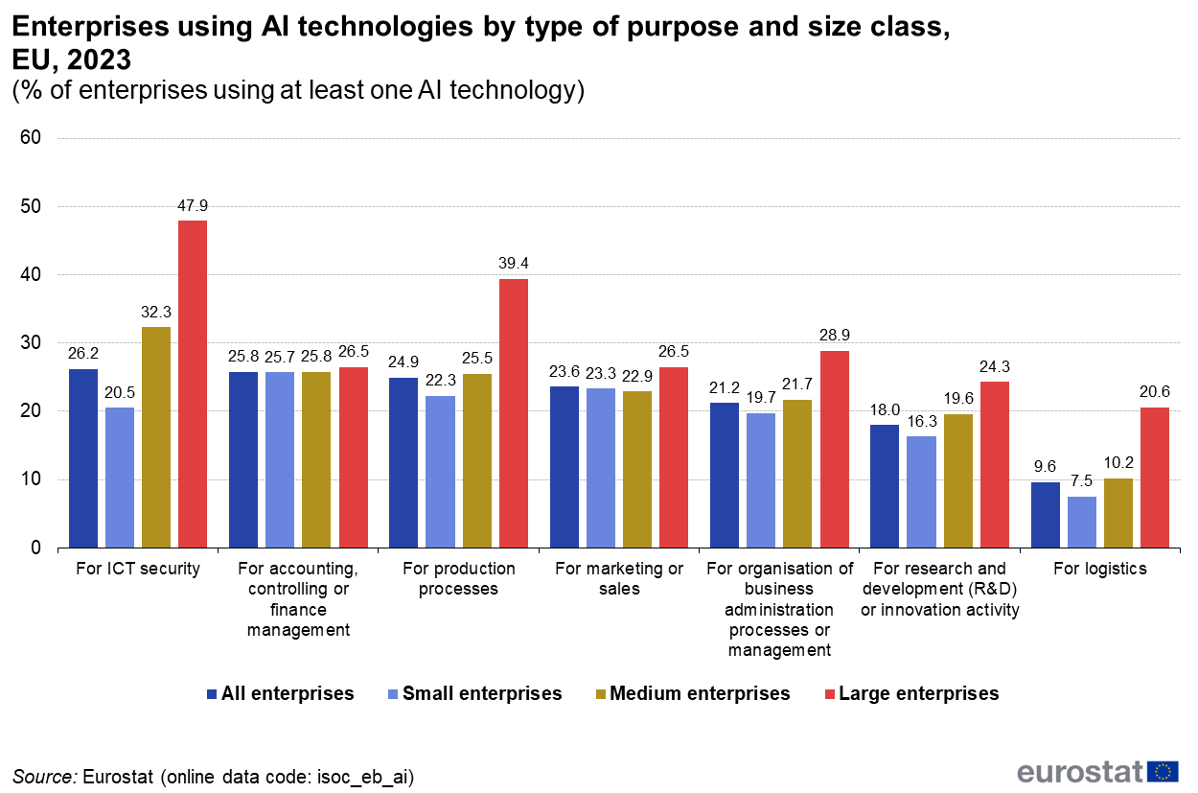
Figure 2
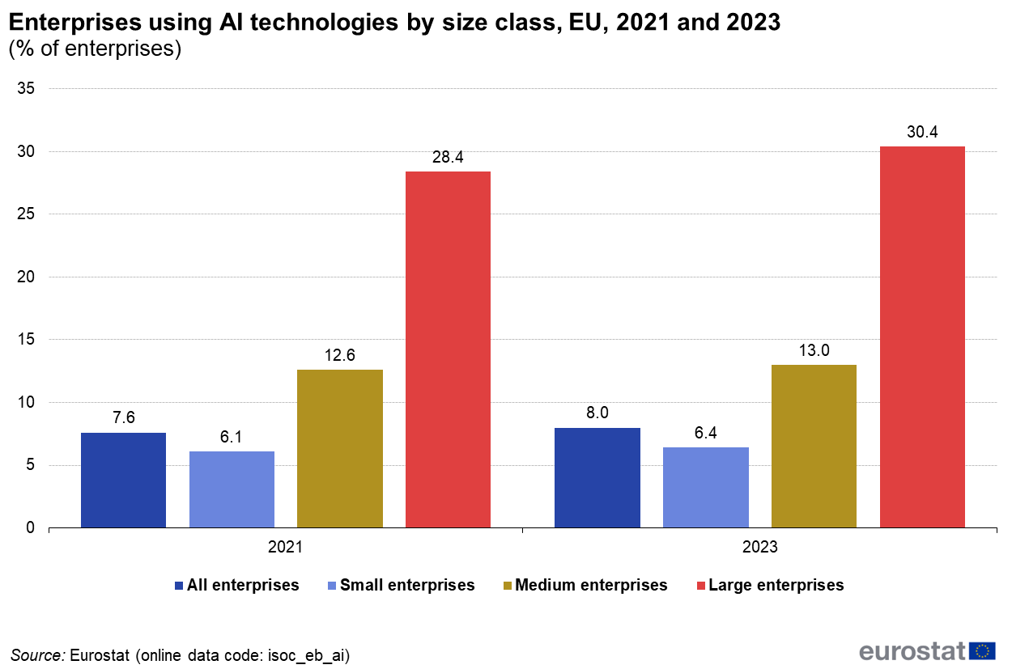
Figure 3
Figure 4
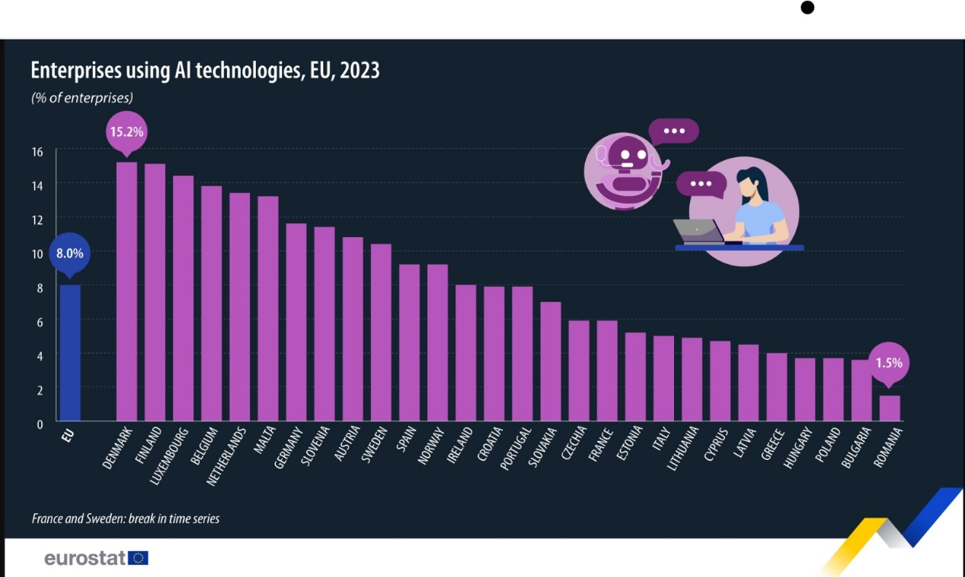
Figure 5
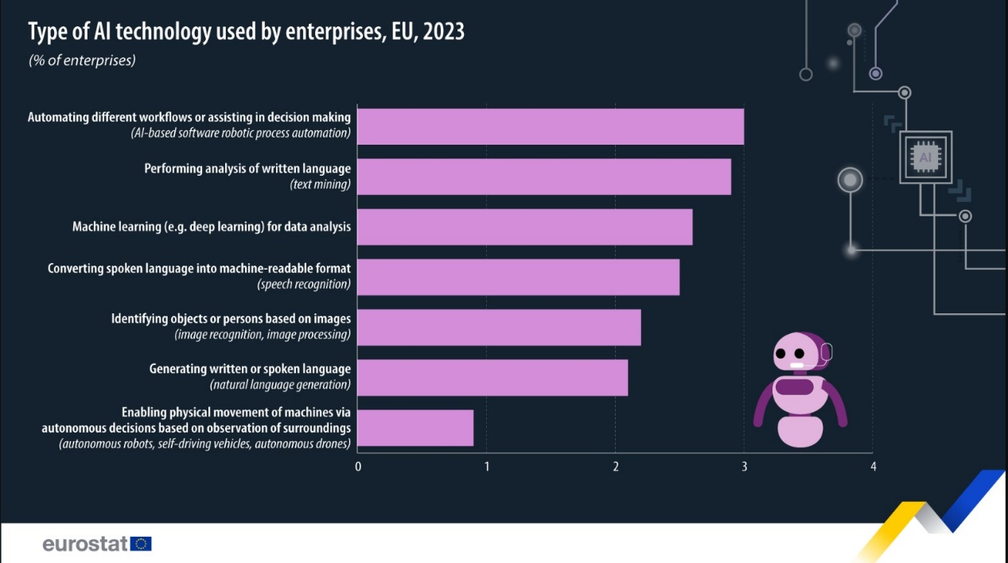

Conclusion
Germany, the United Kingdom, and Finland are at the forefront of advancements in Data Science and Deep Learning, each with unique strengths and strategic approaches. Germany's industrial prowess, the UK's innovation ecosystem, and Finland's focus on AI education and practical applications collectively contribute to the global AI landscape. These countries' efforts in research, industry collaboration, and government support ensure their continued leadership in Data Science and Deep Learning, driving technological progress and economic growth.

Reference
- Oxford-Artificial-Intelligence-Programme
- Oxford-Ai-
- Cambridge_AI_Labortory
- Cambridge_Acceleratescience
- UCL_AI-blog
- UCL_AI-center
- University_Of_London-AI
- University_Of_London-Queen_Mary
- TUM_AI
- TUM_ai
- TU_Berlin_AI
- TU_Berlin-Data_Science
- Aachen_University_AI_center
- RWTH-Aachen-University-Data-Protection
- Aalto_University_FCAI
- Aalto_University_Erasmus Mundus
- University_Of_Helsinki_AI
- University_Of_Helsinki_Data_analysis
- University_Tampere_AI hub
- Finland_Wolt
- Finland_NOKIA
- Germany_Openxcell
- United_Kingdom-Meta_AI
- United_Kingdom_Open_AI
- United_Kingdom_Google_AI

