## Gather the sensor fluctuation

Just place the sensor on a sufficiently flat and stable surface (I used my glass table) and connect it to my laptop through Bluetooth. Record 5,000 samples, which is about 25 sec.

The results of sensor fluctuation on XYZ-axis is as below:

(Summary)



(Distribution by frequency)

While the raw data is within (mean-2σ, mean+2σ), I will ignore it by zero.

Meanwhile, before integration, each raw data should be deducted by the mean value of its fluctuation, respectively.

## Utilize the sensor fluctuation

(Trajectory before processing)

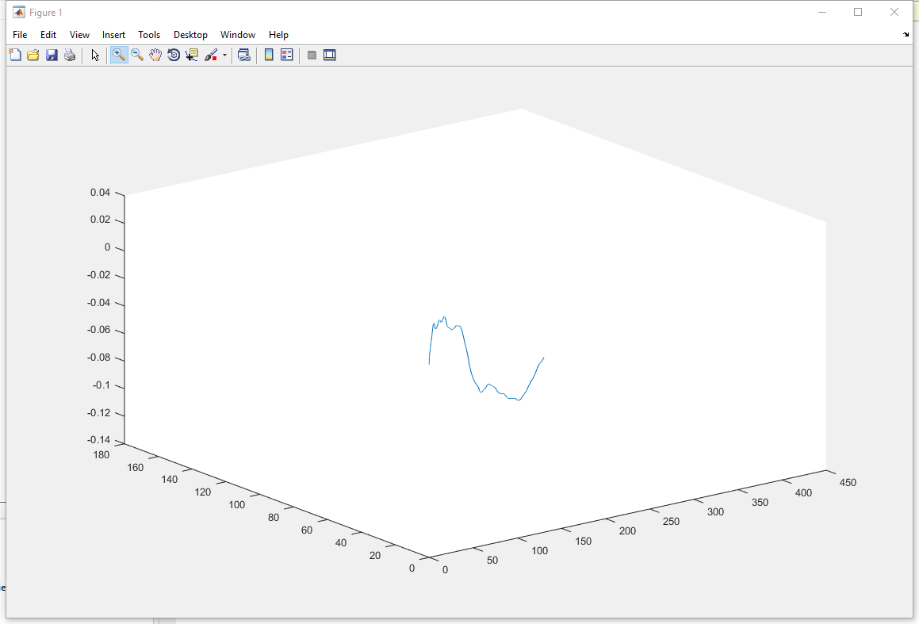

Step 1. Before integration, each raw data should be deducted by the mean value of its fluctuation, respectively.

(Trajectory after Step 1)

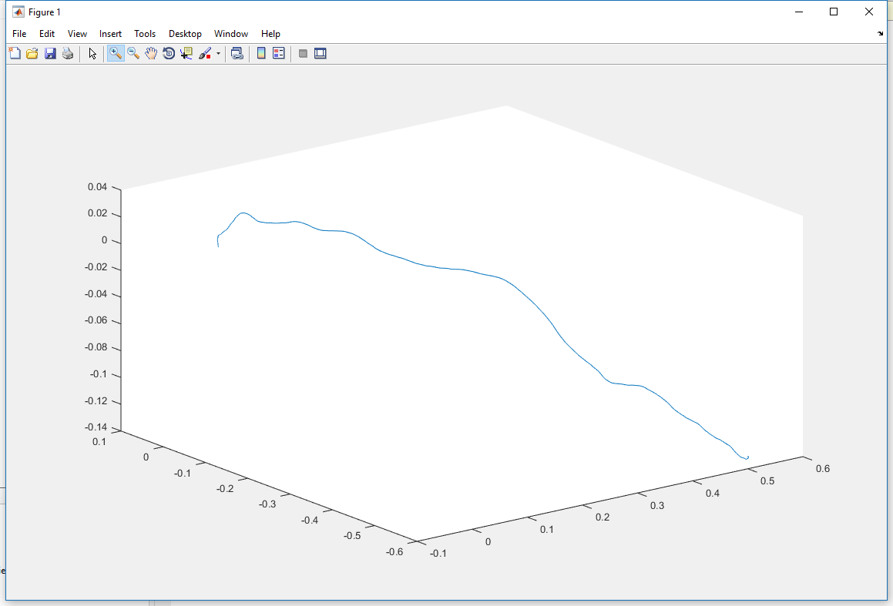

Step 2. While the raw data is within (mean-3σ, mean+3σ), I will ignore it by zero.

(Trajectory after Step 2)

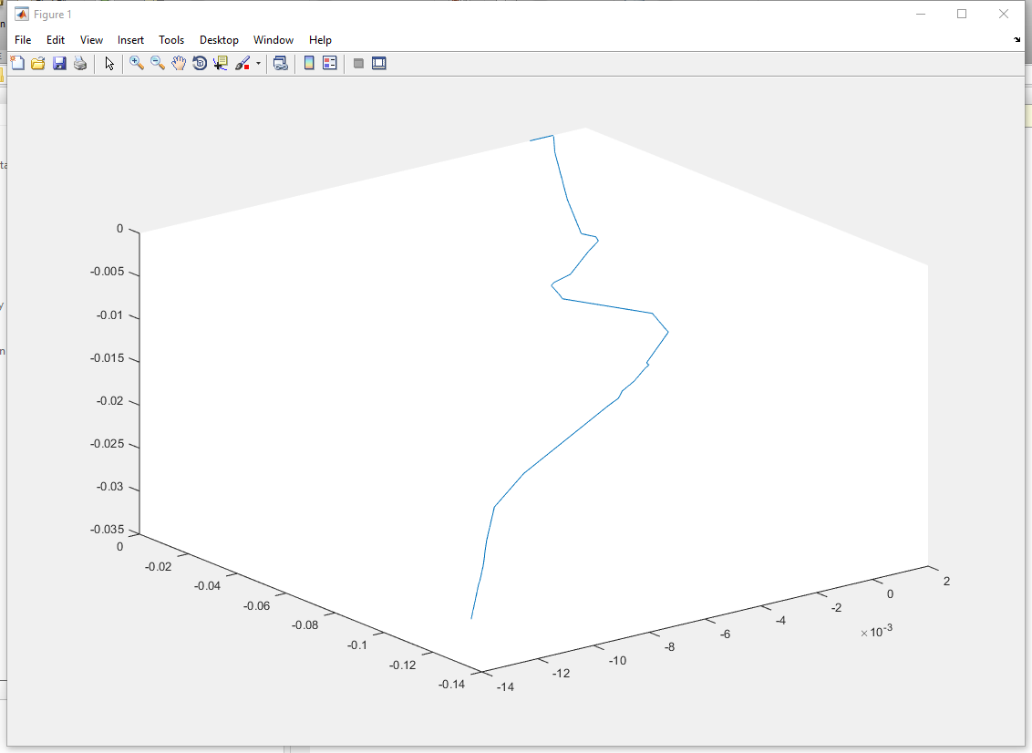

## Conclusion of Zero Velocity Update

There is already a significant improvement (3 order of magnitude, ~103) after Step 1, indicating that the IMU sensor was not well calibrated. Instead, the IMU sensor has a stable bias as shown in the table. By deducting the mean value of acceleration the sensor provided, I manually calibrated the IMU sensor.

However, as I applied Step 2 of Zero Velocity Update, the error had shrink by 0.5~1.5 order of magnitude (3~30 times), as the precision increased to centimeters at its best.