## Plan for experiments:

1. **Assume** the offset for each axis is **uniform**, i.e. for opposite direction, the raw data was **offseted** by the same value.
2. Manually calibrate it to zero. As it is stationary, it should be zero.
3. Manually get direction and deduct the raw acceleration by DotProduct<direction, gravity>.
4. Ideally, as the testing method I have, while I spinning the IMU around a point, the trajectory should remain sufficiently small.
5. In sum, what we want is the calibration of a on 3 axes, i.e. the zero point of a of 3 axes

the calibration of 3 angular directions

the error tolerance of a on 3 axes, i.e. mean±3.5σ.

The trajectory process should be:

Raw data of α => (Remove offset & ZUPT by tolerance) => integrate for direction

||

v

Raw data of a => (Remove offset) => (Remove g by direction) => (ZUPT by tolerance) => integrate => trajectory

## Verification: isotropy of IMU – failed.

**Reason: because we don’t know.**

Just place the sensor on a sufficiently flat and stable surface (I used the floor in MS 6627) with **six** different directions. Record 10,000 samples, which is about 50 sec.

To get the gravity for the hook direction, I use “stationary” suspension for the IMU as shown below:

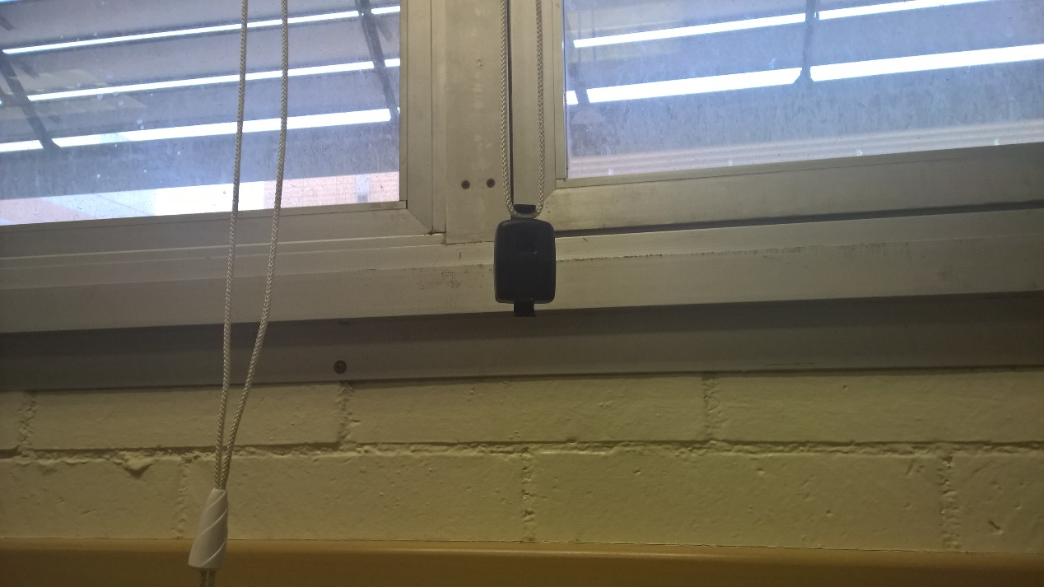

The results of sensor fluctuation on XYZ-axis is as below:

#### Experiment 1 – button upwards



#### Experiment 2 – button downwards



#### Experiment 3 – button leftwards



#### Experiment 4 – button downwards



#### Experiment 5 – button up forwards



#### Experiment 6 – button down forwards



## Summary: at least I get the standard deviation

As it came to my mind and observation that the incoherence of the raw values may be caused from non-flat surfaces on the side of IMU on experiment 3 & 4 (which requires suspension on 5 & 6), I will only use experiment 1 & 2 data for calculating the offset.

Meanwhile, repeating experiments with different directions verified σ remains the same for each axis as IMU is stationary, all the experiments is not that meaningless.

I will repeat the experiment 1 & 2 for more precise offset and gravity data. To reduce the error, I will collect about 10^5 samples.

## Experiment: get the offset and gravity – failed.





X for each experiment did not agree with each other, this concludes that the IMU unit is subject to a portion of gravity in the sensor. In other words, the axis is not perfectly parallel to its surface.

## Experiment: using vector analysis to get and remove its “offset” – failed.

For this time I will disregard the existence of “offset”. Its Z-axis is not directing 100% parallel to gravity. So I will get a vector of g = (0, 0, -1) as it is with an initial angle (or matrix) with each direction as below:

***v*** = A***g***

With this initial angle and the angular acceleration gathered and/or using quaternions, we can get the actual acceleration.

## Experiment: get the mean and tolerance of α from 6 experiments – succeeded.

As through observation, we can just treat the gyroscope as tolerance of 0±2 for ZUPT.

## Plan: utilize the quaternion.

As all my work this week to get the offset failed, I plan to utilize the quaternion. As it is clear that

$$v=Ag$$

While v is the direction of gravity measured by IMU, A is the difference in angle matrix by v and g, and g is the vector of gravity.

Also, we can use quaternion [a, b, c, d] => matrix A.

Also, we can use A => inv(A). Thus we get

$$A^{-1}v=g$$

Then in order to remove the offset, we need to measure g and remove Ag with respect to v and its quaternion => A.

OK, not just g, but also the mean, standard deviation, and distribution of g. With successfully removal of g, we can get the “naked” acceleration with ZUPT and using this acceleration to calculate trajectory.