* The idea of filters would be intrinsic:
  + The **gyroscope** is very precise, but tend to drift.
  + The **accelerometer** is a bit unstable, but does not drift.
* 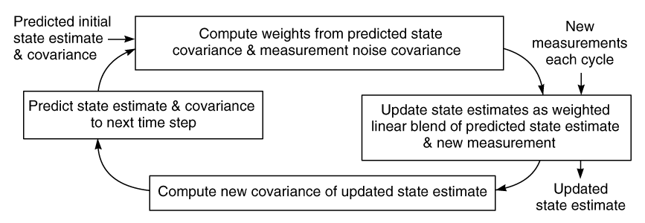Kalman filter

For example...

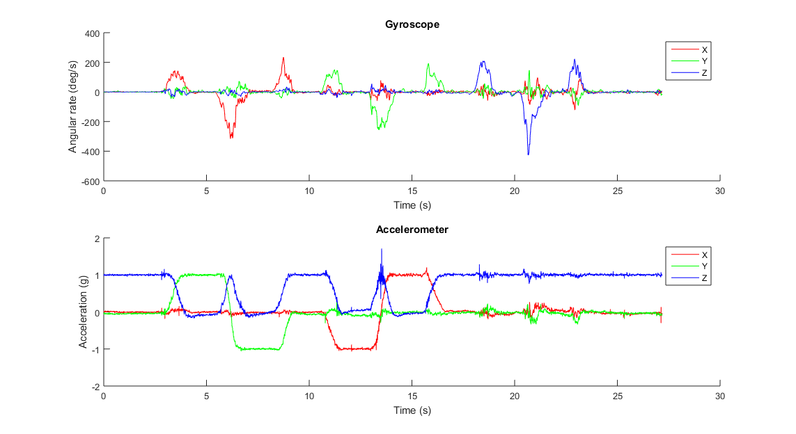

And the result from KF…

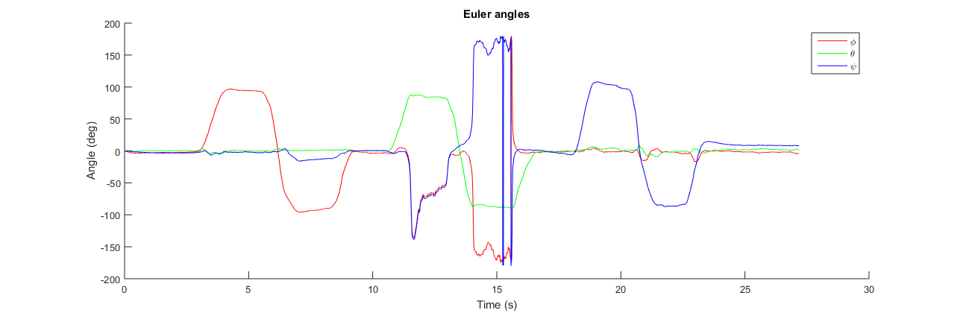

Calculated gravity vector from Euler angles and the a with g removed

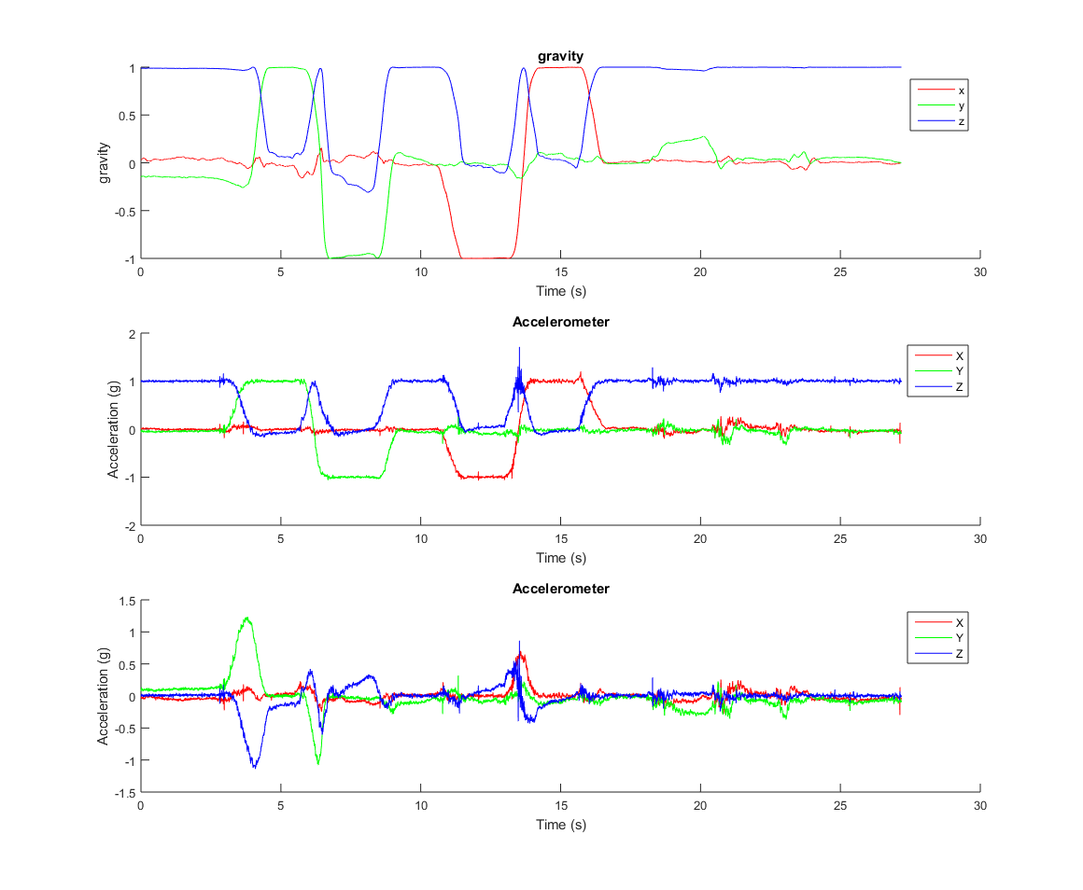

And the trajectory:

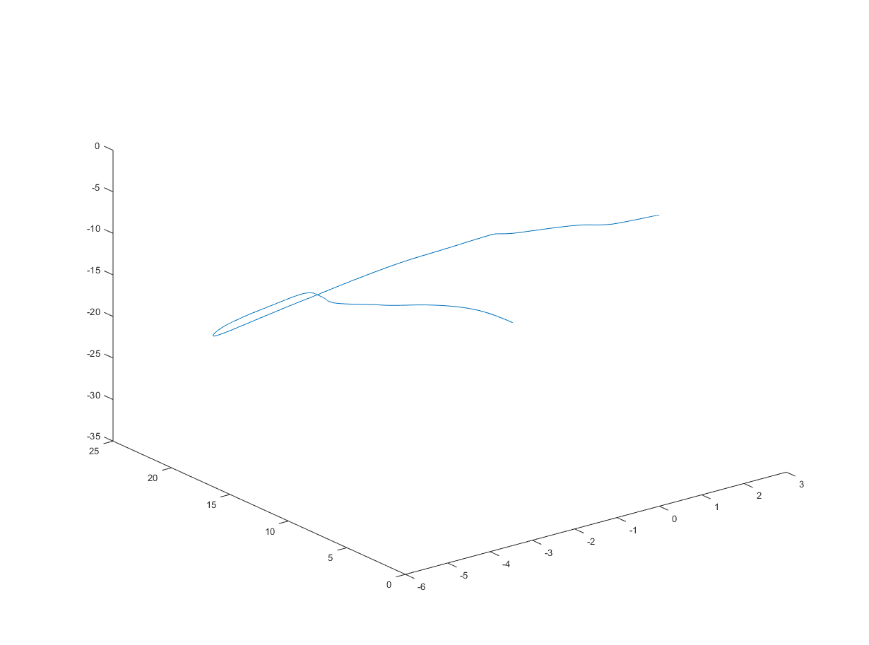

And this is before ZUPT and it’s for 30s…

If we add a ZUPT filter, it would be more reliable.