The calibration is done with the LGM model. We fix the Hull-White mean reversion to a fixed value. The H(t) LGM parameter is then also completely fixed, see relation (186) below. We then only need to find the zeta(t) to find our Hull-White volatilities.

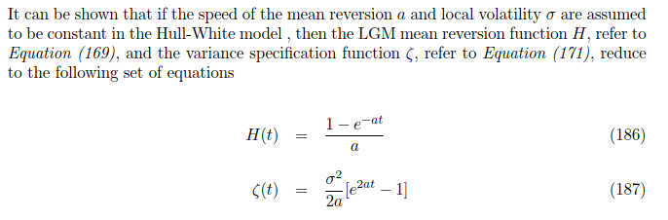

Note that relation (187) between zeta and sigma is a little different for piecewise constant volatilities. We then have that

$$ζ(t_i) = ζ(t_(i-1)) + \frac{{σ(t_(i-1);t_i)}^{2}}{2a}\left[e^{2at_i}-e^{2at_(i-1)}\right]$$

So that once zeta has been calibrated with LGM model. The piecewise constant sigmas can be determined iteratively, starting with the lowest.

# Interest rates

* We calibrate to ATM swaptions for interest rates
* These swaptions have a certain expiry (when the option ends) and tenor (maturity time of the underlying swap)
* Under LGM the swaption price depends only on $ζ(t_expiry)$, so we select swaptions with different expiries to find for each swaption the corresponding $ζ(t_expiry)$ from which we can derive the piecewise constant hull-white volatilities
* For each expiry we can chose the tenor 🡪 this is a model assumption. Two common ones are co-tenor (chose a fixed tenor, e.g. 5Y for each swaption) and co-terminal (chose the tenor of the swaption so that expiry + tenor = maturity of the underlying derivative[1]).
* Below gives a summary on how a swaption is priced under LGM, including dual-curve framework (i.e. LIBOR forwards, OIS discounting) assuming a deterministic LIBOR-OIS basis

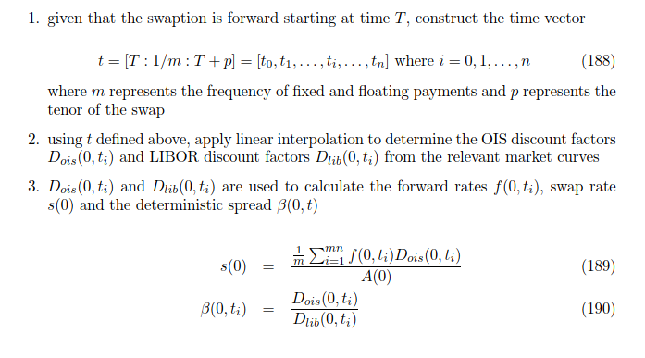

So the beta vector denotes the OIS-LIBOR basis. A(0) is the annuity, determined as sum_j fixed_yearfrac * D(0,t_j)

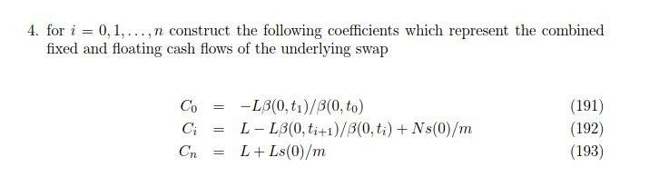

* Note that we are now working on the **FIXED** payment times. We are mapping all cashflows (which happen at different times if fixed and floating frequencies are different) to the FIXED payment times. This mapping is exact. p.113-114 of Lichters, Stamm & Gallagher explains the maths behind this.
* So in this notation m is the amount of fixed payments in a year

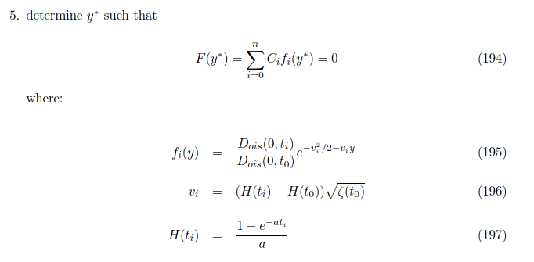

* F_i(y) is the price of a zero-coupon bond (discount factor) under the LGM model.
* Since C_i represent the cashflows of the underlying swap, Equation (194) is just saying that we are going to find LGM parameter y, so that the sum of the discounted cashflows of the underlying swap is zero 🡪 Find the at-the-money value of y under LGM

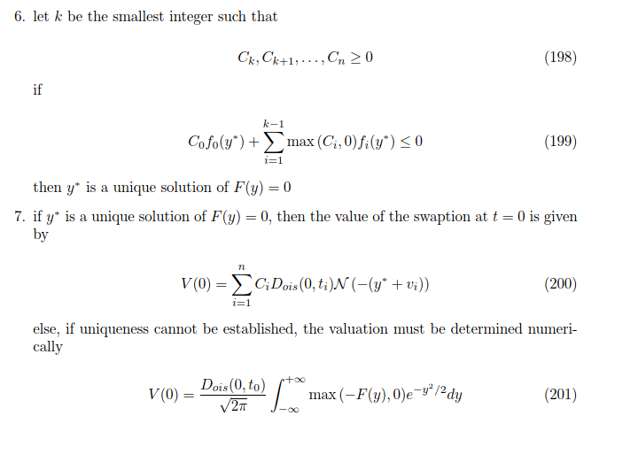

* Equation (200) gives the pricing formula of the ATM swaption under LGM
* This only works if y* is unique 🡪 if not we have to go to the general integral formula for swaptions under LGM (equation (201))

The goal of the calibration is thus to find $ζ(t_i)$ so that equation (200) gives the swaption price closest to the market price of the swaption. This is done using bounded (zeta >=0) minimization of |V(0; zeta) – Market_price|^2 using the L-BFGS-B method.

1. Underlying derivative for which we are calculating the XVA