Recommended Assignment - That Portfolio Though

**-Overview**

In this assignment, you'll build a professional portfolio site using HTML/CSS. These instructions include a short style guide; follow it to design an aesthetically pleasing layout while creating different kinds of complex HTML elements.

**-Before You Begin**

* Welcome to your first opportunity as a front-end web designer. You will be advocating for your most important client—yourself! By making a portfolio, you'll take your first step toward building your web development brand.

* This will be one of your harder assignments, if only because you're just getting your feet wet in web design. Trust us, though; it will get easier. Invest your time in this assignment, and it will pay dividends!

**-Instructions**

1. Create a new repository in GitHub called `Basic-Portfolio`.

2. Clone this repository to your computer using the process we went over in class.

3. Navigate to the `Basic-Portfolio` folder that you just cloned onto your machine. Inside this folder, create the following:

* 3 HTML documents: `index.html`, `contact.html` and `portfolio.html`.

* A folder called `assets`.

* Inside the assets directory, make two additional folders: `css` and `images`.

* In the `css` folder, make a file called `style.css`.

* In the `css` folder, make a file called `reset.css`, and include the code found from the Meyerweb reset located http://meyerweb.com/eric/tools/css/reset/reset.css.

* In the `images` folder, save the images you plan on using (like your profile image, the placeholder images for the portfolio, and the social icon images).

4. Push the above changes to GitHub.

* Make sure to `git add .` and `git commit -m "initial site files"`. Then type `git push origin master` to push your changes to your GitHub repo.

5. Reference these screenshots for your site:

Portfolio About

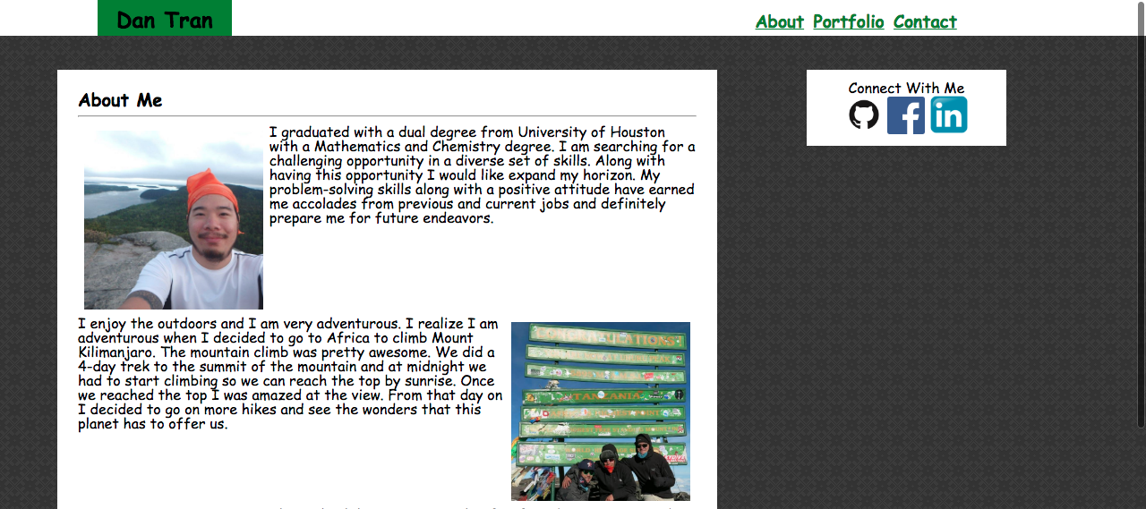

Portfolio Contact

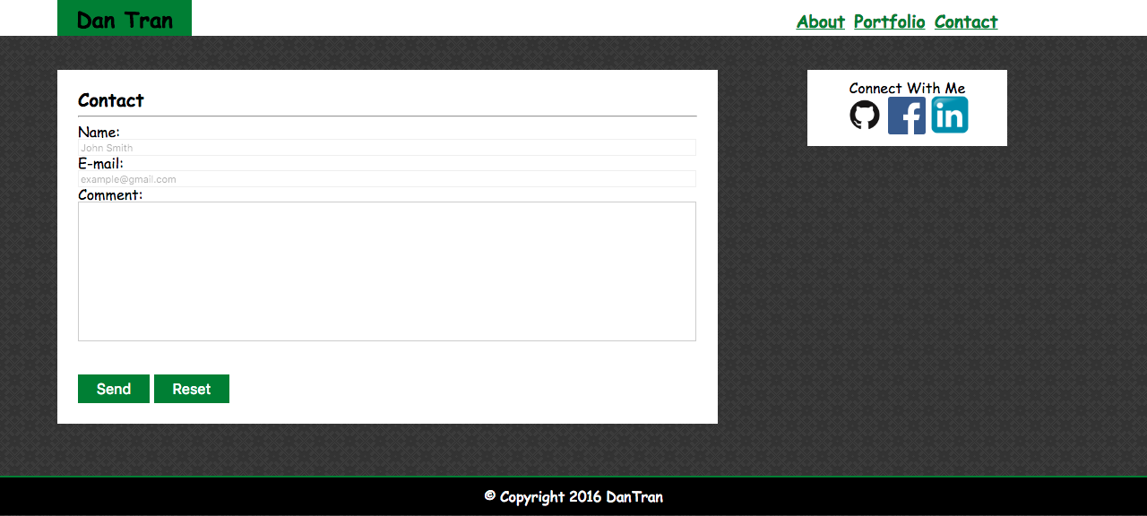

Portfolio Gallery

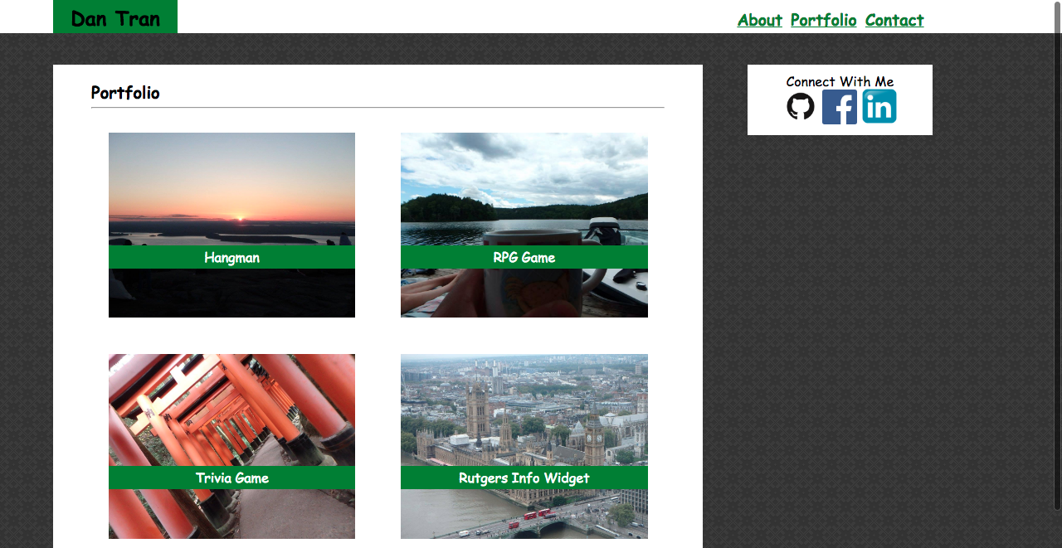

* **IMPORTANT** Your site's layout must match the designs in these screenshots. You'll find the specs for these designs below.

6. When you create a website, it's standard practice to code your HTML files before writing any CSS and to write up one HTML file before moving onto the next. Write your HTML semantically, too:

* If something is a heading, you use a heading tag.

* If something is a list, you use an unordered or ordered list tag.

* So on and so forth.

7. The content for the `index.html` should be unique to **you**.

* Write a paragraph or two about yourself. Make it fun, show your personality!

* The main logo where it says "Your Name" should say your name. This may make the logo section smaller or wider depending on how long your name is—that is fine and expected.

* Add, commit, and push your code to GitHub often, especially when you complete a page.

8. After all of your HTML is written, you can begin styling your pages using the `style.css` file you created.

* Be sure to [validate your html](https://validator.w3.org/#validate_by_input).

* Consult the specs below these instructions for advice on styling your CSS files.

9. Push your changes to Github.

**-Additional Specifcations**

1. Colors _Pro-tip: Use the [Eye Dropper](https://chrome.google.com/webstore/detail/eye-dropper/hmdcmlfkchdmnmnmheododdhjedfccka) Chrome extension to find the colors used on web pages._

* Teal color (used for headings and backgrounds): `#4aaaa5`

* Regular font color (used for paragraphs and all text besides the headings): `#777777`

* Main header background color: `#ffffff`

* Main header border color: `#cccccc`

* Footer background color: `#666666`

* Main content background color: `#ffffff`

* Main content border color: `#dddddd`

2. Fonts:

* For heading fonts use `font-family: 'Georgia', Times, Times New Roman, serif;`.

* For all other fonts use `'Arial', 'Helvetica Neue', Helvetica, sans-serif;`.

3. Profile Image Found on `index.html`:

* Use a picture of yourself.

* If you don't have a picture, you can grab a placeholder image from [LoremPixel](http://lorempixel.com/). Save the images to your `images` folder.

4. Portfolio Images:

* Placeholder images can be found at [LoremPixel](http://lorempixel.com/).

* Save the images to your `images` folder.

5. Social Link Images (Github, LinkedIn, StackOverflow, etc.):

* These images can be found on [IconFinder](https://www.iconfinder.com/).

* Save the images to your `images` folder.

* Ensure that these icons are live links to your GitHub, LinkedIn, and Stack Overflow profiles.

6. Background Images:

* The background pattern used was found on Subtle Patterns https://subtlepatterns.com/. You can browse through that site and find whichever pattern you like.

Bonus

3. Make a "sticky footer." You will notice the dark grey footer will always rest just below the content. This is fine whenever your site has enough content to push it down past the height of most monitors. But if there isn't much content in the body, the footer could rest in the middle of the page:

* Try to code the footer in a way that it will always remain at the bottom of the page, no matter how short the content is. A sticky footer tutorial can be found

https://css-tricks.com/couple-takes-sticky-footer/

Helpful Hints

* Don't forget to look into these concepts: `float`, `padding`, `margin`, `display`, `overflow`, `clear` and `text-align`.