Experiment 2.1 (Reference variables)

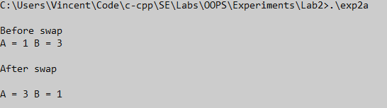

Exp 2.2(Friend functions & inline functions)

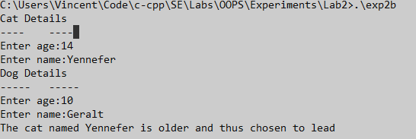

Exp 2.3 (Function overloading)

