1. 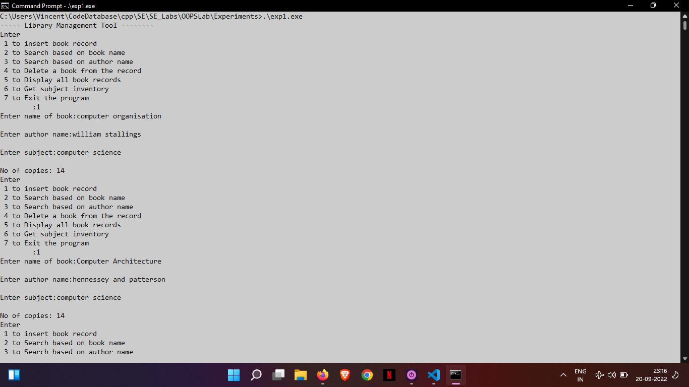 🡪 2. 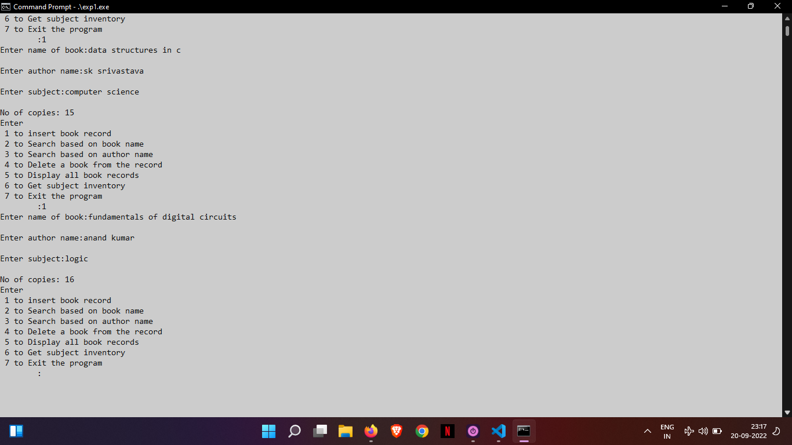

Insertion of books

3. 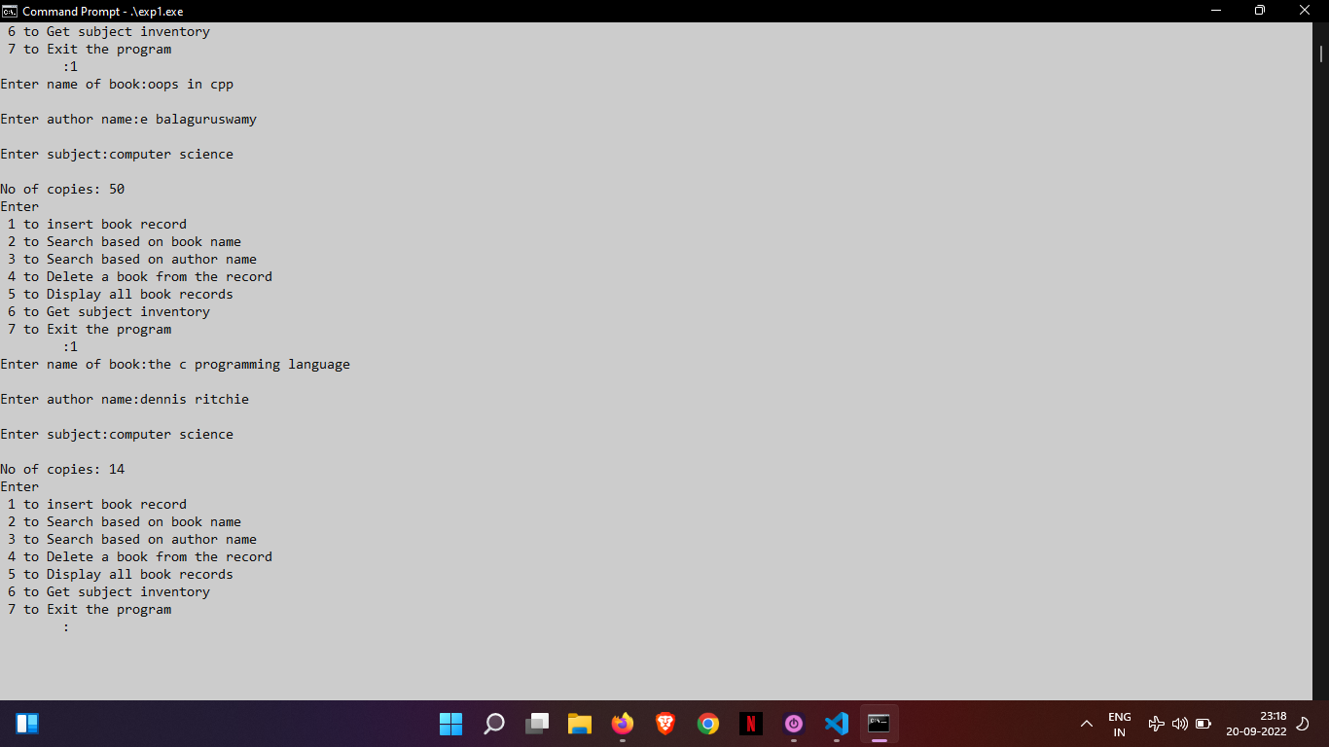 🡪 4. 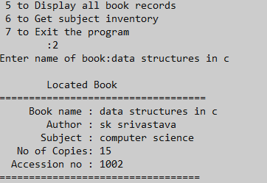

Search book by name

5. 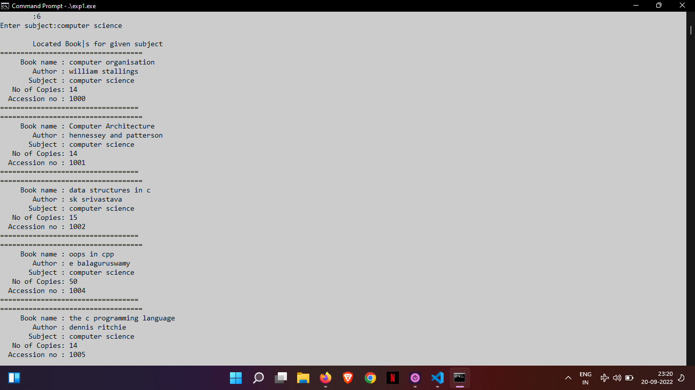 🡪 6. 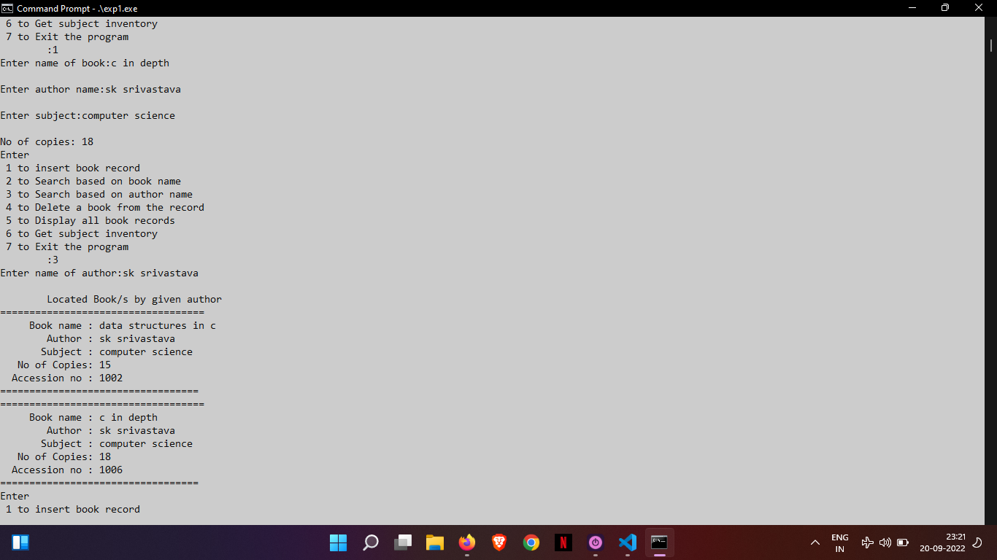

Searching by subject Searching by author name

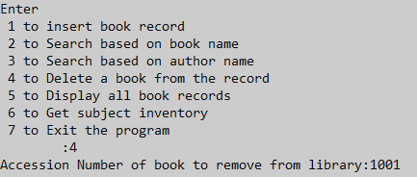

Deletion of book from library

Displaying library

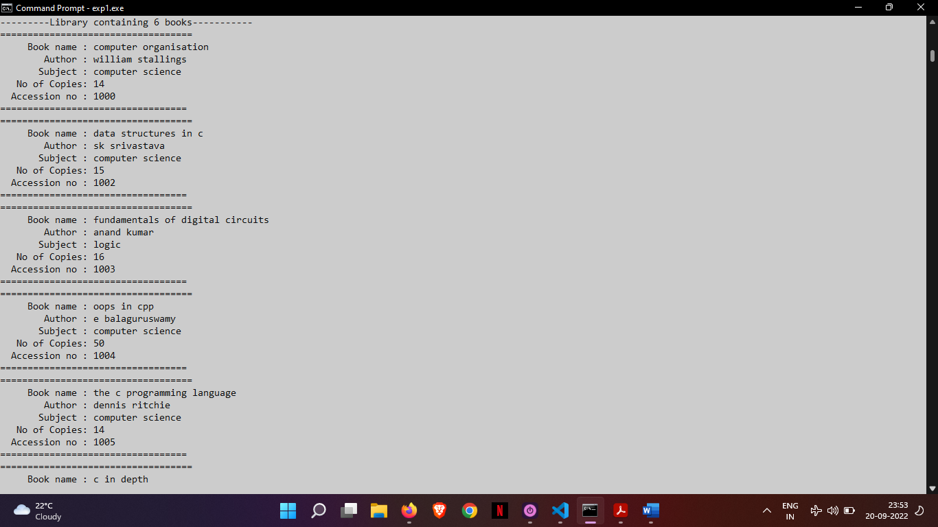

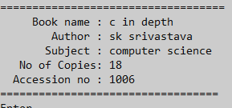

//Experiment 2

#include <iostream>

#include <iomanip>

using namespace std;

class Pair{

int x;

int y;

public:

  void getpair(int a, int b){

  x=a ;  y=b;

  };

  void putpair(){

    cout<<"X= "<<x<<"\tY= "<<y<<"\n";

  }

};

int main(){

  int a,b, n,i;

  cout<<"Enter size of object array to be created: ";

  cin>>n;

  Pair \* start = new Pair[n];

  Pair \* c = start;

  for (i = 0; i < n; i++,c++){

    cout<<"Enter two ints: ";

    cin>>a>>b;

    c->getpair(a,b);

  }

c = start;

for (i = 0; i < n; i++,c++)

  c->putpair();

delete []start;

return 0;

}

Output

