Expression Evaluation

Postfix Evaluation

Take an infix expression 4\*3+(3+2/9\*3)^3

12 + (3+0)^3 = 12 + 27 = 39

Converting the expression to postfix form using infix to postfix convertor:

*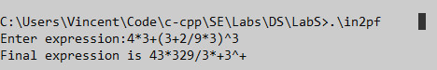*

Postfix expression obtained is 43\*329/3\*+3^+

Evaluating the postfix expression



Result matches original calculation.

Prefix Evaluation

Take an infix expression 2+3\*4-4/3

2 + 12 – 1 = 13

Converting it to postfix using infix to prefix convertor

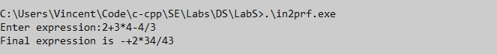

Evaluate it using prefix evaluator

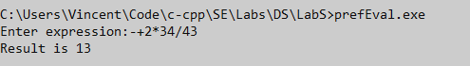

The answer matches original calculated value.

Thus conversions of infix to prefix and infix to postfix, as well as the evaluation of prefix/postfix expressions, is carried out.