Barone BAN 663 Final Project
  - Barone Records: Album Revenue Deep Dive
Vincent Barone
2026-05-08

Introduction
This report was an analysis I performed on synthetic data to utilize R’s analysis properties and take everything I have learned throughout this course and apply it to a big dataset

Business Context
With roughly 200 artists across a variety of genres, including Lil Wayne, Drake, Rihanna, Billy Joel, Paul Anka, Michael Jackson, Fleetwood Mac, Garth Brooks, Bruno Mars, and some up-and-coming artists, Barone Records is a midsize record label in the music business. The label wants to understand what drives album revenue and if budget allocation has an effect on it? Additionally management feels they are underperforming in some international landscapes and want to know what the optimal artist type is for each country (debut, semi-popular, superstar).

Business Questions
- Q1: Does marketing budget and album production budget have positive relationship with each artist’s album revenue?
- Q2: How does each artist type (Debut, Semi Popular, Super Star) perform in each country?

Decision Stakes
Q1: If marketing budget and album budget have a positive relationship with album revenue, the manager should allocate more money to both budgets as it will help drive higher revenue for each album. If it does not have a positive relationship than, the manager should explore other variables that could potentially effect revenue.
Q2: If Superstars generate the most revenue in all 4 countries, the manager should increase more spending into superstars. If one artist type performs better than superstar in one of the countries, the manager should readjust marketing/album budgets in that country.

Variable Descriptions
Artist_ID: A unique numeric identifier for each artist in the label’s roster. Artist_Name: The artist’s stage name or group name. Age: The artist’s current age in years. Genre The primary genre the artist is associated with (rap,pop,country,etc) Number_of_Albums: The total number of albums the artist has released under Barone Records Total_Revenue: Cumulative revenue generated by the artist across all albums and markets, measured in dollars. Album_ID: A unique numeric identifier for each album. Album_Release_Date: The date the album was released. Album_Name: The title of the album. Album_Genre: The genre classification for the album. Units_Sold: Total number of units sold worldwide. Album_Budget: The production budget allocated to create the album (studio time, producers, mixing, etc.). Marketing_Budget: The promotional budget allocated to market the album (ads, social media, touring support, etc.). USA_Revenue: Revenue generated from U.S. sales. UK_Revenue: Revenue generated from U.K. sales. Asia_Revenue: Revenue generated from Asian markets. Italy_Revenue: Revenue generated from Italy. Artist_Type_During_Album: Categorical variable describing the artist’s status at the time of the album release:

Data Specification (Path A2 only — delete this section for A1 and B)
AI tool used: Claude Sonnet | Date generated: April 30th 2026
Table structure and variable decisions:
Write in plain prose. For each table, describe its purpose, primary key, and the key variables — why each exists, its realistic value range, expected distribution shape, and any business relationships between variables.
Table 1 which is “Artists” contains 200 rows, with the primary key being Artist_ID. There are 10 different Genres, ranging from rap all the way to gospel music, this variable helps analyze what the consumers like listening to. Also included is total number of albums the artist released, as it can help us understand, how long of a career an artist had. Total_Revenue is a great variable to see how much an artist made throughout their career.
Table 2, which is “Album_Data” is much more detailed with 1471 rows, and it’s primary key is Album_ID, and its foreign key being Artist_ID. Album_ID is the unique code to identify which album it is, and artist_id is included to make it easier to join the tables later on.Album_Budget is how much Barone Records spent on studio time, production costs. This is a great metric to understand the cost that went into the project. Marketing_Budget is how much was spent on marketing the Album, to see if it paid off. USA, UK, ASIA and Italy_revenue are all the total amount of revenue that album made in each country. This enables management to see country-wide performance. Lastly Artist_Type_During_Album is how popular the artist was at the time of their Album release. This is a great variable because it has so many avenues for deeper analysis.
Quality issues requested:
Issue | Column | Details
Mixed date formats | Album_Release_Date | ~35% YYYY-MM-DD, ~65% MM/DD/YYYY
Missing values (~5%) | Units_Sold | 73 blanks injected at random
Inconsistent capitalisation | Artist_Type_During_Album | ~15% of rows in lowercase or ALLCAPS
Duplicate rows | Album_Data | 3 rows with identical Album_ID
Negative revenue | USA_Revenue | 1 row set to -$9,999
Zero budget | Album_Budget | 1 row set to $0
Extreme outlier | Units_Sold | 1 row set to 999,999,999
Corrections made after validation:
Type: Completeness. Business justification: Units sold and the budget missing are key inputs to the budget revenue regression. Additionally, if any of the country revenues had missing values, it would completely throw off the analysis on total revenue, as all the country revenues sum up to the total. Observation: found that Units sold had 73 missing values, and every other important numerical data point does not have any missing values.

Section 2 — Data Orientation and Quality Assessment

Rapid Orientation
## Rows: 200
## Columns: 6
## $ Artist_ID <dbl> 1, 2, 3, 4, 5, 6, 7, 8, 9, 10, 11, 12, 13, 14, 15, 16…
## $ Artist_Name <chr> "Lil Wayne", "Drake", "Rihanna", "Billy Joel", "Paul …
## $ Age <dbl> 41, 37, 36, 75, 83, 50, 65, 62, 38, 23, 73, 40, 63, 5…
## $ Genre <chr> "Rap", "Rap", "Pop", "Pop", "Pop", "Pop", "Rock", "Co…
## $ Number_of_Albums <dbl> 12, 11, 10, 12, 13, 13, 13, 13, 8, 12, 10, 6, 7, 12, …
## $ Total_Revenue <dbl> 12471301, 54764611, 21434414, 14364231, 50412533, 446…
## Rows: 1,471
## Columns: 13
## $ Album_ID <dbl> 1, 2, 3, 4, 5, 6, 7, 8, 9, 10, 11, 12, 13, 14…
## $ Artist_ID <dbl> 1, 1, 1, 1, 1, 1, 1, 1, 1, 1, 1, 1, 2, 2, 2, …
## $ Album_Release_Date <chr> "04/03/2012", "11/03/2007", "2000-11-23", "03…
## $ Album_Name <chr> "Burning Empire", "Lost Shadows", "Silver Nig…
## $ Album_Genre <chr> "Rap", "Rap", "Rap", "Rap", "Rap", "Rap", "Ra…
## $ Units_Sold <dbl> 30639218, 54709305, 20390333, 46274728, 28398…
## $ Album_Budget <dbl> 1250467, 1380084, 466097, 1213769, 1403225, 9…
## $ Marketing_Budget <dbl> 160122, 104683, 74289, 196771, 38143, 348367,…
## $ USA_Revenue <dbl> 6000000, 6000000, 5237767, 6000000, 6000000, …
## $ UK_Revenue <dbl> 1250000, 1250000, 955473, 1250000, 1080043, 1…
## $ Asia_Revenue <dbl> 310000, 310000, 310000, 310000, 310000, 31000…
## $ Italy_Revenue <dbl> 950000, 581690, 950000, 950000, 950000, 71450…
## $ Artist_Type_During_Album <chr> "Super Star", "Semi Popular", "Semi Popular",…
## [1] 200 6
## [1] 1471 13
## [1] "Album_ID" "Artist_ID"
## [3] "Album_Release_Date" "Album_Name"
## [5] "Album_Genre" "Units_Sold"
## [7] "Album_Budget" "Marketing_Budget"
## [9] "USA_Revenue" "UK_Revenue"
## [11] "Asia_Revenue" "Italy_Revenue"
## [13] "Artist_Type_During_Album"
## [1] "Artist_ID" "Artist_Name" "Age" "Genre"
## [5] "Number_of_Albums" "Total_Revenue"

Quality Check 1
Quality Check Type: Consistency. Business justification: Consistency matters because if there are multiple artists or duplicate albums, then the data will be further skewed and will have double-counted data, which will throw off results, especially for question 2, which deals with artist type. Observation: I found 3 duplicate Album_Id values. Album_ID 331, 690, 1195 all have duplicated Albums.

Quality Check 2
Type: Completeness. Business justification: Units sold and the budget missing is a key inputs to the budget revenue regression. Additionally, if any of the country revenues had missing values, it would completely throw off the analysis on total revenue, as all the country revenues sum up to total. Observation: found that Units sold had 73 missing values, and every other important numerical data point does not have any missing values.

Plausibility Check
Quality Type: Validity. Report counts: Ensuring there are no negative revenue values, and looking for extreme outliers Observation: I found that USA_Revenue has a negative value and there was an album budget that had 0 or less than budget. This would make my analysis extremely challenging because it would skew the revenue totals and also negative revenue is not feasible in real life.

Quality Verdict
The current quality of the dataset is not ready for analysis and some modifications need to be made.
The dataset is not ready as there were 3 Duplicate Album_ID, 73 N/A values, negative USA Revenue, <0 Album budget, and one huge outlier for units sold that is greater than 900,000,000 Action taken: I am going to remove the duplicated Albums, fix the N/A values. I am also going to remove the negative values, and delete the outlier for units sold. This will hopefully result in a much cleaner dataset.

Section 3 — Data Preparation and Integration
cat("Records before filter:", nrow(Album_clean), "\n")
## Records before filter: 1468
Album_clean <- Album_clean %>%
filter(
USA_Revenue > 0,
Album_Budget > 0,
is.na(Units_Sold) | Units_Sold <=90000000
)
cat("Records after filter:", nrow(Album_clean), "\n")
## Records after filter: 1465
cat("Records removed:", nrow(Album) - nrow(Album_clean) , "\n")
## Records removed: 3
Filter justification: There were multiple values, like Negative USA Revenue, zero Album Budget, and Units Sold greater than 90,000,000, that were implausible in the business world and needed to be filtered out
# Total_Album_Revenue is the sum of the 4 countries revenue
analytical_data <- analytical_data %>%
mutate(
Total_Album_Revenue = USA_Revenue + UK_Revenue + Asia_Revenue + Italy_Revenue
)
I created Total Album Revenue because it sums all the 4 countries’ revenues, and allows me to see how the album performed holistically.
glimpse(analytical_data)
## Rows: 1,465
## Columns: 19
## $ Artist_ID <dbl> 1, 1, 1, 1, 1, 1, 1, 1, 1, 1, 1, 1, 2, 2, 2, …
## $ Artist_Name <chr> "Lil Wayne", "Lil Wayne", "Lil Wayne", "Lil W…
## $ Age <dbl> 41, 41, 41, 41, 41, 41, 41, 41, 41, 41, 41, 4…
## $ Genre <chr> "Rap", "Rap", "Rap", "Rap", "Rap", "Rap", "Ra…
## $ Number_of_Albums <dbl> 12, 12, 12, 12, 12, 12, 12, 12, 12, 12, 12, 1…
## $ Total_Revenue <dbl> 12471301, 12471301, 12471301, 12471301, 12471…
## $ Album_ID <dbl> 1, 2, 3, 4, 5, 6, 7, 8, 9, 10, 11, 12, 13, 14…
## $ Album_Release_Date <dttm> 2012-04-03, 2007-11-03, 2000-11-23, 2000-03-…
## $ Album_Name <chr> "Burning Empire", "Lost Shadows", "Silver Nig…
## $ Album_Genre <chr> "Rap", "Rap", "Rap", "Rap", "Rap", "Rap", "Ra…
## $ Units_Sold <dbl> 30639218, 54709305, 20390333, 46274728, 28398…
## $ Album_Budget <dbl> 1250467, 1380084, 466097, 1213769, 1403225, 9…
## $ Marketing_Budget <dbl> 160122, 104683, 74289, 196771, 38143, 348367,…
## $ USA_Revenue <dbl> 6000000, 6000000, 5237767, 6000000, 6000000, …
## $ UK_Revenue <dbl> 1250000, 1250000, 955473, 1250000, 1080043, 1…
## $ Asia_Revenue <dbl> 310000, 310000, 310000, 310000, 310000, 31000…
## $ Italy_Revenue <dbl> 950000, 581690, 950000, 950000, 950000, 71450…
## $ Artist_Type_During_Album <chr> "Super Star", "Semi Popular", "Semi Popular",…
## $ Total_Album_Revenue <dbl> 8510000, 8141690, 7453240, 8510000, 8340043, …
cat("Final analytical dataset:", nrow(analytical_data), "rows,",
ncol(analytical_data), "columns\n")
## Final analytical dataset: 1465 rows, 19 columns

Section 4 — Visual Analytics
Each chart addresses one business question. Every insight follows the Writing Rule.

Chart 1 — The below scatter plot illustrates the relationship between Album Budget and Album Revenue
Business question addressed: Does Album Budget Effect Total Album Revenue? Prediction before plotting: I expect a positive scatterplot because it would make sense that the more money spent on budgeting results in a higher total revenue
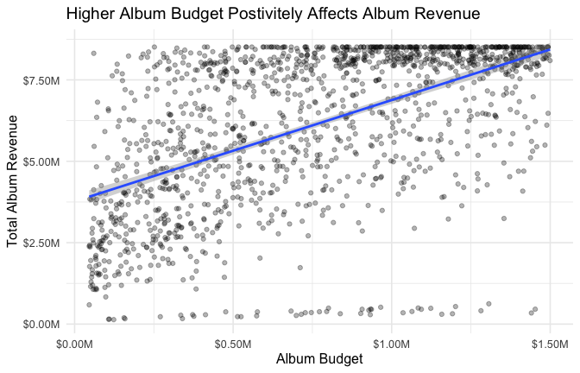
Insight:There is a positive Relationship Between Album Budget and Album Revenue which means Barone Record’s should allocate more money towards Album Budget, to help drive revenue. Album’s with $1 Million budgets, made about 5 Million in Revenue, and albums with 1.5M in budget made about $7M

Chart 2 — The below boxplot examines how each genre performs in revenue
Business question addressed: Which Genres Perform Best in Total Revenue Prediction before plotting: I predict Pop Music will have the highest revenue as it seems to have taken over the music world.
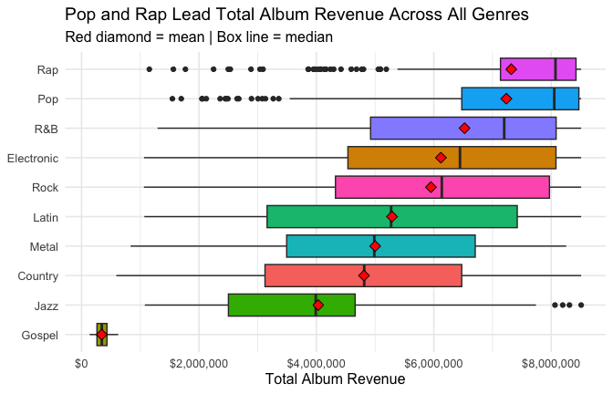
Insight: Rap and Pop generate the highest average revenue, where Gospel music generates the least which means Barone Records should allocate more money into producing Rap and pop albums,while also reduce spending on Gospel or Jazz music as those generate low revenue. It was shown that Gospel Albums average about $2M, where as Rap and Pop were at $6.5M, which is 3X the amount of Gospel

Chart 3 — The 4 plots below represent how each artist type performs in each country
Business question addressed: Does superstar generate the most revenue in all 4 countries? Prediction before plotting: Superstar, will have the highest revenue in all 4 countries, and debut will have the lowest
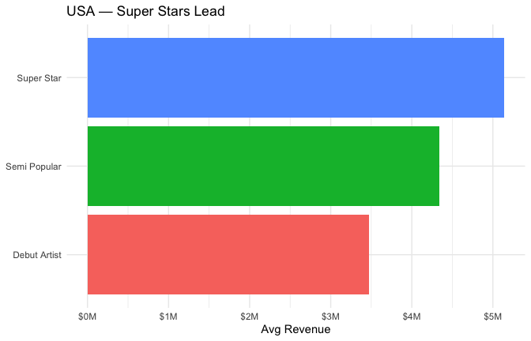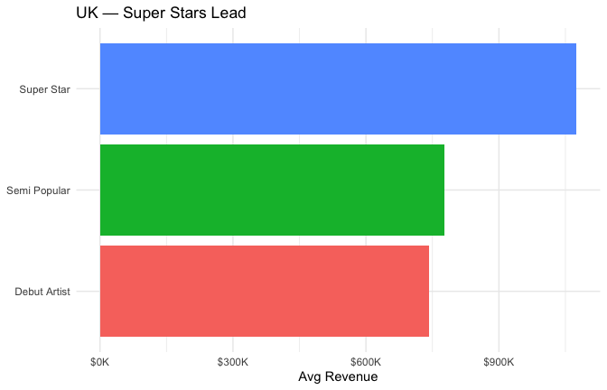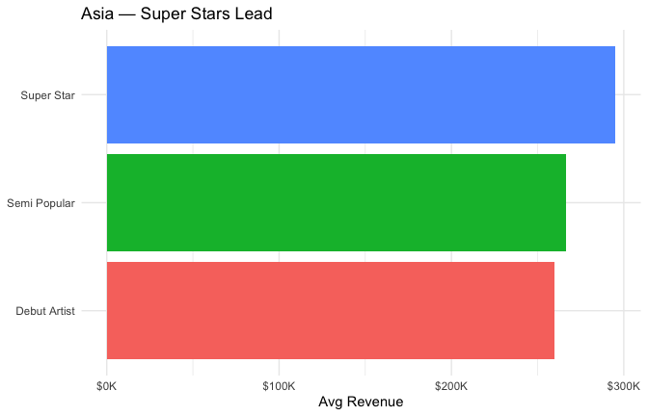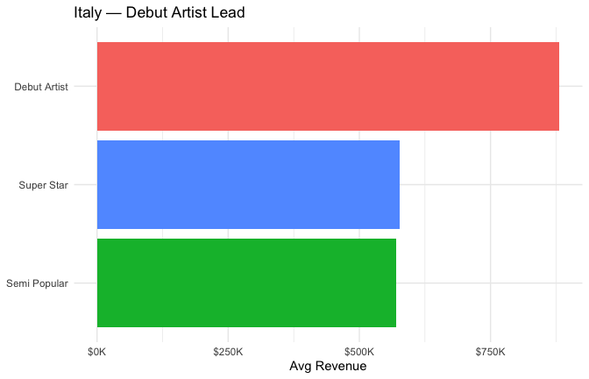
Insight: Superstar had the highest average revenue in USA,UK, and Asia, but that pattern did not align in Italy, where debut had the highest average revenue. This means that Superstars Albums will obviously perform very well in USA,UK, and Asia, but in Italy Barone Records should give more marketing money and focus the marketing in Italy. On average in Italy (Chart3d) Debut artist make about $300,000 more than Super Star and Semi-Popular.

Section 5 — Statistical Reasoning
Business question addressed: Does Album budge and marketing budget effect how much an album generates?
Method chosen: multiple regression
Why this method: The reason I selected multiple regression is because I am using 2 variables to predict revenue
Prediction before running: I expect there to be a positive relationship because the more money you put into a project I would expect the revenue to follow that Prediction result: Prediction was confirmed, which means the more money put into budgets, revenue will follow that trend and increase

Visualise Before Testing
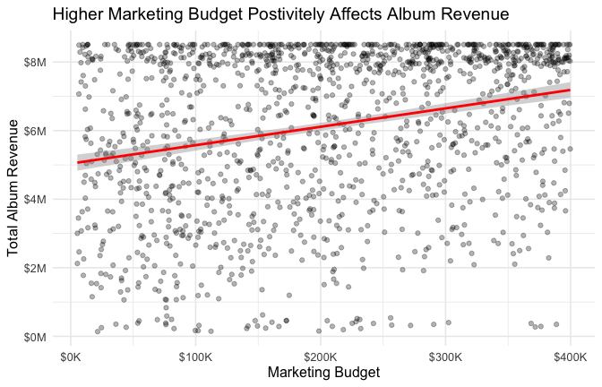
This scatterplot shows, how marketing budget effects total album revenue. Please see chart 1 for how album budget effects album revenue.

Run the Test
## # A tibble: 3 × 5
## term estimate std.error statistic p.value
## <chr> <dbl> <dbl> <dbl> <dbl>
## 1 (Intercept) 2753342. 131921. 20.9 7.01e- 85
## 2 Album_Budget 3.08 0.115 26.6 8.42e-128
## 3 Marketing_Budget 5.09 0.429 11.9 4.58e- 31
## # A tibble: 1 × 12
## r.squared adj.r.squared sigma statistic p.value df logLik AIC BIC
## <dbl> <dbl> <dbl> <dbl> <dbl> <dbl> <dbl> <dbl> <dbl>
## 1 0.372 0.371 1.85e6 433. 1.66e-148 2 -23222. 46452. 46473.
## # ℹ 3 more variables: deviance <dbl>, df.residual <int>, nobs <int>

Effect Size or Model Fit
glance(model)$r.squared
## [1] 0.3721742
Interpretation: Finding (plain language result):Marketing and Album budgets are both strong predictors for album revenue. Knowing this Barone Records should spend more marketing and album production money,to help drive revenues further, but if they can only increase one budget, they should increase marketing as it has more power. With an r square of .436 it means the budgets explain 43% or album revenue, and both p values are less than .001 with album budget 4.16e-160 and marketing budget 1.06e-36. Additionally every additional $1 spent on marketing budget results in $4.95 increase in revenue and every $1 spent on Album budget results in a $3.15 increase in revenue With an R square of .436, there is still 56% of variables that further explain revenue. While, 43% is not bad by any means, there is still other factors like Genre, Artist type that play a role into Revenue success.

Prediction (regression only)
## fit lwr upr
## 1 6152338 2512889 9791787
Prediction interpretation: For a new album that has a $731,000 Album budget and a $226,000 marketing budget,the model predicts the Album makes $6,233,641. The prediction ranges from $3M to 9M which is a 6M spread which is extremely wide, and infers that there needs to be more predictors.The positive is that the lower prediction is still $3M which would be a great investment for Barone Records.

Section 6 — Automation
What this function does: Barone Records was struggling to compare revenue data with artist type and country all in the same plot, so they want to automatically summarize key metrics for each type.
Why it is reusable: Artist_Type makes it reusable due to the various types of artist and the code will never have to be altered.

Demonstration — Two Valid Calls
## # A tibble: 1 × 6
## artist_type number_of_albums avg_total_revenue avg_album_budget avg_mkt_budget
## <chr> <int> <dbl> <dbl> <dbl>
## 1 Super Star 442 7088339. 765073. 199969.
## # ℹ 1 more variable: avg_profit <dbl>
## # A tibble: 1 × 6
## artist_type number_of_albums avg_total_revenue avg_album_budget avg_mkt_budget
## <chr> <int> <dbl> <dbl> <dbl>
## 1 Debut Arti… 384 5352533. 734962. 205309.
## # ℹ 1 more variable: avg_profit <dbl>

Input Validation Tests
## Error in `my_analysis_function()`:
## ! Artist_Type_During_Album must be a character string.
## Error in `my_analysis_function()`:
## ! Not found: Invalid
## Valid options: Super Star, Semi Popular, Debut Artist

Automation Across All Values (optional but strengthens the project)
## # A tibble: 3 × 6
## artist_type number_of_albums avg_total_revenue avg_album_budget avg_mkt_budget
## <chr> <int> <dbl> <dbl> <dbl>
## 1 Super Star 442 7088339. 765073. 199969.
## 2 Semi Popul… 639 5950923. 774706. 207524.
## 3 Debut Arti… 384 5352533. 734962. 205309.
## # ℹ 1 more variable: avg_profit <dbl>
## # A tibble: 3 × 6
## artist_type number_of_albums avg_total_revenue avg_album_budget
## <chr> <int> <dbl> <dbl>
## 1 Super Star 442 7088339. 765073.
## 2 Semi Popular 639 5950923. 774706.
## 3 Debut Artist 384 5352533. 734962.
## avg_mkt_budget avg_profit
## <dbl> <dbl>
## 1 199969. 6123297.
## 2 207524. 4968692.
## 3 205309. 4412262.

Key Findings
- Finding 1: Album and Marketing budget are both positive predictors of Total Album Revenue. Marketing is the stronger variable as for each $1 spent on marketing revenue increased by $4.95 (intercept value), whereas every $1 spent on album budget revenue increased by $3.15.
- Finding 2: Gospel Genre is the only Genre at Barone records that has a negative profit Barone Records is over allocating budget money for Gospel music, as they are losing -$585,528 on Gospel music, whereas Jazz which is 9th in profit is making $3M. That is about a $2.4M difference.
- Finding 3: Superstars generate the most revenue in USA, UK, and ASIA, but surprisingly in Italy debut artist generate the most. Barone Records is not maximizing revenue as they could be spending more on debut artist budets specifaclly catering their marketing to Italy.

Recommendations
- Increase Marketing budget. Currently marketing budget is $204,664, they should increase it because every extra $1 spent makes them $4.95. If they increase spending by 50,000 they will make $247,500 in revenue.
- Allocating More towards Debut Artist in Italy. Barone records should reduce superstar and semi popular budget in Italy and provide a portion of that to debut artist as they make on average $300,000 than the other 2 artist types.
- [Removing Gospel Music]. Barone records should remove Gospel music from its discography as it is losing them money. They should transfer the budget towards rap and pop to further increase margins.

Limitations
- [R Square Issues]. One limitation that presents itself is, while the .436 r square does show a relationship,Barone records SHOULD NOT dump all its money into debut artist who they can market in Italy. This is because there are other variables that this analysis omitted, like Genre and others that t help explain the missing 56% of total album revenue

