Chart1
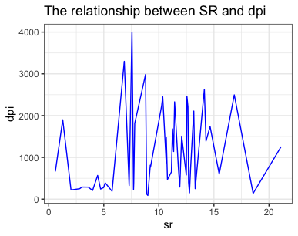

Base on the theory, when DPI increases then SR increases. After analyzing the data, I observed no significant correlation between DPI and SR.

Chart2
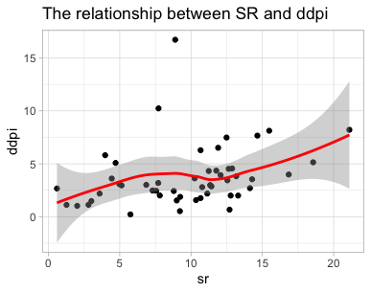

The chart shows that SR and DDPI have positive growth, even with some outliers.
Therefore, I can infer that when people have more savings, their disposable income growth rate also increases.

Chart3&4
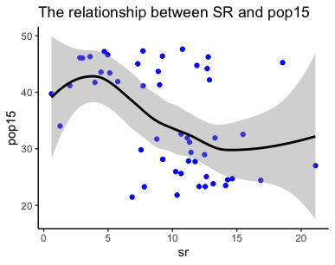
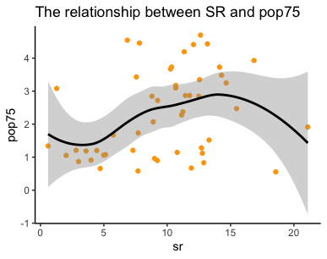

Compare two charts, while the rate of population under 15 is in a decreasing trend, the savings rate (SR) is increasing. However, when we check the results for older ages, we see the opposite trend. This suggests that younger people may lead to more financial stress on families, while older people can take care of themselves without spending their families' savings.

