Chart1
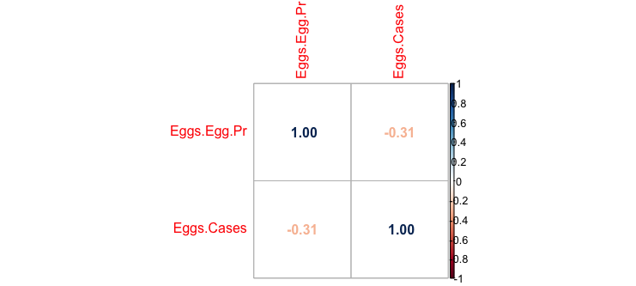

The chart shows a negative correlation between egg price and egg sales, which implies that when egg prices increase, egg sales tend to decrease, and conversely.

Chart2
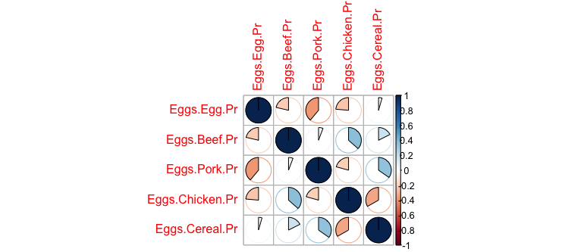

The chart shows no correlation between egg prices and cereal prices. In contrast, egg prices exhibit negative correlations with chicken, beef, and pork prices. This suggests that consumers may substitute eggs for these meats when their prices rise.

