Q1: Discuss differences between programs a, b and c

The difference between A and B is caused by the parameter "right=F". In Program A, the numerical value 8 was assigned to the first bin in the vector data. However, when the parameter "right=F" is incorporated into Program B, this parameter dictates that values equivalent to the right edge of the bin should be counted as belonging to the right bin. Consequently, the numerical value 8 is now counted within the second bin in Program B.

Program C adds “br” which create a vector of bin locations, “bw1” which calculate the bin width and “floor” round the data to the nearest bin. From the result, program C has one more bin between 14 and 16.

Q2: What present chart generated by code below? Please add title to this chart.
It generates density plot with a line plot and rug plot.
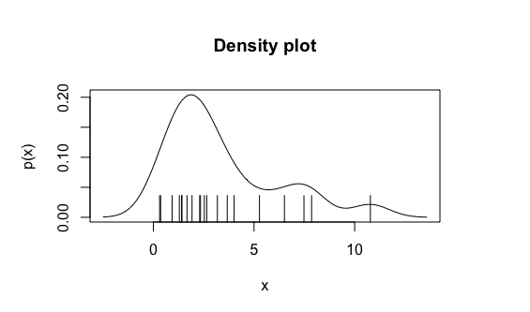

Q3: What present chart generated by code listed below? Please describe the meaning # of arrows. Please add the title.
- It generates strip chart with error bars
- The provided code generates three sets of arrows-
- Arrow1- Starting points are the values 1, 2, and 3. ending points are calculated by adding or subtracting the standard deviation (sd1) from the mean (mean1). Arrow’s angle is 45 degrees, code of 3 which represents solid arrows and length of arrow is 0.07.
- Arrow2- with similar properties to the first set. But with different angle and offset from the mean. Ending points of the arrows are calculated by adding or subtracting two times the standard deviation (2 * sd1) from the mean (mean1). Angle is 30 degrees.
- Arrow3- with different properties from the previous sets. The ending points are calculated by adding or subtracting a small fraction (0.01) of the standard deviation (sd1) from the mean (mean1). Angle of arrow is 90 degrees and length 0.12.
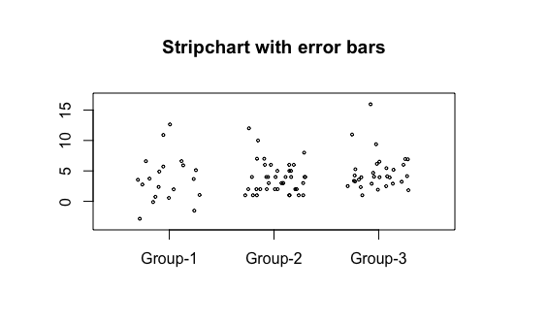

Q4: What present chart generated using code listed below? Please add title and # annotations to make chart easier to interpret.
It generates a boxplot
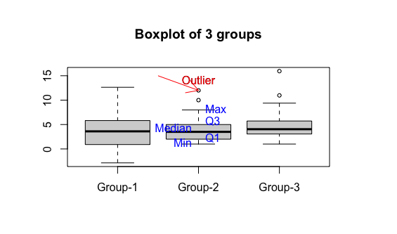

Q5: What present chart generated using code listed below? Please
add title and legend to make chart easier to interpret.
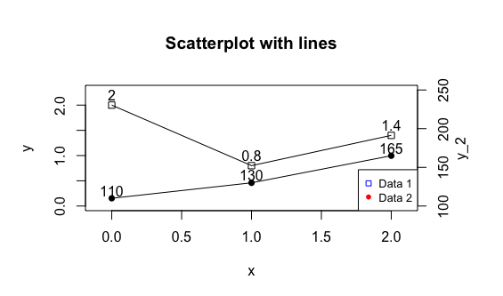
It generates a scatterplot with lines.

Q6: Please analyze code listed below. Please describe meaning of particular sections

The first pie chart includes the "yy" and "name1" arguments, which are used to specify the data and labels for the pie chart, dividing it into three different portions. The "col" argument is utilized to specify the colors for the slices of the pie chart.

To create a new pie chart, use the function "par(new = True)". The "yy2" and "name2" arguments are employed to specify the data and labels for the second pie chart, which displays in five different portions.

In conclusion, "data-a" is equivalent to "data a1", "data-b" is equivalent to "data b1" plus "data b2", and "data-c" is equivalent to "data c1" plus "data c2".

