Untitled
Vincent LE MEUR
2023-09-07

TP1 : Corrélation linéaire et Régression Linéaire Multiple à l’aide de R

Compte rendu
library(readxl)
TP1exel <- read_excel("TP1exel.xlsx")
View(TP1exel)

1 Etape Date
head(TP1exel)
## # A tibble: 6 × 9
## SOL TR A09 A12 A15 A18 A21 A24 A27
## <chr> <dbl> <dbl> <dbl> <dbl> <dbl> <dbl> <dbl> <dbl>
## 1 SL01 2 0.632 0.292 0.318 0.436 0.296 0.069 0.079
## 2 SL02 4 0.552 0.275 0.418 0.468 0.258 0.116 0.072
## 3 SL03 6 0.565 0.3 0.392 0.501 0.279 0.04 0.052
## 4 SL04 8 0.549 0.332 0.502 0.509 0.224 0.055 0.018
## 5 SL05 10 0.57 0.351 0.449 0.48 0.222 0.056 0.025
## 6 SL06 12 0.273 0.309 0.427 0.324 0.156 0.056 0.08
summary(TP1exel)
## SOL TR A09 A12
## Length:16 Min. : 2.00 Min. :0.2540 Min. :0.2750
## Class :character 1st Qu.: 9.50 1st Qu.:0.4677 1st Qu.:0.3202
## Mode :character Median :15.00 Median :0.5265 Median :0.4110
## Mean :15.38 Mean :0.5098 Mean :0.4689
## 3rd Qu.:22.50 3rd Qu.:0.5663 3rd Qu.:0.5835
## Max. :28.00 Max. :0.7540 Max. :0.7930
## A15 A18 A21 A24
## Min. :0.3180 Min. :0.2650 Min. :0.0630 Min. :0.01900
## 1st Qu.:0.4195 1st Qu.:0.4510 1st Qu.:0.1482 1st Qu.:0.04975
## Median :0.5260 Median :0.5050 Median :0.1765 Median :0.05950
## Mean :0.5638 Mean :0.4956 Mean :0.1949 Mean :0.06463
## 3rd Qu.:0.6730 3rd Qu.:0.5218 3rd Qu.:0.2587 3rd Qu.:0.07975
## Max. :0.9390 Max. :0.7850 Max. :0.3130 Max. :0.11600
## A27
## Min. :0.00600
## 1st Qu.:0.03475
## Median :0.07200
## Mean :0.06031
## 3rd Qu.:0.08075
## Max. :0.10000
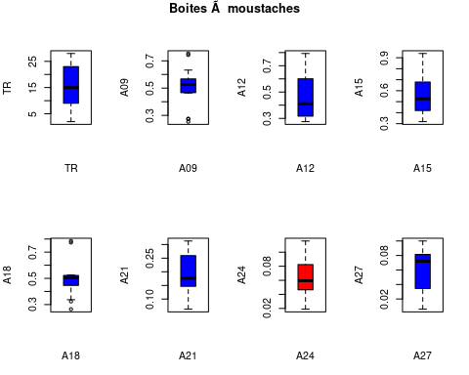

Calcul de la Matrice des Corrélations linéaires et analyse
Le chargement a nécessité le package : lattice
Le chargement a nécessité le package : survival
Le chargement a nécessité le package : Formula
Le chargement a nécessité le package : ggplot2
Attachement du package : 'Hmisc'
Les objets suivants sont masqués depuis 'package:base':
format.pval, units
TR A09 A12 A15 A18 A21 A24 A27
TR 1.00 0.23 0.96 0.92 0.59 -0.23 0.02 0.40
A09 0.23 1.00 0.48 0.56 0.88 0.83 0.25 0.37
A12 0.96 0.48 1.00 0.97 0.76 0.02 0.08 0.51
A15 0.92 0.56 0.97 1.00 0.83 0.13 0.11 0.47
A18 0.59 0.88 0.76 0.83 1.00 0.61 0.22 0.46
A21 -0.23 0.83 0.02 0.13 0.61 1.00 0.21 0.27
A24 0.02 0.25 0.08 0.11 0.22 0.21 1.00 0.30
A27 0.40 0.37 0.51 0.47 0.46 0.27 0.30 1.00
n= 16
P
TR A09 A12 A15 A18 A21 A24 A27
TR 0.3946 0.0000 0.0000 0.0164 0.3967 0.9556 0.1285
A09 0.3946 0.0617 0.0251 0.0000 0.0000 0.3598 0.1527
A12 0.0000 0.0617 0.0000 0.0006 0.9424 0.7605 0.0437
A15 0.0000 0.0251 0.0000 0.0000 0.6187 0.6916 0.0636
A18 0.0164 0.0000 0.0006 0.0000 0.0113 0.4129 0.0760
A21 0.3967 0.0000 0.9424 0.6187 0.0113 0.4409 0.3097
A24 0.9556 0.3598 0.7605 0.6916 0.4129 0.4409 0.2616
A27 0.1285 0.1527 0.0437 0.0636 0.0760 0.3097 0.2616
corrplot 0.92 loaded
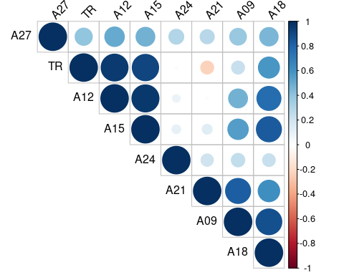
On regarde les correlations dont la p valeur est différente de 0

