Fashion-MNIST

Training set – 60,000 sample (28-pixel x 28 pixel)

Test set – 10,000 sample (28-pixel x 28 pixel)

10 categories including:

T-shirt/top, Trouser, Pullover, Dress, Coat, Sandal, Shirt, Sneaker, Bag, Ankle boot

Top 25 sample in the training set

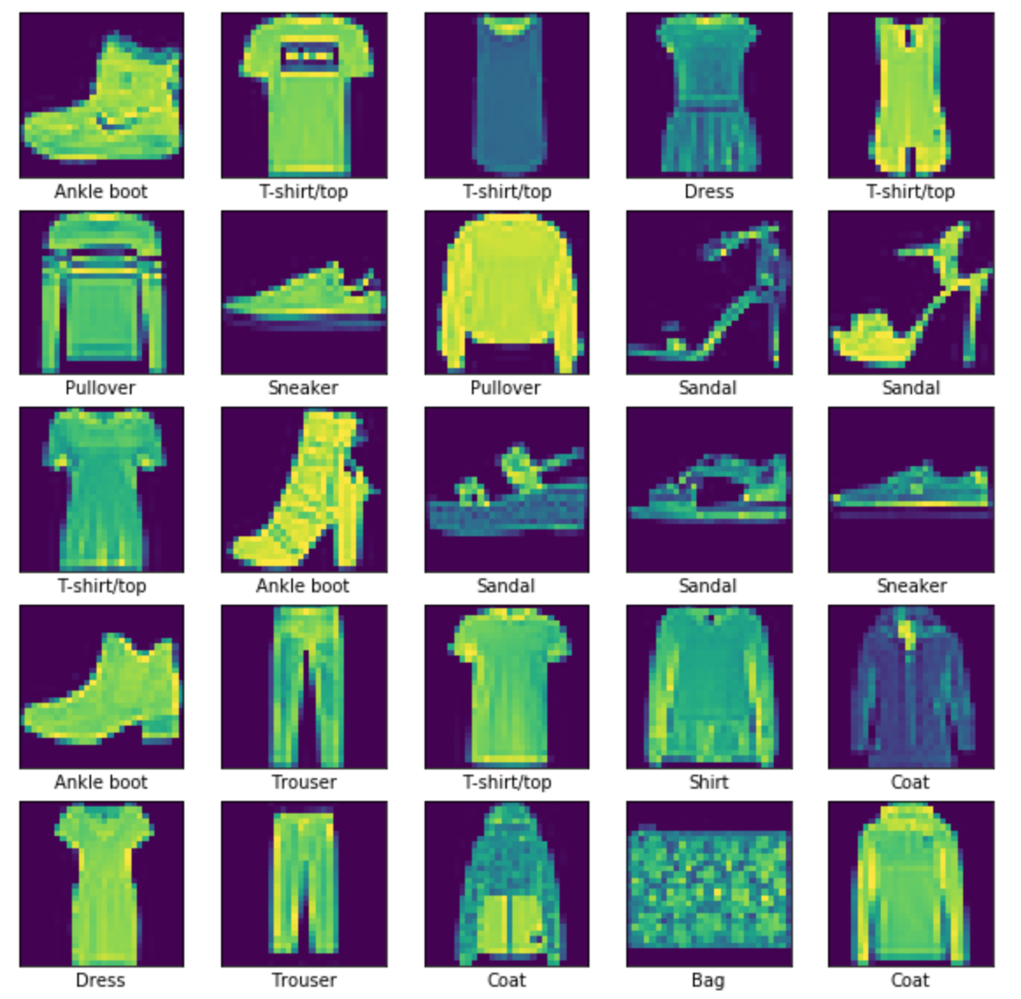

Convolutional Neural Network

Model 1:

Using 3 convolutional hidden layers. Total parameter 1,566,198. Accuracy rate 91.25% with 0.264 loss

TIME?

L1 more conv layer 1

[('filt_9', 0.5364565), ('filt_12', 0.5874183), ('filt_1', 0.6760793), ('filt_13', 0.69604164), ('filt_3', 0.73809403), ('filt_11', 0.75144833), ('filt_7', 0.7709528), ('filt_8', 0.8579972), ('filt_4', 0.9071775), ('filt_5', 0.9346143), ('filt_2', 0.9752368), ('filt_15', 1.0345503), ('filt_10', 1.1193957), ('filt_6', 1.2190223), ('filt_0', 1.3378803), ('filt_14', 1.435839)]

L1 more conv layer 2

[('filt_0', 5.713554), ('filt_16', 5.866627), ('filt_30', 6.192377), ('filt_23', 6.5852804), ('filt_20', 6.7689905), ('filt_31', 6.778879), ('filt_15', 6.883029), ('filt_29', 6.9839573), ('filt_21', 7.2018375), ('filt_28', 7.259144), ('filt_24', 7.3633733), ('filt_1', 7.3639016), ('filt_5', 7.428768), ('filt_22', 7.4344616), ('filt_2', 7.654087), ('filt_6', 7.714178), ('filt_18', 7.8145714), ('filt_8', 7.8480425), ('filt_7', 7.9418564), ('filt_11', 7.9433265), ('filt_25', 7.944233), ('filt_19', 8.149061), ('filt_3', 8.379457), ('filt_10', 8.441942), ('filt_26', 8.450506), ('filt_14', 8.806815), ('filt_13', 8.885986), ('filt_27', 8.919167), ('filt_17', 9.143944), ('filt_4', 9.378191), ('filt_9', 9.574696), ('filt_12', 10.251366)]

L1 more conv layer 3

[('filt_22', 11.009697), ('filt_28', 11.5515375), ('filt_21', 11.588878), ('filt_12', 12.121685), ('filt_1', 12.188551), ('filt_0', 12.440982), ('filt_27', 12.504473), ('filt_19', 12.70278), ('filt_7', 12.72989), ('filt_26', 12.733992), ('filt_3', 12.780612), ('filt_2', 12.997604), ('filt_8', 13.024029), ('filt_11', 13.027661), ('filt_14', 13.074688), ('filt_4', 13.204828), ('filt_23', 13.264367), ('filt_25', 13.381868), ('filt_18', 13.537981), ('filt_29', 13.590523), ('filt_20', 13.674128), ('filt_15', 13.703146), ('filt_17', 13.718312), ('filt_13', 13.783937), ('filt_30', 13.8757515), ('filt_9', 13.911467), ('filt_16', 14.037314), ('filt_6', 14.089248), ('filt_24', 14.66993), ('filt_5', 14.687549), ('filt_10', 14.689802), ('filt_31', 15.309482)]

Removing additional filters

Remove filters 9,12,1,13 in the first hidden layer

Using 3 convolutional hidden layers with fewer filters. Total parameter has reduced to 1,555,666. However, the Accuracy rate has dropped from 91.25% to 81.28$ with 0.6605 loss

TIME?

Conclusion