ii

We,

* Vincent Meyer zu Wickern
* Sachin Kumar
* Viet-Hung Vu

, declare that this paper and the work presented in it are our own. We confirm that:

This work was done wholly or mainly while in candidature for a research degree at this University.

Where any part of this paper has previously been submitted for a degree or any other qualification at this University or any other institution, this has been clearly stated.

Where we have consulted the published work of others, this is always clearly attributed.

Where we have quoted from the work of others, the source is always given. With the exception of such quotations, this paper is entirely our own work.

We have acknowledged all main sources of help.

Where the paper is based on work done by ourselves jointly with others, we have made clear exactly what was done by others and what we have contributed ourselves.

Signed: 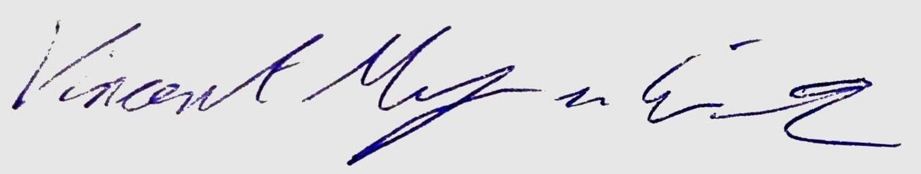 (Vincent Meyer zu Wickern)

Signed: 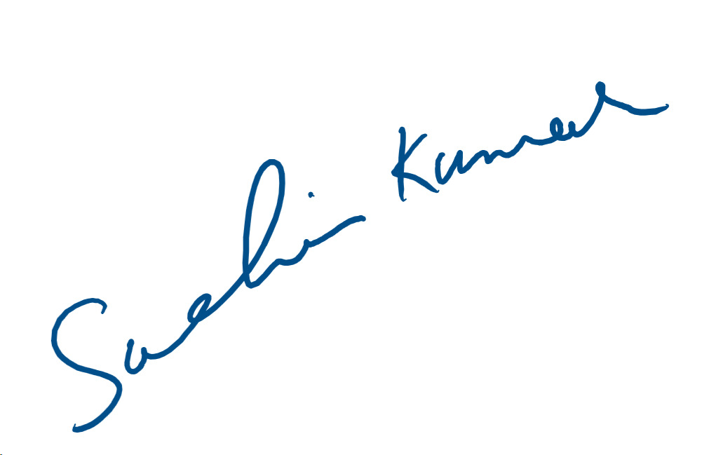 (Sachin Kumar)

Signed: 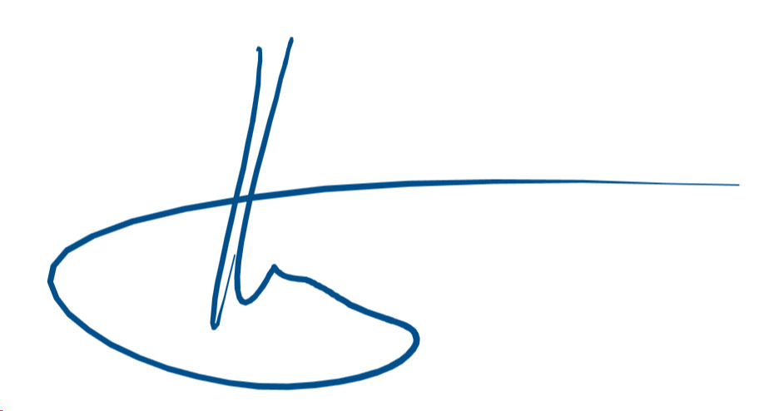 (Viet-Hung Vu)