1. 实际轨迹分析：  
   1. html文件通过读取对应.js文件中的数据进行数据可视化。.js数据可以通过运行script_write_js.py文件自动生成。  
   自动生成js数据时注意：  
   1) 保证各个stay_points文件的命名与原先的一致：stay_point_2017-11-28.txt  
   2) 保证各stay_points数据文件都存放在.py文件的父级目录下的data文件夹中。  
   2.想读取不同天数的坐标点时，修改.html文件的第三十行对应的文件名即可。

3.数据分析结果见后续图例。

1. 程序说明：

在python 3以上的环境中。需要安装的库：pandas, numpy, anytree, sklearn(scikit-learn)

运行SLH-MTM.py 文件，将自己的stay_points数据和POI数据放入对应的文件夹内，不要改变相对文件路径，程序即可输出simResult.txt其中包含各组相似点数据。.

文件说明： utils.py 文件 存储比较common的函数。方便后续调用；

Config.py文件存储此模型的各种配置，比如各种阈值，以及可选的中间模型等。

SLH-MTM.py 为主函数。

可视化是便于原始数据分析的小工具。

三、结果图例

11.27

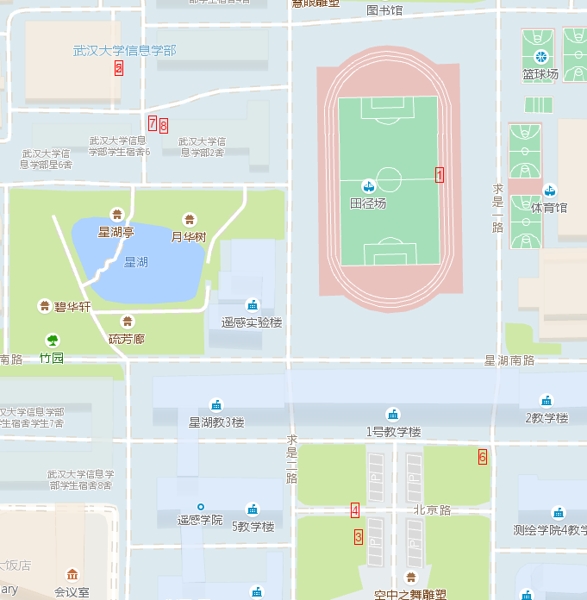

11.28



11.29



11.30



12.01





|  |  |
| --- | --- |
| name | sims |
| stay_point_2017-12-01.txt,stay_point_2017-12-03.txt | 0.0000000% |
| stay_point_2017-11-27.txt,stay_point_2017-12-02.txt | 0.2469534% |
| stay_point_2017-12-01.txt,stay_point_2017-12-02.txt | 0.2798963% |
| stay_point_2017-11-29.txt,stay_point_2017-12-02.txt | 0.3333596% |
| stay_point_2017-12-02.txt,stay_point_2017-12-03.txt | 0.3619153% |
| stay_point_2017-11-28.txt,stay_point_2017-12-02.txt | 0.4094662% |
| stay_point_2017-11-30.txt,stay_point_2017-12-02.txt | 0.7076029% |
| stay_point_2017-11-28.txt,stay_point_2017-12-03.txt | 0.9696991% |
| stay_point_2017-12-02.txt,stay_point_2017-12-02.txt | 1.1007157% |
| stay_point_2017-11-27.txt,stay_point_2017-11-28.txt | 1.8642642% |
| stay_point_2017-11-28.txt,stay_point_2017-11-29.txt | 2.1530148% |
| stay_point_2017-11-28.txt,stay_point_2017-12-01.txt | 2.6241960% |
| stay_point_2017-11-29.txt,stay_point_2017-12-03.txt | 2.7240512% |
| stay_point_2017-11-27.txt,stay_point_2017-12-01.txt | 2.7367723% |
| stay_point_2017-11-28.txt,stay_point_2017-11-30.txt | 3.4976813% |
| stay_point_2017-11-30.txt,stay_point_2017-12-03.txt | 3.6381405% |
| stay_point_2017-11-29.txt,stay_point_2017-12-01.txt | 4.0230035% |
| stay_point_2017-12-01.txt,stay_point_2017-12-01.txt | 4.0412888% |
| stay_point_2017-11-27.txt,stay_point_2017-12-03.txt | 4.1032479% |
| stay_point_2017-11-27.txt,stay_point_2017-11-29.txt | 4.4838964% |
| stay_point_2017-11-28.txt,stay_point_2017-11-28.txt | 5.1464972% |
| stay_point_2017-11-27.txt,stay_point_2017-11-27.txt | 5.2522712% |
| stay_point_2017-12-03.txt,stay_point_2017-12-03.txt | 5.6173484% |
| stay_point_2017-11-30.txt,stay_point_2017-12-01.txt | 5.9599374% |
| stay_point_2017-11-29.txt,stay_point_2017-11-30.txt | 6.4848402% |
| stay_point_2017-11-27.txt,stay_point_2017-11-30.txt | 6.5410815% |
| stay_point_2017-11-30.txt,stay_point_2017-11-30.txt | 10.5224095% |
| stay_point_2017-11-29.txt,stay_point_2017-11-29.txt | 14.1764492% |

相似度问题：相似度并非一个百分比，得到的相似度，所有相似度都除以了sum(all相似度) 做了下归一化。数值上只能说明他们之间哪两个轨迹更相似。

all相似度是11.27 - 12.03之间的所有不重复排列组合