Phase 1: Ideation Phase
Implement Client Script & UI Policy (Incident)
Date | 3/10/26
Team ID | SWTID-2026-9808
Project Name | Implement Client Script & UI Policy (Incident)

1.1 Brainstorm & Idea Prioritization
Brainstorming gave the team an open space to propose ideas for controlling how the Incident form behaves in ServiceNow when an incident has High impact. Every idea was welcome first and filtered afterwards.

Step 1: Team Gathering, Collaboration and Problem Statement
Item | Details
Team Leader | Manav R
Team Members | Krrish Jain, Yash N, Vishal S, Pratham Jain
Selected problem statement | On the Incident form, High impact incidents can be saved without an assignment group or an assigned person, urgency can be set inconsistently, and the State can be changed through list editing. We need form rules that enforce correct data entry.

Step 2: Idea Listing and Grouping
Group | Ideas listed
Field control (UI Policy) | Make Assignment group mandatory when Impact is 1 - High  Make Urgency read-only when Impact is 1 - High  Reverse the effects automatically when Impact is no longer High
Automation (Client Script) | Auto-set Urgency to 1 - High when Impact is changed to 1 - High  Show an information message to explain the automatic change
Validation | Block saving a High impact incident when Assigned to is empty  Show a clear error message next to the Assigned to field
Data protection | Block State changes from list editing  Ask the user to open the Incident form to change State

Step 3: Idea Prioritization
Rank | Idea | Impact | Effort | Decision
1 | UI Policy "High Impact Control" (mandatory Assignment group, read-only Urgency) | High | Low | Implement
2 | onChange Client Script to auto-set Urgency | High | Low | Implement
3 | onSubmit Client Script to require Assigned to | High | Low | Implement
4 | onCellEdit Client Script to block State change in lists | Medium | Low | Implement

1.2 Define the Problem Statement
A customer problem statement keeps the focus on the person facing the problem. The statements below describe the Incident handlers who use the form every day.
Problem Statement (PS) | I am (Customer) | I'm trying to | But | Because | Which makes me feel
PS-1 | A service desk agent handling incidents | Log and route a High impact incident quickly | The form lets me save it without an assignment group or assignee | No rule forces the required fields to be filled for High impact | Worried that critical incidents will be missed
PS-2 | A service desk manager | Keep incident data accurate and consistent | Urgency can be mismatched and State can be changed from the list view | Nothing validates or blocks these changes | Frustrated, because reports and priorities cannot be trusted

1.3 Empathize & Discover: Empathy Map
An empathy map captures what the Incident handler says, thinks, does and feels, so the solution is built around the real user.
Quadrant | Observations (Incident handler)
Says | "This incident is High impact, it must be assigned right now."
Thinks | If I forget a field, the incident may sit unowned and breach its SLA.
Does | Fills in Impact, Urgency, Assignment group and Assigned to, then saves or edits State from the list.
Feels | Pressured and anxious on critical incidents; relieved when the form guides them.
Pains | Incomplete High impact records, inconsistent Urgency, accidental State changes in list view.
Gains | Clear, automatic guidance on the form; fewer errors; reliable priority and reporting.

Phase 2: Project Design Phase-I
Implement Client Script & UI Policy (Incident)
Date | 3/10/26
Team ID | SWTID-2026-9808
Project Name | Implement Client Script & UI Policy (Incident)

2.1 Problem-Solution Fit
Problem-solution fit confirms that the solution actually solves the problem the customer has. It helps the team understand the existing situation so it can be improved for the target group.
Canvas element | Project details
Customer segment | Service desk agents, incident managers and ServiceNow administrators who work with the Incident table.
Problem | High impact incidents can be saved incomplete, Urgency can be inconsistent, and State can be edited from lists without control.
Triggers to act | A High impact incident is created or Impact is changed; a user edits State from the Incident list.
Emotions (before / after) | Before: anxious and unsure. After: confident that the form enforces the rules.
Available solutions today | Manual checks and reviewer reminders, which are inconsistent and easy to miss.
Our solution | One UI Policy with two actions plus three Client Scripts (onChange, onSubmit, onCellEdit) on the Incident table.
Channel of behaviour | Online: Incident form and Incident list in the ServiceNow instance.

2.2 Proposed Solution
S.No. | Parameter | Description
1. | Problem Statement (Problem to be solved) | High impact incidents may be saved without an assignment group or assignee, Urgency may not match Impact, and State can be changed from the list view.
2. | Idea / Solution description | Create the UI Policy "High Impact Control" (Impact is 1 - High) that makes Assignment group mandatory and Urgency read-only, and add three Client Scripts for automatic Urgency, save validation and list-edit protection.
3. | Novelty / Uniqueness | Combines declarative UI Policy rules with targeted Client Scripts, so no server-side code is needed and rules reverse automatically when Impact is no longer High.
4. | Social Impact / Customer Satisfaction | Fewer unowned critical incidents and faster response, which improves the experience of end users who raised the incident.
5. | Business Model (Revenue Model) | Out-of-the-box platform configuration: no additional licence cost, only configuration effort.
6. | Scalability of the Solution | Rules are configured on the Incident table, apply to all desktop form views, and can be extended to other task tables or conditions.

2.3 Solution Architecture
The solution architecture connects the business problem to the technical solution. The solution is configured entirely on the ServiceNow platform and runs on the client side of the Incident form and list.
Layer | Component | Responsibility
User | Service desk agent / manager | Creates and updates incidents on the form or in the list.
Presentation | Incident form and Incident list (Desktop UI) | Displays fields; executes UI Policies and Client Scripts in the browser.
Rules: field behaviour | UI Policy "High Impact Control" + UI Policy Actions | Makes Assignment group mandatory and Urgency read-only when Impact is 1 - High.
Rules: scripts | Client Scripts: onChange, onSubmit, onCellEdit | Auto-set Urgency, block save without Assigned to, block State edits in list view.
Data | Incident [incident] table | Stores the validated incident records.

Data flow: User changes Impact to 1 - High → UI Policy applies (Assignment group mandatory, Urgency read-only) → onChange script sets Urgency to 1 - High → onSubmit script checks Assigned to → record is saved to the Incident table.

Phase 3: Project Design Phase-II
Implement Client Script & UI Policy (Incident)
Date | 3/10/26
Team ID | SWTID-2026-9808
Project Name | Implement Client Script & UI Policy (Incident)

3.1 Data Flow Diagram
The data flow below shows how information enters the system, what changes it, and where it is stored.
Step | From | To | Data / Action
1 | User | Incident form | Enters Impact, Urgency, Assignment group, Assigned to, State.
2 | Incident form | UI Policy | Condition "Impact is 1 - High" is evaluated on load and on change.
3 | UI Policy | Incident form | Assignment group becomes mandatory; Urgency becomes read-only; reversed if condition is false.
4 | Incident form | Client Script (onChange) | Impact value changed; Urgency is set to 1 and an info message is shown.
5 | Incident form | Client Script (onSubmit) | On save, Assigned to is checked; error shown and save stopped if empty.
6 | Incident list | Client Script (onCellEdit) | State edit in list is cancelled and the user is asked to open the Incident.
7 | Incident form | Incident table | Valid record is stored and shown in the Incident list.

3.2 User Stories
User Type | Functional Requirement (Epic) | User Story No. | User Story / Task | Acceptance criteria | Priority | Release
Administrator | UI Policy | USN-1 | As an administrator, I can make Assignment group mandatory when Impact is High. | Assignment group shows as mandatory for Impact 1 - High | High | Sprint-1
Administrator | UI Policy | USN-2 | As an administrator, I can make Urgency read-only when Impact is High. | Urgency is greyed out for Impact 1 - High | High | Sprint-1
Service desk agent | Client Script | USN-3 | As an agent, I want Urgency set to High automatically when Impact is High. | Urgency = 1 - High and an info message appears | High | Sprint-2
Service desk agent | Client Script | USN-4 | As an agent, I must provide Assigned to before saving a High impact incident. | Error is shown and save is blocked when empty | High | Sprint-2
Service desk manager | Client Script | USN-5 | As a manager, I want State changes blocked in list editing. | Alert is shown and the change is cancelled | Medium | Sprint-2

3.3 Solution Requirements

Functional Requirements
FR No. | Functional Requirement (Epic) | Sub Requirement (Story / Sub-Task)
FR-1 | High Impact Control (UI Policy) | Condition: Impact is 1 - High  Action on Assignment group: Mandatory = True  Action on Urgency: Read only = True  Reverse if false, On load and Global enabled
FR-2 | Automatic Urgency (onChange) | When Impact changes to 1, set Urgency to 1 and show "Urgency set to High for High impact incident."
FR-3 | Save validation (onSubmit) | If Impact is 1 and Assigned to is empty, show an error on Assigned to and return false.
FR-4 | List-edit protection (onCellEdit) | On State edit in list view, show an alert and cancel the change.

Non-functional Requirements
NFR No. | Non-Functional Requirement | Description
NFR-1 | Usability | Clear messages: "Assigned To is mandatory for High impact incidents." and the list-edit alert guide the user.
NFR-2 | Security | Scripts run isolated (Isolate script enabled) in strict mode with no direct DOM access.
NFR-3 | Reliability | Rules behave the same on every load; "Reverse if false" restores fields when Impact is no longer High.
NFR-4 | Performance | Lightweight client-side checks with no extra server calls.
NFR-5 | Availability | Runs with the ServiceNow instance; no extra service to maintain.
NFR-6 | Scalability | Rules can be reused or extended for other conditions and tables.

3.4 Technology Stack

Table 1: Components & Technologies
S.No. | Component | Description | Technology
1. | User Interface | Incident form and Incident list used by agents | ServiceNow Next Experience (Desktop UI)
2. | Application Logic 1 | Field behaviour rules (mandatory, read-only) | UI Policy and UI Policy Actions
3. | Application Logic 2 | Form and list validation and automation | Client Scripts (JavaScript: onChange, onSubmit, onCellEdit)
4. | Client API | Reads and writes form fields, shows messages | g_form (getValue, setValue, addInfoMessage, showErrorBox)
5. | Database | Stores incident records | ServiceNow Incident [incident] table
6. | Infrastructure | Hosted instance used for development and testing | ServiceNow developer instance (Cloud)

Table 2: Application Characteristics
S.No. | Characteristics | Description | Technology
1. | Open-Source Frameworks | None required; native platform configuration | ServiceNow platform
2. | Security Implementations | Strict mode, Isolate script and role-based access to configuration | ServiceNow ACL / roles
3. | Scalable Architecture | Rules defined once on the table and inherited where needed | Table-based configuration
4. | Availability | Same availability as the hosting ServiceNow instance | ServiceNow cloud
5. | Performance | Client-side execution, no extra requests | Client Scripts

Phase 4: Project Planning Phase
Implement Client Script & UI Policy (Incident)
Date | 3/10/26
Team ID | SWTID-2026-9808
Project Name | Implement Client Script & UI Policy (Incident)

4.1 Product Backlog, Sprint Schedule and Estimation
Story points follow a simple scale: 1 = very easy, 2 = normal, 3 = moderate, 5 = difficult.
Sprint | Functional Requirement (Epic) | User Story No. | User Story / Task | Story Points | Priority | Team Members
Sprint-1 | UI Policy | USN-1 | Make Assignment group mandatory for Impact 1 - High | 3 | High | Project team
Sprint-1 | UI Policy | USN-2 | Make Urgency read-only for Impact 1 - High | 2 | High | Project team
Sprint-2 | Client Script | USN-3 | Auto-set Urgency to High (onChange) | 2 | High | Project team
Sprint-2 | Client Script | USN-4 | Block save without Assigned to (onSubmit) | 3 | High | Project team
Sprint-2 | Client Script | USN-5 | Block State change in list edit (onCellEdit) | 2 | Medium | Project team
Sprint-2 | Testing | USN-6 | Test all rules and capture evidence | 3 | Medium | Project team

4.2 Project Tracker, Velocity & Burndown
Sprint | Total Story Points | Duration | Sprint Start Date | Sprint End Date (Planned) | Story Points Completed | Sprint Release Date (Actual)
Sprint-1 | 5 | 1 Day | 3/10/26 | 3/10/26 | 5 | 3/10/26
Sprint-2 | 10 | 1 Day | 3/10/26 | 3/10/26 | 10 | 3/10/26

Velocity
Total story points = 5 + 10 = 15 across 2 sprints. Velocity = 15 / 2 = 7.5 story points per sprint. With a 1-day sprint duration, the average velocity is 7.5 story points per day.

Burndown
Checkpoint | Story points remaining | Date
Start of Sprint-1 | 15 | 3/10/26
End of Sprint-1 | 10 | 3/10/26
End of Sprint-2 | 0 | 3/10/26

Phase 5: Project Development Phase
Implement Client Script & UI Policy (Incident)
Date | 3/10/26
Team ID | SWTID-2026-9808
Project Name | Implement Client Script & UI Policy (Incident)

5.1 Implementation Summary
The solution was implemented on the Incident [incident] table in the ServiceNow instance using one UI Policy with two UI Policy Actions and three Client Scripts. All items are in the Global application scope.
Component | Configuration
UI Policy: High Impact Control | Table: Incident; Active; Order 100; Condition: Impact is 1 - High; Global, On load and Reverse if false enabled; Inherit not selected.
UI Policy Action: assignment_group | Mandatory = True; Visible = Leave alone; Read only = False.
UI Policy Action: urgency | Mandatory = Leave alone; Visible = Leave alone; Read only = True.
Client Script: Auto set urgency for high impact | Type: onChange; Field: Impact; UI Type: Desktop; Isolate script enabled.
Client Script: Prevent save if Assigned To missing | Type: onSubmit; UI Type: Desktop; Isolate script enabled.
Client Script: Prevent state change via list edit | Type: onCellEdit; Field: State; UI Type: Desktop; Isolate script enabled.

5.2 UI Policy Configuration
The UI Policies list confirms that "High Impact Control" was created on the Incident table with the condition impact=1.
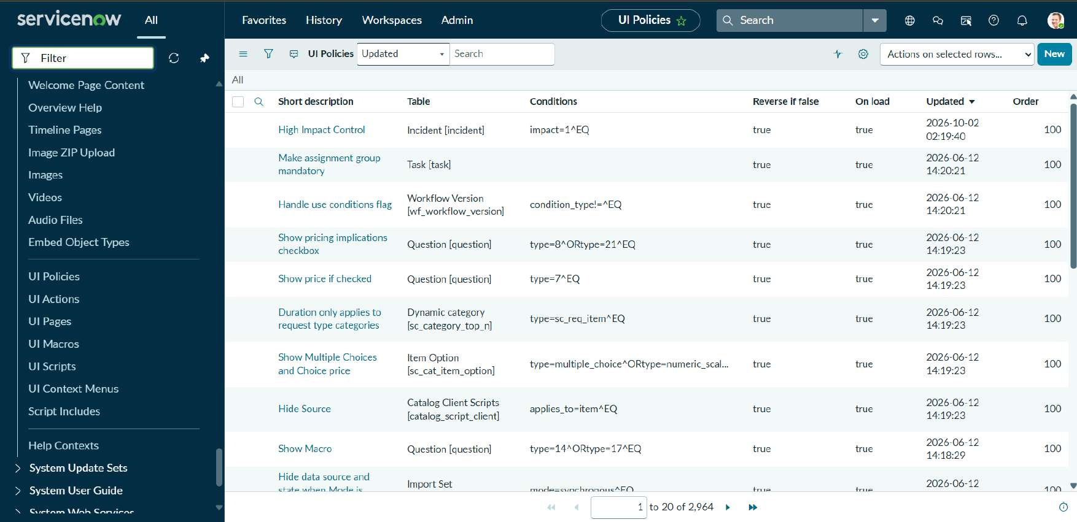
Figure 1: UI Policies list showing "High Impact Control" on the Incident table (condition impact=1^EQ)
The policy applies when Impact is 1 - High. "Reverse if false" returns the form to normal when the condition is no longer met.
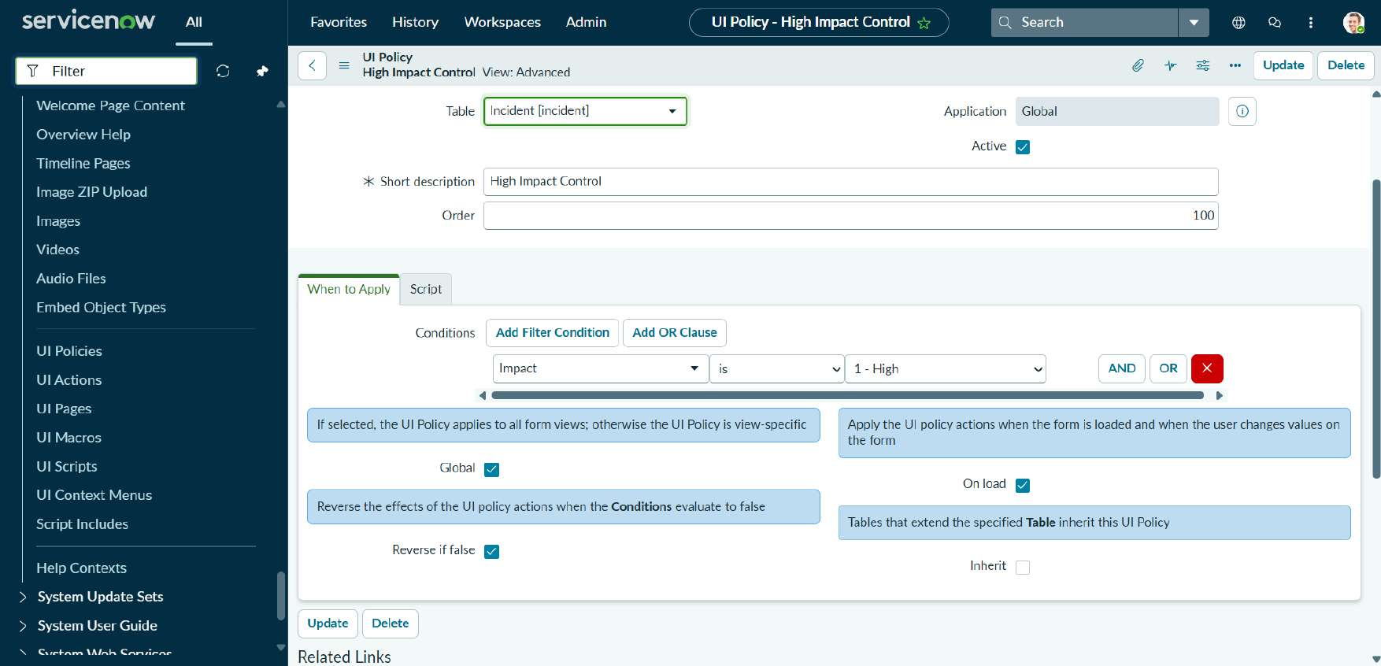
Figure 2: UI Policy "High Impact Control": table, condition, Global, On load and Reverse if false
UI Policy Action 1 makes the Assignment group field mandatory.
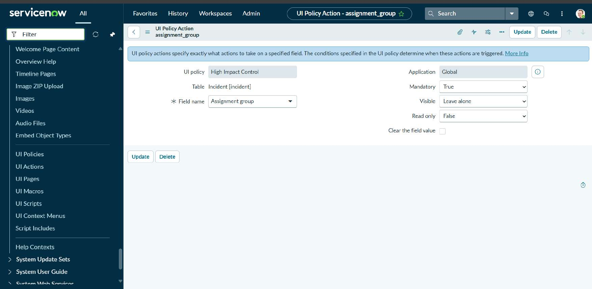
Figure 3: UI Policy Action for assignment_group: Mandatory = True
UI Policy Action 2 makes the Urgency field read-only so it cannot be changed manually for High impact incidents.
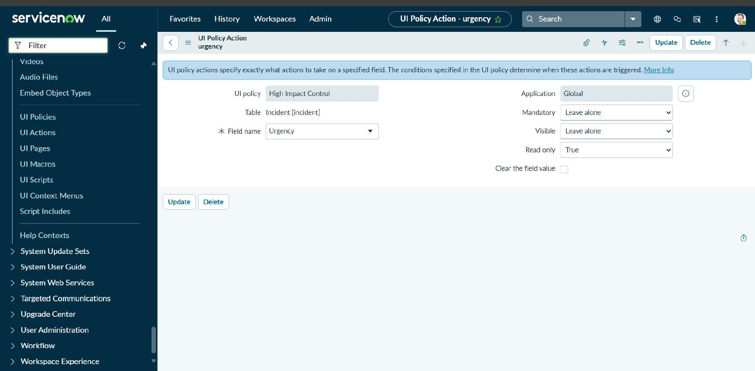
Figure 4: UI Policy Action for urgency: Read only = True

5.3 Client Script Configuration
The Client Scripts list shows the scripts available on the platform; the three project scripts were created on the Incident table.
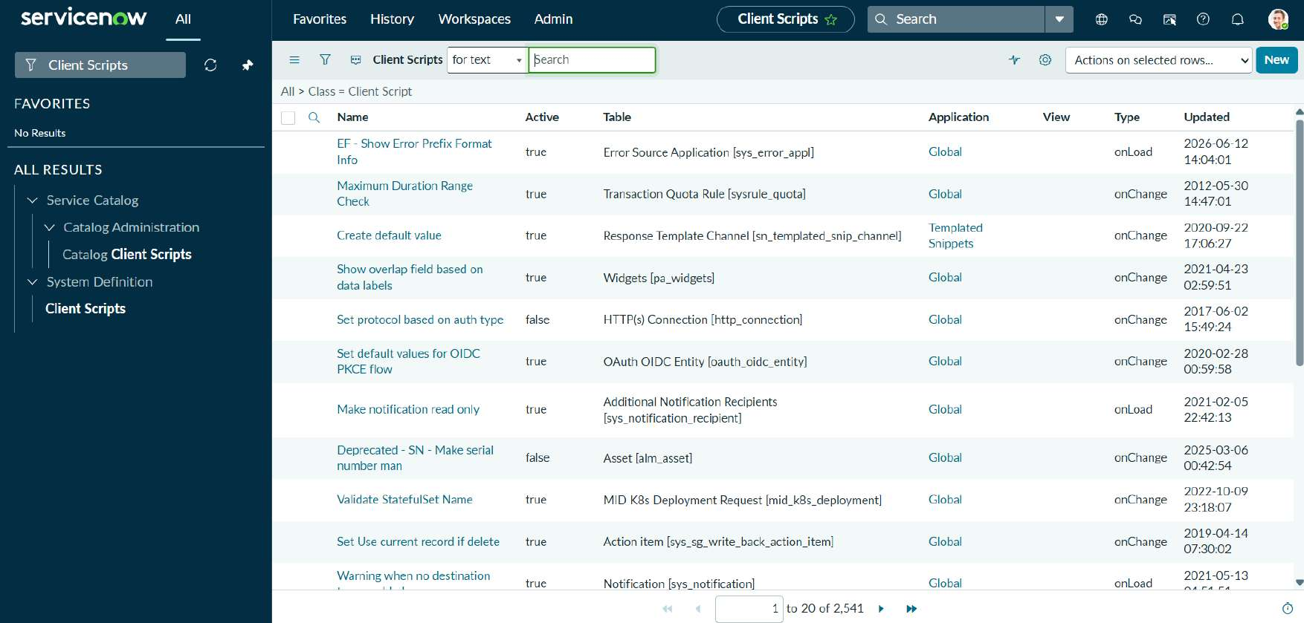
Figure 5: Client Scripts list in System Definition

Script 1: Auto set urgency for high impact (onChange on Impact)
function onChange(control, oldValue, newValue, isLoading) {
if (isLoading || newValue == '') {
return;
}
if (newValue == '1') {
g_form.setValue('urgency', '1');
g_form.addInfoMessage('Urgency set to High for High impact incident.');
}
}
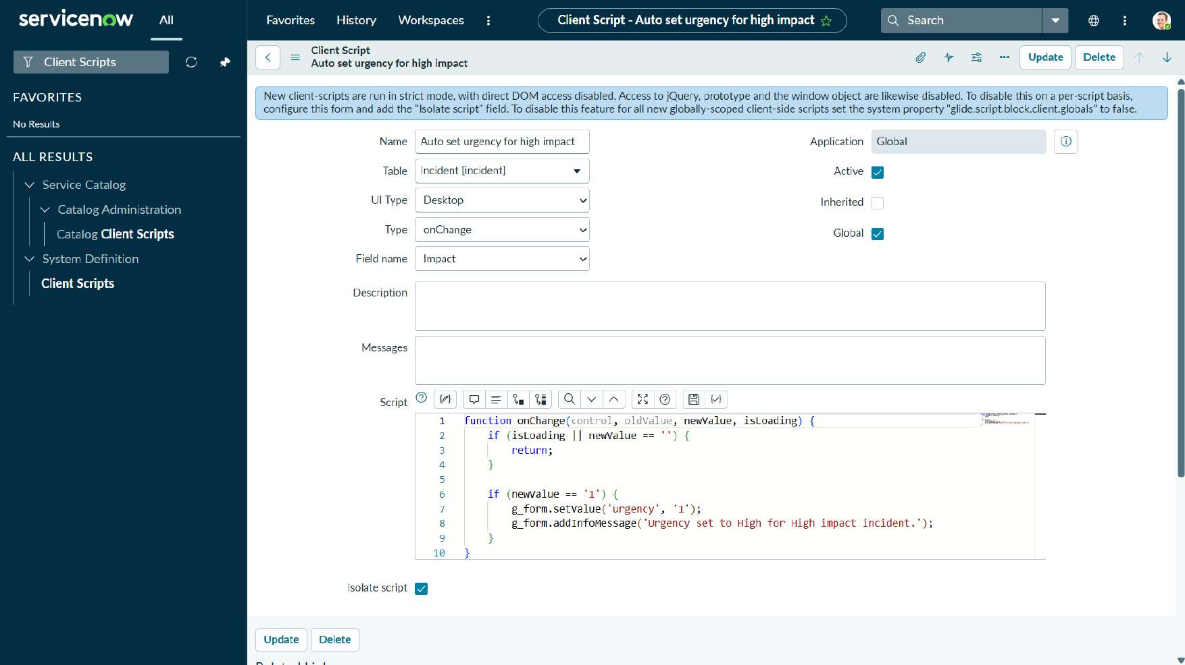
Figure 6: Client Script "Auto set urgency for high impact" (onChange, field Impact)

Script 2: Prevent save if Assigned To missing (onSubmit)
function onSubmit() {
if (g_form.getValue('impact') == '1' &&
g_form.getValue('assigned_to') == '') {
g_form.showErrorBox(
'assigned_to',
'Assigned To is mandatory for High impact incidents.'
);
return false;
}
return true;
}
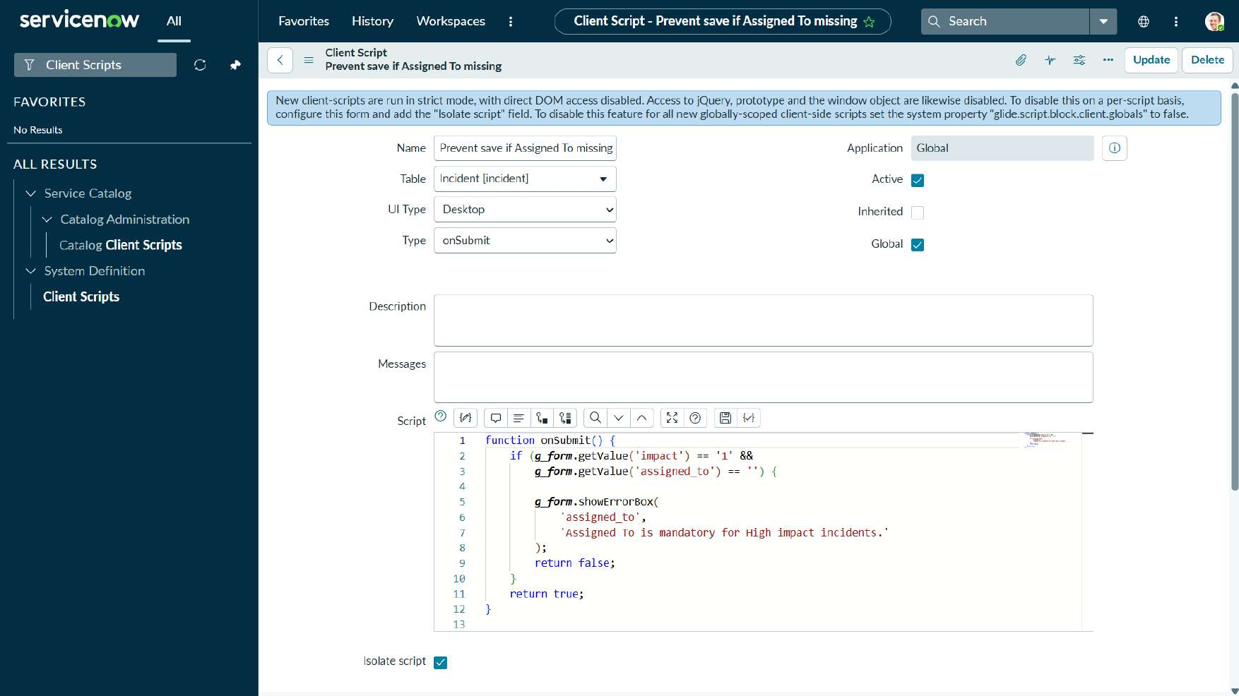
Figure 7: Client Script "Prevent save if Assigned To missing" (onSubmit)

Script 3: Prevent state change via list edit (onCellEdit on State)
function onCellEdit(sysIDs, table, oldValues, newValue, callback) {
alert('State cannot be updated using list editing. Please open the Incident.');
callback(false);
}
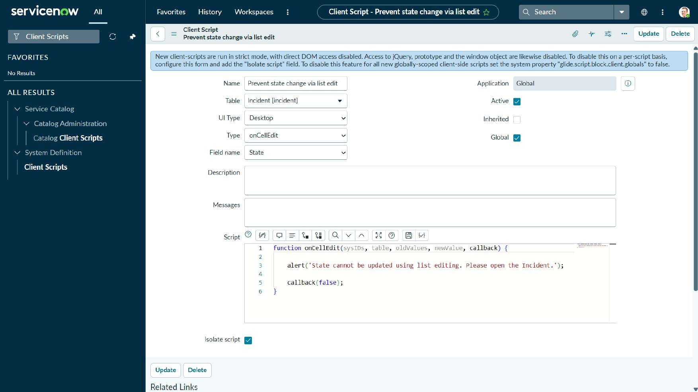
Figure 8: Client Script "Prevent state change via list edit" (onCellEdit, field State)

Phase 6: Testing, UAT & Project Documentation
Implement Client Script & UI Policy (Incident)
Date | 3/10/26
Team ID | SWTID-2026-9808
Project Name | Implement Client Script & UI Policy (Incident)

6.1 Functional Testing: Test Scenarios & Results
Test Case ID | Scenario (What to test) | Test Steps (How to test) | Expected Result | Actual Result | Pass / Fail
FT-01 | High impact sets Urgency and enforces fields | Create a new incident and set Impact to 1 - High | Urgency = 1 - High (read-only); Assignment group mandatory | As expected (Figures 9, 10) | Pass
FT-02 | Save blocked without Assigned to | With Impact 1 - High, leave Assigned to empty and submit | Error "Assigned To is mandatory for High impact incidents." | As expected (Figure 9) | Pass
FT-03 | Save allowed with Assigned to | Set Assignment group and Assigned to (Beth Anglin), set State In Progress, save | Incident saved | INC0010003 saved (Figure 11) | Pass
FT-04 | Rules reverse when Impact is lowered | Change Impact from 1 - High to 2 - Medium | Urgency becomes editable; Priority recalculated | Priority 2 - High, Urgency editable (Figure 12) | Pass
FT-05 | State edit blocked in list view | In the Incident list, edit State and save | Alert shown and change cancelled | Alert displayed (Figures 13, 14) | Pass
FT-06 | State change allowed from form | Open the Incident and save from the form menu | State updated | INC0008111 shows In Progress (Figures 15, 16) | Pass

Performance observation: all rules run in the browser on form load, field change, save and cell edit, and responded immediately in testing without extra server round trips.

6.2 Test Evidence

FT-01 / FT-02: High impact validation on a new incident
A new incident (INC0010002) was created with Impact 1 - High. Urgency became 1 - High and read-only, Priority became 1 - Critical, Assignment group is mandatory, and saving without Assigned to displays the error message.
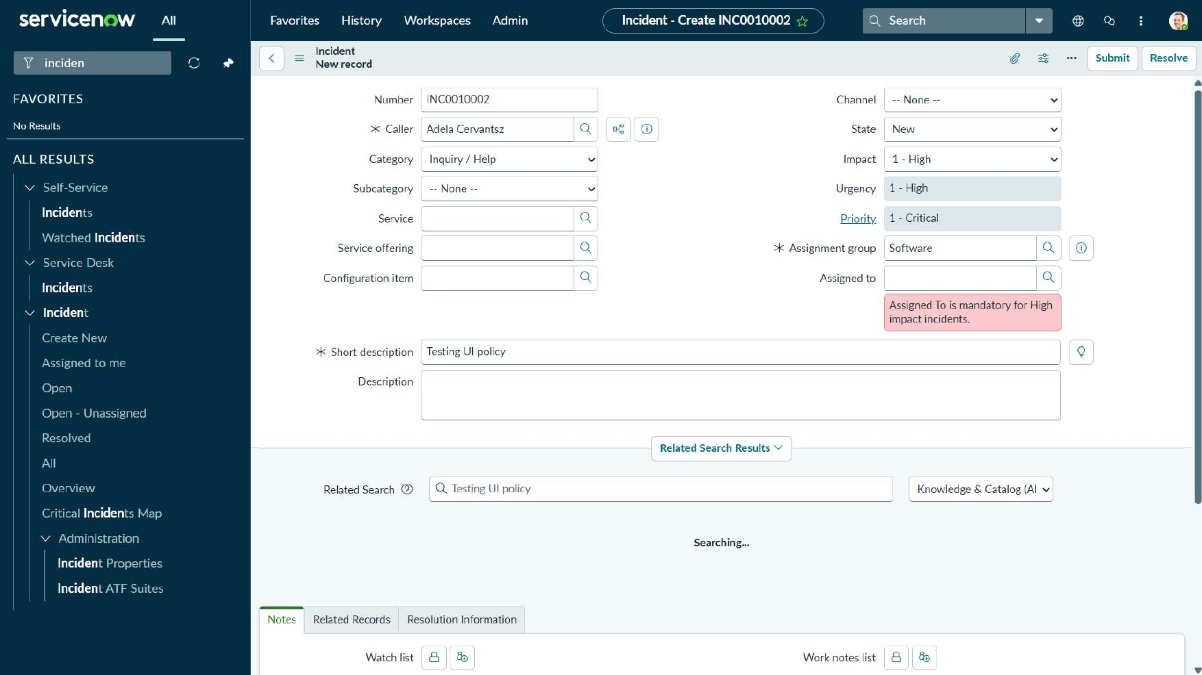
Figure 9: New incident INC0010002: Impact 1 - High, Urgency read-only, error shown under Assigned to
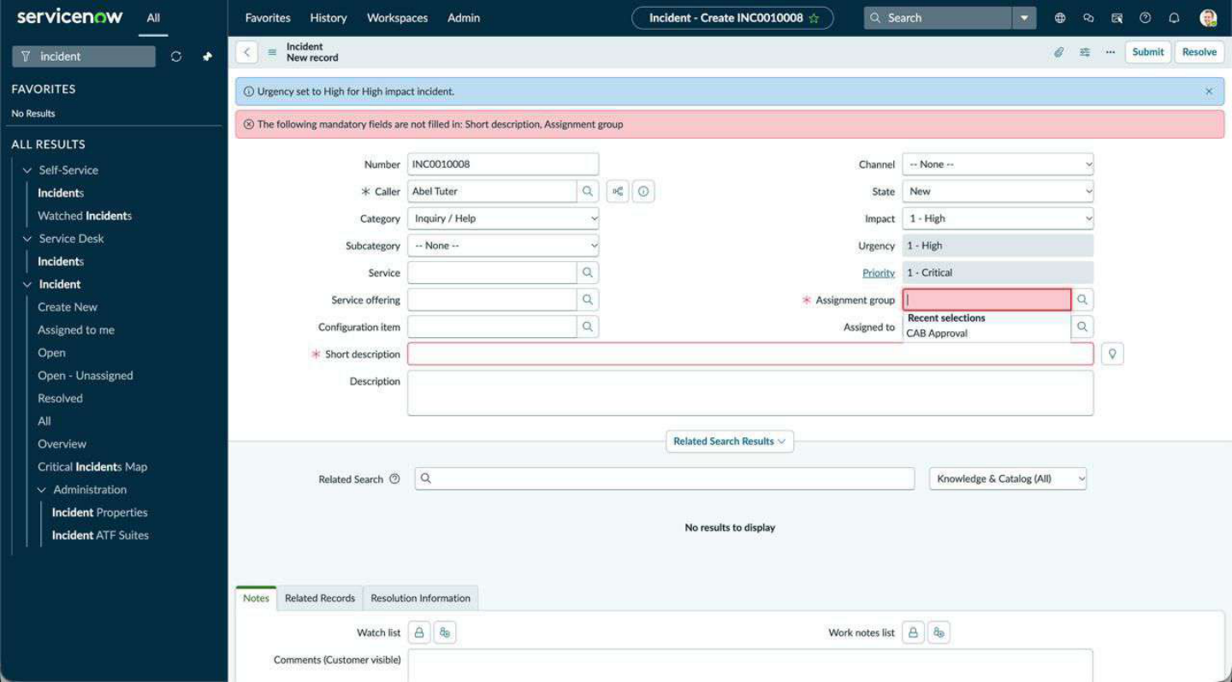
Figure 10: Test result: High Impact sets Urgency to High and displays mandatory-field validation

FT-03: Valid save with Assigned to
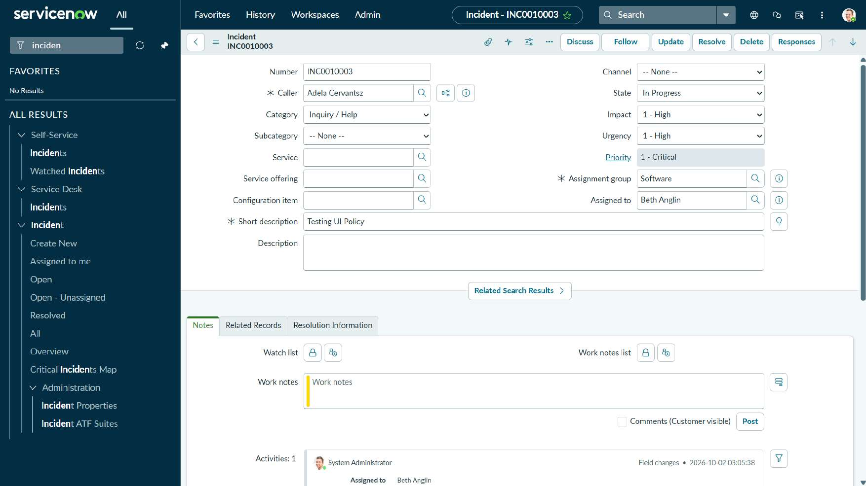
Figure 11: Incident INC0010003 saved with Assignment group Software and Assigned to Beth Anglin

FT-04: Rules reverse when Impact is lowered
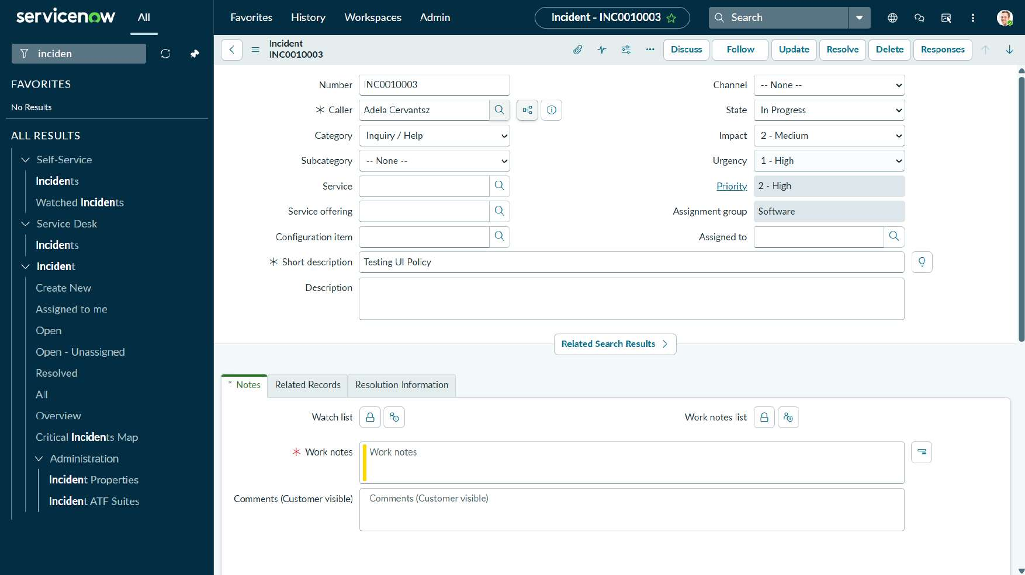
Figure 12: INC0010003 with Impact 2 - Medium: Urgency editable and Priority recalculated to 2 - High

FT-05: State change blocked in the list view
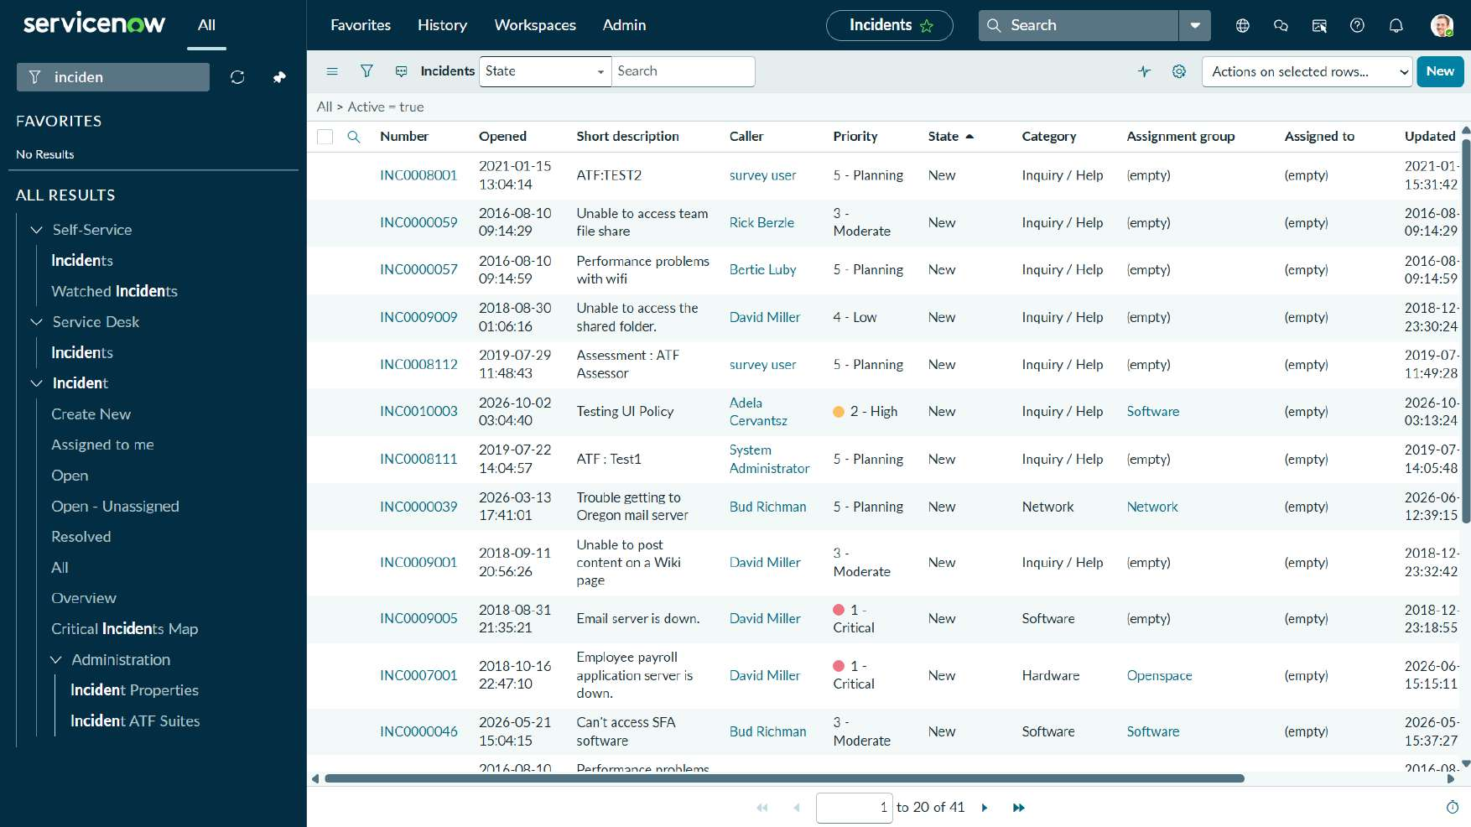
Figure 13: Incident list showing INC0010003 (Priority 2 - High) created during testing
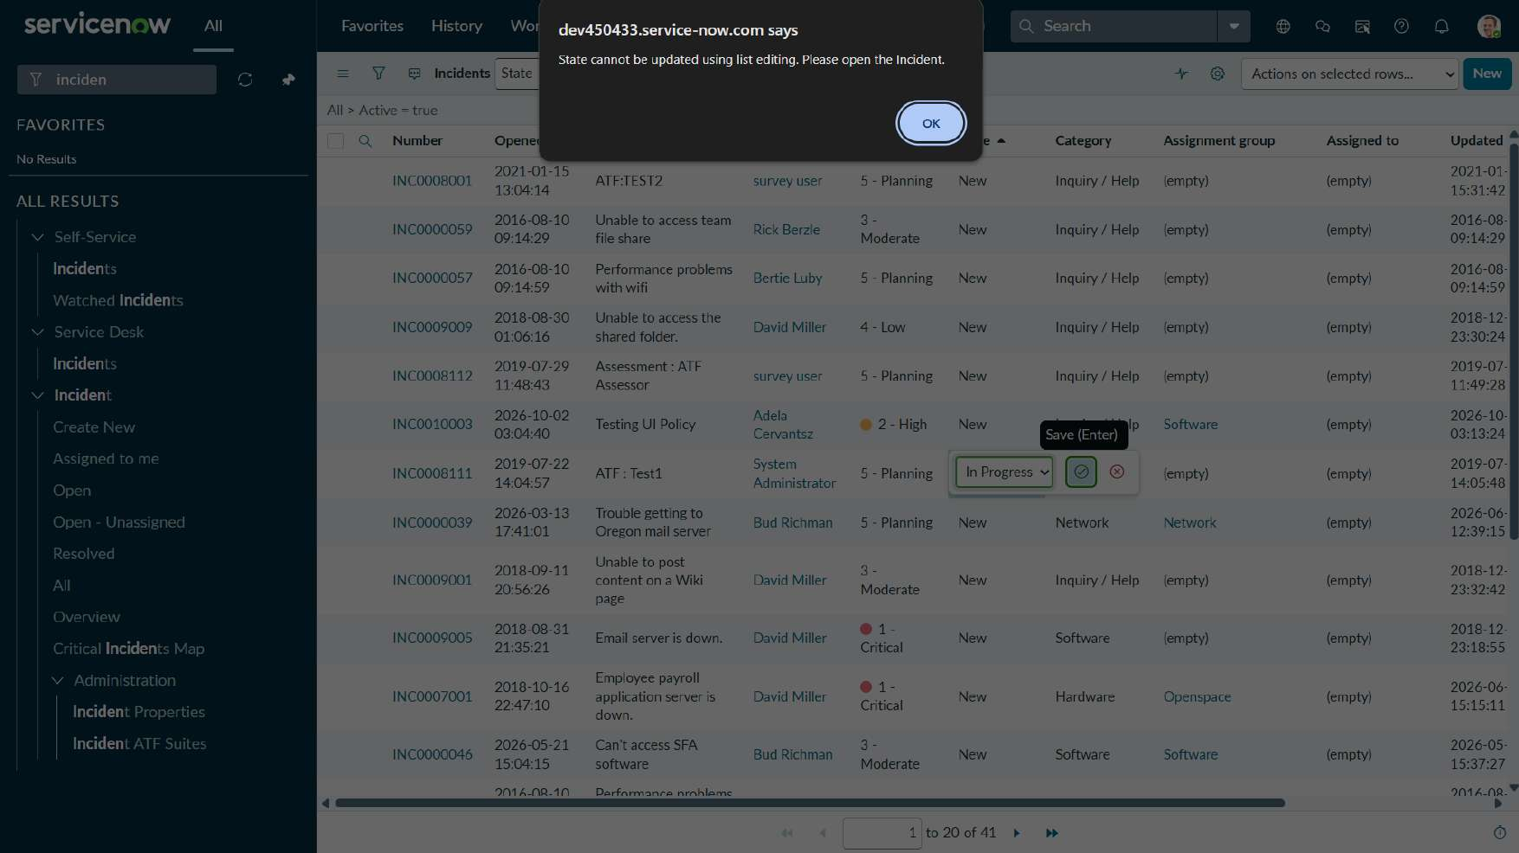
Figure 14: List edit of State blocked with the alert "State cannot be updated using list editing. Please open the Incident."

FT-06: State change from the Incident form
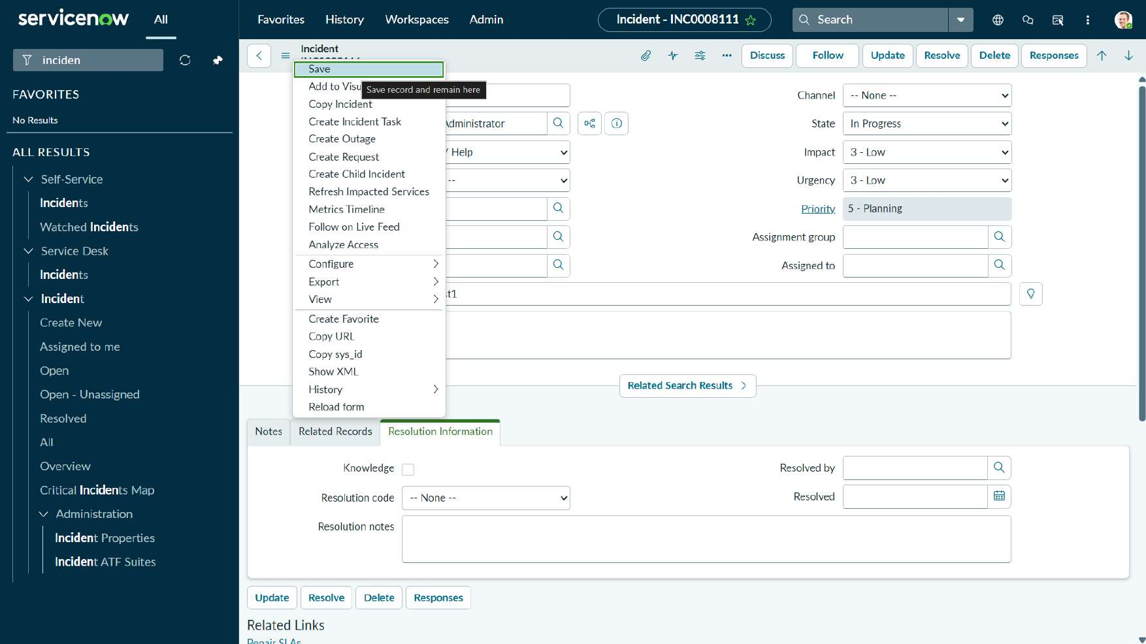
Figure 15: Incident INC0008111 opened and saved from the form menu (State In Progress)
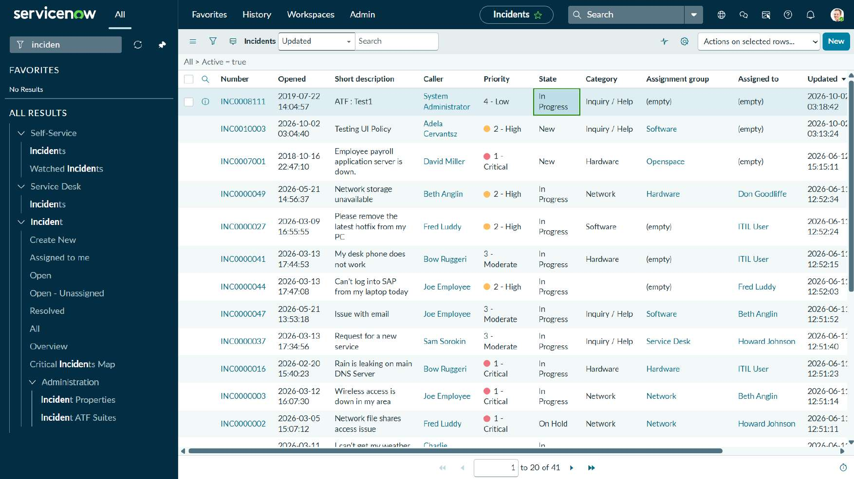
Figure 16: Incident list after the update: INC0008111 now In Progress at the top of the list

6.3 User Acceptance Testing (UAT)

Project Overview
Item | Details
Project Name | Implement Client Script & UI Policy (Incident)
Project Description | Form and list controls for the ServiceNow Incident table using a UI Policy and Client Scripts.
Project Version | 1.0
Testing Period | 3/10/26 to 3/10/26
Testing Scope | High Impact Control UI Policy; auto Urgency script; Assigned to save validation; State list-edit protection.
Testing Environment | ServiceNow developer instance (dev450433.service-now.com), Desktop UI. Credentials are provided separately and are not recorded here.

Test Cases
Test Case ID | Test Scenario | Test Steps | Expected Result | Actual Result | Pass/Fail
TC-001 | High impact incident is created correctly | 1. Open a new Incident. 2. Set Impact to 1 - High. | Urgency 1 - High (read-only); Assignment group mandatory | Matches | Pass
TC-002 | Save without Assigned to | 1. Keep Impact 1 - High. 2. Leave Assigned to empty. 3. Submit. | Error shown; record not saved | Matches | Pass
TC-003 | Save with Assigned to | 1. Select Assigned to. 2. Save. | Record saved | Matches | Pass
TC-004 | Lower the Impact | 1. Change Impact to 2 - Medium. | Urgency editable again | Matches | Pass
TC-005 | List edit of State | 1. Edit State in the list. 2. Save. | Alert shown; no change | Matches | Pass

Bug Tracking
Bug ID | Bug Description | Steps to reproduce | Severity | Status | Additional feedback
BG-001 | No defects were found during UAT | Not applicable | Not applicable | Closed | All test cases passed

Sign-off
Item | Details
Tester | Project team, SWTID-2026-9808
Date of Test Completion | 3/10/26
Result | All test cases passed; ready for deployment approval.

6.4 Project Documentation Summary

Introduction
- Project Title: Implement Client Script & UI Policy (Incident)
- Team Leader: Manav R
- Team Members: Krrish Jain, Yash N, Vishal S, Pratham Jain

Project Overview
- Purpose: Enforce correct data entry on High impact incidents and protect the State field in list view.
- Features: Mandatory Assignment group, read-only Urgency, automatic Urgency, Assigned to validation on save, and list-edit protection for State.

Known Issues
- The Client Scripts apply to the Desktop UI type only; mobile and workspace UIs are not covered.
- Impact is compared with the raw value "1", so changes to the choice values would require updating the scripts.

Future Enhancements
- Extend the rules to other task tables such as Problem and Change.
- Add the same validation on the server side (Business Rule) so API and import updates are also covered.
- Add automated tests using ATF for the Incident rules.

