The OS is just a program, that runs on the bare machine. The OS purpose is to hide all the complexity of the machine. Some programs are provided by the OS to the user. The real core of the OS is the kernel. With the division between kernel and user space, there are different capabilities that cpu has in each of the spaces.
the kernel can be:
-Monolithic kernel: one large kernel, that handles everything, better because if you need many things, you are already in user space, but a corruption crashes everything. Monolithic means performance
-Microkernel: the minimal things are put in kernel space, everything else is in userspace. For example putting the filesystem in userspace. Microkernels are a little bit less fast, for example that isn’t important with programs
FLAT: used in small microcontrollers, we don’t really have kernel and user space separation.
The purpose of OS is making hardware usable by engineers, so for example making it possible to write printf and see the result without knowing the abstraction.
With embedded system, time and space matters, we have very few ram and disk space so we care about the size of programs. Also time, for example the breaks of a car are managed by a microcontroller, and that has to be fast enough.
We have a small computer, that has flash and ram memory. With our example(flat embedded systems), the flash memory is part of the address space. In flat we don’t have MMU.
In the flash there is:
-startup code
-kernel
-drivers
-applications
In a flat operating system we don’t have separation between kernel and userspace, more work to the software designer, because there’s nothing that manages errors, and if you corrupt kernel memory, you just go in kernel panic.
FreeRTOS doesn’t have memory protection, is closer to a microkernel, but it is still a flat OS.
When we switch on a device, we reset the cpu, then we initialize the memory, start the application, react to events, schedule tasks and synchronize all the resources to make the computer work properly.
Usually an OS does many things such as:
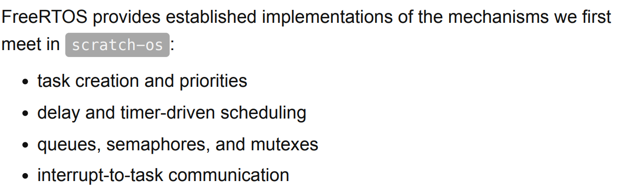
in our, we won’t be able to do all of that.
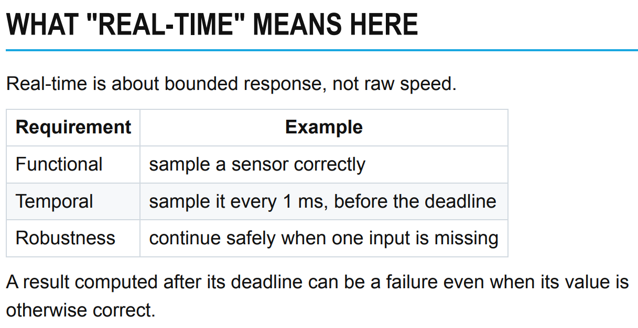

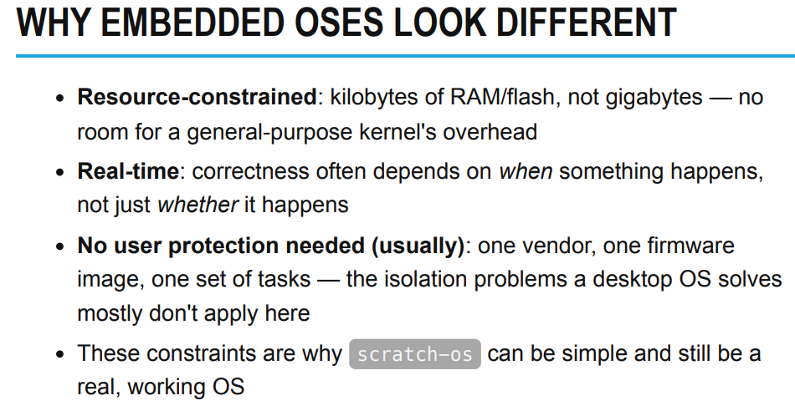
-in embedded we have very few memory, and not more than 100MB for a “normal” OS.
-real time means that time matters in the response(such as in a car)
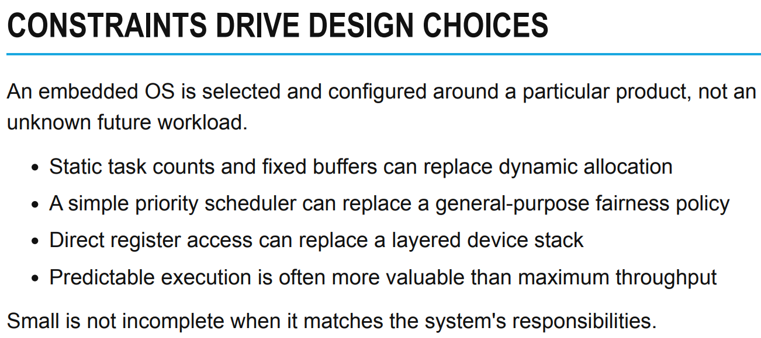
an embedded OS is not general purpose, everything in a microcontroller is already designed, you don’t need flexibility, you just need that the firmware works, with the same tasks. We know wich and how many tasks we have to run, we also know how much memory we need and have, so basically we shouldn’t need memory management. All of that OS(RTOS) works with priorities. Everything HAS to be predictable.
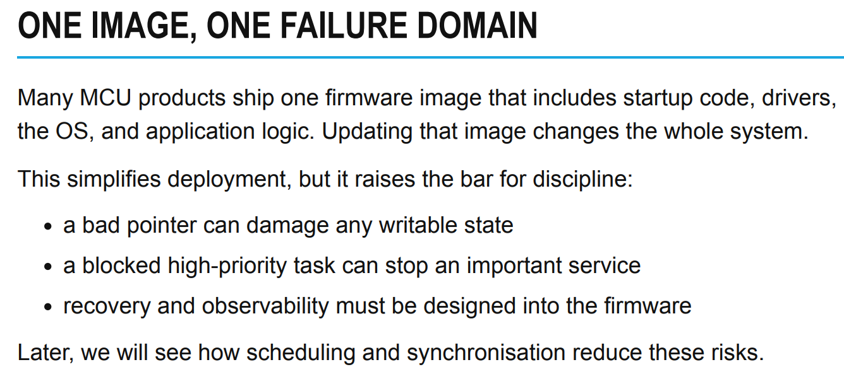
one image in memory, no protection and so one error full system crushes.
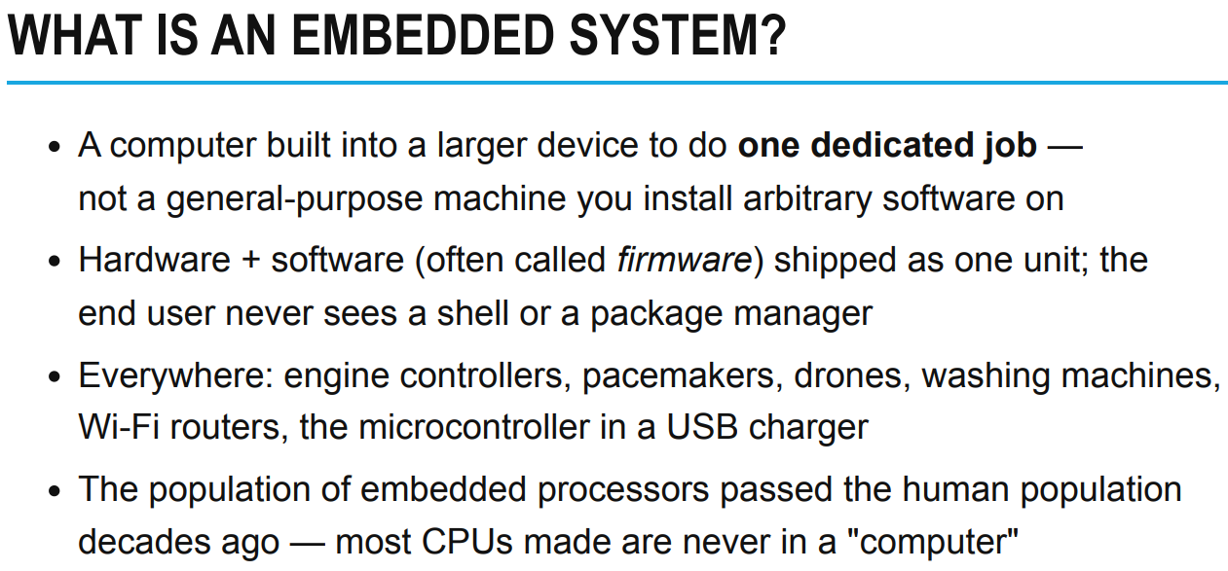
a single image, the firmware, hardware and software together. Many times a software that runs on a board, ONLY work on that board. That doesn’t happen in our computers because there’s a standard(for example UEFI) and so the OS works on top of that. If there wasn’t that agreement, we would have the same issue as firmware, so no compatibility.
To summarize:
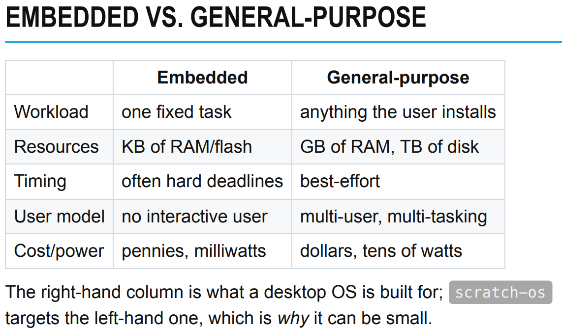
Usually embedded systems interact with sensor and these kind of things instead of humans.

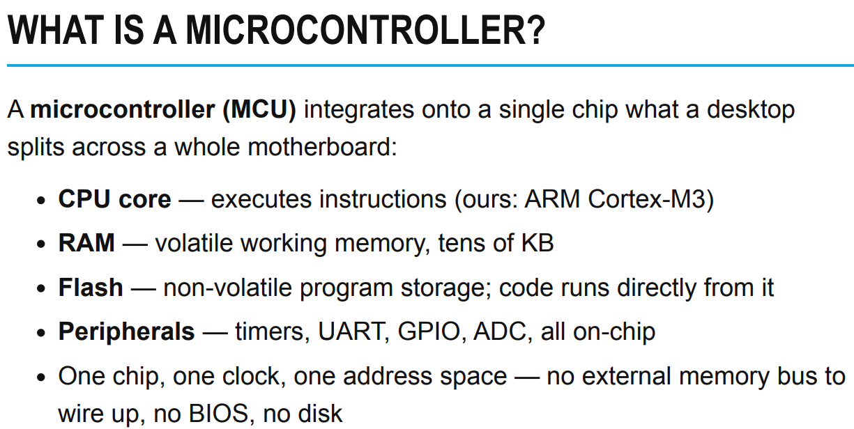
A microcontroller is board computer that contains some things. So you have:
-CPU
-RAM memory
-Flash memory(non volatile)
-Peripherals
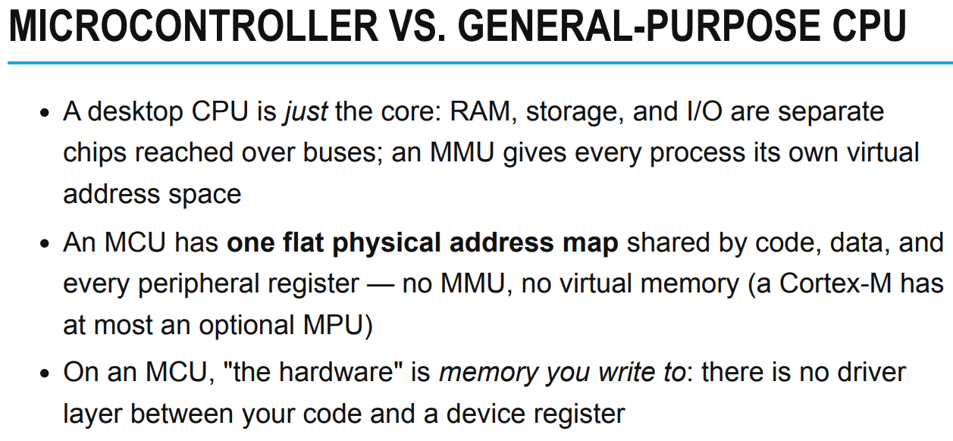
In a microcontroller all is contiguous, flash and ram are part of the same address space. For example a program can be run by flash memory. So the execution starts form a specific address, and we have to keep in mind that, in order to make the MCU do what we want. Variables are still in ram, even in an MCU.
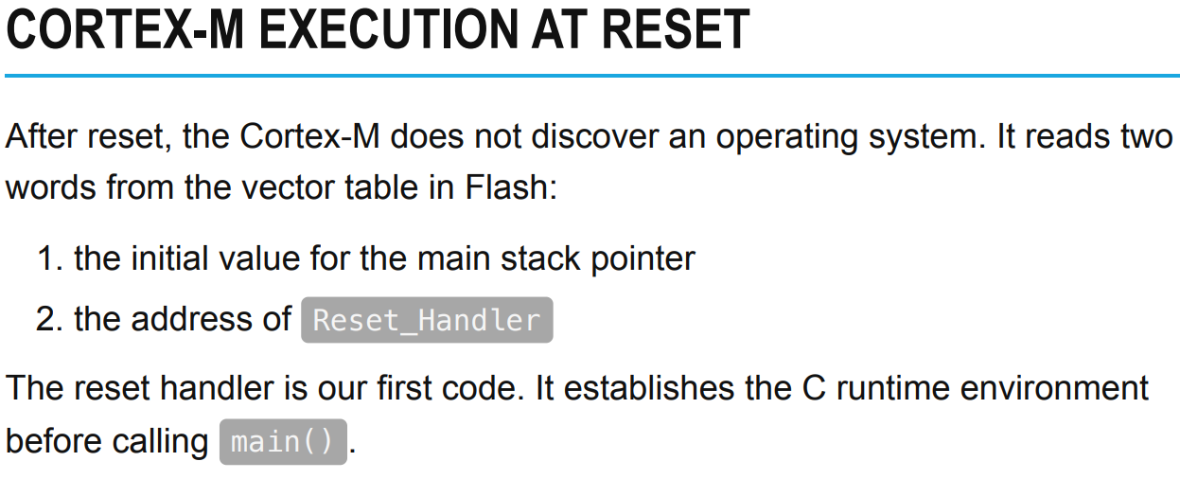
Every CPU has a reset_handler, the first address that the CPU looks for at the start. In some CPU that address is fixed, in ARM you can choose and modify it.
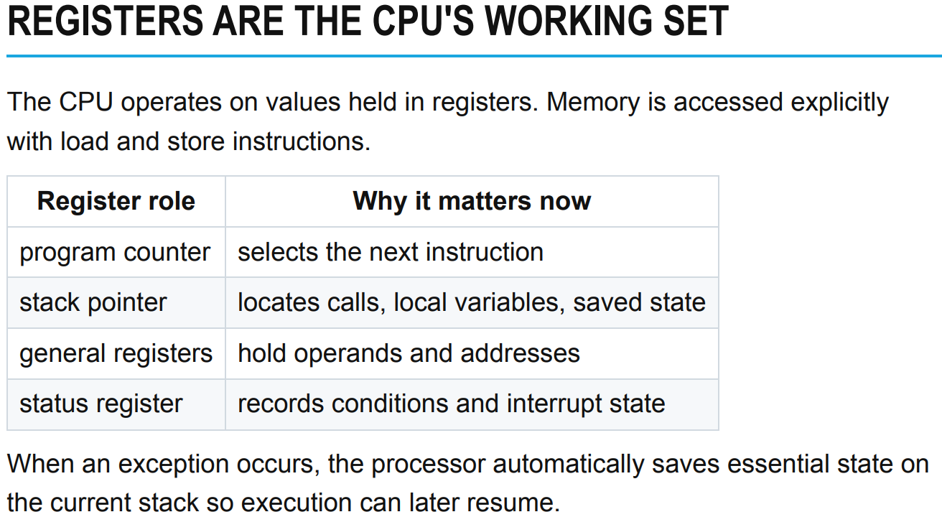
the CPU works with registers. Some registers are important: PC(next instruction) stack pointer, where the stack starts. Status register holds flags, information about the state of the CPU.
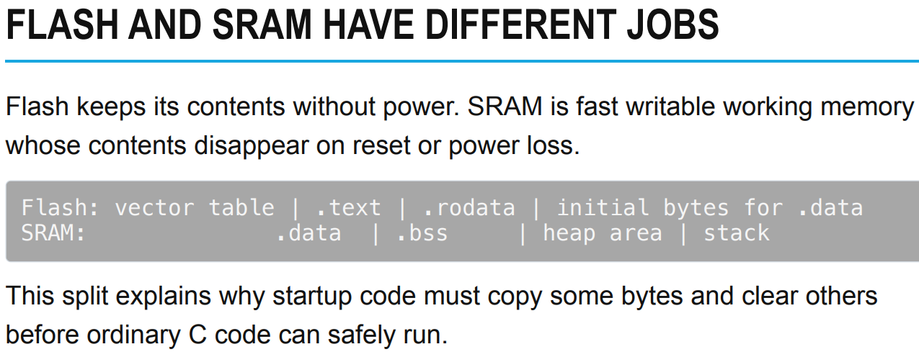
In flash we have:
.data: where the code is
.rodata: where RO data is stored
.data: variables initialized
.bss : variables not initialized
stack: local variables

