Repairing Attention for PointNet++ Point Cloud Classification
Technical Study Across ModelNet40 and 3D MNIST

Abstract. This paper reconstructs an end-to-end research cycle around attention-enhanced PointNet++ classification by inspecting the repository code, experiment logs, and run artifacts directly. The study begins from the upstream PointNet++ single-scale grouping baseline, then follows three architectural branches: channel recalibration with Squeeze-and-Excitation (SE), an initial attention design that underperforms, and a repaired attention-v2 model that corrects the observed failure modes. The central diagnosis is that PointNet++ neighborhood padding is benign for max pooling but mathematically inconsistent with naive softmax attention, because duplicated padding points absorb real probability mass. Attention-v2 addresses that mismatch with explicit neighbor validity masks, hybrid attention-plus-max pooling, richer cross-level tokenization, and a stronger classifier head, while also adding Apple Silicon / Metal Performance Shaders safeguards for masking, indexing, and tensor layout. On ModelNet40, the repaired model improves sharply over attention-v1 from 91.392% to 92.056% instance accuracy and from 86.898% to 89.597% class accuracy, but it still trails the strongest local SSG baseline by 0.403 instance points. On 3D MNIST, attention-v2 slightly exceeds the baseline in both best instance accuracy (98.710% vs. 98.611%) and best class accuracy (98.939% vs. 98.623%). The final conclusion is intentionally balanced: the repaired attention design is technically sound and cross-dataset viable, but its parameter cost is substantially larger and it does not justify replacing a strong PointNet++ SSG baseline on ModelNet40.
Keywords. point cloud classification; PointNet++; masked attention; hybrid local pooling; Apple Silicon; MPS; technical report

1. Introduction
Deep learning on point sets must reconcile three constraints at once: permutation invariance, local geometric structure, and computational stability. PointNet established a strong permutation-invariant baseline by combining shared pointwise multilayer perceptrons with a global symmetric max operator [1]. PointNet++ extended that idea with hierarchical set abstraction, radius-based grouping, and local feature aggregation, which remains one of the most durable design templates for point cloud classification [2].
The repository inspected in this study starts from the upstream PointNet++ single-scale grouping classifier implemented in models/pointnet2_cls_ssg.py. Two goals then shaped the subsequent engineering and modeling work. The first goal was infrastructural: the original code had to become reliable on Apple Silicon and Metal Performance Shaders so that later model comparisons were not confounded by platform-specific instability. The second goal was architectural: attention-like modifications were evaluated to determine whether they could improve the classifier without abandoning the local inductive biases that make PointNet++ effective.
Rather than narrating the project as a clean monotonic gain, this paper preserves the full research cycle. A channel-attention variant improved class balance without winning on instance accuracy. A first attention model underperformed because of concrete implementation and design mismatches. A second attention model repaired those issues and recovered most of the lost performance. That trajectory is valuable because it exposes which attention ideas survive contact with PointNet++ neighborhood semantics and which do not.
- A code-backed diagnosis of why naive local softmax attention is incompatible with PointNet++ duplicate-neighbor padding.
- A repaired attention-v2 architecture with explicit neighbor masks, hybrid local pooling, richer cross-level tokenization, and a stronger classifier head.
- A platform-aware training pipeline for Apple Silicon, plus dataset-aware logging that turns one-off runs into reusable experiment artifacts.
- A balanced evaluation across ModelNet40 and 3D MNIST showing stronger class balance and modest cross-dataset gains, but no decisive ModelNet40 top-line win.

2. Repository Context and Related Work
Within point cloud learning, PointNet [1] and PointNet++ [2] provide the direct architectural lineage for this work. PointCNN and PointConv explored learnable local operators that more explicitly model neighborhood structure [6, 7], while Dynamic Graph CNN emphasized dynamically updated local graphs for feature extraction [4]. Those families show that gains often emerge from better local aggregation rather than from replacing permutation invariance outright.
Attention mechanisms entered this space through both general permutation-invariant architectures and point-cloud-specific transformers. Set Transformer showed that attention can be used as a principled pooling and set-processing primitive [5], while transformer-based point models such as Point Transformer applied self-attention to 3D neighborhoods more directly [8]. At the same time, Squeeze-and-Excitation networks demonstrated that lightweight channel recalibration can improve representation quality without redesigning the full backbone [3].
The current work occupies a narrower but practically important position. It is not a new state-of-the-art point cloud architecture, nor is it a general survey of transformer methods. Instead, it is a repository-grounded case study that asks whether attention can be inserted into a strong PointNet++ SSG baseline in a way that remains faithful to the original local grouping pipeline, robust on Apple Silicon, and honest about performance tradeoffs. The broader literature on realistic point cloud benchmarks, including ScanObjectNN [9], motivates the decision to treat 3D MNIST as a useful secondary validation rather than a definitive generalization benchmark.
Table 1. Repository evolution and experimental branch roles.
Branch | Role | Main contribution
master | Upstream repository | Reference PointNet / PointNet++ implementation and published README benchmarks.
feat/apple_silicon | Platform hardening | MPS-safe indexing, Apple Silicon training stability, SE exploration, and early attention trials.
pointnet2-attn-v2-mac-safe | Mechanism repair | Masked local attention, hybrid pooling, stronger cross-level fusion, and the corrected ModelNet40 run.
3dmnist-attnv2-training | Cross-dataset validation | 3D MNIST dataloader integration plus run_config.json, metrics.csv, and summary.json artifacts.

3. Methodology

3.1 Baseline PointNet++ SSG
The baseline classifier follows the standard PointNet++ single-scale grouping design. It applies three set abstraction stages: SA1 samples 512 centroids with radius 0.2 and 32 neighbors, SA2 samples 128 centroids with radius 0.4 and 64 neighbors, and SA3 performs global aggregation into a 1024-dimensional descriptor. The classifier head maps 1024 -> 512 -> 256 -> num_class with ReLU, batch normalization, and dropout. This baseline is both historically grounded and locally strong, which raises the bar for any augmentation.
Crucially, the local aggregation in this baseline is max pooling. That operator is robust to duplicated neighbors because repeating a value does not change the maximum. The entire attention investigation in this repository effectively revolves around the question of how much expressive attention can be added without losing that robustness.

3.2 SE and Attention v1
The SE variant keeps the PointNet++ feature hierarchy intact but inserts squeeze-and-excitation blocks after SA1 and SA2. It also deepens the classifier head to 1024 -> 512 -> 256 -> 128 -> num_class. This model tests a conservative hypothesis: stronger channel weighting may improve class discrimination while preserving PointNet++ locality.
Attention v1 is more ambitious. It replaces local max pooling with learned attention weights, retains SE channel recalibration, and introduces cross-level fusion by reducing l1, l2, and l3 into three tokens processed by multi-head self-attention. In intent, the model aims to preserve finer local structure than max pooling and to exploit multi-scale information that the global l3 descriptor alone might miss.

3.3 Why Attention v1 Fails
The strongest failure mode is a mismatch between PointNet++ grouping semantics and softmax attention. In the shared utility path, query_ball_point pads missing neighbors by duplicating the first valid point so that downstream tensor shapes remain fixed. That duplication is benign for max pooling but not for attention: the copied entries receive real probability mass and bias the neighborhood aggregation. In short, the model is not attending over the true set of neighbors; it is attending over a padded proxy whose measure has been changed.
A second issue is excessive compression before fusion. Attention v1 collapses each abstraction level into a single mean-pooled token and then averages the attended tokens again, which removes much of the structure that cross-level attention was meant to preserve. A third issue lies in the classifier. The post-fusion head does not introduce enough nonlinear depth, so the richer features are not followed by a suitably expressive decision boundary.
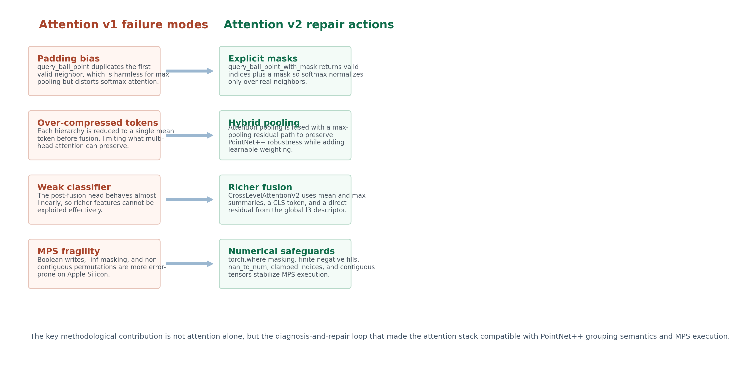
Figure 2. Attention v2 is best interpreted as a repair program for concrete attention-v1 failure modes rather than as a minor extension.

3.4 Attention v2
Attention v2 corrects the three architectural problems and adds platform-aware numerical safeguards. First, query_ball_point_with_mask and sample_and_group_with_mask return both gathered indices and a validity mask. Softmax is applied only over valid neighbors, while padded slots are used solely for safe indexing. This aligns the implementation with the mathematical assumption that attention should normalize over real elements only.
Second, local pooling becomes hybrid rather than purely attentional. Each neighborhood produces both attention-pooled features and a max-pooled residual, and a small fusion block recombines them. This design preserves the strong inductive bias of PointNet / PointNet++ max aggregation while allowing learned reweighting to contribute when it is useful.
Third, cross-level fusion is expanded substantially. Attention v2 uses mean and max summaries for l1 and l2, adds a learnable CLS token, and preserves a direct residual path from the global l3 representation. The final classifier is widened to 512 -> 256 -> 128 -> num_class. Together, these changes make the final stage more expressive and reduce the risk that useful multi-scale signals are averaged away too early.
Table 2. Architectural comparison across the four inspected classifiers.
Model | Local aggregation | Channel attention | Cross-level fusion | Classifier head | Parameters
SSG baseline | Max pooling | None | None | 1024 -> 512 -> 256 -> C | 1.48M
SSG + SE | Max pooling | SE after SA1/SA2 | None | 1024 -> 512 -> 256 -> 128 -> C | 1.65M
Attention v1 | Unmasked attention pooling | SE after SA1/SA2 | 3 mean-pooled tokens | 256 -> 128 -> C | 1.83M
Attention v2 | Masked hybrid attention + max | SE after SA1/SA2/SA3 | Mean/max tokens + CLS + global residual | 512 -> 256 -> 128 -> C | 5.95M

4. Implementation and Experimental Protocol
Engineering support is a first-class contribution in this repository. device_utils.py adds automatic device selection across MPS, CUDA, and CPU. models/pointnet2_utils.py adds MPS-safe index clamping, torch.where-based masking in place of boolean assignment, and contiguous permutations. Attention v2 adds further protections such as finite large-negative masking values instead of -inf and torch.nan_to_num after multi-head attention. These changes are especially important on Apple Silicon, where indexing and masking behavior is less forgiving than on CUDA.
The training pipeline was upgraded so that experiments now preserve their own provenance. train_classification.py writes run_config.json, metrics.csv, and summary.json, copies the exact model and loader files used during training, and supports both ModelNet and 3D MNIST through a common interface. test_classification.py reads run_config.json automatically, which reduces configuration drift at evaluation time.
ModelNet40 remains the primary benchmark because it is the dataset most directly tied to the PointNet++ literature [2]. However, the older ModelNet40 branches still record results mainly in text logs, and the batch size was not fully controlled across all four variants: the baseline and attention v1 use batch size 24, while SE and attention v2 use batch size 16. This does not invalidate the comparison, but it does weaken any claim that the ModelNet40 ranking is perfectly controlled.
3D MNIST was integrated as a second classification dataset with HDF5-backed train and test splits. The local copy contains 5,000 training samples and 1,000 test samples across 10 classes. Point counts vary substantially before subsampling, so the dataset also serves as a useful stress test for the new dataloader and for the repository's point sampling and normalization path. For HDF5 safety on macOS, effective dataloader workers are forced to zero during these runs.
Table 3. Local 3D MNIST dataset characteristics after inspection of the HDF5 artifacts.
Split | Samples | Point-count range | Mean raw points | Classes
Train | 5000 | 9250 to 38200 | 22600.09 | 10
Test | 1000 | 9700 to 34800 | 21950.35 | 10

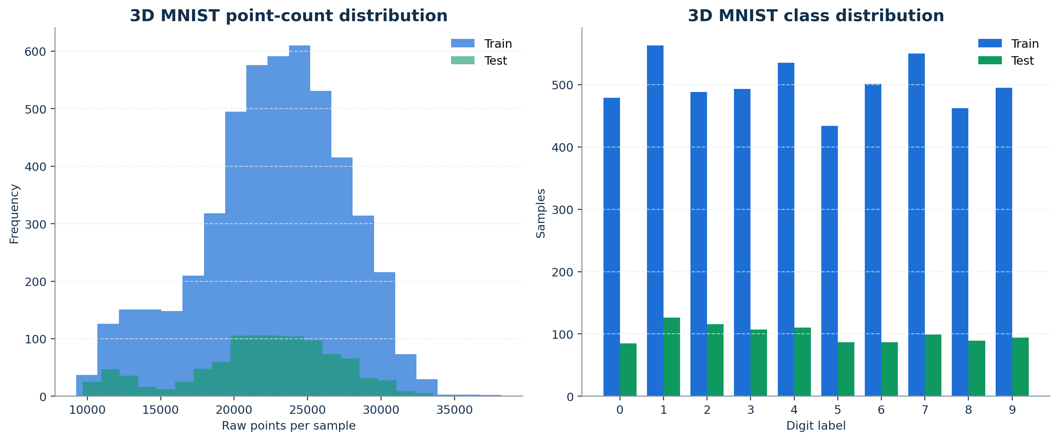
Figure 3. The local 3D MNIST copy is reasonably class-balanced and exhibits a wide raw point-count range before subsampling to 1,024 points.

5. Results

5.1 ModelNet40
The strongest local baseline reaches 92.459% instance accuracy and 89.175% class accuracy. SE trades a small instance-accuracy drop for a class-accuracy gain, which is consistent with channel recalibration helping balance predictions. Attention v1 performs substantially worse, confirming that its issues are material rather than cosmetic.
Attention v2 recovers much of that damage. Relative to attention v1, it gains 0.665 instance points and 2.699 class-accuracy points. Relative to the strongest baseline, however, it remains 0.403 points lower on the main top-line metric even while exceeding the baseline by 0.422 class-accuracy points.
This pattern matters. It suggests that the repaired attention design improves class balance more consistently than raw sample-level accuracy. In other words, attention v2 is not simply a failed variant; it changes the model's behavior in a measurable and partly desirable direction, but not enough to displace a strong PointNet++ SSG baseline on the primary benchmark.
Table 4. ModelNet40 outcomes extracted directly from the four text log files.
Model | Batch size | Best epoch | Best inst. | Best class | Final train inst. | Final test inst. | Final test class
SSG Baseline | 24 | 68 | 92.459% | 89.175% | 95.488% | 91.561% | 88.557%
SSG + SE | 16 | 92 | 91.976% | 89.626% | 92.927% | 91.048% | 87.578%
Attention v1 | 24 | 88 | 91.392% | 86.898% | 92.480% | 89.798% | 84.697%
Attention v2 | 16 | 100 | 92.056% | 89.597% | 94.421% | 92.056% | 89.597%

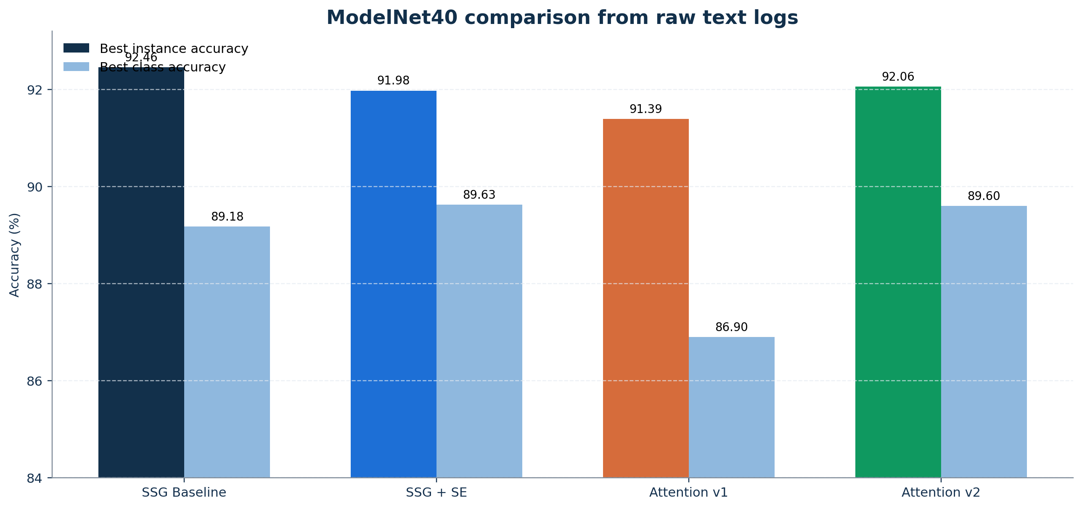
Figure 4. Attention v2 closes most of the gap opened by attention v1, but the baseline retains the highest ModelNet40 instance accuracy.

Table 5. Reference accuracy context for PointNet++ on ModelNet40.
Method | Source | Instance accuracy
PointNet++ paper (XYZ only) | Official paper [2] | 90.700%
PointNet++ paper (XYZ + normals) | Official paper [2] | 91.900%
Repository README SSG (XYZ only) | Repository README | 92.200%
Repository README SSG (XYZ + normals) | Repository README | 92.400%
Local retrain SSG (XYZ only) | Inspected text log | 92.459%

5.2 3D MNIST
3D MNIST provides the cleanest head-to-head comparison in the repository because the baseline and attention-v2 runs share the same batch size, epoch count, optimizer, learning rate, weight decay, point count, and device. Under that matched setup, attention v2 achieves 98.710% best instance accuracy and 98.939% best class accuracy, slightly exceeding the baseline values of 98.611% and 98.623%, respectively.
The convergence curves are informative. The baseline learns much faster in the first few epochs, which is expected for a simpler architecture with fewer parameters. Attention v2 starts slowly, then catches up and eventually produces stronger best metrics later in training. This delayed payoff is consistent with attention v2 being a higher-capacity model that needs longer to stabilize, but which can eventually refine class balance more effectively once optimization catches up.
The gain is modest and should not be overstated. 3D MNIST is simpler than realistic object benchmarks and is not a canonical PointNet++ dataset. Still, the result matters because it shows that the repaired attention design is not inherently broken; under a matched setup on a second dataset, it can edge out the baseline.
Table 6. Matched 3D MNIST comparison using the structured experiment artifacts.
Model | Epochs | Batch size | Best inst. | Best class | Best epoch
SSG baseline | 100 | 16 | 98.611% | 98.623% | 100
Attention v2 | 100 | 16 | 98.710% | 98.939% | 96

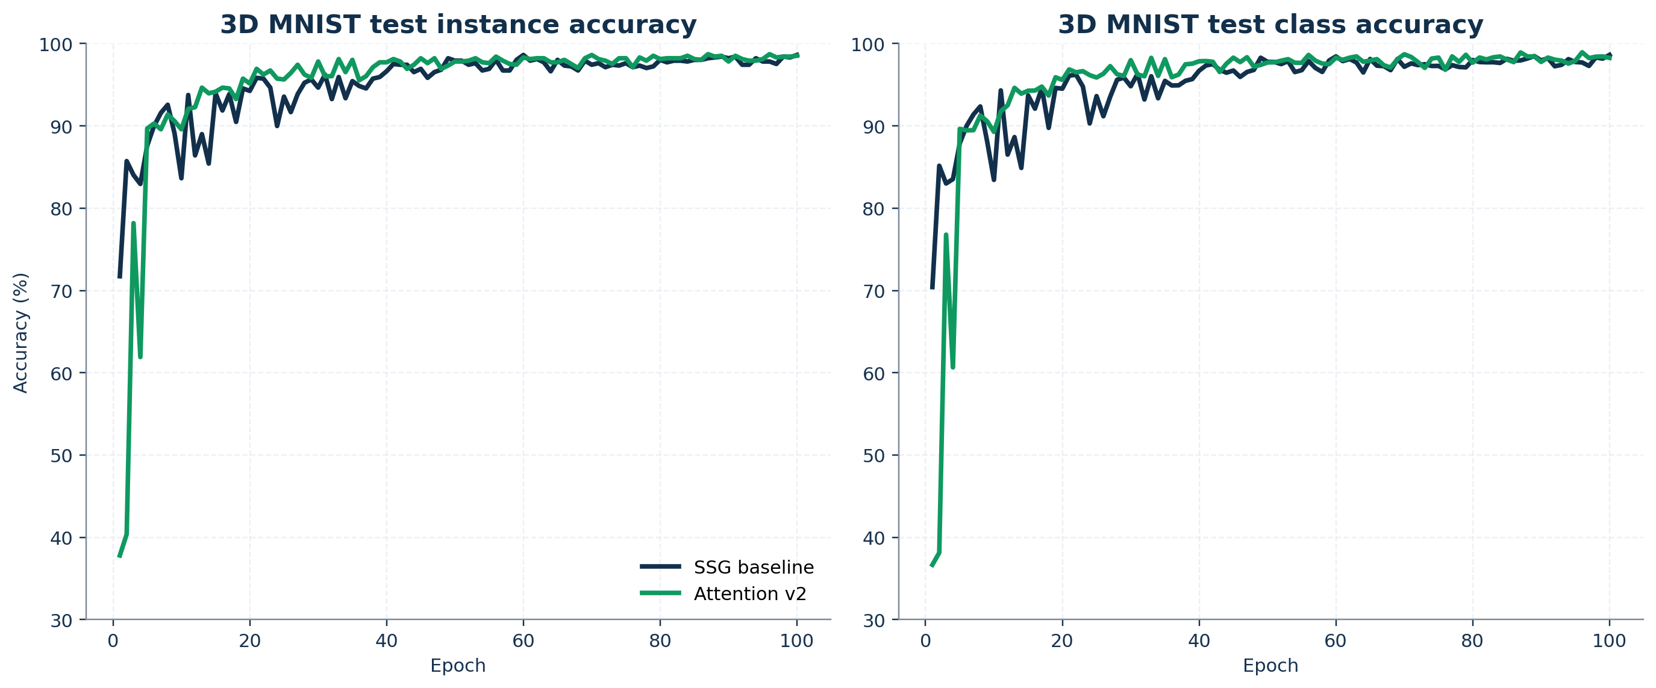
Figure 5. On 3D MNIST, attention v2 converges more slowly but eventually reaches slightly stronger best metrics than the baseline.

Table 7. Parameter cost across the four classifiers.
Model | Parameters | Delta vs. baseline
SSG Baseline | 1,475,688 | baseline
SSG + SE | 1,647,616 | +11.65%
Attention v1 | 1,831,683 | +24.12%
Attention v2 | 5,951,459 | +303.30%

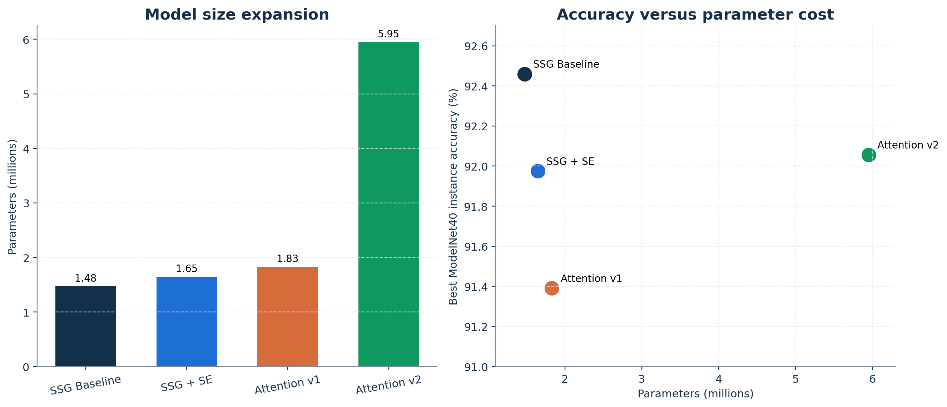
Figure 6. The repaired attention stack trades efficiency for robustness and richer fusion, with attention v2 reaching 5.95M parameters.

6. Discussion
The final model's strongest contribution is methodological rather than purely numerical. It identifies a subtle but consequential incompatibility between PointNet++ neighborhood padding and naive softmax attention, then fixes that incompatibility with an explicit mask path. That diagnosis is portable: any point-cloud pipeline that mixes fixed-size neighborhood tensors with softmax-based local pooling should be audited for the same issue.
The main drawback is efficiency. Attention v2 contains 5,951,459 parameters, or 303.30% more than the baseline. The single largest block is sa3.pool.fuse.0.weight, which alone contains 2,097,152 parameters. This confirms that the current design should be treated as an accuracy-oriented prototype rather than an optimized deployment model.
The results also show the limits of local improvements in a mature architecture family. A strong PointNet++ implementation already exceeds the original paper's XYZ-only number, so the challenge is not merely to beat the 2017 benchmark but to beat the repository's own retrained baseline. Within that harder comparison, attention v2 improves class balance and rescues the failed attention branch, but it does not earn a clear replacement case on ModelNet40.

7. Limitations and Threats to Validity
- ModelNet40 runs are not fully controlled because batch size differs across variants and the older branches record results mainly in text logs.
- No multi-seed evaluation was performed, so the reported rankings may still contain seed sensitivity.
- No ablation isolates masked attention, hybrid pooling, cross-level fusion, or the stronger classifier independently.
- 3D MNIST is a useful cross-dataset check, but it is easier and less realistic than benchmarks such as ScanObjectNN [9].

8. Conclusion
This repository-level study shows that attention can improve a PointNet++ SSG classifier only when the surrounding assumptions are repaired as carefully as the attention block itself. Attention v1 fails because it violates the semantics of padded neighborhoods and compresses too much information before fusion. Attention v2 succeeds in fixing those issues with explicit masking, hybrid pooling, richer tokenization, and a stronger classifier, while also making the implementation safe on Apple Silicon.
The repaired model is clearly better than attention v1, reaches 98.710% / 98.939% on 3D MNIST, and improves ModelNet40 class accuracy relative to the baseline. Yet the baseline still holds the best ModelNet40 instance accuracy at 92.459%, and it does so with far fewer parameters. The most defensible conclusion is therefore balanced: the attention redesign is technically worthwhile and empirically credible, but it is not yet the best default replacement for PointNet++ SSG on the primary benchmark.

References
[1] C. R. Qi, H. Su, K. Mo, and L. J. Guibas, 'PointNet: Deep Learning on Point Sets for 3D Classification and Segmentation,' in Proceedings of the IEEE Conference on Computer Vision and Pattern Recognition, 2017.
[2] C. R. Qi, L. Yi, H. Su, and L. J. Guibas, 'PointNet++: Deep Hierarchical Feature Learning on Point Sets in a Metric Space,' in Advances in Neural Information Processing Systems, 2017.
[3] J. Hu, L. Shen, and G. Sun, 'Squeeze-and-Excitation Networks,' in Proceedings of the IEEE Conference on Computer Vision and Pattern Recognition, 2018.
[4] Y. Wang, Y. Sun, Z. Liu, S. E. Sarma, M. M. Bronstein, and J. M. Solomon, 'Dynamic Graph CNN for Learning on Point Clouds,' ACM Transactions on Graphics, vol. 38, no. 5, 2019.
[5] J. Lee, Y. Lee, J. Kim, A. Kosiorek, S. Choi, and Y. W. Teh, 'Set Transformer: A Framework for Attention-based Permutation-Invariant Neural Networks,' in Proceedings of the 36th International Conference on Machine Learning, 2019.
[6] Y. Li, R. Bu, M. Sun, and B. Chen, 'PointCNN,' in Advances in Neural Information Processing Systems, 2018.
[7] W. Wu, Z. Qi, and L. Fuxin, 'PointConv: Deep Convolutional Networks on 3D Point Clouds,' in Proceedings of the IEEE Conference on Computer Vision and Pattern Recognition, 2019.
[8] H. Zhao, L. Jiang, J. Jia, P. Torr, and V. Koltun, 'Point Transformer,' in Proceedings of the IEEE/CVF International Conference on Computer Vision, 2021.
[9] M. A. Uy, Q. T. Pham, B.-S. Hua, T. Nguyen, and S.-K. Yeung, 'Revisiting Point Cloud Classification: A New Benchmark Dataset and Classification Model on Real-World Data,' in Proceedings of the IEEE/CVF International Conference on Computer Vision, 2019.
[10] A. Vaswani et al., 'Attention Is All You Need,' in Advances in Neural Information Processing Systems, 2017.

