Software Quality Management & Assurance
Student: Dumitrel Marius-Remus
Repository: SQMA_Dumitrel_Marius-Remus
GitHub URL: https://github.com/Vincitur/SQMA_Dumitrel_Marius-Remus

Task 1
Setup
The main class I used Matematica.class
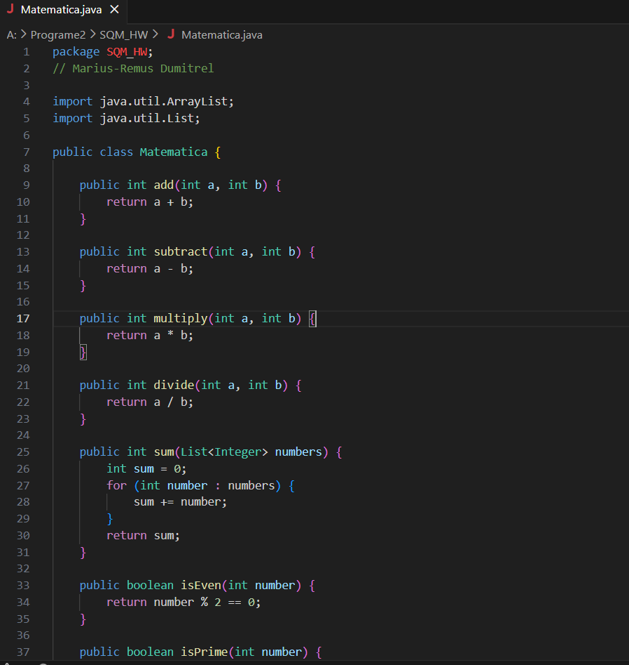

My test classes.
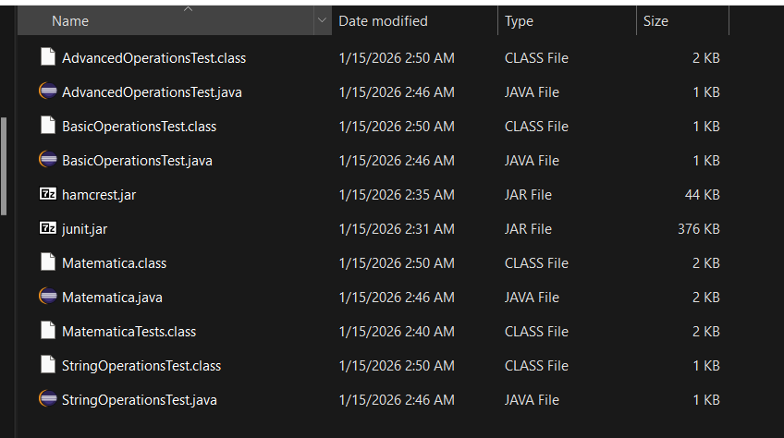
And a run_tests.bat file to check tests work.
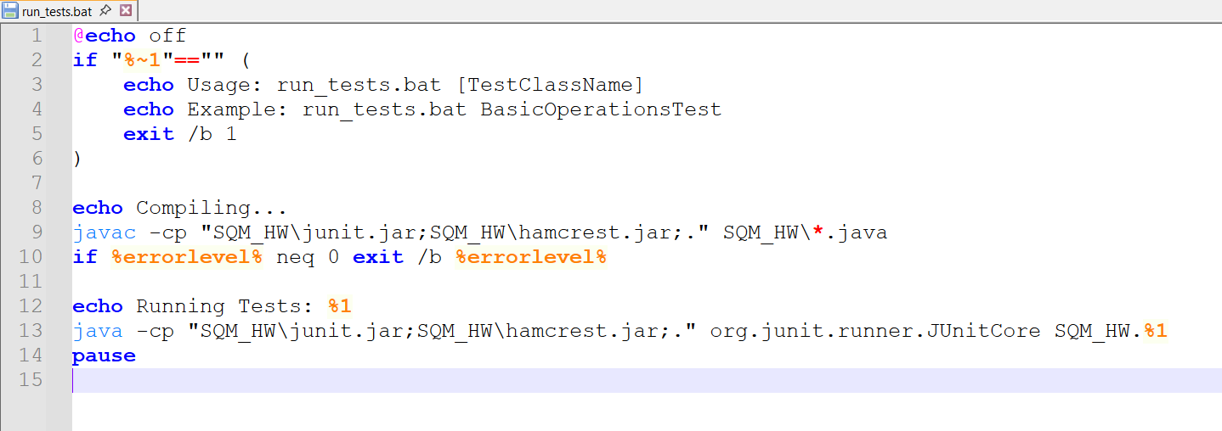
Proof tests work:
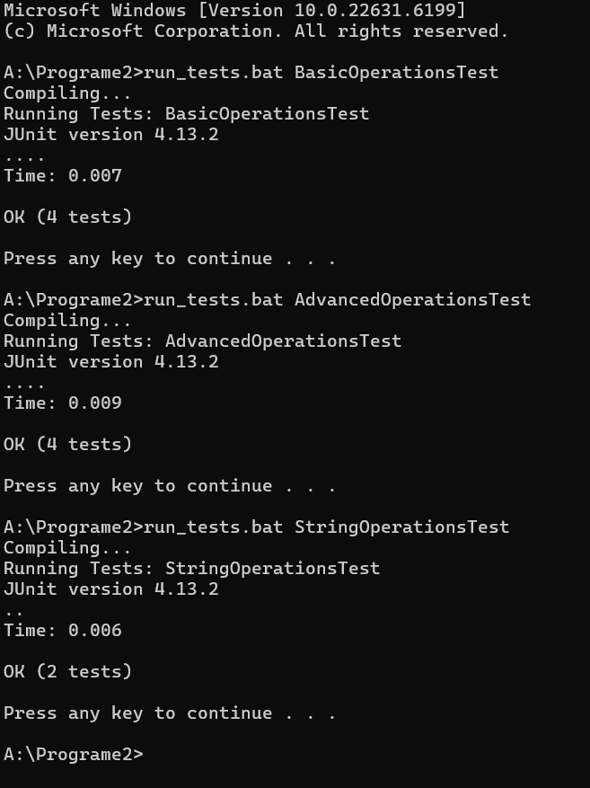

The Git commit and origin main:
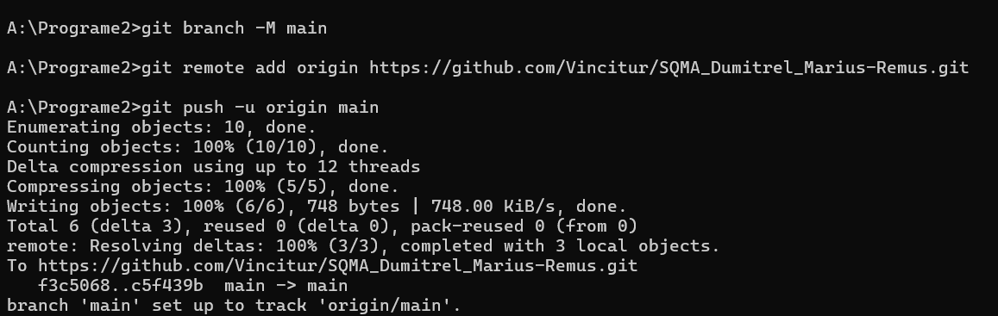

Jenkins Job Setup:
New Item -> SMQA_HW_Job -> Freestyle project
- Configure Parameters:
Check This project is parameterized.
- Click Add Parameter -> Choice Parameter.
- Name: TestToRun
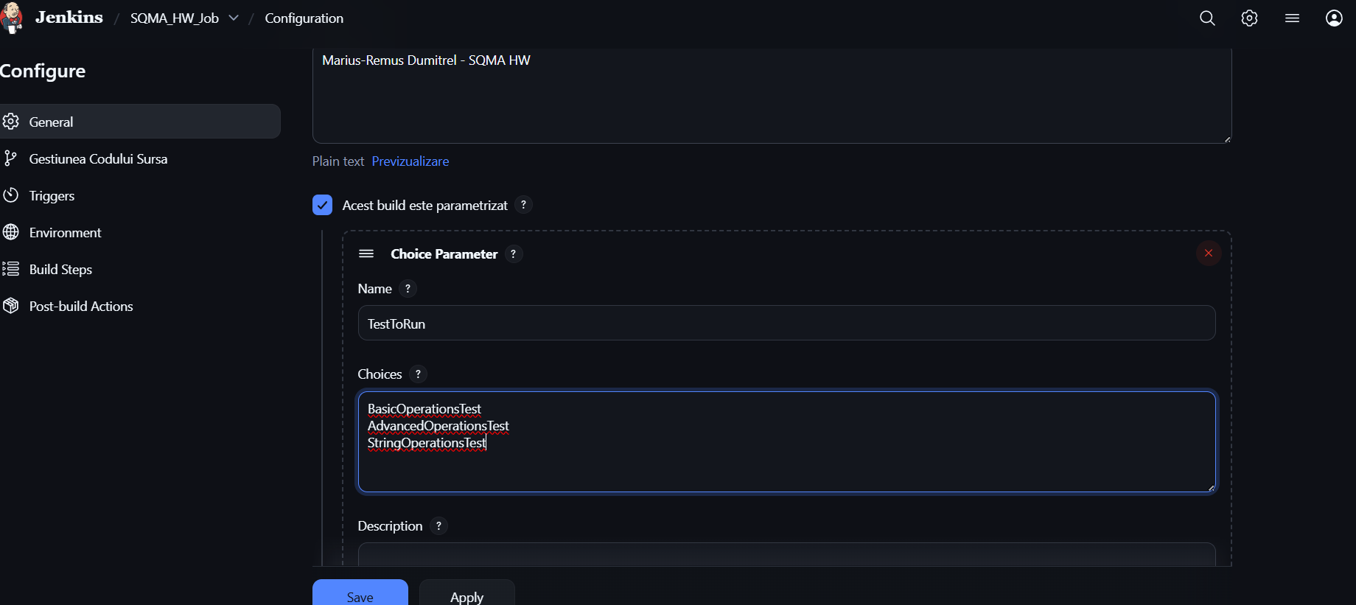
Select Git in Source Code Management:
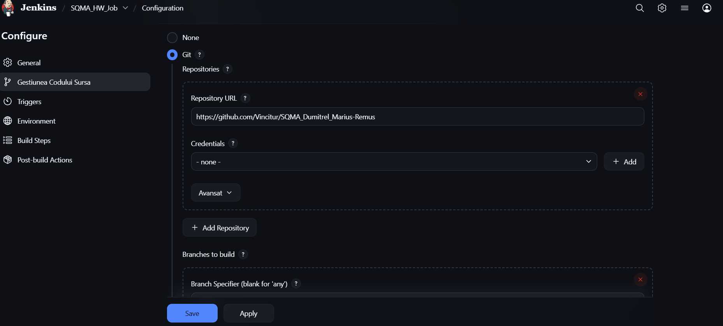
Build steps: run_tests.bat
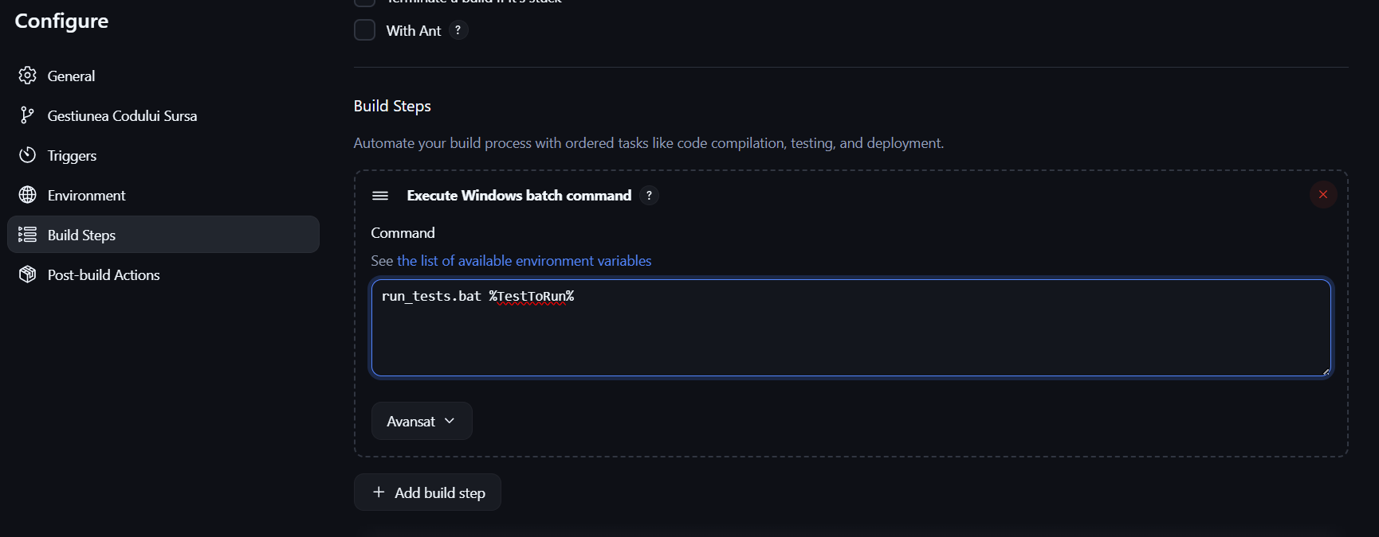
After Build with Parameters:
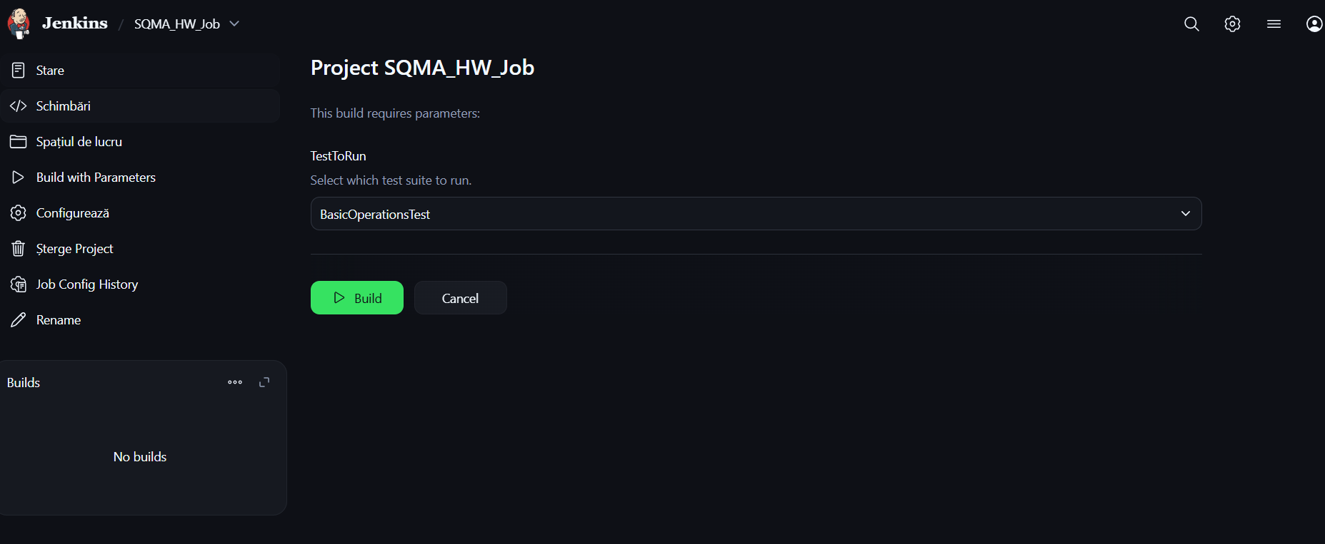
Thus the Choice parameter helps decide which tests to run.
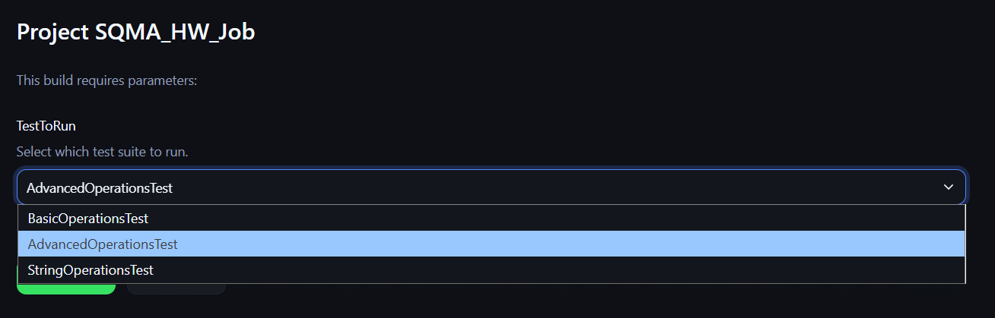
All builds were sucessful.
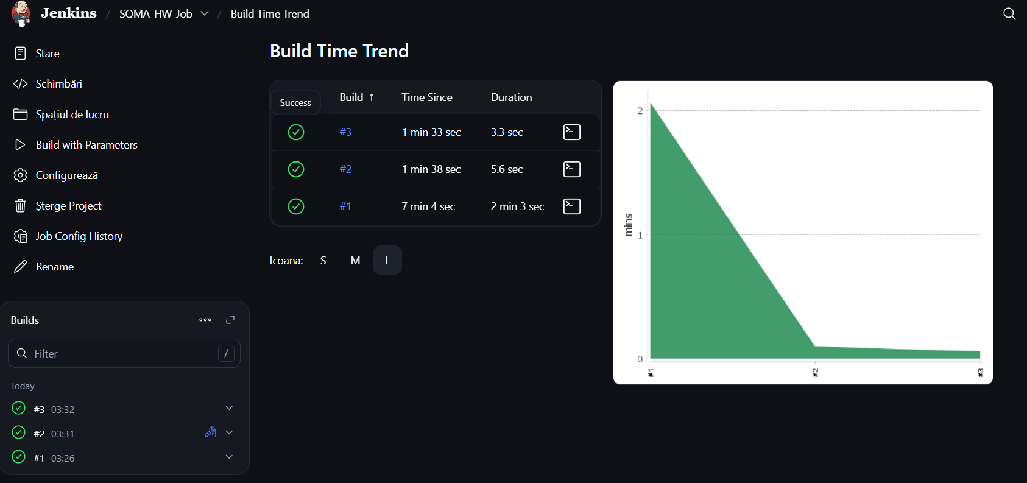
Console example (for build 3):
Started by user Marius-Remus Dumitrel
Running as SYSTEM
Building in workspace A:\Programe2\Jenkins Code\workspace\SQMA_HW_Job
The recommended git tool is: NONE
No credentials specified
> git.exe rev-parse --resolve-git-dir A:\Programe2\Jenkins Code\workspace\SQMA_HW_Job\.git # timeout=10
Fetching changes from the remote Git repository
> git.exe config remote.origin.url https://github.com/Vincitur/SQMA_Dumitrel_Marius-Remus # timeout=10
Fetching upstream changes from https://github.com/Vincitur/SQMA_Dumitrel_Marius-Remus
> git.exe --version # timeout=10
> git --version # 'git version 2.45.1.windows.1'
> git.exe fetch --tags --force --progress -- https://github.com/Vincitur/SQMA_Dumitrel_Marius-Remus +refs/heads/*:refs/remotes/origin/* # timeout=10
> git.exe rev-parse "refs/remotes/origin/main^{commit}" # timeout=10
Checking out Revision c5f439b76ef53cb95cfbda541768ad8a2e2dd92c (refs/remotes/origin/main)
> git.exe config core.sparsecheckout # timeout=10
> git.exe checkout -f c5f439b76ef53cb95cfbda541768ad8a2e2dd92c # timeout=10
Commit message: "Initial assignment submission"
> git.exe rev-list --no-walk c5f439b76ef53cb95cfbda541768ad8a2e2dd92c # timeout=10
[SQMA_HW_Job] $ cmd /c call C:\Users\Marius\AppData\Local\Temp\jenkins15143727660404099321.bat

A:\Programe2\Jenkins Code\workspace\SQMA_HW_Job>run_tests.bat StringOperationsTest
Compiling...
Running Tests: StringOperationsTest
JUnit version 4.13.2
..
Time: 0.007

OK (2 tests)

Press any key to continue . . .
Finished: SUCCESS

Task 2
Jobs in a Pipeline.
First we should create a Jenkinsfile with our Declarative Pipeline, you will find the file in the Github repository, so I can keep this document clean.

