Project (Part I)

Name : Cheng Wing Lam

SID : 1155125313

Topic : 1 Pirate Barrel

Before starting the game :

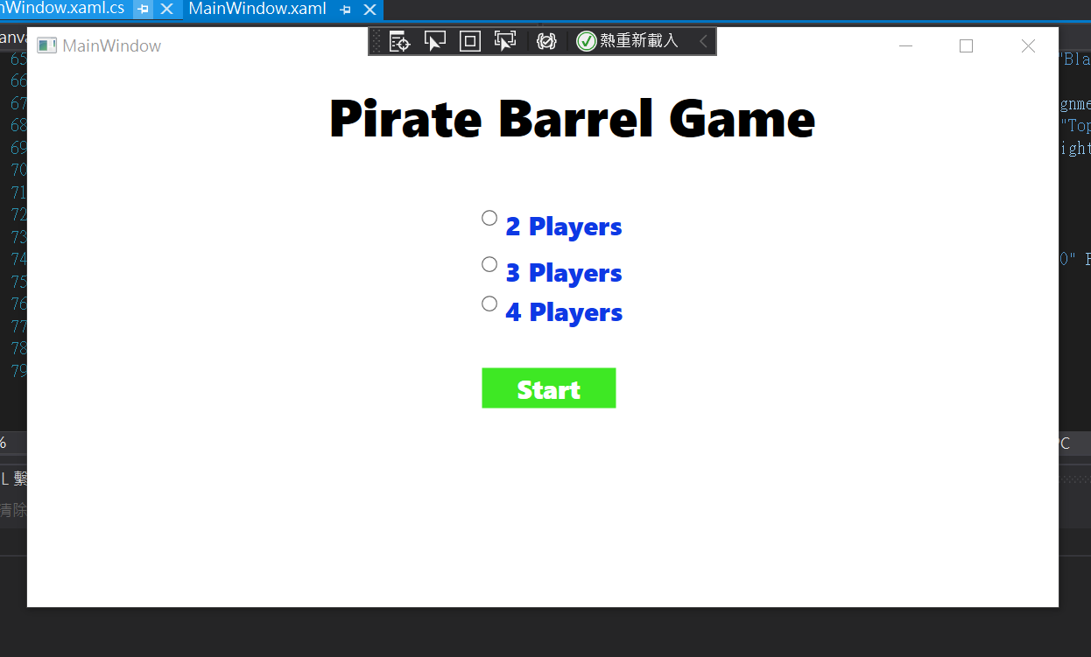

Starting game’s page. Players need to choose the number of players before starting the game.

If players did not choose the number of players and clicked the start button, a message box will pop up until player choose the number of players. Like that.

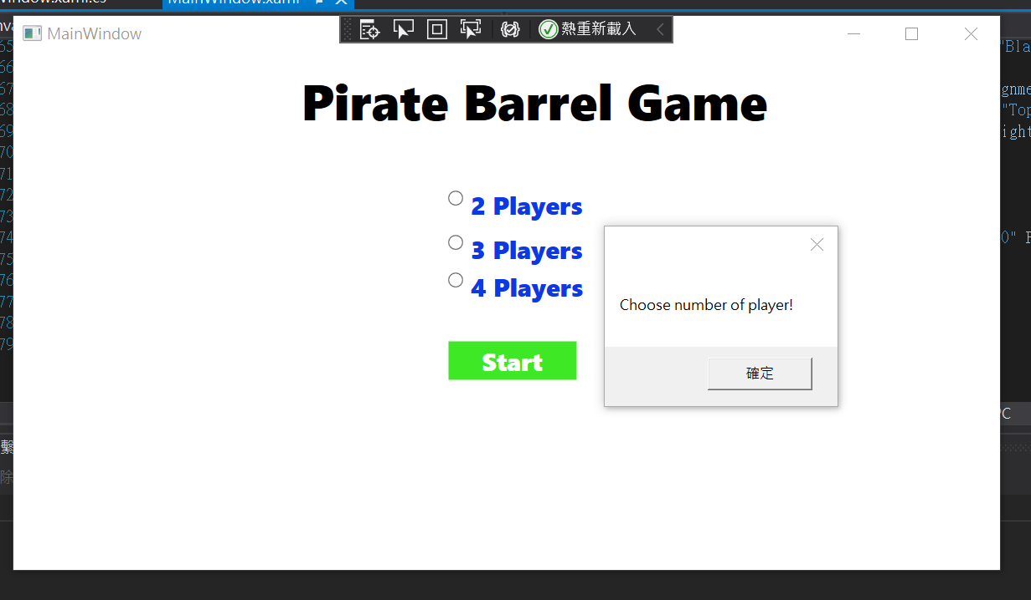

After players choose the number of players, game is started.

Game start (for example this 3-player mode) :

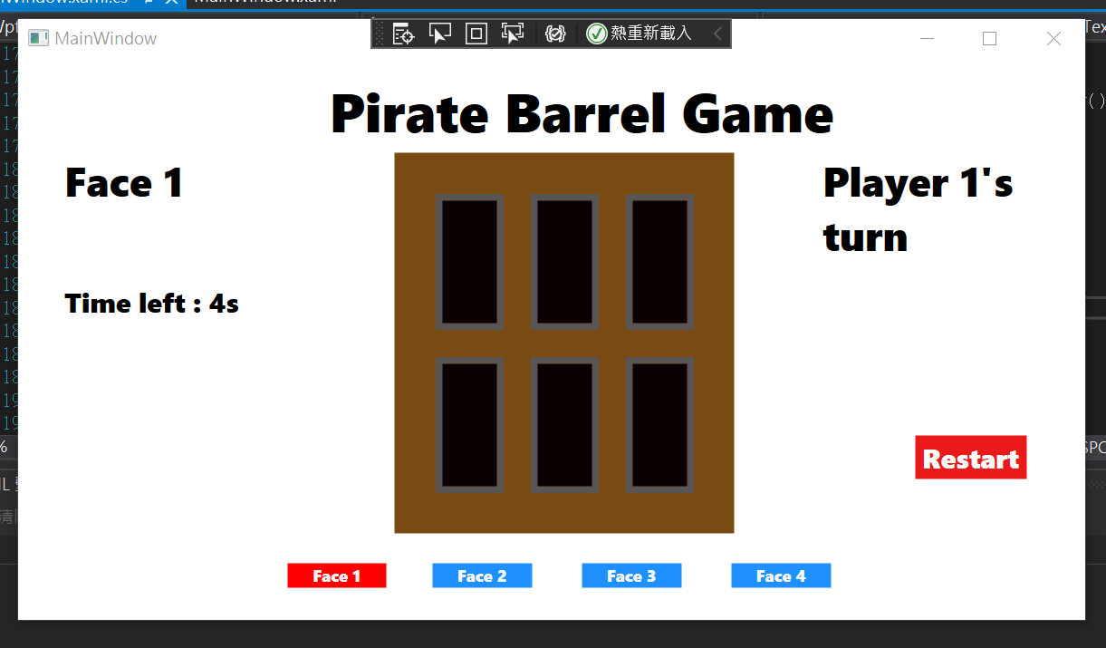

There has a wrap panel and 6 buttons to simulate the barrel and the knife slots. We can see that the button called “Face 1” is chosen. So, it has a text block to show the face that player chose. In this game, it has 4 pages, each page contains 6 knife slots. There have 24 knife slots in total. The right-hand side also show the player’s turn.

A Timer to count-down for the player to take action is under the text block of showing faces.

Choose the knife slot:

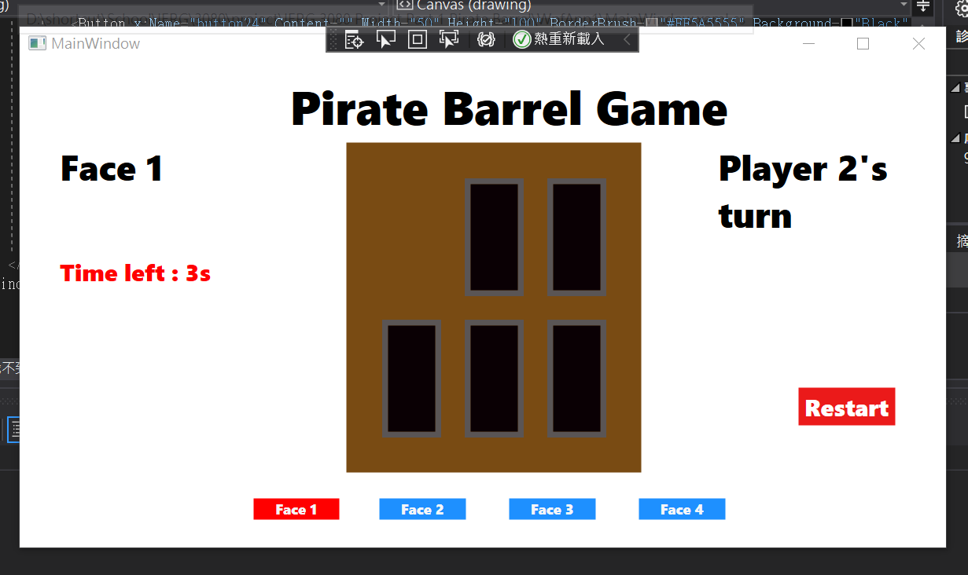

The clicked button disappeared after clicked. If the player did not hit the spot, the player’s turn is changed from “Player 1’s turn” to “Player 2’s turn”.

Hit the spot :

If player hit the spot, it will pop a boom picture and show who lose the game.

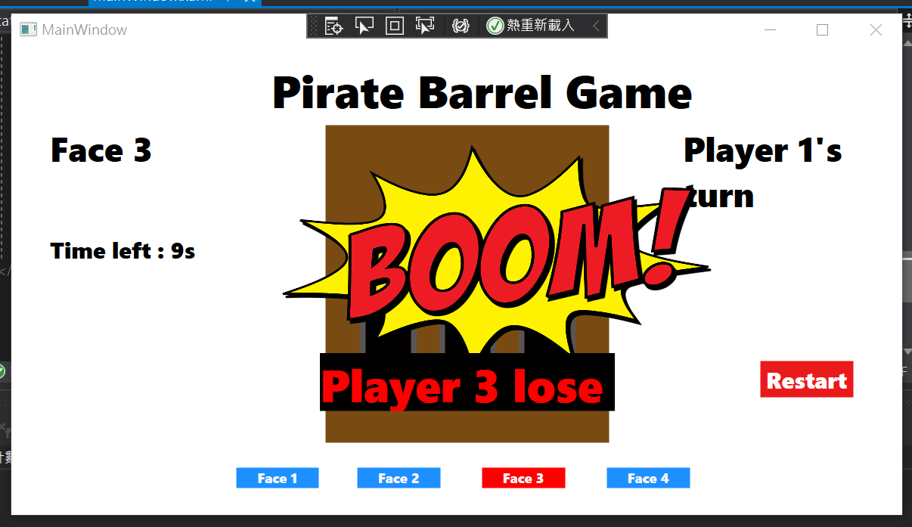

Time out :

If the player did not choose which button to be clicked. He/she will also lose the game.

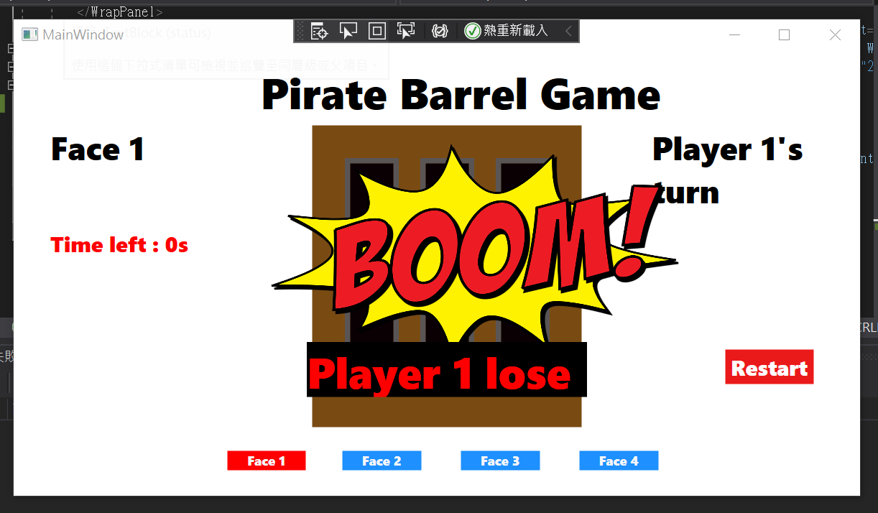

Image that in the game :

<https://pixabay.com/vectors/comic-blast-blast-effect-2340467/>