This is one amongst the popular metrics employed in the trade. the largest advantage of mistreatment mythical monster curve is that it's freelance of the modification in proportion of responders. Let’s initial attempt to perceive what's mythical monster (Receiver operational characteristic) curve. If we glance at the confusion matrix below, we have a tendency to observe that for a probabilistic model, we have a tendency to get totally different worth for every metric.

. 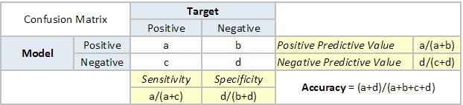

Hence, for every sensitivity, we have a tendency to get a special specificity. The two vary as follows:

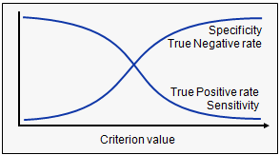

The mythical monster curve is that the plot between sensitivity and (1- specificity). (1- specificity) is additionally referred to as false positive rate and sensitivity is additionally referred to as True Positive rate. Following is that the mythical monster curve for the case in hand.

